Recent trends in power electronics

(February 2016)

Priyanka T. Ghaiwat, student, VI sem., electrical engineering, SRMCEW

Abstract – Power electronics refers to the use of electronics to efficiently control and convert electrical energy so that it becomes suitable for use. The social importance of PE is increasing globally and rapidly, as societies recognize the importance of reducing the electricity consumption, even as they continue to promote economical growth and technological progress. More generally, there is increase in awareness of the urgency of achieving responsible energy use through all available means: by designing low power systems, by replacing fossil fuels with renewable forms of energy and by promoting the use of discarded energy. PE is central to all of these efforts. This paper reviews the advancement in the areas of power electronics such as power semiconductor devices.

pINTRODUCTION
ower electronics addresses the entire life cycle of electricity within a system: generation, transmission, conversion, and storage. Its areas of concern also extend to the configuration and use of these systems. PE comprises numerous technologies: circuit technology, manufacturing technology, usage methods, and more. Today, it appears that PE's most important goal is to find and implement measures for reducing energy consumption. PE engineers are concerned with promoting efficiency in all of the four stages previously mentioned: generation, transmission, conversion, and storage. As a result of their work, we are seeing steady progress in technologies that produce power savings. Electrical power is processed by power electronics to make it suitable for various applications, such as dc and ac regulated power supplies, electrochemical process, heating and lighting control, electrical machine drives, induction heating, electronic welding, active power line filtering, static var compensation, etc. the process involves conversion (dc-ac, ac-dc, dc-dc and ac-ac) and control using power semiconductor switches. In modern power electronic equipment, there are essentially two types of semiconductor element: power semiconductors that can be considered as muscle of equipment and the microelectronic control chips that provide the power of the brain.
The additional cost of power electronics can be recovered by energy saving in a reasonably short time, especially where the cost of electricity is high. Use of electric cars, electric trams and electric subway trains can substantially reduce urban pollution problems. Power electronics permits generation of electric power from environmentally clean photovoltaic, fuel cell, and wind energy sources. Now we are concerned about acid rain and green house effect. Widespread application of power electronics, especially with an eye for energy conservation and generation of power from environmentally clean sources can solve this problem.
The modern era of power electronics started with the invention of power semiconductor devices. The pnpn triggering transistor which was later defined as thyristor or silicon conducted rectifier (SCR) was invented by Bell telephone laboratory in 1956. Since then power electronics has undergone so many evolutions in last three decades.
In this paper we briefly review the recent advances in power electronics that include power semiconductor devices. The research and development trends in these areas are highlighted.

PE development: current issues and achievements
To achieve significant power savings, today’s PE systems must deliver precision control and efficient operation. That’s why MCU-driven digital control is taking the place of conventional analog control implementations.
However, many of today’s experienced PE design engineers are still coming from an analog technology background. Therefore they are often unfamiliar with MCU-based designs. To build effective digital systems, circuit designers must understand how MCUs and related devices are used, and how they interact. Software designers, too, are faced with the need to learn about unfamiliar and complicated circuitry. For these reasons, many engineers working on PE projects have reported significant difficulty in making the transition from analog techniques to digital technology. Typically, they also find that they must devote considerable time and expense to the process of selecting combinations of microcontrollers (MCUs) and other devices that can deliver optimal combinations of functionality, capability and cost-performance.
It is also worth noting here that good PE systems must be capable of carrying out voluminous and complicated mathematical computations. Such designs require high-performance MCUs and sophisticated control software, the efficient application of which necessitates experience and specialized knowledge that many analog designers do not yet have.

POWER SEMICONDUCTOR DEVICES

Power semiconductor devices are used to control the energy transfer of electronic systems. Over the last two decades the technology of power semiconductors has made impressive progress. The power function (switching or protection) is achieved through the combined use of low-voltage data and signal processing circuits with power devices. The evolution naturally involves the integration of the whole or part of the low-voltage elements with the power devices in order to improve performance and to reduce the chip (or system) size. The application of IC technologies on power semiconductor devices has offered efficient protection components, simple drive characteristics, and good control dynamics together with a direct interface to the monolithic integration with the signal processing circuitry on the same chip. As a result, power electronic systems have greatly benefited from advances in power semiconductor technology. In consumer and industrial environments, designers make big efforts of improving the efficiency, to reduce the size and weight of components by combining the functions of several ICs and discrete power semiconductors. Thereby this system costs can be lowered and the system design is simplified by reducing the number of components.
There are two distinct concepts for the development of power semiconductor devices. One concept involves discrete vertical power devices for medium- and high-power applications, and the other uses the lateral power devices for high-voltage (low-current) and smart power applications, and for monolithic integration with low-voltage circuitry. Discrete vertical power devices have evolved from bipolar devices (diodes, thyristors, GTOs, and BJTs) to power MOSFETs, IGBTs and MCTs. Applications of discrete power devices are in the computer, telecommunications, and automotive industries for devices operating at below 300V and motor control, robotics, and power distribution for devices operating at above 300V. The most important step in the development of a new generation of power devices was the introduction of power MOSFETs. The development of these new devices provided a direct link between integrated circuits and power devices. This evolution has led to power device development in terms of structure, design, size reduction, and manufacturing. The design rules reduction in discrete power MOSFETs has allowed a drastic reduction in the on-resistance drastically and in power dissipation. Another important breakthrough in the field of discrete devices has been the development of IGBTs combining the advantages of MOS transistors, such as low power drives by using MOS gate and fast switching, with the advantages of bipolar devices, such as low forward voltage drop by conductivity modulation in the drift region. Improvements in these new power devices, MOSFETs and IGBTs, are related to advances in standard MOS technology. These devices are produced in the same production facilities which were used for integrated circuits. The introduction of MOS technology in power electronics made it easy to integrate power devices into standard technology and integrated circuits have become compatible. For medium- and high-voltage applications IGBTs have been the dominated devices due to scaling of their voltage ratings and refinements to their gate structure achieved by using very large scale integration (VLSI) technology and trench gate regions. In the past ten years, MOSFET technology has been benefited from the drastic improvements achieved in the trench technology and in the characteristics of vertical super-junctions, while IGBT technology has shown improvements in performance due to lifetime control technology and structure enhancements.

MODERN POWER DEVICES

IGBT: An insulated-gate bipolar transistor (IGBT) is a three-terminal power semiconductor device primarily used as an electronic switch which, as it was developed, came to combine high efficiency and fast switching. It switches electric power in many modern appliances: variable-frequency drives (VFDs), electric cars, trains, variable speed refrigerators, lamp ballasts, air-conditioners and even stereo systems with switching amplifiers. Since it is designed to turn on and off rapidly, amplifiers that use it often synthesize complex waveforms with pulse-width modulation and low-pass filters. In switching applications modern devices feature pulse repetition rates well into the ultrasonic range—frequencies which are at least ten times the highest audio frequency handled by the device when used as an analog audio amplifier.
The IGBT combines the simple gate-drive characteristics of MOSFETs with the high-current and low-saturation-voltage capability of bipolar transistors. The IGBT combines an isolated-gate FET for the control input and a bipolar power transistor as a switch in a single device. The IGBT is used in medium- to high-power applications like switched-mode power supplies, traction motor control and induction heating. Large IGBT modules typically consist of many devices in parallel and can have very high current-handling capabilities in the order of hundreds of amperes with blocking voltages of 6000 V. These IGBTs can control loads of hundreds of kilowatts.
The first-generation IGBTs of the 1980s and early 1990s were prone to failure through effects such as latch up (in which the device will not turn off as long as current is flowing) and secondary breakdown (in which a localized hotspot in the device goes into thermal runaway and burns the device out at high currents). Second-generation devices were much improved. The current third-generation IGBTs are even better, with speed rivaling MOSFETs, and excellent ruggedness and tolerance of overloads.^{[1]} Extremely high pulse ratings of second- and third-generation devices also make them useful for generating large power pulses in areas including particle and plasma physics, where they are starting to supersede older devices such as thyratrons and triggered spark gaps. High pulse ratings and low prices on the surplus market also make them attractive to the high-voltage hobbyists for controlling large amounts of power to drive devices such as solid-state Tesla coils and coil guns.

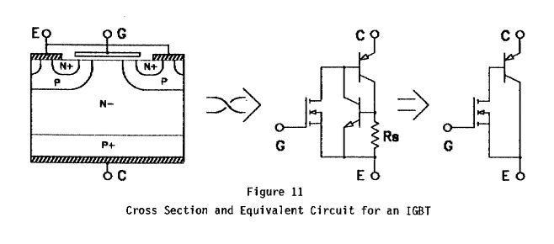
Fig. cross section of IGBT

Fig. equivalent circuit of IGBT
MCT: Out of many semiconductor controlled devices, MCT is considered to be the latest. The device is basically a thyristor with two MOSFET’s built into the gate structure. A MOSFET is used for turning ON the MCT and another one is used for turning it OFF. The device is mostly used for switching applications and has other characteristics like high frequency, high power, and low conduction drop and so on. An MCT combines the feature of both conventional four layer thyristor having regenerative action and MOS- gate structure. In this device, all the gate signals are applied with respect to anode, which is kept as the reference. In a normally used SCR, cathode is kept as the reference terminal for gate signals.
The basic structure of an MCT cell is shown in the figure below.
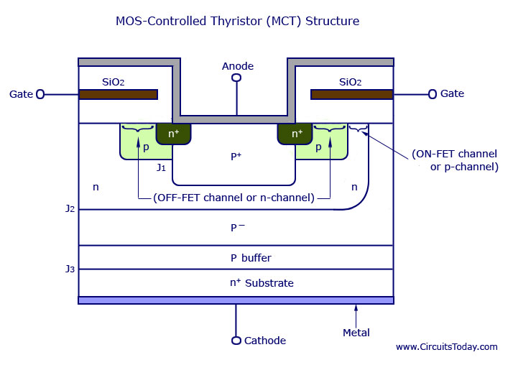

In practice, a MCT will include thousands of these basic cells connected in parallel, just like a PMOSFET. This helps in obtaining a high current carrying capacity for the device.The equivalent circuit of the MCT is shown in the figure below.

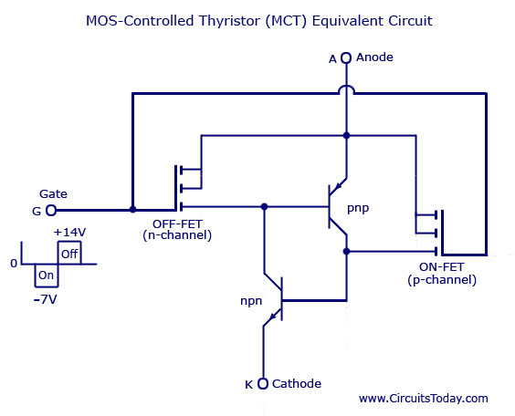
It consists of an ON-FET, an OFF-FET and two transistors. The MOS structure of the MCT is represented in the equivalent circuit. It consists of one ON-FET, a p-channel MOSFET, and an OFF-FET. Both n-p-n and p-n-p transistors are joined together to represent the n-p-n-p structure of MCT. An n-channel MOSFET is represented by drawing the arrow towards the gate terminal. A p-channel MOSFET is indicated by drawing the arrow away from the gate terminal. The two transistors in the equivalent circuit indicate that there is regenerative feedback in the MCT just as it is an ordinary thyristor. The circuit symbol of MCT is shown below.

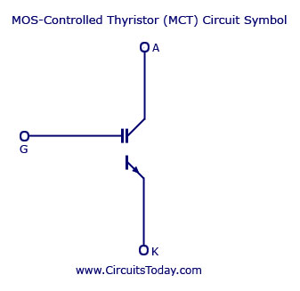
SITH: the SITH also known as field controlled diode. Two similar structures known as Field Controlled Diodes (FCDS) are shown in Figure. with their equivalent circuit. The construction is similar to that of Power JFETs (Figure 4) with the N+ drain region changed to P+. This is the same transformation that converts a MOSFET into an IGOT, and the equivalent circuit is indeed that of a JFET driving a PNP bipolar, and conductivity modulation is achieved with JFET drive characteristics.
Conductivity modulation control is perhaps a little better with the FCD than with the IGBT, but control is still indirect; the gate voltage controls the JFET current which is in turn the PNP transistor's base current. Production variations in control characteristics may be a problem, but the normally-on property is perhaps the greatest stumbling block to most design engineers.

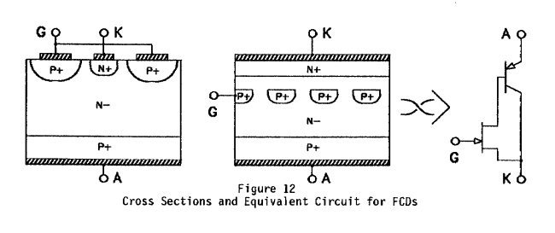

Fig. cross section of FCD
Fig. symbol of FCD

CONCLUSION

The paper describes the several key ideas about the recent advances in power electronics technology such as power semiconductor devices. The structure of IGBT, MCT, SITH are reviewed.
It appears that future R&D efforts in power electronics will be focused in two directions: (1) new and improved devices and (2) microcomputer based high performance control. High temperature super conductive materials when used successfully will have tremendous effect on power electronics. The real evolution in power electronics is yet to come. This new era will begin with the invention of gallium-arsenide, silicon carbide and diamond powered semiconductor devices. The impact will be more significant than that has been brought by thyristors.

REFERENCES

B. K. Bose, Power electronics and ac drives, Englewood cliffs, NJ; prentice – hall, 1986
- www.circuitstoday.com
- B. K. Bose, “power electronics- an emerging technology’’,IEEE trans. Ind. Electronic devices, vol. ED. 33,no. 10
- www.power-tech.com/cartex.htm

