BRIEF ANALYSIS OF AC DRIVES AND AUTOMATION
- Ramanuj Borgohain KDKCE/EE 7028534921 ramanuj_borgohain94@outlook.com
- Shalaka Bhandarkar KDKCE/EE 7038344197 shalakabhandarkar7@gmail.com
- Aishwarya Naik KDKCE/EE 7083751676 aishwarya.naik1997@gmail.com
- Rahul Gupta KDKCE/EE 8446982608 ratedrahul09@gmail.com

Abstract – This article shows the description and operation of AC Drives (Variable Frequency Drive, VFD). The benefits, applications, types and ratings of VFD are also studied. The use of VFD has been increased dramatically in various fields. This article provides basic understanding of how ac drive is being used for automation.
- INTRODUCTION
A variable-frequency drive (VFD) (also termed adjustable-frequency drive, variable-speed drive, AC drive, micro drive or inverter drive) is a type of adjustable-speed drive used in electro-mechanical drive systems to control AC motor speed and torque by varying motor input frequency and voltage.
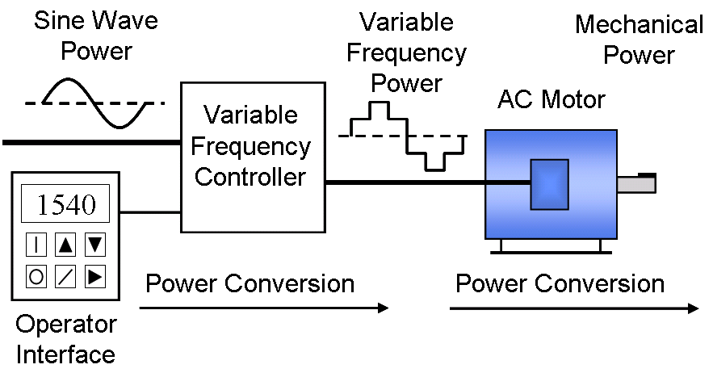
The AC drive industry is growing rapidly and it is now more important than ever for technicians and maintenance personnel to keep AC drive installations running smoothly. AC drives change the speed of ac motor by changing voltage and frequency of the power supplied to the ac motor. In order to maintain proper power factor and reduce excessive heating of the motor, the name plate volts/hertz ratio must be maintained. This is the main task of VFD.
VFDs are used in applications ranging from small appliances to the largest of mine mill drives and compressors. However, around 25% of the world's electrical energy is consumed by electric motors in industrial applications, which are especially conducive for energy savings using VFDs in centrifugal load service, and VFDs' global market penetration for all applications is still relatively small. That lack of penetration highlights significant energy efficiency improvement opportunities for retrofitted and new VFD installations.
Over the last four decades, power electronics technology has reduced VFD cost and size and has improved performance through advances in semiconductor switching devices, drive topologies, simulation and control techniques, and control hardware and software.
AC Drives Basic Working Principle:
- AC drives are used to stepless speed control of squirrel cage induction motors mostly used in process plants due to its ruggedness and maintenance free long life.
- AC drive control speed of ac motor by varying output voltage and frequency through sophisticated microprocessor controlled electronics device.
- AC drive consists of Rectifier and inverter units. Rectifier converts AC in DC voltage and inverter converts DC voltage back in AC voltage.

Constant V/F Ratio Operation:
All AC drives maintain the output voltage - to - frequency (V/f) ratio constant at all speeds for the reason that follows. The phase voltage V, frequency f and the magnetic flux ϕ of motor are related by the equation:

V = 4.444 f N ϕ_{m}
or
V/f = 4.444×N ϕ_{m}

Where, N = number of turns per phase.
ϕ_{m} = magnetic flux
If the same voltage is applied at the reduced frequency, the magnetic flux would increase and saturate the magnetic core, significantly distorting the motor performance. The magnetic saturation can be avoided by keeping the ϕm constant. Moreover, the ac motor torque is the product of stator flux and rotor current. For maintaining the rated torque at all speeds the constant flux must be maintained at its rated value, which is basically done by keeping the voltage - to - frequency (V/f) ratio constant. That requires the lowering the ac motor voltage in the same proportion as the frequency to avoid magnetic saturation due to high flux or lower than the rated torque due to low flux.

II. SYSTEM DESCRIPTION AND OPERATION

A VFD consists of the following three main sub-systems: AC motor, main drive controller assembly, and drive/operator interface.

AC Motor
The AC electric motor used in a VFD system is usually a three-phase induction motor. Some types of single-phase motors can be used, but three-phase motors are usually preferred. Various types of synchronous motors offer advantages in some situations, but three-phase induction motors are suitable for most purposes and are generally the most economical motor choice. Motors that are designed for fixed-speed operation are often used.

    - Controller

The VFD controller is a solid-state power electronics conversion system consisting of three distinct sub-systems: the Rectifier unit, DC Bus and the Inverter unit. The supply voltage is firstly pass through a rectifier unit where in gets converted into AC to DC supply, the three phase supply is fed with three phase full wave diode where it gets converts into DC supply. The DC bus comprises with a filter section where the harmonics generated during the AC to DC conversion are filtered out. The last section consists of an inverter section which comprises with six IGBT where the filtered DC supply is being converted to quasi sinusoidal wave of AC supply which is supply to the ac motor connected to it.
From the ac motor working principle, we know that the synchronous speed of motor (rpm) is dependent upon frequency. Therefore by varying the frequency of the power supply through AC drive we can control the synchronous motor speed:

Speed (rpm) = Frequency (Hertz) x 120 / No. of poles
Where:
Frequency = Electrical Frequency of the power supply in Hz.
No. of Poles = Number of electrical poles in the motor stator.
Thus we can conveniently adjust the speed of an AC motor by changing the frequency applied to the motor. There is also another way to make the ac motor work on different speed by changing the no. of poles, but this change would be a physical change of the motor. As the VFD provides the frequency and voltage of output necessary to change the speed of a motor, this is done through Pulse Width Modulation VFDs. Pulse width modulation (PWM) variable frequency drive produces pulses of varying widths which are combined to build the required waveform.
As the frequency can easily variable as compared with the poles of the motor therefore ac drives are frequently used.

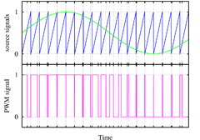

    - Drive/Operator Interface

The operator interface provides a means for an operator to start and stop the motor and adjust the operating speed. Additional operator control functions might include reversing, and switching between manual speed adjustment and automatic control from an external process control signal. The operator interface often includes an alphanumeric display and/or indication lights and meters to provide information about the operation of the drive.
Referring to the accompanying chart, drive applications can be categorized as single-quadrant, two-quadrant, or four-quadrant; the chart's four quadrants are defined as follows:
- Quadrant I -- Driving or motoring forward accelerating quadrant with positive speed and torque
- Quadrant II -- Generating or braking, forward braking-decelerating quadrant with positive speed and negative torque
- Quadrant III - Driving or motoring, reverse accelerating quadrant with negative speed and torque
- Quadrant IV - Generating or braking, reverse braking-decelerating quadrant with negative speed and positive torque.
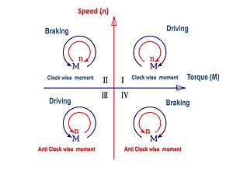

III. AUTOMATION USING AC DRIVES

As the AC drive provides the frequency and voltage of output necessary to control the speed of an AC motor, this is done through PWM VFDs. PWM drives produce pulses of varying widths which are combined to build the required waveform. A diode bridge is used in some converters to reduce harmonics. PWM drives produce a current waveform that more closely matches a line source, which reduces undesired heating. PWM VFD have almost constant power factor at all speeds which is closely to unity. PWM drives can also operate multiple motors on a single VFD.
Thus the carrier frequency is derived from the speed of the power device switch remains ON and OFF. It is also called switching frequency. Therefore higher the carrier frequency higher the resolution for PWM contains. The typical carrier frequency ranges from 3KHz to 4 KHz or 3000 to 4000 times per second as compared with older SCR based carrier frequency which ranges from 250 to 500 times per second. Thus it is clear as much as higher the carrier frequency higher will be the resolution of output waveform. It is also noted that the carrier frequency decreases the efficiency of the VFD because it led to increase the heat of the VFD circuit.
- BENEFITS

- High efﬁciency and low operating cost

- Minimal motor maintenance

- Controlled linear acceleration and deceleration provide soft starting and stopping and smooth speed changes

- Multiple motor operation is easily accomplished

- Current limit provides for quick and accurate torque control

- Adjustable speed operation can be accomplished with existing AC motors

- Improved speed regulation can be accomplished by slip compensation

- AC motors are available in a wide variety of mechanical conﬁgurations

- Flexibility of machine design due to the light weight and compact size of AC motors

- IR compensation provides high starting torque easily and economically

- AC motors are available in enclosures suitable for hazardous or corrosive environments

- Fewer spare motors are required since the same motor can be used for both adjustable speed and constant speed operations.

- Cutler-Hammer rugged and reliable designs ensure minimum downtime expense

- High speed operation can be economically accomplished using extended frequency operation

- Reverse operation is accomplished electronically without the need for a reversing starter

- APPLICATIONS OF AC DRIVE

Matching the AC Drive to the Motor PWM and Vector AC Drives are designed for use with any standard squirrel cage motor. Sizing the drive is a simple matter of matching the drive output voltage, frequency and current ratings to the motor ratings. Output Voltage and Frequency Most modern AC Drives are designed for use with various voltages and frequencies. By adjusting the V/Hz properly, almost any 3-phase motor can be used. Output Current AC drive full load currents are matched to typical full load motor current ratings as listed in NEC Table 430-150. Usually an AC drive can be matched to an AC motor by their hp ratings, however, actual motor current required under operating conditions is the determining factor. If the motor will be run at full load, the drive current rating must be at least as high as the motor current rating. If the drive is to be used with multiple motors, the sum of all the full load current ratings must be used, and adding up the hp ratings of the motors will usually not provide an accurate estimate of the drive needed. Motor Protection Motor overload protection must be provided as required by the applicable codes. Motor protection is not automatically provided as part of all AC drives. It may be provided as a standard feature on one model or it may be an optional feature on another. The best means of motor protection is a direct winding over temperature protection such as an over temperature switch imbedded in the motor windings. Direct over temperature protection is preferred because overheating can occur at normal operating currents at low speeds. Most AC drives are equipped with electronic overcurrent protection, such as I²t protection, similar to a conventional overload. Conventional overloads also may be used. In some modern drives, the I²t protection can be conﬁgured to protect the motor during low speed operation. In Motor Winding Damage The voltage output of AC drives contains voltage steps. In modern PWM drives, the dV/dt of a motor causes can cause very large voltage spikes. Voltage spikes of 1500 volts or more are typical for a 460 volt motor. This can cause multiple motor applications, individual motor overload protection must be provided even where electronic protection is provided by the drive. In some cases, short circuit protection may be required. the end windings of a Non-Inverter Duty or standard induction motor to fail. This problem gets worse as the cable length from the drive to the motor gets longer. Corrective action is normally required for cables longer than 150 feet. Load side reactors, installed at the drive output terminals, will reduce the voltage spikes at the motor terminals. Most drive manufacturers have load side reactors available as an option.

- CONCLUSION

Thus after the study of AC drive, it becomes possible to control the speed of AC motor as well as to conserve the electrical energy. The frequency variation leads to the harmonic change in machine. With the process of PWM the frequency given to the AC Motor can be set in order to control the speed of AC Motor. There are also various benefits of using AC Drives such as: Reduction of Noise and Vibration Level, Reduction of Themal and Mechanical Stresses.
As we know that the energy conservation has become an important subject to all over the world, increase in efficient energy use, decrease in energy consumption and/or consumption from conventional energy sources is reduced that leads to the conservation of energy.

REFERENCES

- https://en.wikipedia.org/wiki/Variable-frequency_drive
- www.acdrive.org
- Cutler-Hammer, AC Drive Theory and Application.

