Solar Chimney Power Generation System

Mrunal Kolhe Department of Electrical Engineering, KDKCE, Nagpur
Suraj Dhanvijay Department of Electrical Engineering, KDKCE, Nagpur
Bhairavi Gatthekar Department of Electrical Engineering, KDKCE, Nagpur
Prof.C.J.Sharma Department of Electrical Engineering, KDKCE , Nagpur

Abstract- During next century the global pattern of energy consumption will see a shift towards creation of new renewable energy capacities in the growing economics of the developing world. An increasing proportion of the future energy demand will have to be met in the form of electricity. Renewable energies can satisfy more than the half of the global primary demand by the middle of next century. In order to take the long term view and to realize the full potential of renewable, it is necessary to formulate comprehensive renewable energy policies, which will encompass govt., industry, research institute, local communities and users. We are also planning to give new direction to this solar chimney power generation system for house hold uses by installing it on the roof of our houses. The concept is creating! The temperature difference in the medium (Air) and allowing it to pass through the nozzle converting the pressure energy into Kinetic Energy leading to the rotation of the wind turbine in the way. Parameter to be studied shall be the area under sun, availability, costing, technology, and need.
Keyword: Circumferentially-1, Adversely-2, Corrugated-3, Exploitable-4, Propeller.
- INTRODUCTION:
Man learn to make active use of solar energy at a very early stage, green houses helps to grow food, chimney suction ventilated and cooled buildings and wind mill generated power for pumping water, ground corn etc. All the above components used in the tapping of solar energy and carried out energy related activities in ancient time are essentially combined in the solar chimney power plant. Thus, three components, viz. glass roof collector, chimney and wind turbine that forms a solar chimney power generation unit is known to the man kind since a long time. This kind of renewable energies are now a days very useful in shortage of energy sources.
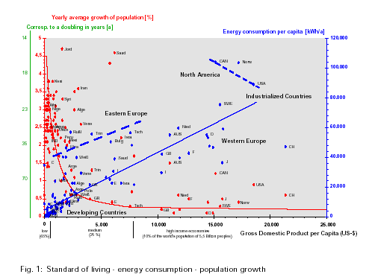
Fig 1. Standard of living – energy consumption – population growth
The principal of SCPGS is of thermosyphon effect caused by solar heating of air within a glass roof collector. Thus, the basic components of SCPGS are glass roof collector, chimney& wind turbines. It has got a tall chimney at the center of circular glass cover. Sun rays heat the air inside chimney & outside cold air. It creates an air circulation through the system. The kinetic energy of air is thus utilized to drive wind turbines& generate electricity. The whole process can be subdivided into heat input to air, up draughts & power output. During night hours, the plant can be operated with the stored energy from the solar source. The heat energy collect during day time, stored & supplied through suitable heat transfer systems ensures night time operation of SCPGS.
It is apparent that system is very simple & has no moving parts expect the turbines & few water pumps for night time operation. If the pressure take-off at the turbine is increased, the air mass through flow reduces and the temperature in the collector rises. This results in an increase in the surface temperature of the collector cover and resultant thermal losses due to IR emissions and convection losses. Pressure take-off at the turbine and temperature determine plant output to varying degrees. Thus for each power output there is an optimum pressure take off.
- PART OF SOLAR CHIMNEY POWER:
- The solar collector:-
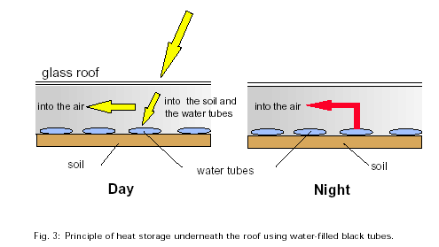
Fig. 2: principle of heat storage underneath the roof using water filled black tubes
The collector is a simple air heater enclosing the air between the glass cover and ground. The incident radiation passes through the cover and heats the air as well as ground. The ground acts as heat storage medium and dissipates energy over a long period thus utilizing both direct and diffuse radiation for the purpose. The hot air moves radial inward to the base of the chimney where wind turbines are placed circumferentially. Cover material and areas of the collector place vital role in efficient and economical working of the plant. The first comprehensive experimental studies on a commercially exploitable solar chimney power generation system were carried out during the period from 1981 to 1989 in Manzanares (Spain) (1995).
- Chimney:-
Chimney creates the necessary for air circulation. It is the difference of weight of air inside & outside of chimney for the same column height that produces the pressure difference for circulation.
Efficiency of chimney= g * H _{ch} / (CPA * T_{amb})
Above e.g. Implies chimney efficiency is dependent only on the height of chimney & ambient temp. From the references from Bergermann (1997). Bergermann (1997) has predicted height of chimney for various power o/p of the plant in below table. The chimney profile is considered as tapered in order to reduce the losses.
Table for cost optimized plant
 | 5MW | 30MW | 100MW
Chimney height(m) | 445 | 750 | 950
Chimney radius(m) | 27 | 43 | 57.5
Collector radius(m) | 555 | 1100 | 1800
Collector height ,outer | - | 4.5 | 6.5
Collector height ,inner | - | 15.5 | 20.5
No of turbines | 33 | 35 | 36

- Wind Turbine:-
Wind turbine converts the kinetic energy of air and pressure difference across the turbine into useful mechanical work, which then converts to electrical energy by generators. the turbine is basically of propeller type arranged circularly at the based of the chimney .the dimensions are fixed hence limits the minimum radius at which the turbines are kept horizontal and a radial space of about one dia. Of chimney is provided for accommodating gear boxes, generator, etc.
Turbine power o/p, p = efficiency of gen.* efficiency of turbine*difference of pressure * volume of turbine* area of turbine.
- Pressure Loss:-
The major losses are identified as entry loss, exit loss, chimney friction loss and collector friction loss and bend loss.
∆p_{loss} = collector friction loss + chimney friction loss + bend loss + exit loss+ entry loss
=∆p_{col} + ∆p_{ch} + ∆p _{bend +}∆ p_{exit +}∆p _{entry.}
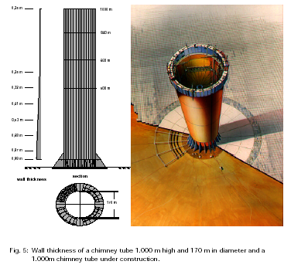

Fig 3. Wall thickness of a chimney tubes 1,000 m high and 170 m in diameter and a 1,000 m chimney tube under construction.
Thermal design of the plant (day time operation)
The design is directed to find the radius of the collector so that an output of 220 MW is obtained.
- DAY TIME OPERATION
A suitable computer program has been developed to obtain radius of collector and simultaneously optimizes various parameters of the plant in order to reduce the losses.
P (actual power produced) =220MW
With optimized computer model of solar chimney power plant, effect of other parameters namely –collector outer height, chimney diverging angle, ambient temp.
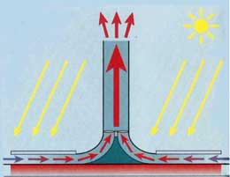
Fig 4. Day time operation of the solar chimney power generation system
Result and Discussion (Day Time Operation):
A preliminary thermal design with straight chimney and using solar and climatologically data of the selected site suggests that about 17% of the total draught produced waste away through various losses. The overall efficiency of the plant was about 1.24%. some of the parameters that effects the design and its performance significantly are -chimney diverging angle ,air temperature rise ,height of chimney .ambient temp, collector height and chimney diameter.
Effect of change in diverging angle of chimney:
With increase in diverging angle, there is reduction in radius of collector but the rate of reduction is negligible after 10 degree, because of constructional difficulty, the diverging angle is restricted to 6 degree.
Effect of change in air temperature rise:
With increase in temp rise, radius of collector reduces at a greater rate initially. An increase of temperature rise from 25⁰ c to 35⁰ c leads to
Above value is refered from reference (1)(2)(3)
1) Exit loss reduction of 67.2%, 2) entry loss reduction of 60%, 3) bend loss reduction of 67.2%, 4) chimney friction loss reduction of 65%, and collector friction loss reduction of 67%.
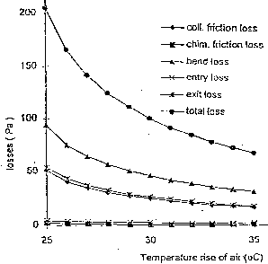
Fig 5. Reduction losses with temperature rise of air
Effect of Ambient Temperature:
With the ambient temperature rise, average air velocity in the collector increases leading to a linear rise in the total pressure loss, however their may be reduction in convective heat loss from the collector to the environment. The air draught generation descends because of lesser density differences between the column of hot air inside and outside of chimney .this adversely affects the power o/p of the plant.
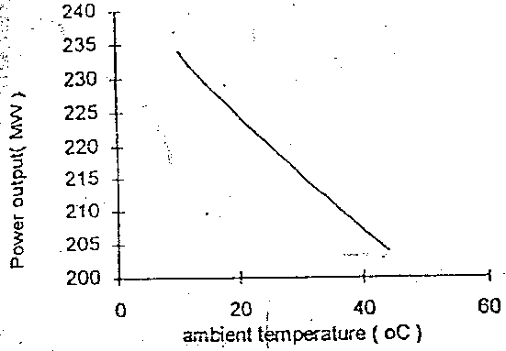
Fig 6. Reduction in power output with rise in ambient temperature
Effect of Increase in Chimney Diameter:
Increase in chimney diameter, reduces the radius of collector .however the reduction is marginal after 24.2 meter of chimney diameter with the assumption of 6⁰ diverging angle and 1000 meters height of chimney. A change of chimney diameter from 15.5 meter to 24.2 meter reduces the collector area by 2.7 %.And also,
- collector friction loss =22%
- exit loss=75%
- chimney friction loss=84%
- bend loss =61.2%
- entry loss =1.835

Effect of Increase in Collector Outer Height:
  - An increase in outer height of the collector from 7.5 to 9.5 m reduces radius of 10m.
  - among the losses ,entry and collector friction losses are influenced more because of reduction in the inlet air velocity
Effect of Increase in Chimney Height:
Efficiency of the plant increases; chimney diameter and collector are requirement reduces constantly considered at day time.
Thermal System for Night Operation:
Operating the plant for round the clock will improve its use factor and reduce generation cost.
However, night time operation will require heating of air through some extended means. Tijare and Majumdar carried out detailed studies on few solar assisted heat exchanges that can be incorporated in solar chimney power plant. Garg suggested the use of hot water to heat air by spraying during night time. One of the novel ways is to store solar heated water and circulate in suitable heat exchangers provided in the collector to heat air during night time.
Heat Exchangers:
For night operation, air is heated using solar heated water. The heat exchanger proposed is of recuperator, counter –flow and single through type.
Heat exchangers are arranged inside the glass roof collector such that it provides minimum obstruction to air flow. The unit heat exchangers are arranged in series radially outward .below table gives the technical data for design of heat exchanger.
Flat Plate Collector (FPC):
FPC is the main device of collecting the solar energy through water medium which will be used for the night time operation.
It has to heat water sufficiently to include all losses and energy required for heating the air in the chimney collector during night time which is bare corrugated type.
- CONCLUSION
- It is more effective renewable energy source.
- It is used for domestic purpose.
- Cost factor is low as compared to any other renewable energy source.
Concluding remarks:
With its large covered ground area, the solar chimney power plant possesses theoretically a natural energy store, which costs virtually nothing the radiation power incident on to the collector is converted into a rise in temperature at the ground surface.
SCPP is more suitable to take base load. At day time, the supply energy can not be controlled based on the load. Hence the plant continuously produces the rated output.
REFERENCES
- S BERGERMANN,(1997), The solar chimney transferability of results from the manzanarus solar chimney plant to large scale plants’, report, s bergermann und partner, Civil Engineers, Stuttgart , Germany
- D.W .Tijare, (1997),”heat transfer systems foe 220 Mw solar chimney power plants”, M.E dissertation, Mech Engg. Dept.
- Prasanna Majumdar, (1998),” thermal system design of optimum performance of a 220 Mw solar chimney power plant “, M.E Dissertation. Mech Engg.Dept., faculty of Tech. & Engg, M.S.U of Baroda.
- Haaf W (1984) “Solar Chimneys – Part II : Preliminary Test Result from the Manzanares Pilot Plant”

