Enhancement of Voltage Quality In Isolated Power System
Amol Jumade, Namita Jibhakate, Mohit Moon
KDKCOE, Nagpur
amolrj143@gmail.com

Abstract – A traditional method to achieve improved power quality (PQ) is to use passive filters connected at the sensitive load terminals. Power quality is the main problem that the industry is facing today. The used of series compensators in improving power quality of isolated power system. The role of the compensator is not only to mitigate the effects of voltage sag, but also to reduce the harmonic distortion due to the presence of non linear loads in the network This is achieved through phase adjustment of load terminal voltage Matlab simulation and comparative study of output across sensitive load without and with Series Compensation applied to the power system. Harmonics occurs due to the connection of the main drive load (non linear load). All these factors affect the sensitive load which is connected in parallel to the main drive load. So the proposed system protects the sensitive load by mitigating the harmonics and voltage sags using series compensator technique.
Keywords— Voltage quality, power quality, series compensator, voltage sags/swells
- Introduction
Isolated power systems are commonly found in rural and remote areas of the world The sensitive loads which are present in the isolated power systems are much more affected by the power quality problems. Power Electronics and Advanced Control technologies have made it possible to face power quality problems and maintain the operation of sensitive loads. Among power system disturbances, voltage sags, swells and harmonics are some of the severe problems to the sensitive loads, because the occurrence of voltage sag in the system can cause devices/process down time, effect on product quality, failure/malfunction of equipments etc.
This paper analyses the key issues in the power quality problems, In the proposed system Voltage sag occurs due to the three phase fault in the transmission line and harmonics occurs due to the connection of controlled six pulse converter (rectifier) to the main drive load(non linear load). All these factors affect the sensitive load which is connected in parallel to the main drive load. So the proposed system protects the sensitive load by mitigating the voltage sags and harmonics using series compensation technique.

- POWER QUALITY
Power systems, ideally, should provide their customers with an uninterrupted flow of energy at smooth sinusoidal voltage at the contracted magnitude level and frequency. However, in practice, power systems, especially the isolated systems, some of the primary source of distortion can be identified as Non – Linear Loads, Power Electronic Devices, IT and Office Equipments, Arcing Devices, Load Switching, Large Motor Starting, Larger capacitor bank energies, Embedded Generation, Electromagnetic radiations and Cables, Storm and Environment Related Causes etc.
- SYSTEM MODEL
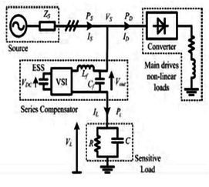
Fig.1. Basic Structure of Series Compensator
The simple isolated power system model shown in Fig. 1 is used to explain the principle of the proposed harmonics compensation method of the SC. The upstream generators are represented as an ideal voltage source and ZS represents the equivalent source impedance. The main drives or machinery loads are modeled as a lumped resistance-inductance load connected to the source through a power converter which is assumed to be an uncontrolled six-pulse rectifier in this study.
The main drives or machinery loads are modeled as a lumped resistive- inductive load connected to the source through a power converter, assumed to be a six-pulse rectifier. The much smaller capacity sensitive loads are assumed to be supplied through point of common coupling and are modeled by the resistor R in parallel with the capacitor C. The SC is connected upstream from the sensitive load through an injection transformer. It is series connected with the sensitive load. The function of the SC is to ensure that the voltage across the sensitive load terminals is of high quality. The central part of the SC is an energy storage system (ESS) and a VSI where a PWM switching scheme is often used. The ESS can be a capacitor of suitable capacity. Because of the switching, harmonics are generated, and filtering is required.
The harmonics is generated in the load terminals using six pulse converters with fixed firing angle are connected to the main drive non linear load which is parallel to the sensitive load. Voltage sag is created at load terminals via a three phase fault. The above voltage problems are sensed separately and passed through the sequence analyzer. The magnitude component is compared with reference voltage (Vref). Pulse width Modulation (PWM) control technique is applied for inverter switching so as to produce a three phase 50 Hz sinusoidal voltage at the load terminals. Chopping frequency is in the range of few KHz. The IGBT inverter is controlled with PI controller in order to maintain 1 per unit voltage at the load terminals. PI controller (Proportional Integral Controller) is a closed loop controller which drives the plant to be controlled with a weighted sum of the error (difference between the output and the desired set point) and the integral of that value. One advantage of a proportional plus integral controller is that the integral term in a PI controller causes the steady-state error to be zero for a step input.
- Principle of harmonic compensation

The underlying principle when the SC is used to compensate for upstream voltage sag/swell has been discussed in distorted voltage VL will appear on the upstream source-side of the sensitive load and the phase voltages can be expressed as

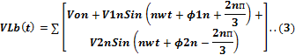

where n is the harmonic order; V0n is the zero phase sequence voltage component; V1n and φ1n are the magnitude and phase of the positive phase sequence voltage components; V2n and φ2n are the magnitude and phase of the negative phase sequence voltage components. Clearly, the distorted voltage is undesirable at the sensitive load terminals.

The proposed voltage injection method is to compensate for the difference between VL and the desired voltage described by (1)-(3). This is achieved by injecting an ac voltage component in series with the incoming three-phase network. Hence from (1)-(3), the desired injection voltages are,

5)

The above equations can be written in a compact form. From (4)-(6), define 𝑉𝐿𝑓 =[Vla(t), Vlb (t), Vlc (t)]T and from (1)-(3), denote as, 𝑉𝐿𝑓 =[Vla(t), Vlb (t), Vlc (t)]T, Let VLh be the vector containing all the harmonic components in (1)-(3). Hence, from (7)-(9), the injection voltage of the SC would be
V*=VLf-VL=VLh

VL can be measured online and its fundamental voltage VLf can be obtained using, for example, a Phase Locked Loop (PLL) scheme. Hence the injection voltage V*can be generated online and used to mitigate the harmonic distortions in the manner described below.

The harmonics is generated in the load terminals using six pulse converters with fixed firing angle are connected to the main drive non linear load which is parallel to the sensitive load. Voltage sag is created at load terminals via a three phase fault. The above voltage problems are sensed separately and passed through the sequence analyzer. The magnitude component is compared with reference voltage (Vref). Pulse width Modulation (PWM) control technique is applied for inverter switching so as to produce a three phase 50 Hz sinusoidal voltage at the load terminals. Chopping frequency is in the range of few KHz. The IGBT inverter is controlled with PI controller in order to maintain 1 per unit voltage at the load terminals. PI controller (Proportional Integral Controller) is a closed loop controller which drives the plant to be controlled with a weighted sum of the error (difference between the output and the desired set point) and the integral of that value. One advantage of a proportional plus integral controller is that the integral term in a PI controller causes the steady-state error to be zero for a step input.

For the convenience of analysis and to avoid complicated mathematical expressions, a single-phase equivalent system is used to describe the three-phase system shown in Fig. If the function of the SC is solely for the purpose of harmonics compensation, the instantaneous power at the SC output will be of the form

The average power is

Power components associated with the harmonics are contained in P. P is either imported into or exported from the SC to the external system. The losses in the VSI would be low and can be ignored. Hence the energy exchange between the SC and the external power system is

Over the time interval T. The SC supplies energy to the external system when E>0. As the only significant source of energy storage in the SC is the ESS, the export of the energy to the external system will result in a decrease in the voltage VDC. Hence VDC has to be controlled within certain range. In order to achieve this, there must be control on the energy flow. This can be achieved by adjusting the phase of the fundamental component of the reference voltage of the SC. If a phase shift α is introduced to the reference voltage for, say phase “a” of (1), one obtains

The fundamental voltage component is involved in the phase shift, the second in (4) has been omitted in (11). Furthermore, notice that the intention is not to change the magnitude of the fundamental component of the load-side voltage VL. Hence VL has the same magnitude as without the phase shift. With an assumed constant impedance load model, I1 will also remain constant following the phase shift. It then follows that the new injection voltage is

Refer to above equations, the energy flow between the ESS and the external power system now becomes

From (13), it can be seen that E could be forced to be zero if α is selected to be α0 where

- SERIES COMPENSATOR

Series capacitive compensation was active line impedance and there by increase the transmittable power. Subsequently, within the FACTS initiative,ithas been demonstrated that variable series compensation is highly effective in both controlling power flow in the lines and in improving stability. The voltage sourced converter based series compensator, called Static Synchronous Series Compensator (SSSC).SSSC provides the virtual compensation of transmission line impedance by injecting the controllable voltage in se-ries with the transmission line.The virtual reactance inserted by the injected voltage source influences electric power flow in the transmission lines independent of the magnitude of the line current. The ability of SSSC to operate in capacitive as well as Inductive mode makes it very effective in controlling the power flow in the system. The following are the im-portant parts of Series Compensator as explained in below.
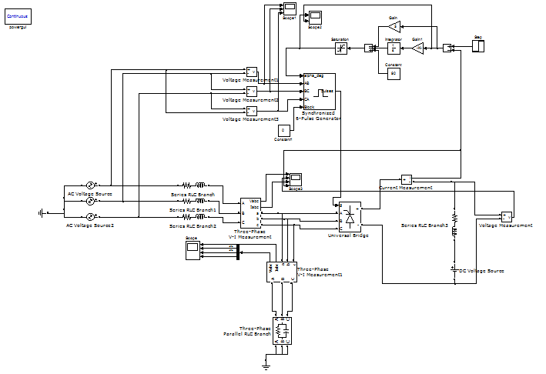
Fig. 2: Simulink diagram of isolated power system with series compensator

A.Voltage Source Inverter/VSI
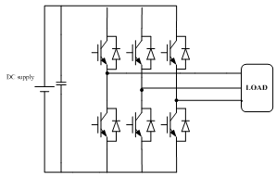

Fig.3 Voltage Source Inverter/VSI
A VSI is a power electronic system consists of a storage device and switching devices, which can generate a sinusoidal voltage at any required frequency,magnitude, and phase angle. Either a conventional two level converter (Graetz Bridge) or a three level converter is used. There are four main types of switching devices: Metal Oxide Semiconductor Field Effect Transistors (MOSFET), Gate Turn-Off Thyristors (GTO), Insulated Gate Bipolar Transistors (IGBT). Each type has its own benefits.

- CONTROLLING SYSTEM USED IN SERIES COMPENSATOR
The harmonics is generated in the load terminals using six pulse converters with fixed firing angle are connected to the main drive non linear load which is parallel to the sensitive load. Voltage sag is created at load terminals via a three phase fault as shown in the below MATLAB circuit. For compensation purpose the voltage is sensed at the two positions, i.e., at the starting of source and at the load terminals. This gives an error value which is fed to the control circuit. The control circuit consists of discrete PLL, abc to dqo transformation blocks, discrete Proportional Integral (PI) controller, and a Pulse Width Modulator(PWM). The output of the contol circuit is pulses, which is given to the Voltage Source Invert-er(VSI) and thus the inverter will operate and injects the required value of voltage for the operation of sensitive load and thus reduced the problem of voltage sag, in the mean while the harmonics which are produced due to the operation of six pulse converter are also mitigated to the acceptable level as mentioned in the below Simulink results. The mitigated har-monics outputs and the voltage sag reduction outputs which are practically obtained using MATLAB software.

Here the inverter circuit may be designed with IGBT, MOSFET, GTO electronic elements for the compensation purpose. Pulse width Modulation (PWM) control technique is applied for inverter switching so as to produce a three phase 50 Hz sinusoidal voltage at the load terminals.The IGBT inverter is controlled with PI controller in order to maintain 1 per unit voltage at the load terminals. PI controller (Proportional Integral Controller) is a closed loop controller which drives the plant to be controlled with a weighted sum of the error (difference between the output and the desired set point) and the integral of that value. One advantage of a proportional plus integral controller is that the integral term in a PI controller causes the steady-state error to be zero for a step input. PI controller input is an actuating signal which is the difference between the Vref and Vin. Output of the controller block is of the form of δ.

Output of comparator = Vref – Vin
Where (1p.u. =Base Voltage)
Vref equal to 1 p.u. voltage
Vin voltage in p.u. at the load terminals.

The angle δ is provided to the PWM signal generator to obtain desired firing sequence
Fig.4 PI CONTROLLER
The convergent method used to determine PI and PID controller settings will be discussed for two mathematical models of controlled systems, namely

and

In general, responses of these models approximate the higher-order controlled system under identification with the accuracy sufficient for engineering appli- cations. Coefficients of transfer functions (1) and (2) can be found from the controlled system identification procedure using, for instance, the momentum method or neural networks. The method under consideration can be also used for integrating type controlled systems given, by the transfer function

or the transfer function in series with a delay unit given by the transfer function e−st0 . Instead of the transfer function e−st0 we take then the approximation given by its expansion into Pad´e series. The introduced method is a novel one. It serves to determine controller settings for the supposed simplified model of controlled system. The method can be used to run computer-aided simulation studies and to determine dynamics of closed-loop control systems.

- VOLTAGE SAG MITIGATION USING SERIES COMPENSATOR

The main advantage of series compensator is not only to mitigate harmonics but also to solve voltage sag problems. In simulink model when the fault is introduced at the point of common coupling, sag appears at certain time period as re-quired in all the three phases as shown in the below figures. When the series compensator is connected to thesystem the appeared voltage sag is mitigated.

- Voltage Swells

The second simulation shows the DVR performance during a voltage swell condition. The simulation started with the supply voltage swell is generated. The amplitude of supply voltage is increased about 25% from its nominal voltage. As can be seen from the results, the load voltage is kept at the nominal value with the help of the DVR. Similar to the case of voltage sag, the DVR reacts quickly to inject the appropriate voltage component (negative voltage magnitude) to correct the supply voltage.

- RESULTS

1. Simulation result without series compensator are shown in below

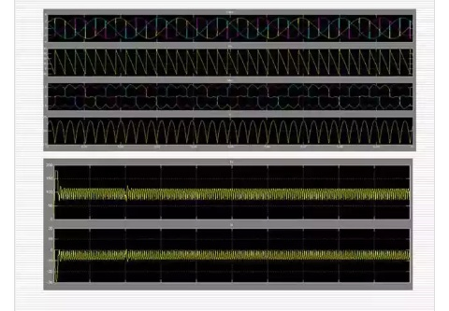

2. Simulation result with series compensator are shown in below

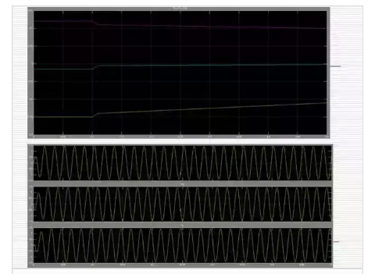

Conclusion
Voltage quality improvement in an isolated power system through series compensation has been investigated. The power system contains significant proportion of fluctuating nonlinear load and a high level of harmonic distortions is observed. The SC is also designed to maintain the fundamental frequency component of the terminal voltage of protected sensitive load. In this paper, a complete simulated series compensator system has been developed by using Matlab Simulink software. It is shown that the simulated SC developed works successfully to improve power quality. PWM technique is used to control the injection voltage of the SC so that it can mitigate the effects of the harmonics and voltage sag has been proposed. The proposed system performs better than the traditional methods in mitigating harmonics and voltage sags. The proposed SC can handle both balanced and unbalanced situations without any difficulties and would inject the appropriate voltage component to correct rapidly and anomaly in the supply voltage to keep the load voltage balanced and constant at the nominal value.

References
[1] Enhancement of Voltage Quality in Isolated Power Systems JBV Subrahmanyam, TC Subramanyam Electrical&Electronics Engineering Dept.,Bharat Institute of Engineering &Technology, mangalpally, ibrahimpatnam, RR district, Hyderabad,AP,INDIA 501 510

[2] Voltage Quality Enhancement In An Isolated Power System Through Series Compensation Pooja Shrivas1, Arun Pachori21Pooja_shrivas87@yahoo.com

[3] IMPROVE POWER QUALITY THROUGH SERIES COMPENSATION IN ISOLATED POWER SYSTEM Sachin A. Jalit1, Dr. N. J. Phadkule2 1M.tech student, 2Assistant Professor G. C. O. E., Amravati, India

[4] Reducing the Voltage Sag and Swell Problem in Distribution System Using Dynamic Voltage Restorer with PI Controller Raunak Jangid, Kapil Parkh, Pradeep Anjana

