The Supercapacitor Bringing Revolutionary Change in Electical Storage Systems

Auther 1 : Parag Sawai kdkce/EE Mob No.99756544932 sawaiparag!@gmail.com
Auther 2 : Rishab Belsare kdkce/EE Mob no.8793772625 rishabjain911@gmail.com
Auther 3 ; Abhijeet Shende kdkce/EE Mobno.8793593544 abhijeetshende3097@gmail.com

Abstract; Supercapacitor is a high capacity electrochemical capacitor with a capacitance value much higher than ordinary capacitor. Its a basically a storage device than means battery.
A supercapacitor (often called an ultracapacitor) differs from an ordinary capacitor in two important ways: its plates effectively have a much bigger area and the distance between them is much smaller, because the separator between them works in a different way to a conventional dielectric..
In this paper declare study of supercapacitor is done and how it make the changes in electric sorage system is explaines.

Introduction (Heading 1)
A supercapacitor (SC) (sometimes ultracapacitor, formerly electric double-layer capacitor (EDLC)) is a high-capacity electrochemicalcapacitor with capacitance values much higher than other capacitors (but lower voltage limits) that bridge the gap between electrolytic capacitors and rechargeable batteries. They typically store 10 to 100 times more energy per unit volume or mass than electrolytic capacitors, can accept and deliver charge much faster than batteries, and tolerate many more charge and discharge cycles thanrechargeable batteries. They are however 10 times larger than conventional batteries for a given charge.
Supercapacitors are used in applications requiring many rapid charge/discharge cycles rather than long term compact energy storage: within cars, buses, trains, cranes and elevators, where they are used for regenerative braking, short-term energy storage or burst-mode power delivery. Smaller units are used as memory backup for static random-access memory (SRAM).
Supercapacitors do not use the conventional solid dielectric of ordinary capacitors. They use electrostatic double-layer capacitance orelectrochemical pseudocapacitance or a combination of both instead
Electrostatic double-layer capacitors use carbon electrodes or derivatives with much higher electrostatic double-layer capacitance thanelectrochemical pseudocapacitance, achieving separation of charge in a Helmholtz double layer at theinterface between the surface of a conductive electrode and an electrolyte. The separation of charge is of the order of a
few ångströms (0.3–0.8 nm), much smaller than in a conventional capacitor.
Electrochemical pseudocapacitors use metal oxide or conducting polymer electrodes with a high amount of electrochemical pseudocapacitance. Pseudocapacitance is achieved by Faradaic electron charge-transfer with redox reactions, intercalation or electrosorption.
Hybrid capacitors, such as the lithium-ion capacitor, use electrodes with differing characteristics: one exhibiting mostly electrostatic capacitance and the other mostly electrochemical capacitance.
The electrolyte forms a conductive connection between the two electrodes which distinguishes them from electrolytic capacitors where the electrolyte is the second electrode (the cathode). Supercapacitors are polarized by design with asymmetric electrodes, or, for symmetric electrodes, by a potential applied during manufacture

Current Scenario
Fields where SUPER CAPACITOR going to be speed booster
- Electronic devices
Mobile phones, laptop batteries , power bank,
Mobile storage units etc.
- Automobiles
Electrical cars ,electrical scooters, Segway vehicle etc

HOW SUPER CAPACITOR PROVE TO BE BETTER THAN CONVENTIONAL BATTERIES
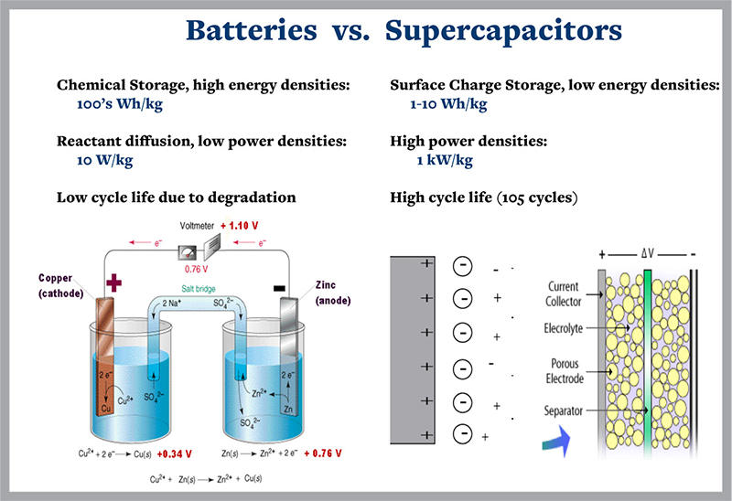
Fig.1
Capacitors (10 to 100 times the power of batteries) as shown below.
Supercapacitors have these advantages over battery solutions: • Long operating life - do not need replacing. • Rapid charge - ready to provide back-up in seconds. • Low ESR - capable of providing higher peak power. • Environmentally friendly - no heavy metals or disposal issues. • Customized packaging available. Supercapacitors have reasonably high energy density compared to rechargeable batteries. In most applications, batteries have far more energy than is required and several drawbacks, including: • Take too long to charge. • Do not like to be held fully charged. • Degrade with shallow discharge - NiCd
.
4.High Power Supercapacitors Enable
New Power Applications...
And
Replace Batteries
The ultimate energy storage device should have high energy
density that can be rapidly
released. High energy batteries have
been developed for single use or rechargeable systems, but they
typically require from minutes to hours to discharge, not seconds.
High power, standard capacitors are ca
pable of discharging rapidly,
but they only have low energy density.
Cooper Bussmann
®
PowerStor
®
Supercapacitors are
environmentally-friendly, lead free, RoHS compliant and have no
disposal issues at end of life. The European WEEE directive
requires companies to recover and recycle the Lithium batteries
currently used for back-up. Similar regulations are also being
considered in China and Japan.
The new PowerStor Supercapacitors incorporate both the high energy density
of batteries (100 times the energy of electrolytic
capacitors) and the
high power
of capacitors (10 to 100 times the
power of batteries) as shown below.

Supercapacitors have these advantages over battery solutions:
• Long operating life - do not need replacing.
• Rapid charge - ready to provide back-up in seconds.
• Low ESR - capable of providing higher peak power.
• Environmentally friendly - no heavy metals or disposal issues.
• Customized packaging available.
Supercapacitors have reasonably high energy density compared to
rechargeable batteries. In most a
pplications, batteries have far
more energy than is required and several drawbacks, including:
• Take too long to charge.
• Do not like to be held fully charged.
• Degrade with shallow discharge - NiCd memory effect
5.Chemical and electrochemical ageing of carbon materials used in supercapacitor electrode
Electrochemical double layer capacitors–supercapacitors–are usually based on highly porous activated carbon electrodes. The chemical and electrochemical inertness of carbon assures a very long lifetime. However, on the timescale of months the capacitors slowly lose some capacitance, and the equivalent series resistance rises. This “ageing” is faster when temperature and operation voltage are increased. To elucidate ageing processes in the electrodes, we analyzed aged samples of activated carbon, and also of carbon black, which is used as conductive additive. The experimental methods were infrared, Raman, and photoelectron spectroscopy, and nitrogen porosimetry. The electrodes are not completely inert, and their ageing is due to chemical and electrochemical reactions at the carbon. Moreover, the ageing procedures are much stronger at the positive pole. We found that oxygen, hydrogen, nitrogen, and fluorine, which originate from trace water and from the electrolyte, can covalently attach to the electrodes and form various chemical groups (e.g. OH, COOH, CONH, and F).

6.Most used supercapacitors

Graphene-Based Supercapacitor with an Ultrahigh Energy Density

A supercapacitor with graphene-based electrodes was found to exhibit a specific energy density of 85.6 Wh/kg at room temperature and 136 Wh/kg at 80 °C (all based on the total electrode weight), measured at a current density of 1 A/g. These energy density values are comparable to that of the Ni metal hydride battery, but the supercapacitor can be charged or discharged in seconds or minutes. The key to success was the ability to make full utilization of the highest intrinsic surface capacitance and specific surface area of single-layer graphene by preparing curved graphene sheets that will not restack face-to-face. The curved morphology enables the formation of mesopores accessible to and wettable by environmentally benign ionic liquids capable of operating at a voltage >4 V.
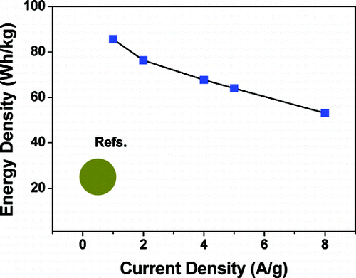
Fig.2
7.Current Applications

1.Solar supercap powered wireless rocket ignition system
Always turn receiver off before
checking for malfunctions.
This system is reliable, simple, and
works quite well. We have used it for
many launches. It will work forever
without ever needing a battery and
there is no need to string long lengths
of snarly wire to and from the igniter
and controller.
The system works well with Estes
igniters, but other igniters can be used
or made to suit your needs. They would,
of course, have to be tested with the
system for compatibility and tweaked.
For making igniters from Nichrome resistance wire, we have found that #30
wire works well. You can, of course, try other gauges to suit your needs.


Fig.3
8.hybrid electric car battery
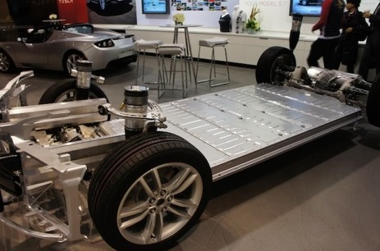

Fig.4
Toyota has revealed the full powertrain details of the Yaris Hybrid-R concept that it teased a few weeks ago. The intriguing concept uses a 420-hp 4WD driveline that's derived from racing. In an interesting twist, Toyota uses a combination of super capacitor and motor-generator, in place of the battery pack that typically powers the motors in contemporary hybrids.

Toyota says that the super capacitor has a higher power density than an NiMH hybrid battery, along with faster charge/discharge speeds. This makes it suitable for the fast bursts of boosting power needed, both in the TS030 Hybrid race car and in the Yaris Hybrid-R, which Toyota envisions as a track-focused hot hatch. The super capacitor is charged via regenerative braking provided by the dual rear electric motors.

solar super capacitor power supplies
Supercapacitors are presently available in two voltage ratings, 2.5, and 2.7
volts per cell. A bank of six series connected 2.5 volt supercapacitors will
give you a total voltage of 15 volts. A bank of six series connected 2.7 volt
supercapacitors will give you a total voltage of 16.2 volts. At first glance it would seem that you need to use the 2.7 volt bank at 16.2 volts tcoverthe 15.5 volts needed for the system. This would be a good choice; however, you can also use the 2.5 volt supercapacitors as they have overcharge margin of about 1 per cell. This would allow you about 15.6 volts for chariing. This is just within the range of general charging and
equalization voltage needed. Parallel connected
2.0 volt hybrid system
Solar Supercapacitor Power Supplies
.
.Solar hydrogen fuel cell
Solar hydrogen fuel cell systems
Supercapacitors can be used in
parallel connection with electrolyzers
and/or fuel cells to aid in a smoother
delivery of either gas output or volt
-
age generated from the fuel cells.
Solar powered electrolyzers reduce
output with quickly changing cloud
transits. A supercapacitor allows
smoother, more consistent gas pro
-
duction.
Coupled in parallel with fuel cells,
supercapacitors provide a buffer for a fuel cell or fuel cell bank when current
surges are needed to start electromagnetic devices such as motors.

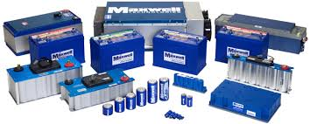
Fig.5

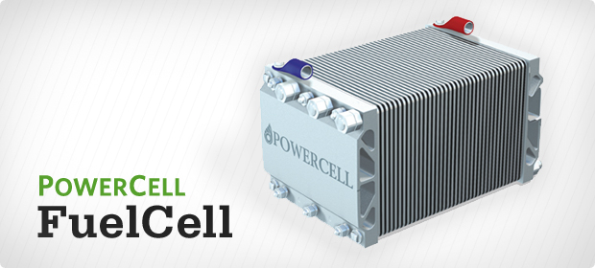

Fig.6

Conclusion :

Super Capacitors Will Be Used In Every Field Of Electrical Storage System
Capacitors store energy in an electrostatic field rather than as a chemical state as in batteries.
No chemical actions involved which means very long cycle life is possible.
No limit on the cell voltage imposed by the "cell chemistry" as with galvanic cells.
The terminal voltage directly proportional to the State of Charge (SOC) which limits range of applicability somewhat
Hence Baterry Will Be Replaced By Supercapacitor In Near Future.

Future scope
1.All The Electronic Devices Batteries Going To Be Replaced By The Supercapacitors Batteries.
2. It Is Going To Be Replacing All Fuel Systems And Electrical Storage Systems In Future.
3. Due To The Supercapacitors The Mobile Phone Batteries Will Be Charged In 1 Minute Because Of Supercapacitors.
4.The Fuel Cell Ignition System Will Be Taken To Whole New Level Due To The Supercapcitors.
5.Automobile Industries Will Be Revolutionalize Due To The Supercapacitors Used In Them.
6.The Whole World Power Supply Storage System Will Get The Boost Due The The Supercapacitors.

Refrence
1.Abstract
On 1st page form the source
http://www.explainthatstuff.com/how-supercapacitors-work.html

2.In introduction on 2nd page we have defined what supercapacitors are and therefore explained it.

3.On page 2 we have describes how supercapacitors are better than ordinary batteries and explained it structure
4.On page 4th we have described the current applications of the supercapacitors and it is taken from the book [Super capacitor applications by :Phillip Hurley]
5.On page 5th we have given the conclusion why the supercapacitors should be used
6.On page 5th we have also given the future scope of supercapacitors in technology.

