Osmotic Power Generation

Author 1 : Yash Upadhye KDKCE 9423762645 yashupadhye96@gmail.com
Author 2 : Vaibhav Gedam KDKCE 8237555829 vaibhavgedam91@gmail.com
Author 3 : Nikhil Pikalmunde KDKCE 8149679897 nikhilpikalmunde786@gmail.com
Author 4 : Riyaz Sheikh KDKCE 8055443844 meriyazsheikh@rediffmail.com

Abstract- We can't continue using several of our energy sources from where we gain energy today. For example fossil fuels contaminate our environment and we are also running out of them. It is therefore necessary to find other ways of producing energy. This paper focuses on one of those alternatives; osmotic energy. Osmosis means passage of water from a region of high water concentration (often freshwater) through a semipermeable membrane to a region of low water concentration (often NaCl).
Osmotic powers excellent environmental performance and CO2-free power production will qualify for green certificates and other supportive policy measures for renewable energy. The estimated energy cost is comparable and competitive with the other renewable energy sources. For both the commercial power companies and technology suppliers Osmotic Power represent an attractive new business potential.
Keywords- Renewable source, osmotic pressure, semipermeable membrane.

Introduction
The need of new energy sources has led to a number of alternatives. Some better than others. One of those alternatives is energy created by transportation of solutions, osmotic energy or salinity gradient energy [2][4]. In the osmotic process two solutions with different salt-concentrations are involved (often freshwater and salt-water). A semipermeable membrane, which is an organic filter, separates the solutions. The membrane only lets small molecules like water-molecules pass. The water aspires to decrease the salt-concentration on the side of the membrane that contains most salt. The water therefor streams through the membrane and creates a pressure on the other side [2]. This pressure can be utilised in order to gain energy, for example by using a turbine and a generator. There are several different types of power plants using osmosis (the osmotic process); both land-based plants and plants anchored to the sea floor. The thing the plants we have studied have in common is that osmosis is not directly used to generate power. What the osmosis does is that it creates a flow through the plant and it is that flow that forces the turbine to rotate. Energy created by osmosis has very little impact on the environment and that is of course an important fact to consider when it comes to determine whether osmotic energy is something to invest in or not. Another advantage is that osmotic energy is renewable, since the process does not "consume" the salt. (Salt-water evaporation leads to precipitation over land.)
The major fact when it comes to the disadvantages is the high cost[1]. Osmotic-produced power is much more expensive than for example fossil fuels. There are also engineering problems to be overcome. The high cost has made us draw the conclusion that osmotic energy is not something for ABB Alstom Power to invest in, at least not in the nearest future, since no one wants to buy the energy when it is so expensive. The possibility to use osmotic power from our oceans lies within the technology that needs to be developed. There are many possible ways to exploit energy from salinity gradients. It seems, as osmotic pressure will be crucial with each of the possibilities [2][3].

- BACKGROUND

The pressure on the environment by human activities and especially with carbon dioxide emissions being at all time high calls for alternatives to be thoroughly researched. Since the Kyoto protocol in 1997, the call for reducing carbon emission has been intensified [4]. Oil and gas reserves are restricted and will with the current pace be depleted within some decades. EU has adopted ambitious targets for energy and climate with 20 percent of energy consumptions from renewable sources, 20 percent reduced greenhouse gas emissions and 20 percent increased energy efficiency put in place by 2020. The major source of low cost, conventional energy globally is fossil fuels. The use of fossil fuels will continue to be the major source of energy the next decades. Nevertheless, as the global consumption of energy is growing, there will be a need for new renewable energy sources as well as reduction in the use of fossil fuels as an energy source [4]. Besides climate and environmental considerations, R&D is about business survival and growth ambitions, meaning that we need to create a better balance between improvements of existing technologies and be well prepared to build new renewable solutions. We are searching for alternative carbon dioxide free energy sources. Such energy sources could be offshore wind,wave and tidal, photovoltaic, and osmotic power. Statkraft, a Norwegian utility company with a strong tradition in hydropower, has been engaged in technology development attempting to develop new renewable energy technologies. Since 1997 one of these development areas has been to aim at cost-effective Osmotic Power generation[3].

III.THE OSMOTIC PROCESS

The main thing with osmotic energy is transportation of solutions (often pure water and salt-water), separated by a special filter, a membrane. In the osmotic process it is not possible to use an ordinary filter. You need a "Semipermeable membrane"[4]. A semipermeable membrane is an organic filter with extremely small holes. The membrane will only allow small molecules, like water molecules, to pass through. The thin layers of material cause this and that is what the osmotic energy process is all about.

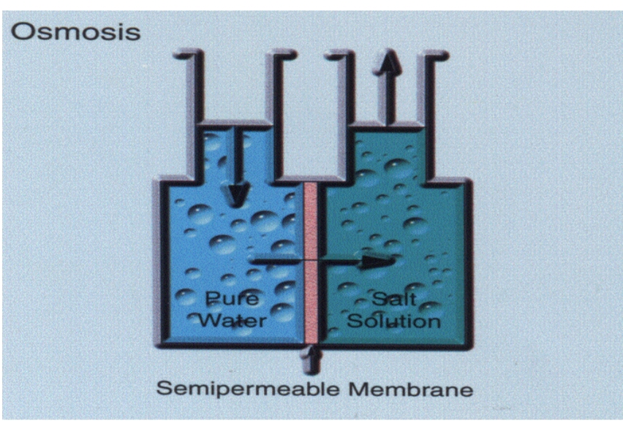Fig. 1 Osmosis Process [1]

The picture here on the right shows a simple test rig for this process. The left side contains pure water. The right side contains a solvent with water and salt (NaCl). The only thing that separates them now is the semipermeable membrane. The process is about to begin.

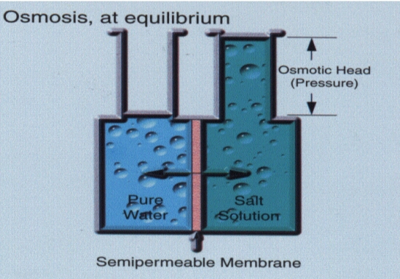
Fig. 2 Osmosis Process at equilibrium [1]

When the process gets started the pure water on the left side aspires to decrease the salt-concentration on the right side of the membrane. The amount of water on the right side will now increase and create an "Osmotic head pressure". We can use this pressure, for example, to force a water- turbine to rotate. The amount of freshwater that will pass through the membrane depends on the salt-concentration in the saltwater, before the osmotic process begins. For instance, if the salt-concentration from the beginning is 3.5%, the osmotic pressure will be about 28 bars.
The problem with the test rig is that the saltconcentration in the salt-water will decrease and the process will slow down. The only way to fix this is to continuously, empty and refill both the left and the right side. This must be done very quickly to avoid runinterference. Another problem is that the membrane can, and will wear out because of all silt and other contamination that will get stuck in the membrane. If we don't consider this fact a membrane's length of use is about 6 months. This sort of process could not only be used for energy purpose. The main use area today is Reverse Osmosis, where you create a pressure larger than the osmotic head pressure and push the salt water through the membrane. From this process you gain fresh water out of salt-water.

- EXPLOITATION POSSIBILITIES

There are many possible ways to exploit the energy from salinity gradients. With each of the possibilities it seems as osmotic pressure will be crucial. Here are two brief descriptions of possible approaches:

  - Reverse Electro dialysis

This process involves direct electrochemical conversion in dialytic cells. Dialytic cells use the potential found between solutions of different salt concentrations, which are separated by charged membranes. For instance, fresh water has, in general, 850 parts per million dissolved salt water. That is equal to a potential of 80 millivolts at the interface (the membrane). By putting many cells in series it is possible to create more power[3].
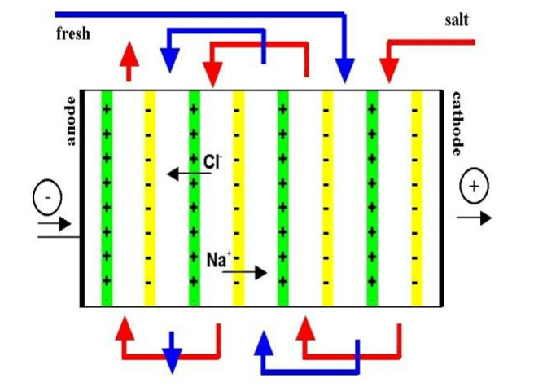
Fig. 3 Reverse electrodialysis [3]

  - Vapour Pressure Differences:
Another approach is to build a device that can use the difference in vapour pressure between fresh water and salt water. The difference can be used to run a turbine.

There are many limitations to this system, but there are advantages too. For example no membranes are required (in order to use the vapour pressure differences).
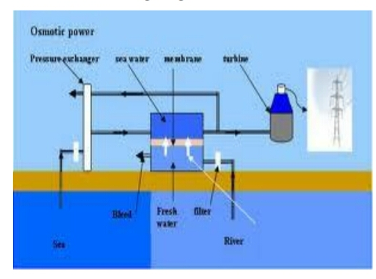
Fig. 4: Osmosis used for power production

- MEMBRANE DEVELOPMENT
The membrane should have characteristics that make it suitable for PRO, meaning high water permeability, low salt permeability and low resistance in the support layer of the membrane. Low affinity to fouling substances is also desirable a requirement[4]. The development of a membrane especially designed for PRO has been the main focus since Statkraft got involved in 1997 with one of the aims being to develop a cost-effective membrane. The target for a PRO membrane is to generate 5 W/m2 net to produce power at a cost which is comparable to other renewable energy sources. As an example, the current power density of the membrane is approximately 3 W/m2, which is up from less than 0.1 W/m2 a few years back. These achievements show that we are getting closer to a real application in this process which stated as a mere idea[4]
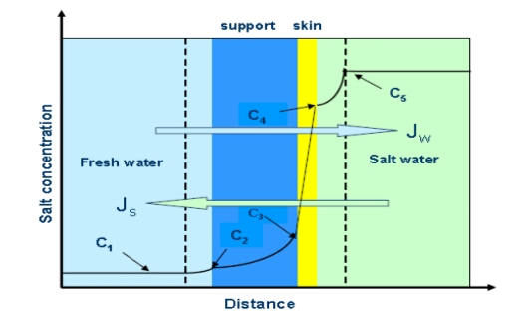
Fig.5.The flow conditions for a typical PRO membrane

The fresh water (JW) flows through the support and the skin into the sea water which is diluted. The salt in the salt water (JS) flows through the skin of the membrane and the support into the fresh water. The figure shows the salt gradient through the system. C1 is the salt concentration in the bulk of the fresh water, C2 is the salt concentration at the interface between the fresh water and the membrane support, C3 is the salt concentration at the interface between the membrane support and the membrane skin, C4 is the salt concentration at the surface of the membrane skin, while C5 is the salt concentration in the bulk of the salt water. The figure illustrates that there is a considerable salt gradient in the membrane support, which is the difference between C3 and C2. This salt gradient must be minimized, achieved by having a thin and open structured support which allows fast diffusion of the salt molecules into the fresh water. Likewise it is important to minimize the salt gradient at the sea water side (C4 – C5) and the salt gradient at the fresh water side (C2 – C1) which is achieved by having sufficient velocity across the membrane in both the sea water and the fresh water channels on each side of the membrane. The salt gradient across the membrane skin (C4 – C3) much be as high as possible which is obtained through high water permeability and a low salt permeability of the membrane[4]. The membranes are fitted into membrane elements containing a specific amount of membrane area[4]. In the desalination industry the so-called spiral wound element design and the hollow fibre design are the most common cost effective designs. Statkraft is working on developing these designs to fit with the special requirements for PRO. The design criteria are, that the elements must be able to have flow on both the fresh water and the sea water side of the membrane, the elements must contain a large membrane area, fouling must be minimised, and the design must be cost effective.

- THE OPPORTUNITY

The application of osmosis to generate electricity is limited to where you have abundant fresh and salt water. This implies that any estuary reaching out into the sea has a potential.

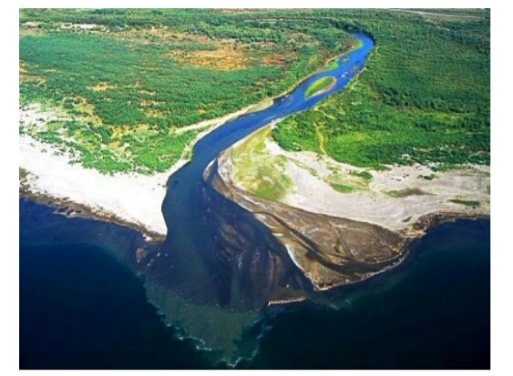
Fig 6: River fresh water and salt water mixing

Experts have already established that the potential for osmotic power in Europe is three times the potential of wind and solar combined. The fact that it can operate 24 hours a day, 7 days a week makes it as competitive as gravity. HydroQuebec, the Canadian power company has calculated that the St. Lawrence River estuary has a potential of 12 Gigawatts. Countries with an abundant rainfall and a long shoreline are all expecting to harness this potential. The Tokyo Institute of Technology and Kyowakiden Industrial Co. from Nagasaki have started testing osmosis in Fukuoka[1].

- FIRST IMPLEMENTATION

The world's first osmotic power plant with capacity of 4 kW was opened by Statkraft on 24 November 2009 in Tofte, Norway[4]. This plant uses polyimide as a membrane, and is able to produce 1W/m² of membrane. This amount of power is obtained at 10 l of water flowing through the membrane per second, and at a pressure of 10 bar. Both the increasing of the pressure as well as the flow rate of the water would make it possible to increase the power output. Hypothetically, the output of the SGPplant could easily be doubled.

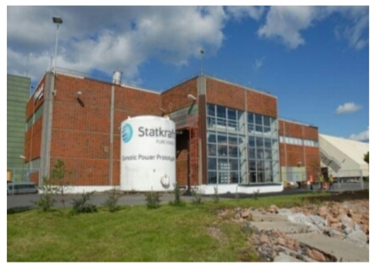
Fig 7: The prototype at the East coast of Norway [4]

- THE INNOVATION

Since most baseload power is supplied by coal and nuclear, there is a search for renewable energy that can provide not only intermittent, but also baseload[2] power. Concentrated solar power is one of the promising renewable energy technologies. It can collect and store energy in pressurized steam, molten salt or purified graphite. Wind energy has been combined with a wide variety of storage systems including pumped hydroelectric storage, batteries, regenerative fuel cells, flywheels and magnets. However the most promising seems compressed air energy storage (CAES) which stores air in underground (geological) structures. The challenge remains that these storage facilities require extra investment costs and increased maintenance, further increasing the cost per kilowatt hour. Stein Erik Skilhagen, the Vice-President for Osmotic Power at the Norwegian Statkraft observed the power of a Redwood tree which sucks water up to 100 meters. The tree exploits the difference in concentration, pushing moisture all the way up. When fresh water from the mountains flows into salt seawater, a lot of energy is released through the change of concentration of salt. He observed that the flow of rivers into the ocean is a never ending flow thanks to the natural cycles of evaporation, condensation and precipitation[3][4]. Therefore, the energy that is released through the difference between higher salinity that has higher pressure, and lower salinity with lower pressure could operate 365 days without any interruption. This is an ideal renewable baseload energy source. The mere exploitation of differences in concentration that generate pressure implies that the source of energy comes from within the realm of physics, the type of innovations proposed by The Blue Economy. This power source is also known as osmotic power or salinity gradient power, exploiting the difference in salt concentration between fresh river or rain water and salt water. The technique to generate electricity out of this gradient has been tested in the Netherlands through reverse electro-dialysis (RED)[2], and has been put into practice in Norway through pressure retarded osmosis (PRO)[2]. The membrane that keeps the two water types apart is the key to success. While fresh water migrates to the salt side, it creates a pressure differential. This pressure is used to spin the turbine. Just like reverse osmosis (RO), this PRO generates a by-product. However unlike RO which produces brine with a high salt content, PRO generates brackish water that could be used in the production of algae, permitting the colocation of PRO-based energy plants and algae farms. This clustering of economic activities permits the generation of multiple cash flows, another characteristic of the innovations proposed by the Blue Economy.
Osmotic Power is a renewable energy source with no CO2 emissions. The mixing of seawater and freshwater is a process that occurs naturally all over the world. The Osmotic Power plants will extract the energy from this process without interfering with the environmental qualities of the site, and the process produces no other significant effluents that will interfere with the global climate. A possible source of harm on the local area is the impact of the brackish water on the local marine environment. Brackish water is the main waste product of Osmotic Power, and the discharge of brackish water into the marine environment may alter the environment and result in changes for animals and plants living in the local location. However, most of the rivers run into the ocean in a city or an industrial area. This means that most of the Osmotic Power potential can be utilized without constructing power plants in unspoiled areas. In already developed areas the effects on the estuary are changed adversely. Controlled and careful building of the inlet, plant and outlet for an osmotic power plant can improve the present condition of biotopes of the river, the estuary and the sea. This means that most of the osmotic power plants can be build without constructing in unspoiled areas. The plants can be constructed partly or completely underground and would fit well into the local environment. In these areas the environmental impact on shore are estimated to have a limited impact with regards to grid, roads, etc.

- FUTURE PROSPECTS

The possibility to use the salinity gradient[2] in the ocean for power lies within the technology that needs to be developed. There are currently two hurdles to overcome, which includes the membrane water part and sunlight. If we could develop the membrane to use saltwater as fresh water and brine with a higher saltconcentration as the concentrated solution, then it would be more feasible to use salinity for power. Or, the vapour pressure technique could be further developed. However, the biggest hurdle that needs to be overcome is the cost. Salinity power is not economically feasible compared to fossil fuels Currently, more effort is being put into developing salt-gradient solar ponds for energy (where osmosis is used). Therefore in the world of salt, there is more potential in using salt from the solar ponds as opposed from the ocean[1]. The salt percentage will be much higher, which will increase the osmotic head pressure and more energy can be extracted.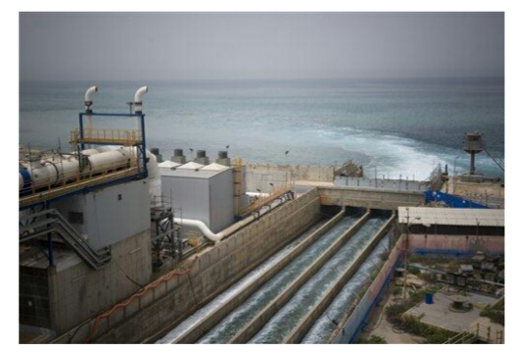 Fig 8: Power Plant at Statkraft

- ADVANTAGES

- The energy produced is clean and nonpolluting.
- There is no carbon dioxide or any other byproducts released. It produces no greenhouse gases or other waste.
- It is a renewable energy that will help reduce our reliance on the burning of fossil fuels. 4. So the electricity supply is constant and efficient.
- Once you've built it, the energy is free because it comes from the ocean's power
- It needs no fuel.
- It produces electricity reliably.
- Not expensive to maintain.
- Offshore turbines and vertical-axis turbines are not ruinously expensive to build and do not have a large environmental impact.
- A plant is expected to be in production for 75 to 100 years
- Uses an abundant, inexpensive fuel source (water) to generate power

- DISADVANTAGES

- You will need to find a way to connect the electricity to the grid.
- Pose same threats as large dams, altering the flow of saltwater in and out of estuaries, which changes the hydrology and salinity and possibly negatively affects the marine mammals that use the estuaries as their habitat
- The average salinity inside the basin decreases, also affecting the ecosystem
- A barrage across an estuary is very expensive to build, and affects a very wide area - the environment is changed for many miles upstream and downstream. Many birds rely on the tide uncovering the mud flats so that they can feed.
- Barrage systems require salt resistant parts and lots of maintenance
- Effects on marine life during construction phases.
- Operation and control must be provided remotely and maintenance is complicated due to sea-basing of the generation facilities.
- Expensive to construct
- Power is often generated when there is little demand for electricity

XII. CONCLUSION

The need of new energy sources has led to a number of alternatives. Some better than others. However in the future if the technology is further developed and the costs will decrease, osmotic energy might be an alternative to the energy sources we use today.

REFERENCES
- www.exergy.se/goran/cng/alten/proj/97/o/
- www.climateandfuel.com/pages/hydro.htm
- http://www.greenoptimistic.com/2010/07/20/osmosis-powerplant-netherlands

