Power Quality Monitoring In Distribution Systems
Nikhil S. Morey Department of Electrical Engineering KDKCOE, Nagpur
Chanchal J. Yadav Department of Electrical Engineering KDKCOE, Nagpur
Amrut V. Parode Department of Electrical Engineering KDKCOE, Nagpur
Prof. Sampada Fagne. Department of Electrical Engineering KDKCOE, Nagpur

Abstract – This paper is concerned with the review of power quality monitoring. Different kinds of disturbances that affect power quality have a bib importance in the industry. To define with exactitude the cause and origin of this disturbances, that propagate through the net, is a complex problem that needs a correct monitoring and analysis to propose correcting actions.
First, aspects related to power quality monitoring are reviewed. Last, an algorithm that allows to determine the disturbance origin is proposed and commented.
Keywords: power quality, monitoring, fault location, voltage sag

- INTRODUCTION
Recently, the importance of power quality issues has increased due to various reasons [1, 2]. First of all, there have been changes in the nature of electrical loads. On one hand, the characteristics of load have become more complex due to the increased use of power electronic equipment, which results in a deviation of voltage and current from its sinusoidal waveform. On another hand, equipments have become more sensitive to power quality due to its electronic nature.

Deregulation of the electrical power market is a second factor that has increased the importance of power quality. Deregulation has divided what was a single utility into three: supplier, transmitter and distributor. It is important to evaluate power quality level and identify the source of faults that origin electrical disturbances in electrical power systems, which determines the responsibility of a bad quality of

power. In order to evaluate and identify the disturbances and its origin, power quality monitoring is the tool that utilities and customers use.

In this paper, firstly a revision of the state of art in power quality monitoring is presented. The main focus of this review is the use of the information that monitoring provides in order to determine the source of voltage sags in distribution systems. The main points that are discussed are: classification and characterization of disturbances, propagation of disturbances, measurement campaigns, and fault location. Lastly, an algorithm that determines the origin of the fault starting from registered data is presented. It has been developed by means of data registered in a substation located in Salt (Girona).

- POWER QUALITY MONITORING

The objectives for a power quality monitoring program determine the methods for collecting data, the type of measurement equipment, etc. Depending on the power quality category (harmonics, sag, swell, interruption, flicker …) equipments must have determined features and the measurement must be done in a specific way [3, 4].

A simple classification of power quality monitoring could be:

System monitoring: its objective consists in determining the quality of power and the behaviour of the electrical system globally. For example, to check that voltages in all buses are in the range indicated by legislation, that the number of sags is under the maximum allowed …
Local monitoring: its objective consists in determining the quality of power that is delivered to a single customer. It may be useful to identify if the utility is supplying power with the level of quality accorded by contract, identify if the source of electrical disturbances are internal or external, enhance power quality service, etc.

Power quality monitoring involves several issues like classification and characterization of electrical disturbances, propagation of disturbances, measurement campaigns, i.e. optimizing the number of monitoring points.

- CLASSIFICATION AND CHARACTERIZATION OF DISTURBANCES

The monitoring of power quality includes the detection of electrical disturbances such as sags, harmonics, swells, etc. Once the disturbance has been detected and recorded, analysis of the captured waveforms can give more information about the disturbance. This information that can be got from the registered data characterizes the disturbance, and allows to established similarity criteria between disturbances. These similarity criteria can be used for locating the origin of disturbances as it will be discussed later.

The variables that can characterize a disturbance, depends on the type of disturbance [5]. For example, in a basic level: for sags or swell, duration, magnitude (min or max), kind, starting time, clearing time, mean value; for harmonics: duration, THD, starting time, clearing time, mean value.

Tools as Fourier transform, wavelet transforms, WignerVille distribution, etc. are used for extracting features from recorded data [6]. In [7] methodologies to extract features that characterize power quality disturbances (peak amplitudes, RMS, frequency, etc.) are presented. User friendly software can be developed, as it is shown in [8], in Matlab in order to extract voltage sag parameters from measured or monitored results.

[9] present algorithms to characterize three-phase unbalanced voltage dips, which allows, as the previous methods, present statistics and the characteristics to be used, for example, to locate the origin of the voltage dip.
- PROPAGATION OF ELECTRICAL DISTURBANCES

The propagation of disturbances in the system and the influence of components, such as transformers and loads, are important issues related to how the monitoring could be done and extract information that could be useful for locating the origin of the disturbances, showing for example in which direction it is located, respecting the place where the disturbance has been recorded, or enclosing the area where the origin is located. As well as starting from measured registers, the propagation of disturbances can be studied by means of simulation software.

Several studies can be found in the literature. [10] focuses on studying the propagation characteristics of sag and harmonics in medium voltage distribution systems by using EMTP simulation, analysing the effects of fault locations on sag levels, nature of sag produced by different types of faults, effects of line length on sag/swell propagation, transformer connection effects on the nature of sag and swells effects, swell propagation characteristics and the total harmonic distortion in different parts of the systems.

In the same way, [11] shows the potential of using simulation for analysing the analysis of power quality disturbance propagation. This analysis, together with monitored registers, should be useful for locating the origin of the disturbance in the system and assess the impact of system components on the propagation of electrical disturbances. One main point of interest is the influence of the connection transformers, showing that for some kinds of connections the disturbances are mitigated (wye/wye and delta/wye connections).

Last, studies as [12] focus in analysing the influence of component systems as embedded generators and induction motor on voltage sag characteristics and propagation. Again, the study is carried out by means of simulation software tools, and shows that generally embedded generators increases voltage sag magnitudes and the presence of induction motors reduces it.

The results obtained in this kind of analysis, generally obtained starting from simulation techniques in the system, should be useful for determining the area or the location where the disturbance was originated.
- MEASUREMENT CAMPAIGNS

One interesting point in power quality monitoring is the design of the measurement campaign, for example, to determine the minimum number of monitoring points that allows to obtain reliable information relating with the whole distribution system that it is being analysed. Information obtained in the two previous points could be useful in order to optimize the monitoring points.

As it has been commented previously, power quality monitoring may focus on different objectives to be analysed and different parts of the system (customer, supplier) can have its particular interests. Electrical utilities are interested in observing the legislation in force, giving a good service quality to the customer or knowing the origin of a problem in order to solve it. Customers may be interested in knowing if equipment will work properly connected to the system or the quality of the electricity that are buying. For this reason, measurement campaigns can be done for analysing one particular aspect related with power quality supply.

Power quality analysis can be done starting from collecting electrical related to disturbances that have occurred for a long time (more than one year), in a high number of different locations. [13] presents three wide analysis made in North America for identifying the electrical environment in that area. Starting from the collected data, and focusing on voltage sags, a map that shows the voltage sag frequency, depending on magnitude and duration sag, can be obtained. Intensive studies can give information about the behaviour of connected loads in the electrical system, or the number and kind of disturbances that may be expected during the exploitation of the system. Information about the critical locations in the system can be obtained too, which may be useful for designing the suitable measure for improving the quality service in those places.

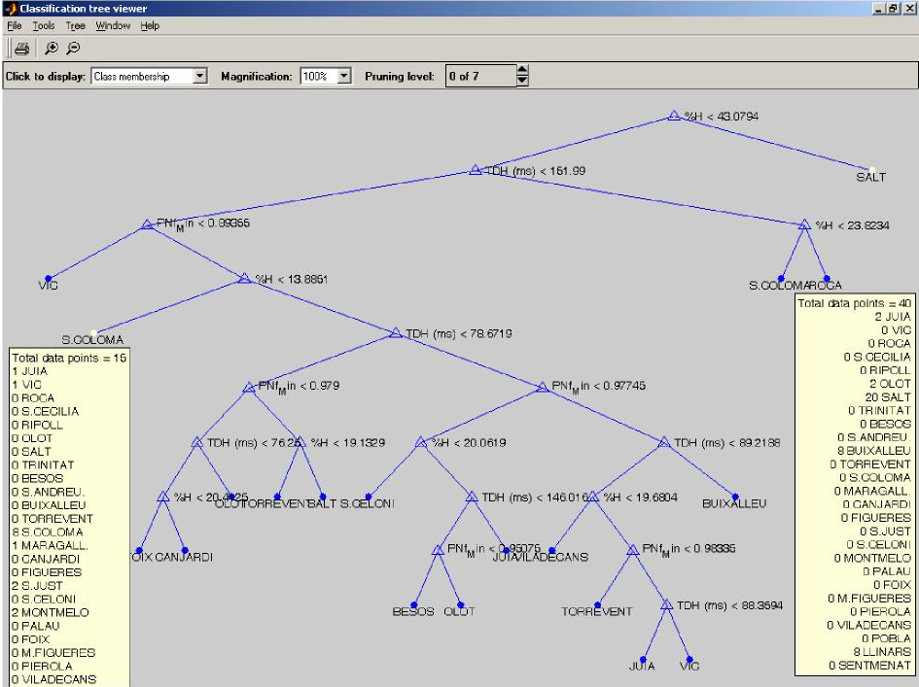
Fig. 1. Classification tree for locating the origin of voltage sag starting from registered data
One interesting aspect for distribution utilities consists in monitoring permanently the system, knowing its state. Thus, it is important to minimize the number of installed monitoring equipment and to maximize the obtained information. [14] proposes an algorithm based in formulating an optimization problem, where the number of monitored locations would be the variable to be optimized, and the conditions that shows the observed system locations, once a monitoring equipment has been installed, are obtained from the well-known Ohm and Kirchhoff laws

Another different way, for analysing the minimum number of locations that should be monitored, consists in the statistic analysis of interesting variables, starting from intensive system simulations. [15] shows a procedure for the measurement of voltage harmonics in wide areas. Results obtained from computer simulations of the system are analysed in order to detect the locations that have a similar behaviour. Those locations that have a similar behaviour can be evaluated and analysed by mean of one only monitoring equipment.

Another possibility consists in using results obtained from monitoring and from computer simulations of the system. Studies made starting from the network model, by using probabilistic methods, can give predictive information about the frequency with which a disturbance may occur [16]. Measurements done in the system can corroborate the predictions and the goodness of this kind of methods for being used as one more tool for evaluating the impact of predicted disturbances in the system.

Lastly, studies as the one shown in [17] are based in the correlation of several variables between the different levels of voltage in the system (regression equations). In this way, measurements obtained in a few locations can give information about the rest of locations that are not monitored. These methods require obtaining those equations by trial and error, until the desired correlation level is achieved.
- TOOLS FOR DISTURBANCE ORIGIN LOCATION

To illustrate the usefulness of power quality monitoring in distribution systems, it is presented a tool for locating the origin of sag voltage starting from registered data. The tool is based in regression trees. A regression tree is a sequence of questions that can be answered as yes or no, plus a set of fitted response values. Each question asks whether a predictor satisfies a given condition (predictors can be continuous or discrete). Depending on the answers to one question, we either proceed to another question or we arrive at a fitted response value.
The tool has being developed and tested by using 225 registers from a substation in Salt (Girona). In order to
implement the tool, the next voltage sag characteristics have been used: maximum voltage sag depth and duration, and minimum PN factor.

By analyzing the recorded data comparing the three previous characteristics and fitting its values, the origin of the disturbance could be delimited. As it can be seen, first step would consist in obtaining a set of historical data by monitoring the system, and then, the disturbance (in this case, voltage sag) is characterized. By using more information, like the origin of each disturbance, together with the characterization disturbance, the origin of future disturbances could be determined.

Figure 1 shows, for the system analysed, the regression tree developed. It can be seen in the graph the variables relating to voltage sags that has been used, and the values that have been assigned to discriminate the origin of the disturbance.

In the figure, two voltage sags are analysed, showing for both of them, the most probable locations where they have been originated.
- CONCLUSIONS

The paper presents a state of art of power quality monitoring, showing and commented different related issues. Classification and characterization of disturbances, propagation of disturbances, and measurement campaigns are the different topics that are focused in the paper.

A tool for locating voltage sag origin, based in registered and analysed disturbance data, based in regression trees is presented, showing the possibilities of power quality monitoring for locate the place where disturbances are originated and allow to solve the problem, avoiding future disturbances.
REFERENCES
- R.C. Dugan, M.F. McGranaghan, S. Santoso, H.W. Beaty, “Electrical Power Systems Quality. 2nd edtion”, McGraw-Hill, New York, 2002.
- M.H.J. Bollen, “Understanding power quality problems: voltage sags and interruptions”, IEEE Press, New York, 2000. IEC 61000-4-30, “Power quality measurement standard”. IEEE Standard 1159-1995, “Recommended practice on monitoring power quality”. D. Won, I. Chung, J. Kim, S. Moon, J. Seo, J. Choe, “Development of power quality monitoring system with central processing scheme”, IEEE Power Engineering Society Summer Meeting, Vol. 2, pp 915-919, July 2002.
- O. Poisson, P. Rioual, M. Meunier, “New signal processing tools applied to power quality analysis”, IEEE Trans. on Power Delivery, Vol. 14, No. 2, April 1999, pp 561-566.
- S. Santoso, W.M. Grady, E.J. Powers, J. Lamoree, S.C. Bhatt, “Characterization of distribution power quality events with Fourier and wavelet transforms”, IEEE Trans. on Power Delivery, Vol. 15, No. 1, Jan. 2000, pp 247254.
- R.M. Gnativ, J.V. Milanovic, “Identification of voltage sag characteristics from the measured responses”, 10th Int. Conf. on Harmonics and Quality of Power, Oct. 2002, pp 535-540.
- M.H.J. Bollen, “Algorithms for characterizing measured three-phase unbalanced voltage dips”, IEEE Trans. on Power Delivery, Vol. 18, No. 3, July 2003, pp 937-944.
- J. Xu, R.V. Annamraju, V. Rajagopalan, “Propagation characteristics of sag and harmonics in medium voltage distribution systems”, IEEE Power Engineering Society Winter Meeting, Vol. 4, pp 2582-2587, Jan. 2000
- N. Nimpitiwan, G.T. Heydt, R. Ayyanar, J. Blevins, K. Koellner, K. Kittredge, M. Chandler, “The propagation of disturbances in power distribution systems”, 2003 IEEE PES Transmission and Distribution Conference and Exposition, vol. 1, pp 6-12, Sept. 2003.
- R.G. Gnativ, J.V. Milamovic, “Voltage sag propagation in systems with embedded generation and induction motors”, IEEE Power Engineering Society Summer Meeting, Vol. 1, pp 474-479, July 2001
- D.S. Dorr, M.B. Hughes, T.M. Gruzs, R.E. Jurewicz, J.L. McClaine, “Interpreting recent power quality surveys to define the electrical environment”, IEEE Trans. on Industry Applications, Vol. 33, No. 6, pp 1480-1487, Nov./Dec. 1997.
- M.A. Eldery, E.F. El-Saadany, M.M.A. Salama, “Optimum number and location of Power Quality Monitors”, 11th Int. Conf. on Harmonics and Quality of Power, pp 50-57, Sept. 2004.
- C. Ammer, H. Renner, “Determination of the optimum measuring positions for power quality monitoring”, 11th Int. Conf. on Harmonics and Quality of Power, pp 684 – 689, Sept. 2004.
- D.L. Sikes, “Comparison between power quality monitoring results and predicted stochastic assessment of voltage sags – “real” reliability for the customer”, IEEE Trans. on Industry Applications, Vol. 36, No. 2, March/April 2000, pp 677-682.
- M. Didden, R. Belmans, W. D’haeseleer, “Geographic generalization of limited voltage sag monitoring data”, CIGRE/IEEE PES International Symposium Quality and Security of Electric Power Delivery Systems, pp 42-47, Oct. 2003.

