DRIVES , CONTROLS AND AUTOMATION
MONALI KOHALE, PRERNA TEMBHULNILKAR , KANCHAN AGASHE
DEPARTMENT OF ELECTRICAL ENGG
SMT,RAJASHREE MULAK COLLEGE OF ENGG. FOR WOMENS

Abstract—
From mining to farming, issues like widespread labor shortages, safety, and productivity are influencing the bottom line. For example, the California Farm Bureau Federation reported that 71% of farmers experience labor shortages causing one in five farmers to fall short of harvesting their full yield. Automation systems, like the Nav™ automation system, can help these farmers and other organizations to more with less. Autonomous vehicles may be the answer. Discover one of the key benefits of unmanned vehicle technology in the CFBF 2012 Agricultural Employee Survey.

Keywords— Electric Drives - Motor Controllers and Control Systems Basic Motor Control Functions and Applications

INTRODUCTION -Whenever The Term Electric Motor Or Generator Is Used, We Tend To Think That The Speed Of Rotation Of These Machines Are Totally Controlled Only By The Applied Voltage And Frequency Of The Source Current. But The Speed Of Rotation Of An Electrical Machine Can Be Controlled Precisely Also By Implementing The Concept Of Drive. The Main Advantage Of This Concept Is, The Motion Control Is Easily Optimized With The Help Of Drive. In Very Simple Words, The Systems Which Controls The Motion Of The Electrical Machines, Are Known As Electrical Drives. A Typical Drive System Is Assembled With A Electric Motor (May Be Several) And A Sophisticated Control System That Controls The Rotation Of The Motor Shaft. Now A Days, This Control Can Be Be Done Easily With The Help Of Software. So, The Controlling Becomes More And More Accurate And This Concept Of Drive Also Provides The Ease Of Use. This Drive System Is Widely Used In Large Number Of Industrial And Domestic Applications Like Factories, Transportation Systems, Textile Mills, Fans, Pumps, Motors, Robots Etc. Drives Are Employed As Prime Movers For Diesel Or Petrol Engines, Gas Or Steam Turbines, Hydraulic Motors And Electric Motors.
- Automation and controls-
- DCS Programming & Configuration
- Operator display construction
- Level 2 communication
- Electrical design
- Control Loop

- Logic control
- AC/DC drives
- Field bus engineering
- Installation Design
-Layouts, Cabling, containment
- Site services

Electrical drives classification parts and advantages of electrical drives Dynamics of Electrical drives
Control of electrical drives
Synchronous motor drives
DC motor drives
Induction motor drives
Variable frequency drives
Stepper motor drives
Servo motor controller drives

Automation and Control Guides
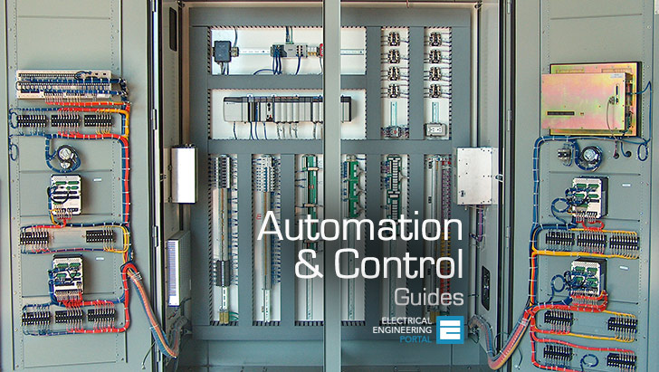

SCADA…units

ADVANTAGES :
- Replacing human operators in tasks that involve hard physical or monotonous work.
- Replacing humans in tasks done in dangerous environments.
- Performing tasks that are beyond human capabilities of size, weight, speed, endurance, etc.
- Economy improvement: Automation may improve in economy of enterprises, society or most of humanity.

DISADVANTAGES :
- Unemployment rate increases due to machines
replacing humans and putting those humans out of
their jobs.
- Technical Limitation
- Security Threats
- High initial cost.

- REFERENCE

• Campbell, Sylvester J. (1987). Solid-State AC Motor Controls. New York: Marcel Dekker, Inc. pp. 79–189. ISBN 0-8247-7728-X.
• ^ Jump up to: ª ^{b} ^{c} Jaeschke, Ralph L. (1978). Controlling Power Transmission Systems. Cleveland, OH: Penton/IPC. pp. 210–215.
• ^ Jump up to: ª ^{b} Siskind, Charles S. (1963). Electrical Control Systems in Industry. New York: McGraw-Hill, Inc. p. 224. ISBN 0-07-057746-3.
• ^ Jump up to: ª ^{b} NEMA Standards Publication (2007). Application Guide for AC Adjustable Speed Drive Systems. Rosslyn, VA USA: National Electrical Manufacturers Association (now The Association of Electrical Equipment and Medical Imaging Manufacturers). p. 4. Retrieved Mar 27, 2008.

Autonomous

vehicles may be the answer.
Discover one of the key benefits of unmanned vehicle technology in the CFBF 2012 Agricultural Employee Survey.
- Keywords— Electric Drives - Motor Controllers and Control Systems

Basic Motor Control Functions and Applications

- Automation and controls-
- DCS Programming & Configuration
- Operator display construction
- Level 2 communication
- Electrical design
- Control Loop

- Logic control
- AC/DC drives
- Field bus engineering
- Installation Design
-Layouts, Cabling, containment
- Site services

Electrical drives classification parts and advantages of electrical drives Dynamics of Electrical drives
Control of electrical drives
Synchronous motor drives
DC motor drives
Induction motor drives
Variable frequency drives
Stepper motor drives
Servo mot

or controller drives

Automation and Control Guides

. SCADA…

units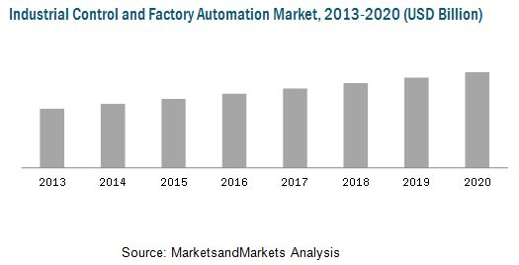

Multiples | Prefix name |  | deca | hecto | kilo | mega | giga | tera | peta | exa | zetta | yotta
Multiples | Prefix symbol |  | da | h | k | M | G | T | P | E | Z | Y
Multiples | Factor | 10⁰ | 10¹ | 10² | 10³ | 10⁶ | 10⁹ | 10¹² | 10¹⁵ | 10¹⁸ | 10²¹ | 10²⁴
Fractions | Prefix name |  | deci | centi | milli | micro | nano | pico | femto | atto | zepto | yocto
Fractions | Prefix symbol |  | d | c | m | μ | n | p | f | a | z | y
Fractions | Factor | 10⁰ | 10⁻¹ | 10⁻² | 10⁻³ | 10⁻⁶ | 10⁻⁹ | 10⁻¹² | 10⁻¹⁵ | 10⁻¹⁸ | 10⁻²¹ | 10⁻²⁴

ADVANTAGES :
- Replacing human operators in tasks that involve hard physical or monotonous work.
- Replacing humans in tasks done in dangerous environments.
- Performing tasks that are beyond human capabilities of size, weight, speed, endurance, etc.
- Economy improvement: Automation may improve in economy of enterprises, society or most of humanity.

DISADVANTAGES :
- Unemployment rate increases due to machines
replacing humans and putting those humans out of
their jobs.
- Technical Limitation
- Security Threats
- High initial cost.

- REFERENCE

• Campbell, Sylvester J. (1987). Solid-State AC Motor Controls. New York: Marcel Dekker, Inc. pp. 79–189. ISBN 0-8247-7728-X.
• ^ Jump up to: ª ^{b} ^{c} Jaeschke, Ralph L. (1978). Controlling Power Transmission Systems. Cleveland, OH: Penton/IPC. pp. 210–215.
• ^ Jump up to: ª ^{b} Siskind, Charles S. (1963). Electrical Control Systems in Industry. New York: McGraw-Hill, Inc. p. 224. ISBN 0-07-057746-3.
• ^ Jump up to: ª ^{b} NEMA Standards Publication (2007). Application Guide for AC Adjustable Speed Drive Systems. Rosslyn, VA USA: National Electrical Manufacturers Association (now The Association of Electrical Equipment and Medical Imaging Manufacturers). p. 4. Retrieved Mar 27, 2008.

