Study for Designing The Electrical Distribution Panel of KDK Boys Hostel
Shweta Wagh KDKCOE, Nagpur 7028712976 Shwetawagh83@gmail.com,
Prashant Ganer KDKCOE, Nagpur 9595111018 prashant.ganer@gmail.com
Shubham Dhage KDKCOE, Nagpur 8983701936 shubhamdhage.1994@gmail.com

Abstract - A distribution board also known as panel board or breaker panel is a enclosure that houses the fuses, circuit breaker and ground leakage protection units used to distribute power to numerous individual circuits or consumer points. It divides an electrical power feed into subsidiary circuits, while providing a protective fuse or circuit breaker for each circuit in a common enclosure. The electrical distribution panel in KDK Boys Hostel was installed about twenty six years ago with old technologies and equipments. Thus there is need to study the old distribution panel and suggest new installation of panel as per Indian Standards Rules. This paper provides an overview of electrical power distribution system encountered in KDK Boys Hostel. It discusses the representation of distribution panel through the use of single line diagram and introduces history and use of the National Electrical Code. This paper describes common system voltage used in existing distribution panel which includes the series of fuses to protect the individual circuit. This paper also covers the study of clearances adopted in existing distribution panel and provide the suggestions for the new installation of panel as per IS Rules and use of advanced protection scheme use of MCCB or MCB instead of ICTP or ICDP. On account of a comprehensive study of the existing distribution panel considering various aspects such as distribution panel rules and standards, improved protection equipments, future load expansions etc the installation of new distribution panel would be done in future.

Keywords – Distribution system planning, design of distribution panel, protection scheme, I.S. Rules.

Introduction
Electric distribution panels can be customized and configured to meet the power requirements of the residential, commercial and industrial buildings. Distribution panel are majorly used in order to distribute the incoming power supply to various sub distribution boards and corresponding loads connected to it. In case fault occurs in a distribution panel, trained personnel and special measuring instruments are used for quick and accurate fault location. In order to restore supply at earliest possible time, thus design of the distribution panel should be systematic with respect to certain standards. Certain standards have already been laid down by various respective authorities in accordance to which distributions panels are designed and installed. The distribution panels which are designed under these standards have better overall life and are easily supervisable under undesired fault conditions. Since the designing of distribution panel is based upon certain constraints as distribution panel rules and standards, improved protection equipments, future expansions etc a comprehensive data analysis is required.

objectives

At the end of this paper, you will :

- understand the overall function of the electrical power distribution systemin a building.
- Understand the basic philosophy behind the development or reinstallation of power distribution system.
- Have knowledge of the more common system voltages used for power distribution.
- Have an appreciation of the National Electrical Codes.
- Appreciate the need for interaction and communication among the various professionals desciplines involved in a design project.

overview of power distribution system
Before attempting to design the electrical power distribution system for a building, you must understand the basic elements that make up the overall power distribution system. The overall layout of the major components of a power distribution system is often the first step in the design process. It is at this beginning stage that the designer developes a general idea as to the nature af the distribution system. For example, in this early stage the designer will probably establish the location of the service enterance, inquire as to the service voltages available from the local utility company, determine the locations of electrical closets and vaults, determine approximate location for distribution panel boards and switchboards, and so forth.

existing distribution panel
Power distribution system, consisting of a main distribution board (MBD), Sub Main Distribution Board (SMDBs) and Final Distribution boards, by which the electrical energy is transmitted via branches to reach the exact end users. An MDB typically has a single or multiple incoming power sources and includes main circuit breaker and residual current or earth leakage protection devices. The condition of existing distribution panel in KDK boys hostel is shown in figure 1 below. There is three and half core 415V incomer cable from SNDL Nagpur coming inside the hostel premises of about 50 Sq mm which energizes the entire distribution panel. The protection equipments used in the existing distribution panel are iron clad triple pole and iron clad double pole switches (ICTP and ICDP) and simple rewirable fuses. The main distribution panel is thus further divided into two

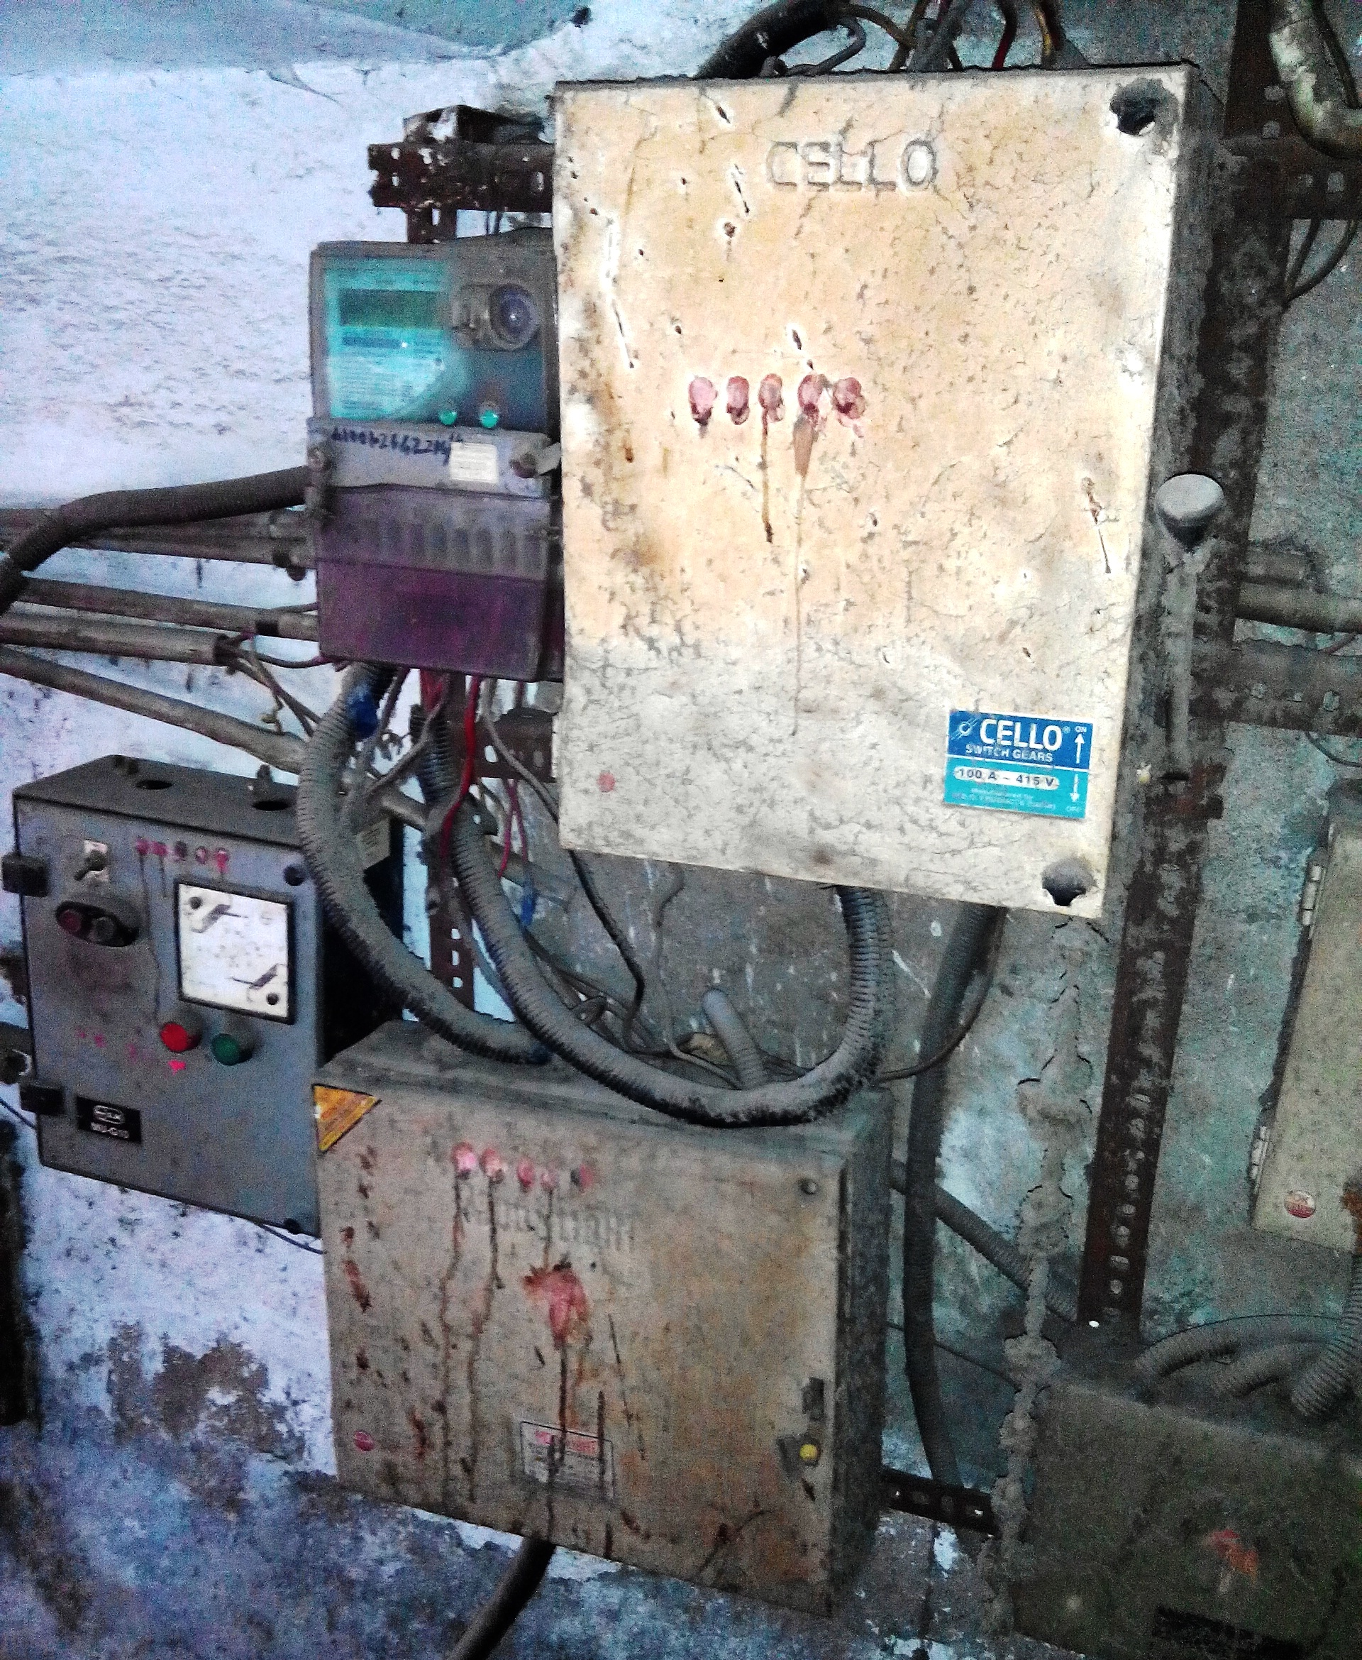

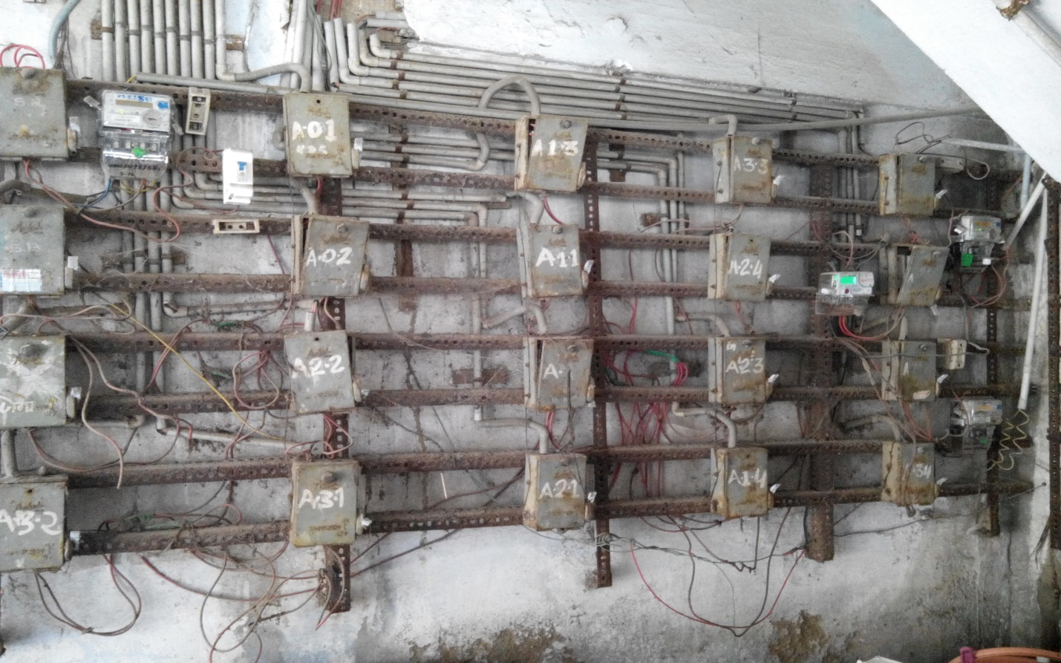

Fig. 1 Existing Distribution Panel

Sub distribution panels by taking taps from the main bus bars respectively. The three phase loads present in the hostel premises are the two 5 hp motors which are used for pumping water to the overhead water tank from the well. Out of two motors, one is submersible which is used as running water while the other one is used as running motor while the other one is used as a standby motor in case of fault conditions.

specification and clearances of existing distribution panel

S.N. | Component | Ground to Meter Height (ft)
1 | Energy Meter | 4.2ft
2 | ICTP | 4ft
3 | Bus bar | 2.2ft
4 | DOL Starter | 1.8ft
5 | Mini Starter | 4ft

B.DIMENSIONS OF EXISTING MAIN DISTRIBUTION PANEL

S.N
1 | Length | 8.7ft
2 | Height | 3.10ft
3 | Ground to panel height | 2.4ft
4 | Stairs to panel distance | 2.7ft
5 | Floor to panel height | 2.5ft
6 | Diagonal | 9.5ft

single line diagram of existing distribution panel

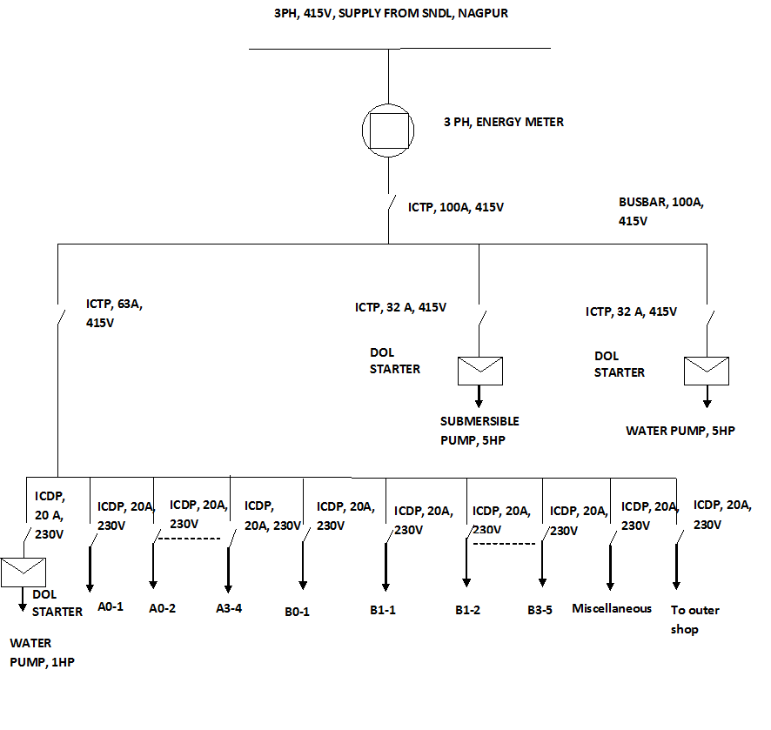

Fig. 2 Single line diagram of existing distribution
panel

The single line diagram of the existing panel itself indicates the old protection components i.e. ICTP and ICDP switches, there also exists a series of fuses as shown in fig 2. As the existing distribution panel is not an enclosed one, rusting has also taken place to certain extent thus there is always risk that the metal framework entirely or a part of it may be collaps causing interruption of supply or even short circuit in adverse condition. Also the design of the old distribution panel is not advanced thus it cannot house modern electrical components and related extension accessories for enhancement. Hence there is need to change the existing panel with new one.

Study required to Install New Distribution panel
The old distribution panel currently feeds about 14-15KW of connected load excluding the other outer shops outside the KDK Boys Hostel premises. As the old distribution panel was built about twenty six years ago, its design is thereby not much advanced for installing new protection equipments which are these days almost essential in order to ensure smooth and uninterrupted supply of electrical power. Thus there comes a need to design a new panel which would host of modern protection equipments and would be capable of incorporating any kind of future expansions as and when required.

While designing the distribution panel board the following details should be incorporated into it.

1. Location and dimension of the panel.
2. Load description, Amperage, Voltage required.
3. Phases and their balancing.
4. Horsepower, cable size and conduit size.
5. Number of wires a conduit carries.
6. Type of insulation
TECHNICAL SPECIFICATION FOR ELECTRICAL PANEL DESIGN

  - GENERAL REQUIREMENTS

The installation shall generally be carried out in conforming with the requirements of the Indian Electricity Act, l9l0 as amended up to date and the Indian Electricity Rules, l956 framed there under, the relevant regulations of the Electric Supply Authority concerned, and also with the specifications laid down in the Indian Standard I.S. 732 -l963 Code of Practice
and I.S. 2309-1969 Code of Practice for the protection of Buildings and Allied Structure against Lighting and IS 3043 - Indian code of Practice for Earthing. The wiring shall also be according to the I.S specifications, NEC, Local Government Body.

  - MAIN SWITCH GEAR

MCB and MCCB used instead of Iron clad switch fuse and isolator units should conform to relevant I.S. Standard. The quick make and break mechanism shall be self interlocked with the cover. In "Off" position there must be two breaks per pole. Main switch gear shall be properly earthed with two numbers conductors if M.V and one number of L.V.

  - DISTRIBUTION BOARDS

These totally enclosed metal clad type Distribution Boards with hinged lids shall be in accordance with I.S. 2147 - 1952 and 2675 - l966 and B.S. 2l4 and shall be of welded construction and fabricated from rust proofed sheet steel and finished with anticorrosive stove enamel paint and have provision for fixing on wall and have earthing terminals. Power Distribution Boards (415 volts) shall be constructed from l6 SWG sheet steel and Branch Distribution Boards (230 volts from l8 SWG sheet steel). The MCB shall be mounted on Din rails supports of proper dielectric & mechanical strength. If fuses/fuse banks are used these shall be mounted on ebonite supports of proper dielectric and mechanical strength. Cables shall be connected to a terminal by crimped lugs.

  - BUSBAR CHAMBER (B.B.C)

This shall be totally enclosed, metal clad type fabricated from rust proofed l6 SWG sheet steel on angle iron frame and provided with sheet steel or cast iron detachable front cover and undrilled detachable end plates, suitable for mounting on wall or angle iron floor stand and painted with high quality enamel paint. G.I. bolts and nuts shall be used for assembly with suitable packing materials to ensure dust proof finish. Meters shall be provided on suitable sheet steel boxes. Switch shall be provided with cable end boxes as required. The depth of B.B.C. shall be 250 mm (minimum). Minimum clearance of phase bars to
earth shall be 26 mm and between bus bars shall be minimum 32 mm.

  - INTERCONNECTION IN B.B.C, SWITCH FUSE, METERS

For ratings above 150 Amps these shall consist of insulated copper strips of adequate section considering current density as specified in Clause 4 above. For rating below 150 Amps PVC copper cable tails of appropriate size, terminating in tinned copper sockets may be used considering 1.5 Amp/sq.mm for copper & 1.0 Amp/sq.mm for aluminium. The above are to be enclosed either in sheet metal trunking or conduits so that no part is exposed.

F.CABLES AND CONDUCTORS

All cables shall conform to I.S-692, IS-7098, IS-1554 (Part-I) 1964 and IS 694-1990 or latest . Conductors of all cables except for flexible cables, shall be of aluminium, unless specified otherwise.

  - FLEXIBLE CABLES

Conductors of flexible cables shall be of copper. The minimum size of core acceptable is 1.50 sq.mm.

  - INSTALLATION OF MAIN SWITCH BOARD, BDB'S MAINS, SUBMAINS, DISTRIBUTION WIRING TO INDIVIDUAL POINTS

The exact positions of all main switch board, BDB's and all runs of mains and submains, and distribution wirings to individual points including the exact position of all light fittings and switch boards shall be first marked on the buildings and shall be approved by the Engineer-in-Charge before actual commencement of the work. The D.Bs shall generally be installed at a height of 2.l3 m (7 ft) from floor level.

conclusion an d future extension
Thus after such comprehensive study this paper will be beneficial from the point of view of installing the new distribution panel in KDK boys hostel in future. So that old component can be replaced by new easily available modern protection component such as MCB and MCCB in the market. Also new design of panel can be installed with proper specification as per Indian Standard rules discussed above. Also we can put forward an idea of installing a DG Set for the KDK Boys Hostel. Installing a DG Set would thereby ensure that the supply of electricity would be available as and when required. The average loading of the hostel premises comes out to be 14-15 KW for which a DG Set of 18KVA would be sufficient.

references

1. V.K Jain & Amitabh Bajaj ,“A Textbook of Design of Electrical Installations”; Laxmi Publications Pvt Limited,1993.1st Edition.
2. J.B. Gupta, “A Course in Electrical Installation, Estimating & Costing”; Published by S.K Kataria & Sons, 9th Edition.
3. A. S. Pabla, “Electrical Power Distribution System” ;Tata McGraw-Hill, 5th Edition.
4. Indian Electricity Regulation, 1956.
5. Jignesh Parmar, “Design Of An Electric Panel Board”.

- Valley, CA

