Implementation of Wi-Fi Based Smart Carrier Machine

Ashish Thamke
KomalBanpurkar
Vishal Wasekar

Introduction
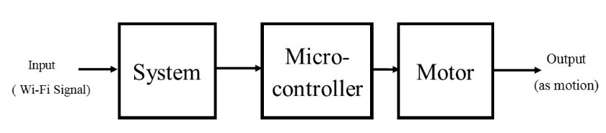
We live in the21st century where technology is booming every day.Due to rapid growth in technology many organizations are lagging in technology. Hence to cope up with that the projects like digital India have taken initiative in automation technology and reducing human efforts for development of India.In current organization the work load is tremendously increasing on human labour and the economy required for that is too high that’s why the economic development of the organization takes time to achieve the quick gain. Hence to minimize the number of labor required and bring automation in the organization we have to do the research work in proper working and the fusion of automation in organization.In order to contribute efforts in industrial application and commercial process-automation we have to work on future aspects of this process. So we are proposing this project ‘Smart Carrier Machine’ which can reduce the human effort and work smartly in organization.
The concept of this project is based on idea, providing security to confidential documents & material and to reduce the workload. This synopsis describes the design and implementation steps of project. The aim of this project is to reduce the workload on human beings in organizations. The objectives of this project is to do smart and efficient work, to save the human labour, to do the work securely.
The robot will be operating on the frequency receiver which is placed in the robot. The robot will detect the particular frequency corresponding to identified cabin. Now frequency will be decoded by receiver corresponding to cabin number and pass on to microcontroller. Microcontroller identifies path and

give instruction to motor. The motor will turn ON and starts its motion from reference to required position.

The robot performs the particular task which is given by user. It provides the digital locking system for security of confidential documents & material which increases safety of operation.

AIM AND OBJECTIVE
The aim of this project is to reduce the workload on human beings in organizations. The objectives of this project is to do smart and efficient work, to save the human labour, to do the work securely.

WORKING PRINCIPLE

Basic working principle of the project is shown in the fig. above. Input will be given to the system in the form of Wi-Fi signal. System get actuated when it receives Wi-Fi signal. System will generate the proper input for microcontroller. Microcontroller will perform the proper operation to get the desired output in the form of motion of the motor.

BLOCK DIAGRAM

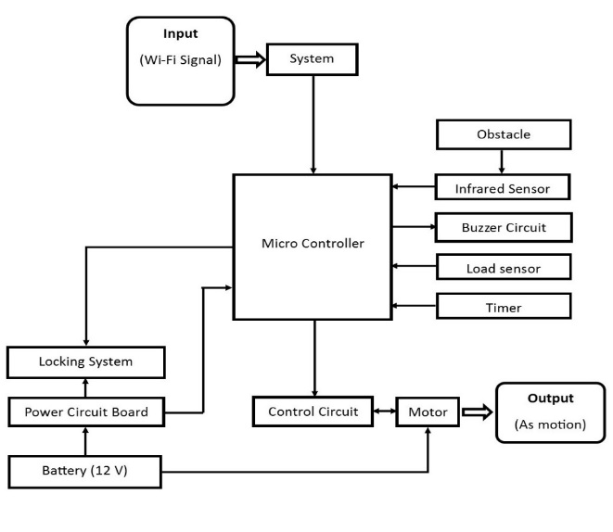

Fig2: Block diagram of totalArrangement

Above fig. shows the block diagram of total arrangement of the smart carrier machine. Input is given in the form of Wi-Fi signal to the system.System will generate the input for the microcontroller. The block diagram shows the flow of operation. Microcontroller is connected to the control circuit block. This control circuit is connected to motor block which will operate to do the motion of the robot. This assembly require the 12 V supply to the motor as the specification of the motor. We also require the supply for locking system installed for the security purpose. Which will be given through the same battery we connected,with the help of power circuit board.
Input signals are also brought through the sensors and output signal will be given toauxiliary output devices. Infrared sensor and load sensors are used to take input and the required output signal will be given to the buzzer circuit.

- PCB LAYOUT
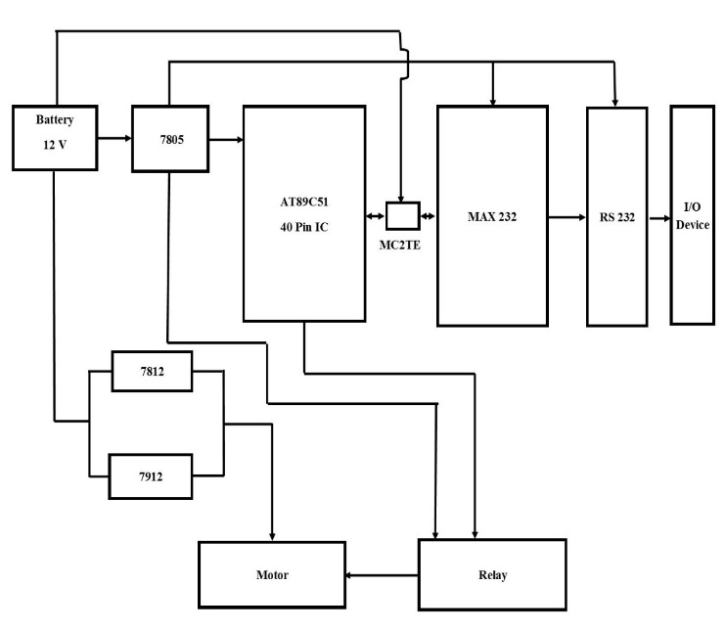

IC – Microcontroller (AT89C51) ,MC2TE (6 PIN) , MAX232
Relay – 6V DC
Capacitor – 10µF, 1µF ,33pF
Infrared sensor
Load sensor
Crystal oscillator – 11.59MHz
Resistor – 10KΩ ,1KΩ
8 motors – 12V DC gear (10 RPM)
Transistor – BC547(NPN)
Voltage regulated IC – 7805 ,7812 ,7912

- FLOWCHART

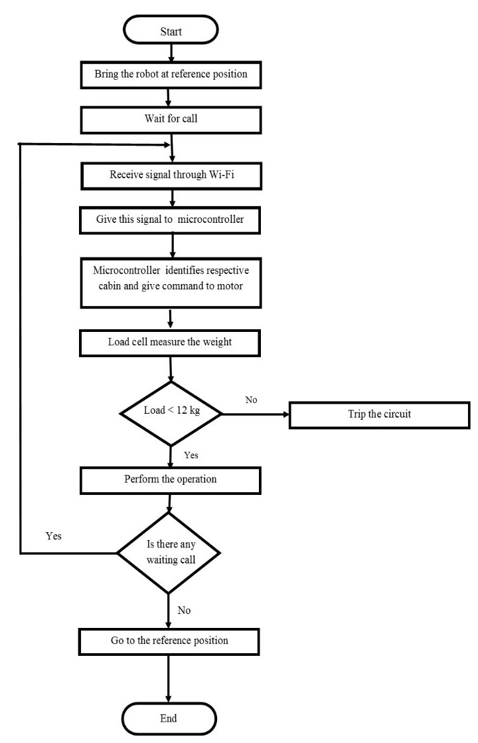

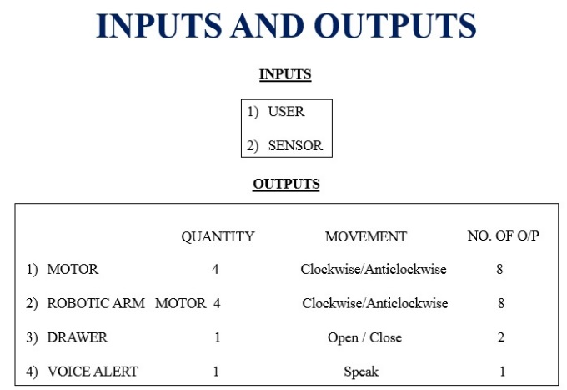

Input and output of the different equipment of the smart carrier machine have to be calculated to assign the different pin of the microcontroller.
For input purpose a 8 line port slot will be given to user and input will also take from the sensors.
Motor have two type of output i.e. it will rotate clockwise or anticlockwise and hence have two output. We are using 4 motors for movement of the robot. And 4 motors for robot arm. And hence for total for all clockwise and anticlockwise motion of the motors we need 16 output lines. Drawer will have two output i.e. open and close. And for voice alert we need 1 output. So totally we need 19 output lines.

- SOFTWARE REQUIRED

- Visual Basic
- Microsoft Office Visio
- PCB Designer
- Orcad

- MERITS
- Quick response
- Security
- Accuracy
- Reduce human need
- Saving on human wages

- DEMERITS
- Weight limitation
- Obstacle increases operation time
- Requires plain surface
- Initial cost high
- CONCLUSION
The robot can be used for different application like laboratories, commercial offices, banks etc. It can be concluded that with the use of this machine the operation will become very efficient, prompt and reliable.

REFERENCES
[1] Hui Liu, Norbert Stoll, Steffen Junginger and Kerstin Thurow , “Mobile Robotics transportation in LabortaryAutomatiosn: Multi-robot control, Robot-Door Integration and Robot-Human Interaction.” In proceedings of the 2014 IEEE International Conference on robotics and Biomimetic December 5-10, 2014, Bali, Indonesia.
[2] Muhammad Bilal Khan, Muhammad Awais Hussain, KhurramShahzad, Sajid Nawaz, Mohammad Umar Touheef, Raja Jawad Ali Khan, “A Bidirectional Prototype Mobile Robot to Experiment Light ScaleObject-Transportation Schemes.”(IEEE 2014)
[3] J. Borges Sousa*, F. Lobo Pereira*, E. Pereira da Silva*, A. Martins*, A. Matos*, J. Almeda*, N. Crus*, R. Tunes*, S. Cunha*, “ON THE DESIGN AND IMPLEMENTATION OF MOBILE ROBOTIC SYSTEM.” (IEEE 1995)
[4] RedwanAlqasemi, Kevin Edwards, Rajiv Dubey, “Design, Construction and Control of 7 DoF Wheelchair-Mounted Robotic Arm”(IEEE 2006)

