Swing Electricity Generation System

Ajinkya Phutane, Gaurav Daware, Vijay Dube
Department of Electrical Engineering
YCCE, Nagpur

Abstract – Energy need of today’s modern world is growing dayby days because of consumption of some or larger extent or amount of growing population. This project is about a swing, which is used by children for playing that produces electricity while being used. In the swinging action of swing makes the horizontal beam member turns through some angle continuous it’s to and fro motion. Now this motion is transferred to link which transfers this angular motion of the beam to rotary motion of the flywheel, which is rigidly connected at the end. The flywheel is connected to a generator by specific transmission to increase the speed at generator end. The generator converts the mechanical energy into electrical and thus electricity is produced. The swing generates electricity while being used. Along with this project uses that energy that is given a way in playing.

Keywords— Swing, Generator, Flywheel, Wheel, Bearings.

I. INTRODUCTION

Energy is the ability to do work. Energy need of today’s modern world is growing day by day because of increase in population. This project is about a swing, which is used by children for playing that produces electricity in both side of swing. The electricity thus produced can be used for local use, free of cost and is ecologically friendlier. This way of generation of electricity if implemented at various parks, play houses, schools etc. can certainly help saving electricity.

This swing electricity project not only generates electricity but also can be a very useful tool to educate children to learn to conserve energy. This project utilizes energy that is given away while playing.

II. OBJECTIVE

The objective of the project is to convert obtained mechanical energy during the movement of seating of swing set into electrical energy along with no added effort and also storing the electricity thus generated into a battery, which can be

utilized whenever needed.

III. WORKING PRINCIPLE

The main aim of this project is to utilize the mechanical energy generated during the swinging action of swing set and
convert it into electricity, and store the electricity thus generated into a battery. It works based on the principle that energy can neither be created nor destroyed but can be converted from one form to another.
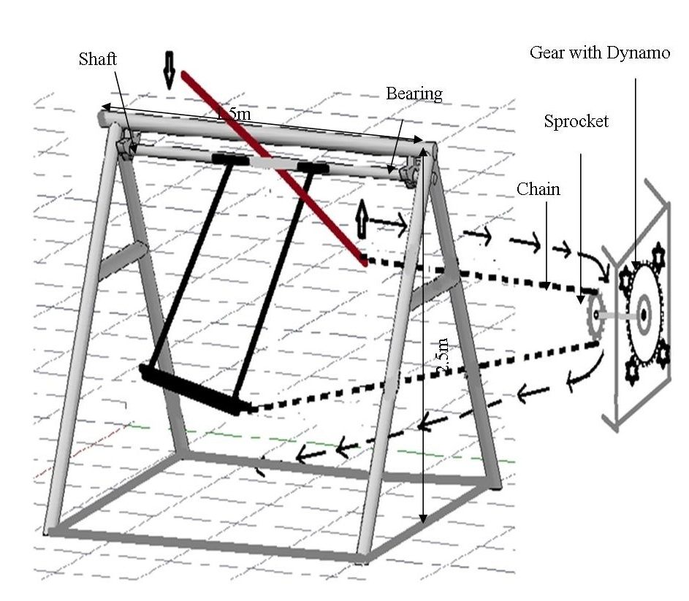
Fig. 1. Working Mechanism

IV. METHODOLOGY

This project is about a swing, which is used by people for playing that produces electricity while being used. In its construction, the swinging action of swing makes horizontal beam member turns through some angle continuously to and fro motion now this motion is transferred to link which transfers to link which transfers this angular motion into linear one as amplifies the same this amplified motion is then transmitted to a free wheel that using flexible link the free wheel turns this linear reciprocating motion in to circular one directional motion and transmits the same to flywheel.
The flywheel is connected to a generator by specific transmission to increase the speed at generator end. The generator converts the mechanical energy into electrical and this electricity is produced. The swing generates electricity while being used only.
The system is made up of mostly light weight material. The system uses DC generator for generation of electricity and it can be converted into AC as per requirement. The main part of system is which converts oscillatory motion into rotatory motion. The oscillatory motion is the projection of rotatory motion on diameter of the circle.
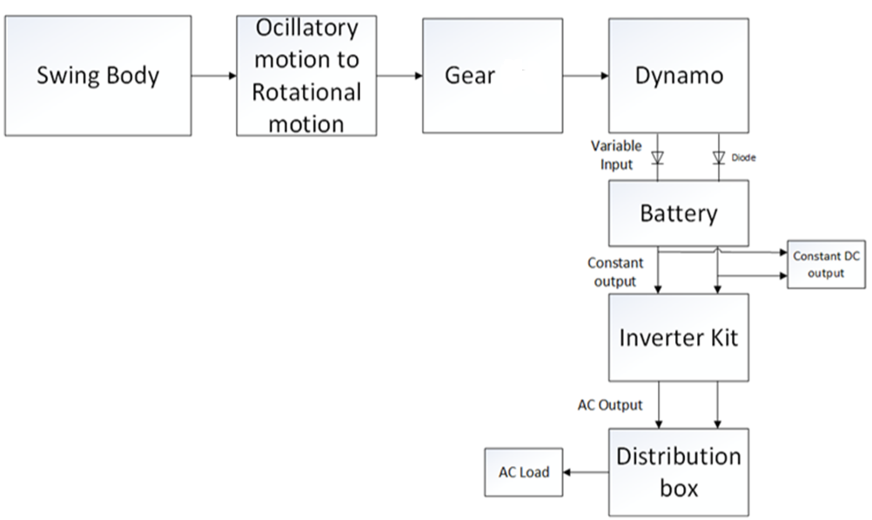
Fig. 2. Block Diagram of Swing Electricity Generation

V. CALCULATION OF MECHANICAL ENERGY INPUT
The swing can be considered as simple pendulum doing Simple Harmonic Motion SHM whose length is l and with time period T. The length l of this swing is chosen shorter than the ordinary swing. Because as l is small T is small and as T inversely proportional to the frequency f another reason is that it also increases the potential energy of system as compared to the pendulum with longer length.
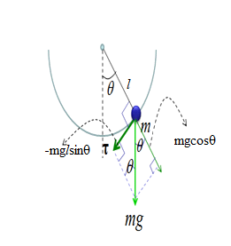

Fig. 3. Mechanical Designing Equation
The potential energy (PE) of body with mass m at height h is given as
PE=mgH
Here H= l-lcosθ
Where ϴ is the angle of swing
Therefore, PE = mgl(1-cosθ)=150Kg×9.8m/sec²×2m×(1-cos25⁰)=1332.27 Joules.
The torque (τ) generated by SHM is given as τ =150Kg×9.8m/sec²×2m×sin25⁰⁼1242.49N-m
Where m is mass of the body and g is acceleration due to gravity.
The relation T with l can be given as:
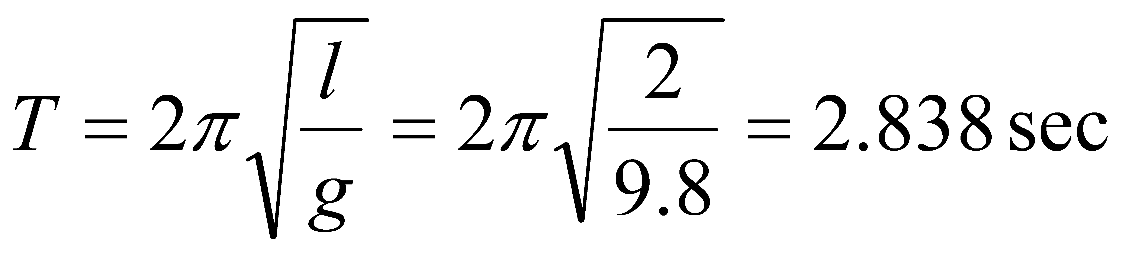
The time period T is fixed since length is fixed. This time period T is essential for calculation of final mechanical input RPM.
The freewheel is used for conversion of this SHM into unidirectional rotational motion. The flywheel is also used for storage of energy which will supply uniform mechanical input to generators.

VI. ADVANTAGES, LIMITATIONS & APPLICATIONS

Following are the Advantages, Limitations & Applications of developed model,

Advantages

- Pollution free electricity generation.

- This power can be stored in battery array so as to use it further.

- Can be installed at places such as schools, playgrounds where mass transit of children is sighted e.g. hotels, fairs etc.

- Easy installation and maintenance.

- Simple mechanism.

Limitations

- Require periodic checkups.

- Implementation cost is bit higher than overall average production cost.

- Power generation is not continuous.

Applications

The system can be employed in places such as,

- Schools

- Nurseries

- Parks

- Gardens

- Playgrounds

VIII. CONCLUSION
- The proposed system offers an innovative method to generate electricity from the mechanical energy produced during the swinging action of swing seat with no added effort to the person sitting on it, which would otherwise be wasted.

- The proposed system can be used to generate electricity effectively in a non–polluting manner at various places like schools, parks, playgrounds, garden, etc.
- It is an attractive technology for optimal use of available sources.

REFERENCES

- R.S.Khurmiand J.K.Gupta S.R.Pandian,"Abstract". A Human Power Conversion System Based on Children's Play. IEEE, May 16, 2013, pp.5 and 54.
- Cleveland Motley, "A Swing Set that Generates Electricity", May 26 -2009
- .M.M,"Swing Generator using Power Electronics", IJETER Jan 27 -2015, Chennai, India.
- Manjunatha C J, Manjunatha K, Suresha P,"Swing Electricity Generation System", IJSPR, Volume-13,Number-01,2015,Bangalore,India. available www.beproject.com/mechanical-abstract/c1-swing-electricity-generation-system.html
- Baratraj E, Devarapalli Prudhvi Raja Reddy, Mubeena
- R.S.Khurmi and J.K.Gupta "Machine Design", Eurasia Publication, Revised edition 2005.
- S.Rao and B,Parulekar, Energy technology, Khanna Pub.,Delhi, India,2007, pp.20.

