Harmonic Suppression by Shunt Active Power Filter Using MATLAB
Shweta Pali KDKCOE, Nagpur shwetapalisp@gmail.com
Kalyani Titarmare KDKCOE, Nagpur kalyani199318@gmail.com
Ketan Kitukle KDKCOE, Nagpur kkitukale@yahoo.com
Prof. Bhushan KDKCOE, Nagpur bhushi912@gmail.com

Abstract – Due to wide use of non-linear power electronic devices in low voltage side the harmonic pollution has increased in the power system to the larger extent. Improving power quality has become the biggest challenge for electrical engineers. There are many ways to improve the power quality like using passive filter, FACTS devices like (DPFC, UPFC, UPQC, STATCOM, SAPF). In this paper the power quality improvement is done by using Shunt Active Power Filter as it has become an effective alternative for controlling harmonic levels. The results obtained by using the active filters are quite satisfactory to mitigate harmonic distortion, reactive power compensation and power factor improvement. The Shunt active filter reduces the THD as per the IEEE-519 standards .The Shunt Active Filter employs a simple method for the reference compensation current based on Fast Fourier Transform. This paper describes the operation of Shunt Active Power Filter to improve power quality by compensating harmonic and reactive power required by the load.

Index Terms— non-linear load, Unified Power Flow controller (UPFC), Distributed Power Flow Controller (DPFC), DSTATCOM(Distribution Static Synchronous Compensator), SAPF(Shunt Active Power Filter),THD (Total Harmonic Distortion).

I. Introduction
Harmonics contamination is a serious problem in Electric Power System. Different methods to eliminate harmonics are, Capacitor Bank, Compensators, Passive Filter, Active Filter. Out of these Active Power filtering constitutes most effective proposed solutions. A shunt active power filter that achieves low current Total Harmonic Distortion (THD), reactive power compensation and power factor correction is presented. Hence, it is necessary to reduce the dominant harmonics below 5% as specified in IEEE-519 harmonic standard. The shunt APF based on Voltage Source Inverter (VSI) structure is an attractive solution to harmonic current problems. The Shunt Active Filter is a Pulse Width Modulated (PWM) VSI that is connected in parallel with the load. It has the capability to inject harmonic current into the AC system with the same amplitude but opposite phase than that of the load. The principal components of the APF are PWM Converter, Instantaneous power calculation, reference current calculation, DC voltage regulator. The performance of an active filter depends mainly on the technique used to compute the reference current and the control method used to inject the desired compensation current into the line [1].

Type Of Filters
Two type of filters used for the above purposes
which are:-
1. Passive filter
2. Active power filter
Active power filter can be classified into three categories as per their Connection to the PCC, namely:-
1. Shunt active power filter
2. Series active power filter
3. Hybrid active power filter
But shunt active power filter is widely used due to its simpler construction and robustness [2].

II. SHUNT ACTIVE POWER FILTER
The principal of shunt active power filter is to produce harmonic current equal in magnitude but opposite in phase to those harmonics present in grid. Phase shift of harmonic current induced by the shunt active power filter is 180 degree. As the lower order harmonics in the system are eliminated by the shunt active power filter, the current in the non linear load becomes linear. Therefore the Shunt active filter can compensate reactive power and can also mitigate lower order harmonics and distortion present in the system. A shunt active power filter achieves low current Total Harmonic Distortion (THD), reactive power compensation and power factor correction is presented. Hence, it is necessary to reduce the dominant harmonics below 5% as specified in IEEE-519 harmonic standard. Therefore APFs are widely used in three phase system[3].The performance of proposed method is compared with PWM current control scheme. Hysteresis Band Pulse Width Modulated current controller is more efficient in terms of fault tolerance, switching loss and Total Harmonic Distortion thus improving the performance of Active Power Filter[4].

Fig.1. Shunt active power filter
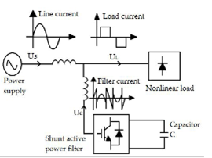

Fig.2 Waveform for actual load current (A), desired source current (B) and the compensating filter current (C).

III. Design Of Shunt Active Power Filter
The shunt active power filter mainly consists of PWM Converter, Instantaneous power calculation, reference current calculation, DC voltage regulator.

Instantaneous power calculation

The control algorithm block diagram for p-q method is depicted in fig.3. The three-phase source voltages (Va, Vb, Vc) and load currents (Ia, Ib, Ic) in the a-b-c coordinates are algebraically transformed to the α-β co-ordinates using Clarke’s transformation as per equation (1) and (2) For a 3- phase system without ground/neutral we can neglect the zero sequence component and the matrices are transformed as(3), followed by the calculation of the instantaneous active power (p) and reactive power (q) by following (4).

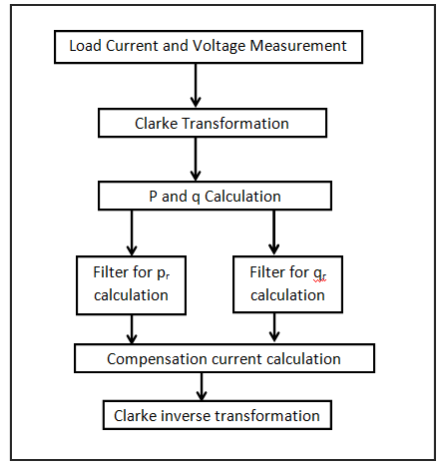

Fig.3.Algorithm for instantaneous power
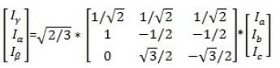
(1)

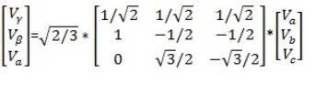 (2).
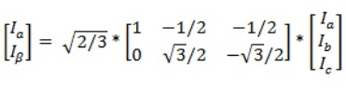 (3).
()
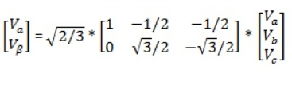 (4)

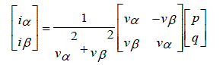 (5)
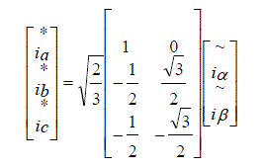
(6)

Hysteresis controller
The HBPWM is basically an instantaneous feedback current control method of PWM where the actual current continually tracks the command current within a specified hysteresis band. The Fig explains the operation principle of HBPWM for a half bridge inverter. The control circuit generates the sine reference current wave of desired magnitude and frequency, and it is compared with the actual phase current wave. As the current exceeds a prescribed hysteresis band, the upper switch in the half-bridge is turned off and the lower switch is turned on. As a result the output voltage transitions from +0.5Vd to -0.5Vd, and the current starts to decay. As the current crosses the lower band limit, the lower switch is turned off and the upper switch is turned on. The actual current wave is thus forced to track the sine reference wave within the hysteresis band by back- and-forth switching of the upper and lower switches. The inverter then essentially becomes a voltage source is the pulse separation circuit for the separation of pulses to the IGBTs in the upper and lower leg of the inverter.
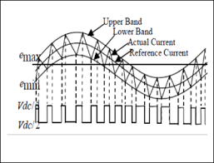
Fig.4 Hysteresis band operation.
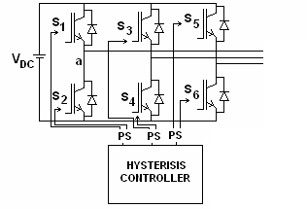

Fig.5. Pulses to Converter by hysteresis controller

  - DC Voltage Regulator
The DC link capacitor mainly serves two purposes-
(a) It maintains almost a constant DC voltage.
(b) It serves as an energy storage element to supply real power difference between load and source during transients. In this scheme the role of the DC link capacitor is to absorb/supply real power demand of the load during transient. Hence the design of the DC link capacitor is based on the principle of instantaneous power flow.

Construction Of PI Controller
Fig shows the internal structure of the control circuit. The control scheme consists of PI controller, limiter, and three phase sine wave generator for reference current generation and generation of switching signals [12]. The peak value of reference currents is estimated by regulating the DC link voltage. The actual capacitor voltage is compared with a set reference value.
The error signal is then processed through a PI controller, which contributes to zero steady error in tracking the reference current signal. The output of the PI controller is considered as peak value of the supply current (Imax), which is composed of two components: a) fundamental active power component of load current, and b) loss component of APF; to maintain the average capacitor voltage to a constant value.
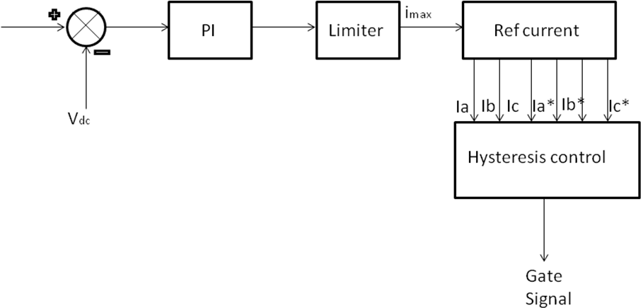

Fig.6 PI Controller

IV. Simulation And Performance Analysis
The operation of the simulation model shown below is described as – first the capacitor voltage is sensed which is compared with the reference voltage and the error signal is given to the PI controller for processing to obtain the maximum value (Im) of the reference current which is multiplied with the unit vector template i.e. sinωt to get the reference current Im sinωt for phase a. This signal is now delayed by 120 for getting the reference current for phase b, which is further delayed by 120 to get the reference current for the phase c. these reference currents are now compared with the actual source currents and the error is processed in the hysteresis controller to generate the firing pulses for the switches of the inverter. And the switches are turned on and off in such a way that if the reference current is more than the actual source current then the lower switch is turned on and the upper switch is turned off and if the reference current is less than the actual source current then the upper switch of the same leg is turned on and the lower switch is turned off. The output of the shunt active power filter is such that the source current is purely sinusoidal and the harmonic current is drawn or supplied by the filter.

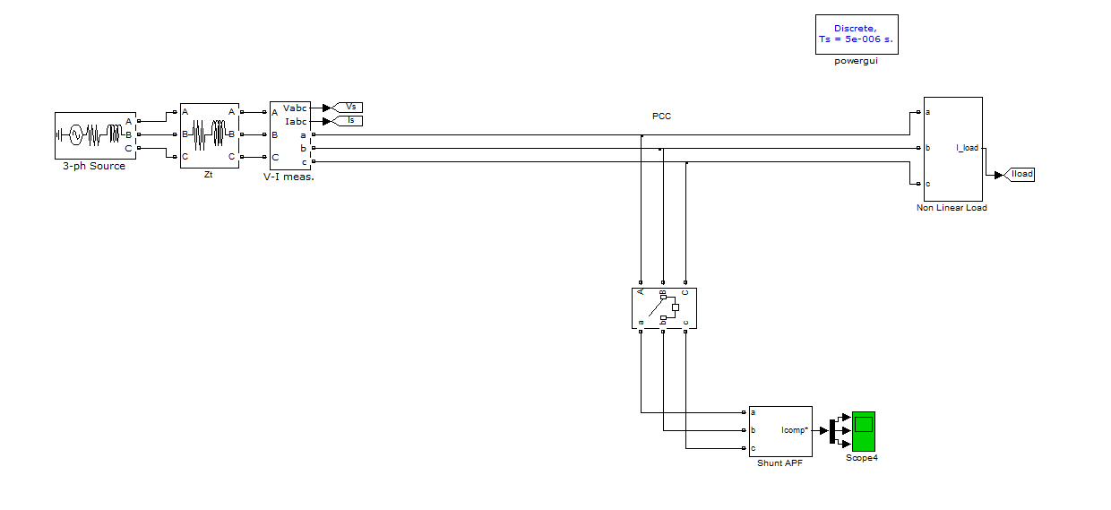

Fig.7. MATLAB simulation model

Fig.8 FFT Analysis for source current

The waveform shown in fig.12 and fig.13 demonstrates that source current is reduced THD from 21.83% to 0.89%.

References

- Suresh Mikkili, Anup Kumar Panda “Instantaneous Active and Reactive Power and Current Strategies for Current Harmonics Cancellation in 3-ph 4-Wire SHAF with Both PI and Fuzzy Controllers” International Journal of Advanced Research in Electrical, Electronics and Instrumentation Engineering,vol.2,issue 22 March 2011,p-p285-298
- VikashAnand , Dr. S.K.Srivastava, “Performance investigation of SAPF using Hysteresis current controller method,” International Journal of Engineering Research &Technology, vol.1, issue 4, June-2012.
- Seifossadat, S. G., et al. “Quality improvement of shunt active power filter, using optimized tuned harmonic passive filters”, Power Electronics, Electrical Drives, Automation and Motion, 2008.
- Dahono, P. A. “New hysteresis current controller for single-phase full-bridge inverters,” Power Electronics, IET 2.5 (2009), pp. 585-594.
- B.Rangandh, A.Mallikarjuna Prasad, Madichetty Sreedhar, “Modelling and simulation of a hysteresis band pulse width modulated current controller applied to a three phase voltage source inverter by using MATLAB,” International Journal of Advanced Research in Electrical, Electronics and Instrumentation Engineering, vol.2, issue 9, September 2013

