Speed Control of Single Phase Induction Motor using AC Chopper by Asymmetrical PWM Technique

Payal Jagmade, Payal Bhende, Pradnya Gowardhan, Nupur Mekratwar
Department of EE, Smt. Rajashree mulak college of engineering for women, Nagpur
nitufunde@gmail.com, nitumeshram49@gmail.com

Abstract – Single phase induction motors are widely used in domestic applications. Sometimes variable speed operation of the single phase induction motor is necessary, hence remarkable efforts has been taken in adjustable speed single phase induction motor drive. Now a day, by improvement of the power electronics devices, the flow of power to the motor is controlled by a switching action of the power switches (MOSFET, IGBT etc), which thereby control the speed of the induction motor. The main objectives of our project are to maintain the speed constant at different load condition. This is achieved by using asymmetrical PWM technique with ac chopper which reduces the harmonics contains in the motor current. AC chopper will give a variable controlled output voltage from fixed AC source which thereby control the speed of the single phase induction motor. The simulation is carried out in MATLAB/SIMULINK with split phase induction motor, in which asymmetrical PWM technique used to operate the power electronics switches (IGBT) of an AC chopper.

Keywords: AC chopper, speed control, asymmetrical PWM.

Introduction
Single phase motors are widely used in home appliances. The advantages of this motor are their ability to operate from a single phase power supply. Therefore they can be used whenever a single phase power is available. There are also other aspects for their popularity, low manufacturing cost, reliability and simplicity. In many applications it may be desirable to change the speed of motor. Then it is useful for varying AC induction motor speed. Generally speed control of motor can be achieved by varying the input parameters of motor such as current, voltage etc. This can be achieved by various methods such as field control methods, armature control method, ward leonard etc for DC or AC motors.

Conventional method for starting and speed control of single phase induction motor need often quite expensive

external electrical equipment. Moreover, they require mechanical switches, which are more troublesome part.

These switches suffer from mechanical wear, which affects the motors performance.

Now a day, by the improvement of the power electronic devices, flow of power to the motor is control by the switching action of power switches (MOSFET, IGBT etc). The most popular technique of supplying single phase AC motors is the conduction angle control. To carry out this control a triac device is used. The conduction angle is adjusted by changing the switching instant of the triac device. This method represents of cost effective solution but it produces a very high harmonic content in both motor and supply current waveform. After that many authors have suggested and analyzed the performance of the single phase induction motor fed from inverter circuit with space vector PWM but both methods need complicated circuit with high cost. However, AC chopper seems to be an acceptable solution when a wide range of speed control is required.

II. CONCEPT OF AC CHOPPER

The concept used in this motor control is to implement the power switching device to chop the input source voltage. This method will cause the pulse-width of the AC voltage waveform to change. So, this method of AC voltage controller is called symmetrical pulse width modulation (PWM) AC figure1 shows the circuit diagram of an AC The current in the inductive load always has a continuous path to flow regardless of its direction. To explain the operation of this circuit, three operating modes are proposed, namely active mode, freewheeling mode and dead time mode. The advantages of the AC chopper are simplicity, ability to control large amounts of power, low waveform distortion, high power factor and high response.
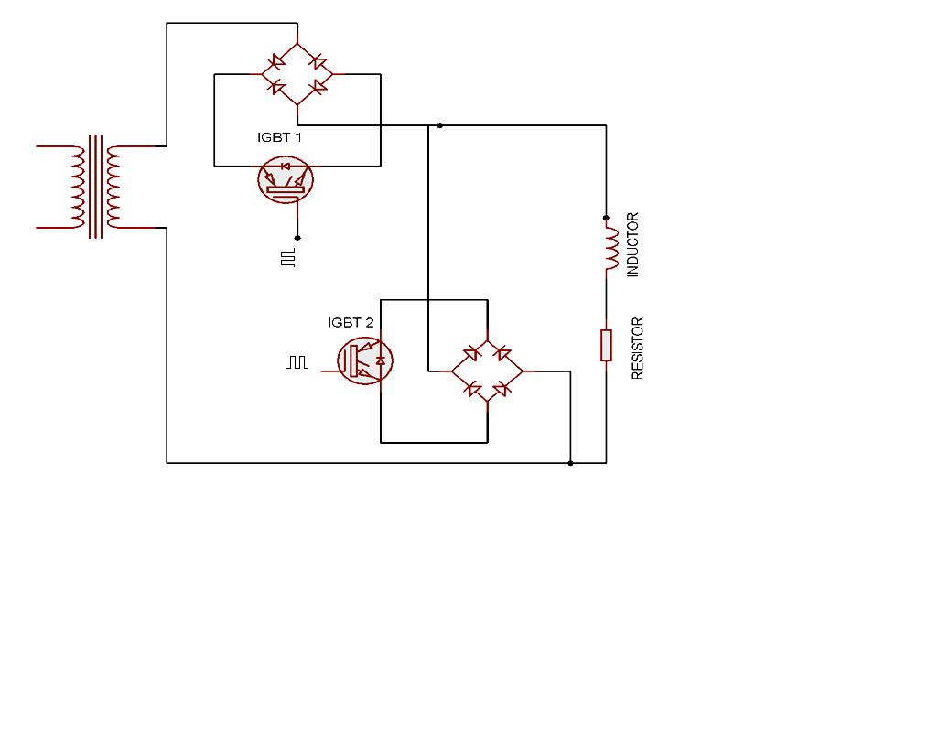
Figure 1 circuit diagram of symmetrical PWM AC chopper

A. Active Mode
The active mode occurs when switch 1 is closed and the current is flowing across the load as shown in figure 2(a). During this stage switch 2 is opened. Power flows from the supply to the load.

B. Freewheeling Mode
As for the freewheeling mode, switch 1 is opened and the load is disconnected from the supply. Meanwhile switch 2 is closed. The load current freewheels and naturally decays
through the freewheeling path according to the direction of the load current as shown in
figure 2(b). The current can flow until the energy in the inductor is fully depleted. The trapped energy in the inductor is dissipated in the resistances of the freewheeling path.

Figure 2(a) & (b) AC chopper operation modes

III.MATERIALS AND METHODS

Matlab software has been used to simulate the AC controller circuit, The load and component ratings chosen for power circuit in this work were about 10A and 230V. The main components used are as follows:-

i. IGBT (insulated gate bipolar transistor)
The IGBT is chosen with VCES = 600V and Ic = 12A. The rise time (29ns) and fall time (32ns) is also very fast, so it is excellent for fast switching operations.
ii. Rectifier
The bridge rectifier which consists of a power diode is implemented. The bridge rectifier provides the DC voltage to IGBT because current can only flow through IGBT in one direction.
iii. Gate Drive
To provide voltage isolation and floating points required to operate the IGBTs, Single channel gate drives have been used. There are a number of ways in which the gate to source, Vgs floating supply can be generated, one of these being the bootstrap method. The duty cycle and on-time are limited by the requirement to refresh the charge in the bootstrap capacitor (long on-times and high duty cycles require a charge pump circuit). This means that the output has to be off for a short time enough to charge the bootstrap capacitor.
iv. Freewheeling diode
A “freewheeling diode” is put into a circuit to protect the switching device from being damaged by the reverse current of an inductive load. Without the “freewheeling diode”, the voltage can go high enough to damage the switching devices.
v. The motor parameters are found by the no-load test and blocked rotor test of single phase induction motor. The motor parameters are as shown in the figure 3.

Figure 3 motor parameters of single phase IM

IV. SIMULATION OF SINGLE PHASE INDUCTION MOTOR

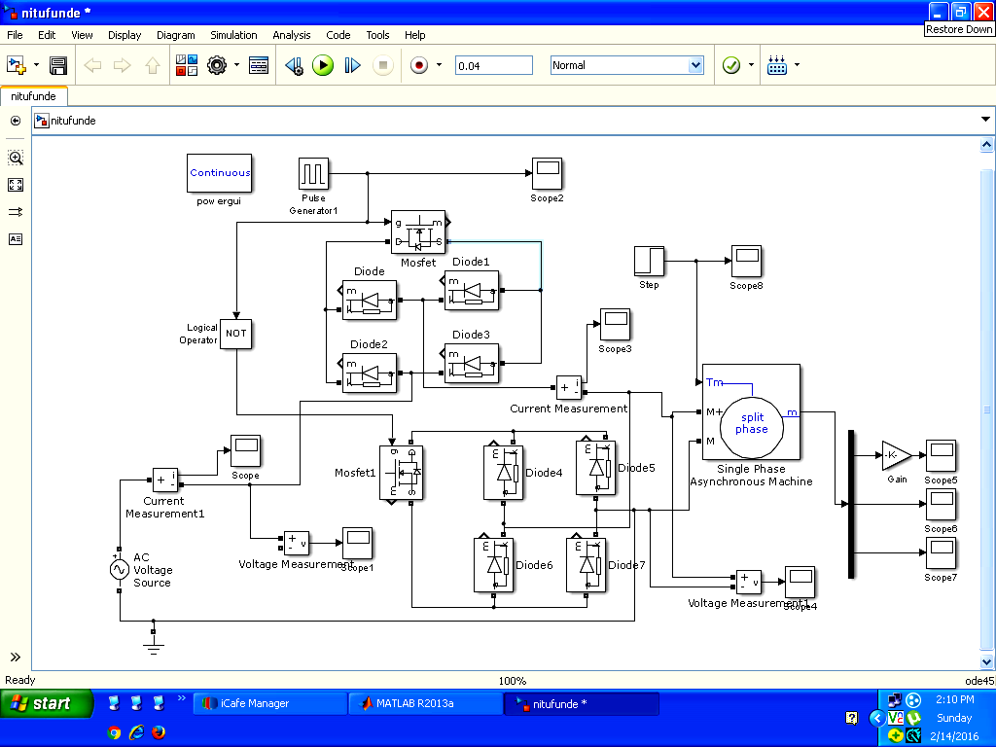

Figure 4 Speed control through the AC chopper-PWM

Simulation of speed control of single phase induction motor is carried out in two different control techniques are shown below.
1) PWM- Pulse Width Modulation control
2) HPWM- Hysteresis (Asymmetrical) Pulse Width Modulation control
In symmetrical PWM technique harmonics of higher order are present; to reduce them asymmetrical PWM technique is used with AC chopper in which harmonics are eliminated. Asymmetrical or hysteresis PWM method creates a
Hysteresis band and makes the error signal to lie in that created limit. The error Signal will be the signal which is obtained by the comparison of output signal and reference signal. The whole circuit is as shown in figure 4.The motor torque will be compared with the reference signal which is also a sinusoidal signal and error signal will held to ‘relay’ where the bandwidth will be set as shown in figure 5. The output of relay will be pulses, which is fed to the switches, the triggering of AC chopper switches are controlled by the pulses generated through error signal.

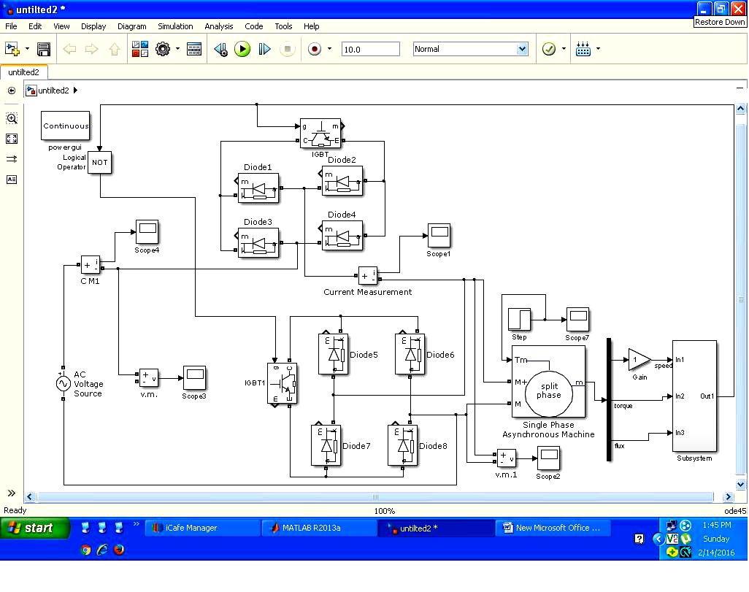

Figure 5 Simulation circuit of hysteresis PWM technique

Figure 6. Subsystem of hysteresis switching block

V. RESULT AND DISCUSSION

The pulses obtained from subsystem of hysteresis switching block are shown in figure7 which are then applied to igbt1

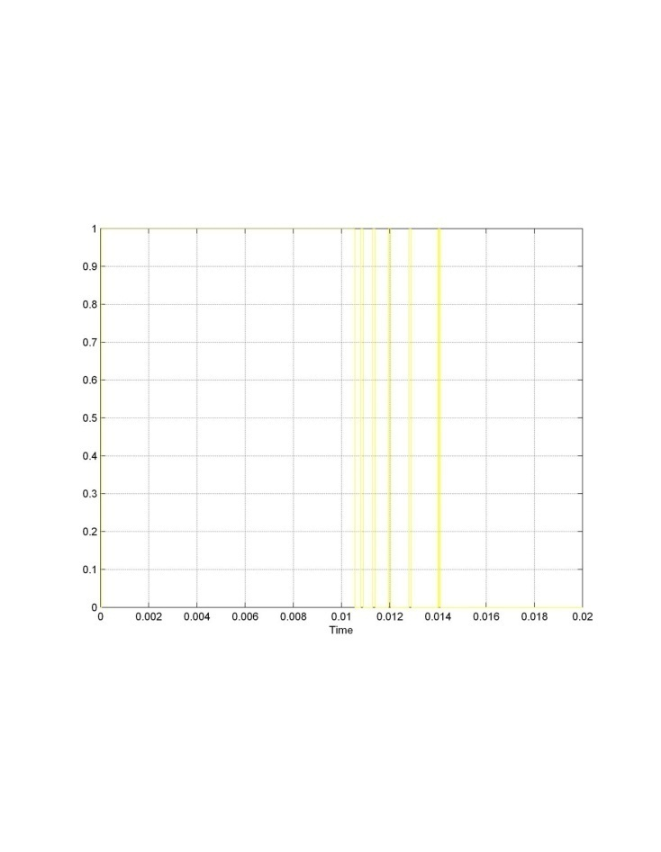
Figure 7 pulses genrated through hysteresis switching block

The resultant waveform of the speed is as shown in figure 8 when the the load is applied the speed decreases and it made costant.

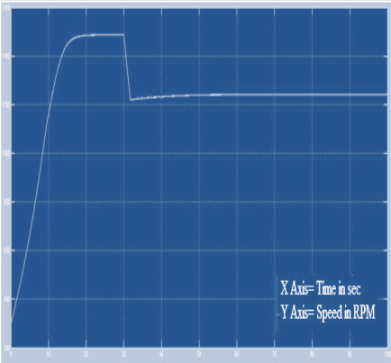

VI. CONCLUSION
To control the speed of induction motor inverters are commonly used, but in this project AC chopper is implemented to control speed of single phase induction motor by implementing the asymmetrical PWM method the efficiency of the motor is improved and harmonics distortion in motor current will be reduced as compared to traditional PWM method.

ACKNOWLEDGEMENT

This completion of project on “speed control of single phase induction motor using ac chopper by asymmetrical PWM technique” has given us immense pleasure an knowledge. We are over whelmed by a profound debt of gratitude to us guides Mrs. Sudha Shrikant madam and co-guide Mrs. Neha jain madam for interest in the work and extended their valuable time, guidance expertise criticism, moral support and expedition completion to this dissertation work.

Our special thanks to all teaching and non teaching staff in Electrical Engineering department of Smt. Rajashree Mulak college of engineering for women, Nagpur. For expending moral support.

REFERENCES

- Simulation & Implementation Of Three Phase Induction Motor On Single Phase By Using PWM Techniques BAM University Ashwini Kadam1 ,A.N.Shaik Engineering, akadam572@gmail.com,9960158714
- G.Choe,M.park, An improved PWM Technique for A.C. Chopper. P.C.SEN, principles of electric machines & power electronics, wiley 1999
- M.M.R. Ahmed and M. Soliman, Speed Control of AC Series Motor Using AC Chopper Voltage Control ,IEEE Electrical Power & Energy Conference, 2010 IEEE
- DO-HYUN JANG, improvement of input power factor in ac choppers using asymmetrical pwm technique, transactions on industrial electronics, vol. 42, no. 2, pp.179 185. APRIL 1995

