COMPARATIVE STUDIES OF LMS AND NLMS ALGORITHM FOR ADAPTIVE BEAMFORMING SYSTEM

Auther 1 :Nidhi Rajput 9730322775 nidhir537@gmail.com
Auther2 :Prajakta Jagtap 9604391341 prajaktajagtap61@gmail.com
Auther 3 :Apoorva Bokde 8983702357 apurvabokde95@gmail.com

Abstract - The demand of new communication techniques arising day by day, due to the increasing the numbers of users. There are many techniques which are used to increase the efficiency of the communication system like cell sectoring, cell splitting, directional antenna etc. The smart antenna is used where interference is critical problem in the communication system. The smart antenna plays an important role to reduce the interference in communication environment. The adoption of smart/adaptive antenna techniques in future wireless systems has impact on the efficient use of the spectrum of network. Smart antenna can place nulls in the direction of interference via adaptive updating of weights linked to each antenna element. Smart antenna cancels out the co-channel interference resulting in better quality of reception and reduces the no. of dropped calls. In this paper, we analyze the performance of smart antenna system on LMS and NLMS algorithm and comparative analysis is done using MATLAB.

Index Terms - Beamforming, DOA, LMS and NLMS algorithm.

Introduction
Smart antennas are also known as adaptive array antennas , multiple antennas and recently MIMO are antenna arrays with smart signal processing algorithms used to identify spatial signal signature such as the direction of arrival (DOA) of the signal. It is mainly used to calculate beamforming vectors, to track and locate the antenna beam on the mobile/target. Smart antenna is defined as an antenna array system that is aided by a processing system that processes the signals received by the array or transmitted by the array using suitable array algorithms to improve wireless system performance. Its array consists of a set of distributed antenna elements (dipoles, monopoles or directional antenna elements) arranged in certain geometry of desired signal strength and reduces the interference from other signals. Hence they can be viewed as a combination of regular or conventional antenna elements whose transmit or received signals are processed using smart algorithms.
The Smart antenna (SA) technology is gaining more and more interest in increasing the wireless network capacity [1] that helps to meet the demand for the subscriber growth and the high speed.
The conventional base station antennas were Omnidirectional i.e. they used to radiate power in all direction, where there will be a waste of resources since power is radiated in all direction other than the desired user view of direction. A smart antenna is an array of radiating antenna elements combined with digital signal processing to transmit and receive in the adaptive manner [2-6].
Adaptively in the sense, it automatically adjusts the directionality of its radiation pattern in response to the signal environment. They are also known as adaptive array antennas. Thus smart antennas can increase capacity of the channel, broadens range coverage, steer multiple beams to track many mobiles, compensates aperture distortion or reduce multipath fading and co-channel interference.
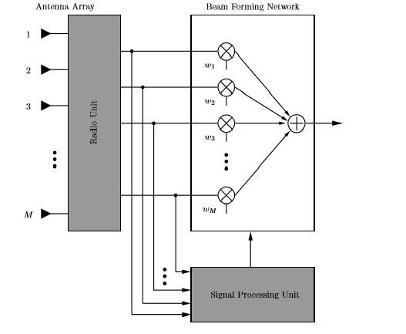

Dig : . Basic diagram of smart antenna

The digital signal processor interprets the incoming signal information using antenna array elements, determines the complex weights (amplification and phase information) and multiplies these weights to each element output to optimize the array pattern. This optimization is based on particular criteria i.e. which minimizes the interference and maximizes the main beam gain at desired direction. Thus, for computing these optimum weights and updating them we have several adaptive beamforming algorithms. But we are interested in localizing the sources, so for this, we implement DoA estimating algorithms that are mainly based on the specific properties of desired signal covariance matrix. Thus the observation space is subdivided into 2 spaces, one is signal space and other is noise space.

  - LMS
One of the simplest algorithms that is commonly used to adapt the weights is the Least Mean Square algorithm (See Fig.2). The LMS algorithm is a low complexity algorithm that requires to direct matrix inversion and no memory [3]. Moreover, it is an approximation of the steepest descent method using an estimator of the gradient instead of the actual value of the gradient, since computation of the actual value of the gradient is impossible because it would require knowledge of the incoming signals a prior. Therefore, the error can be defined as desired signal minus output of array weight
The output response of the uniform linear array is given by
y(n) = w(n).x(n)…………...(1)
Where w is the complex weight vector and X is the received signal vector given. The complex weight vector w is obtained using an adaptive Beam forming algorithm. The least mean square algorithm is a gradient based approach in which an error, e (n) is formed as
e(n) = d(n) − y(n) …………......(2)
Where d (n) denotes the sequence of reference or training symbols known a priori at the receiver at time n. This error signal e is used by the beamformer to adaptively adjust the complex weight vector w so that the mean squared error (MSE) is minimized. The choice of weights that minimize the MSE is such that the radiation pattern has a beam in the reference signal and that there are nulls in the radiation pattern in the direction of the interferers. The LMS algorithm is based on the steepest descent method which recursively computes an updates the sensor array weights vector w. It is reasonable that successive corrections to the weights vector in the direction of the negative of the gradient vector should eventually lead to minimum MSE, which point the weights vector assume its optimum value. In a standard LMS algorithm, the array weights vector w is initialized arbitrarily, and is then updated using the LMS equation given below
w(n+1)= w(n) +μ.x(n).e*(n)…………(3)
Where w (n + 1) denotes the weights vector to be computed at iteration n + 1 and µ is the LMS step size which is related to the rate of convergence. In order to ensure the stability and convergence of the algorithm, the adaptive step size should be chosen within the range specified as
0<µ<1/2λmax
where λmax is the maximum Eigen value of the input correlation matrix.

  - NLMS
The normalized least-mean-square (NLMS) algorithm which is also known as the projection algorithm, is a useful method for adapting the coefficients of a finite-impulse response (FIR) filter for a number of signal processing and control applications. It can persist over a wide range of stepsizes. Theoretically, LMS method is the most basic method for calculating the weight vectors. However, in practice, an improved LMS method, the Normalized-LMS (NLMS) is used to achieve stable calculation and faster convergence. The NLMS algorithm can be formulated as a natural modification of the LMS algorithm based on stochastic gradient algorithm. Gradient noise amplification problem occurs in the standard form of LMS algorithm.
Normalized Least Mean Square Algorithm is an extension of the LMS algorithm being directly proportional to the input vector x(n), which overcomes the limitation of LMS algorithm. The stability problem occurs in LMS due to its weight vectors w(n+1). In other words, the Normalized least mean squares filter (NLMS) is a variant of the LMS algorithm that solves this problem by normalizing with the power of the input.
w(n+1)=w(n)+ μ(n).x(n).e*(n)……….(5)
In the equation (5), the step size is given by
μ (n)= μ | 𝑥 𝑛 |2 ……………….(6)
μ is a constant , the value of μ lies in between 0 and 2.µ(n) is the normalized version of LMS (NLMS) because step size is divided by the norm of the input signal to avoid gradient noise amplification due to x(n).

  - ANALYSIS OF LMS AND NLMS ALGORITHM:-
LMS(LEAST MEAN SQUARE) ALGORITHM:- In the analysis of this algorithm, the input signal is S=cos(2*pi*t/T),the snr is 10db,the no. of antenna elements are N=10, angle of arrival is 10 degree and angle of interference is 70 degree. The distance or spacing between the antenna elements of the array is 0.5λ.The array factor defines the positions of the antenna elements in the array and the weight used. The array factor of the LMS based smart antenna w.r.t. angle of arrival is shown below:-

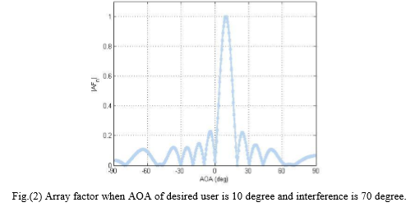
In the above figure, antenna places deep nulls in the direction of interfering signal and maximum in the direction of the desired signal. The Mean Square Error (MSE) of the algorithm defines the error between the desired and actual signal. Fig. (3) shows Mean Square Error v/s No. of iterations when DOA of desired user is 10 degree and interference is 70 degree.
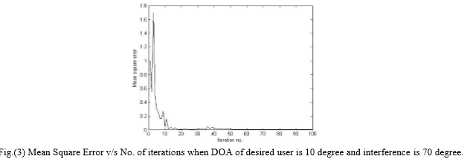
In the above plot, the MSE reduces as the numbers of iterations increases. Convergence time also defines by this plot because it defines the time at which the error converges and comes in real condition. The weight updation of the LMS.
Algorithm is given in equation (3).In this analysis the weights for the N = 10 ULA are:
w1 = 1
w2 = 1.0064+0.62254i
w3 = 0.22841+1.0108i
w4 = -0.29592+1.1036i
w5 = -0.97059+0.49151i
w6 = -1.0899+0.011474i
w7 = -0.76956-0.84212i
w8 = -0.26487-1.0037i
w9 = 0.60677-1.0146i
w10 = 0.88734-0.46312i
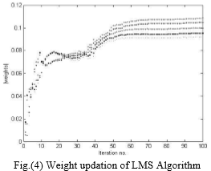

After updation of weights, the final output converges according to our desired direction. The difference between the desired and antenna output is shown below.
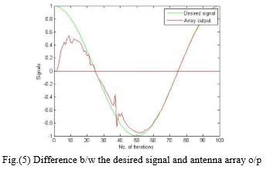
  - NLMS (Normalized Least Mean Square) Algorithm:-
The NLMS algorithm is same as LMS algorithm but it has fast convergence time and achieves the good calculation. The difference between the LMS algorithm and NLMS is only the weight updation. The weight updation of the NLMS algorithm is given in equation(5). The Fig(6) shows the direction of arrival from the desired user:-
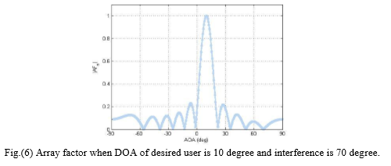
The figure(6) shows the antenna main beam in the desired direction and nulls are fitted in the interference direction. The difference between the desired and antenna output is shown below(in fig(7)). The antenna output is more accurate in NLMS Algorithm as compared to the LMS algorithm.
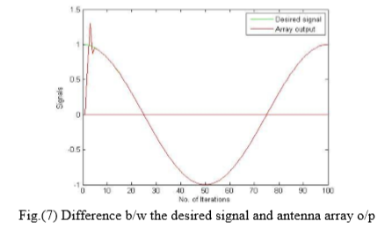

The updation of weights of NLMS Algorithm is faster than LMS algorithm which is shown in fig(8):-

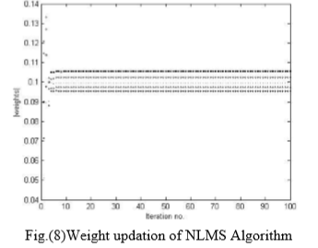
The Updation of weights in NLMS algorithm in 10 ULA Elements in given below:-
w1 = 1
w2 = 1.002+0.62029i
w3 = 0.22946+1.0102i
w4 = -0.29612+1.099i
w5 = -0.96845+0.49263i
w6 = -1.0865+0.0093512i
w7 = -0.76945-0.83869i
w8 = -0.26211-1.0022i
w9 = 0.60315-1.0124i
w10 = 0.88738-0.46105i
The NLMS algorithm Mean Square Error reduces very fast as compared to LMS. The plot between the Mean Square error and No. of Iterations is shown below:-
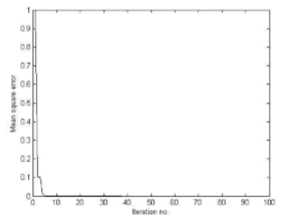
Fig.(9) Mean Square Error v/s No. of iterations when DOA of desired user is 10 degree and interference is 70 degree.

The above figure also shows that the convergence speed of the NLMS is more as compared to LMS.

CONCLUSION

Smart antenna technology will form a vital part of wireless communication . There are many benefits in using an adaptive antenna especially on handset like increased coverage, data rates, reduced intereference, increased in spectrum efficiencvy , which are beneficial to radio communication.From the analysis of both algorithms, it is concluded that the NLMS algorithm is much better as compared to LMS algorithm in the mobile communication, But the NLMS algorithm requires a minimum of one additional multiply, divide and addition as compared to LMS. The LMS algorithm is basic method for updating the weight vectors and NLMS is an improved LMS algorithm for fast convergence. The NLMS algorithm gives better convergence characteristics than the LMS algorithm, because it can reduce the increase of the noise by dividing the step size parameter by input vector power. So finally, we can say that the NLMS is more useful for mobile communication system.

References
- Carl B. Dietrich, Jr., Warren L. Stutzman, Byung-Ki Kim, and Kai Dietze, “Smart Antennas in Wireless Communications: Base-Station Diversity and Handset Beamforming”, IEEE Antennas and Propagation Magazine, Vol. 42, No. 5, October.
- Salvatore Bellofiore, Jeffrey Foutz, Constantine A. Balanis, and Andreas S. Spanias. “Smart-Antenna System for Mobile Communication Networks Part 2: Beamforming and Network Throughput”, IEEE Antenna's and Propagation Magazine, Vol. 44, NO. 4, August 2002.
- Bellofiore, S.; Balanis, C.A.; Foutz, J.; Spanias, A.S.; Smart-antenna systems for mobile communication networks. Part I. Overview and antenna design Volume 44, Issue 3, and Page: 145 – 154 Jun 2002.
- M.Lakshmu naidu and L.Rambabu, “Smart Antenna system design using adaptive beamforming algorithms to minimize Noise,” IJSETR, Volume 4, Issue 7,pp 2322-2325, 2015.
- L. Yun-hui a n d Y. Yu-hang, ―A modified multitarget adaptive array algorithm for wireless CDMA system‖, Journal Zhejiang Univ SCI, Vol. 5, No. 11, pp. 1418-1423, 2004.

