Medicine Solubility Testing Machine
Auther 1 : Vinita Vazirani S.V.P.E.C.T. vinitavazirani1@gmail.com
Auther2 : Pranjal Metange S.V.P.E.C.T. pranjalmetange@gmail.com
Auther 3: Varsha Lanjewar S.V.P.E.C.T. lanjewarvarsha582@gmail.com

Abstract - This project describes the efficient method of testing the solubility of the medicine. Solubility rate determination is crucial because this enables the doctor to analyse ones tendency to digest the medicine according to ones body parameters. Tests to obtain the solubility were performed on humans but they gave erroneous results so a need of a robot that determines the solubility rate arised. The machine uses GUI and 8051 microcontroller that will make a mechanical jaw act like a human jaw. By setting different parameters like temperature, pressure and motor speed solubility rate can be found out.

Index Terms - 8051 Microcontroller, MATLAB (GUI), Mechanical Jaw, DC Motor, Camera.

Introduction
Medicines play an essential role to cure any kind of illness. The solubility of a medicine means the rate at which the medicine reacts with the saliva. Currently the medicine which has to be swallowed directly i.e. the solid tablet is used. The reaction of solid tablet requires more time and to overcome this drawback chewable medicines are being introduced. So the rate at which this chewable medicine reacts with the saliva is known as the solubility of the medicine and a machine to find the same is being designed.
Human beings can be employed for the purpose of chewing a medicine, but the test may require time and no human being can chew the medicine for a defined time period applying the same pressure and at the same frequency leading to erroneous results. So designing a machine which gives accurate results and reduces human labour is essential. There exists a machine to find out the solubility i.e. IN- VITRO RELEASE TESTING MACHINE. But this machine is very costly and hence not affordable for every pharmaceutical company and even pharmacy colleges. This prototype is a cost efficient one which can be used everywhere to find out the solubility of the medicine.
- Basic Block diagram
The block diagram of Medicine Solubility Testing Machine is as shown.
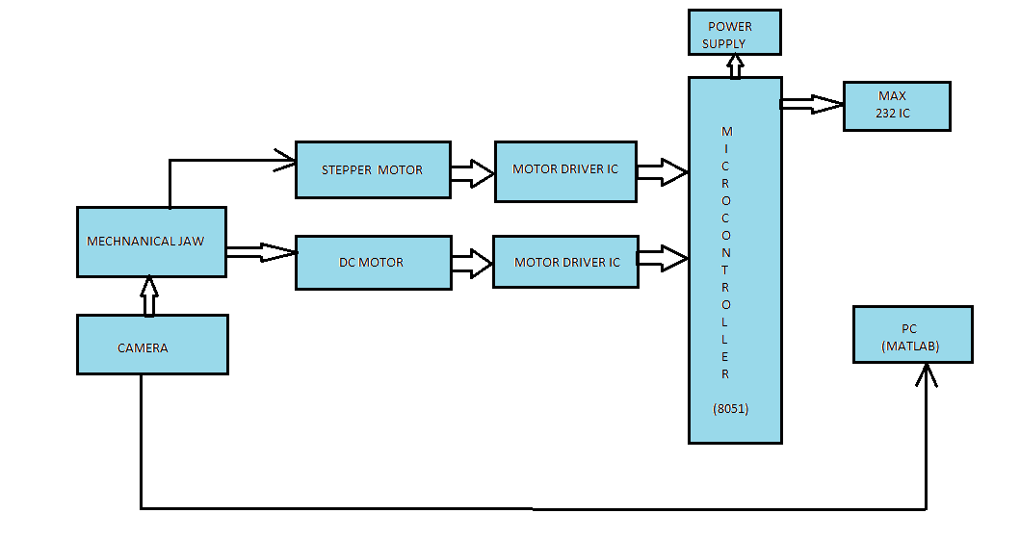
Fig 1. Block diagram

It consist of Mechanical Jaw, Stepper Motor, DC Motor, Motor Driver IC, 8051 Microcontroller, MATLAB, Camera, MAX 232 IC.

1.1 WORKING PRINCIPLE OF MEDICINE SOLUBILITY TESTING MACHINE
Here we are using dc motor to control the motion of the mechanical jaw. The mechanical jaw is based upon the crank shaft mechanism and stirring mechanism where in crank shaft mechanism it is used to convert circular motion of riveted plates into reciprocating motion and stirring mechanism where this stirrer will be required for maintaining the constant temperature. The tablet that we are using is in the chewing gum form, so riveted plates are used for crushing the tablet. Thus the mechanical jaw will act like a human jaw and different parameters will be set for different age groups and the motor will move in configuration with the given parameters so as to obtain the solution containing the medicine and hence this will be sent for the lab tests and later the solubility rate will be found out. Brief description of block diagram is given below-

1.2 PC (MATLAB)
MATLAB is a versatile software that contains different functions one being GUI. GUI stands for Graphical User Interface which has been designed in MATLAB for image processing to obtain appropriate and user friendly result.

1.3 MICROCONTROLLER

The Microcontroller has an on chip flash that allows the program memory to be user programmed by a conventional non-volatile memory programmer .This is used for holding the two values and computing the values required for finding out the rate.

1.4 D.C MOTOR

The DC motor controls the motion of mechanical jaw .A 12V DC motor is used over here. The speed of DC motor can be controlled by changing the voltage applied to the armature or by the field current.
Movement of the motor i.e in horizontal and vertical direction will be controlled with the help of microcontroller.

1.5 TEMPERATURE SENSOR

In this we are using DS1621 IC which is digital thermometer and thermostat, it provides 9bit temperature reading a MAX232 IC is used for serial communication which converts RS232 signals to suitable TTL signal.
The required or specific temperature is given to the microcontroller by PC via MAX232.Simontaneously DS1621 IC reads the temperature of the saliva and gives it to the microcontroller.

1.6 RELAY
The comparison between the temperatures is done using relay. If the temperature of the saliva is less than the required temperature then the heater will be switch on and after reaching the required temperature the heater will automatically stop.
1.7 MOTOR DRIVER IC
To establish the connection between the microcontroller and DC motor, a motor driver IC is used. The 1293D motor driver IC allows the DC motor to drive in either direction.
1.8 MECHANICAL JAW
In mechanical jaw crank shaft mechanism and stirring mechanism are used.
SOFTWARE WINDOW-
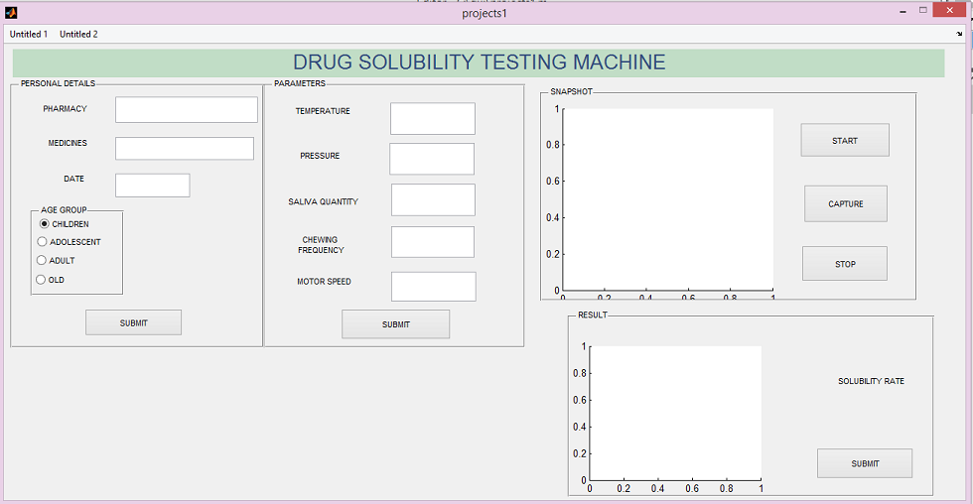
Fig.2 Software window
JAW DESIGN-
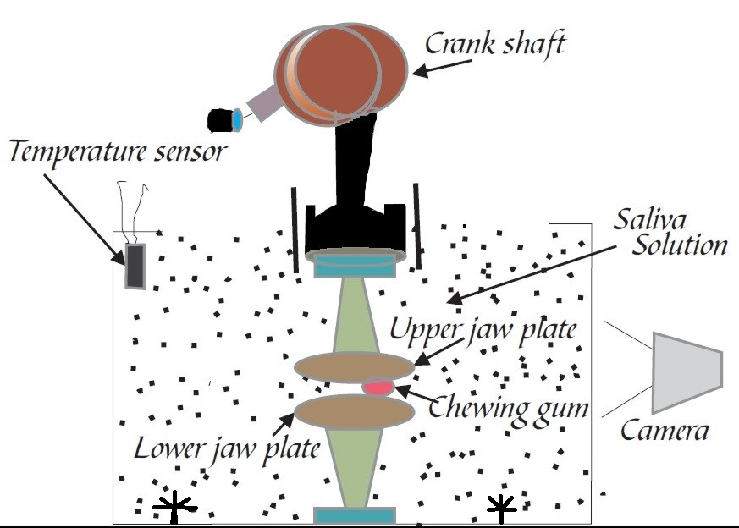
Fig3. Jaw design
RESULTS
The GUI window is completed using MATLAB software. The temperature sensor program and speed controlling program is dumped in the microcontroller. Also the designs has been finalised.

CONCLUSION
This project uses various software programmes and mechanical hardware to determine the solubility of the medicine. Our prototype is beneficial for not only the pharmaceutical companies but the pharmacy college students can also perform experiments on the same. The chewable medicines are more advantageous than the normal tablets so our prototype is a solution to the problems incurred while secretion of the medicine from the chewable tablet into the digestive system.

References
- Proceedings of 22nd IRF International conference, 22nd march of 2015, Pune, India, ISBN: 9789382702818
- www3.ntu.edu.sg/home/ehchua/programing/java/J4a_GUI.html
- Deshmukh ND, “IJPRBS”, 2012; Volume 1(5): 364-378M.
- Invent Rapid: NDDS Vol. 2015, Issue 2 [ISSN 0976-3791L.
- Journal of pharmacy Research Vol.4.Issue 4.April 2011.
- www.maxim-ic.com

