Solar 3D Printer
Auther 1 : Puja Sain S.V.P.E.C.T. poojasnk22@gmail.com Auther2 : Mayuri Bakde S.V.P.E.C.T. mayuribakde11@gmail.com

Abstract - 3D printing technology is a boon for humans. It is the process by which we can form any solid shape from a digital model. The 3D prototypes include the advantage of being embedded within more appropriate shape. The 3D printer developed will be powered using solar energy. The major components of this 3D printer i.e. the stepper motors which will drive the extruder will be derived from e-waste such as CD and floppy drives. Use of e-waste will bring down the overall cost of the printer. Arduino mega 2560 board will be used to control the movement of the stepper motors. The printer will be made to respond to G-code instructions. The machine will be tested using PLA (poly lactic acid) plastic which is a bio-plastic and has its advantages over ABS (acrylonitrile butadiene styrene) filament. The final output of this project will be a small 3D printer built with recycled components, which has a great potential and helps to reduce the cost significantly. On one side, an introduction to machine building is achieved and on the other side a small 3D printer built out of refused electronic parts is obtained.

Introduction
3D printing or additive manufacturing is a process of making three dimensional solid objects from a digital file. The creation of a 3D printed object is achieved using additive processes. In an additive process an object is created by laying down successive layers of material until the entire object is created. Each of these layers can be seen as a thinly sliced horizontal cross-section of the eventual object. It all starts with making a virtual design of the object you want to create. This virtual design is made in a CAD (Computer Aided Design) file using a 3D modeling program. To prepare a digital file for printing, the 3D modeling software “slices” the final model into hundreds or thousands of horizontal layers. When the sliced file is uploaded in a 3D printer, the object can be created layer by layer. The 3D printer reads every slice (or 2D image) and creates the object, blending each layer with hardly any visible sign of the layers, with as a result the three dimensional object. Not all 3D printers use the same technology. There are several ways to print and all those available are additive, differing mainly in the way layers are build to create the final object. [1]

Scope of work
With the patents of older technologies like stereolithography (SLA or SL), selective laser sintering (SLS) and fused deposition modelling (FDM) or fused filament fabrication (FFF) having expired recently, their easy availability has helped the open source community to increase their use in 3D printing technology. Moreover, 3D printing has also gone mobile with the availability of apps which can help fabricate designs without physically being close to any printer. Evolution of 3D printing based on specific environmental needs has given rise to newer technologies like biomimicry and light-directed EPD. Some of the innovations made through research and development in the world of 3D printing include 3D printed edibles, living organs, green vehicles and ethical filament. Thus, 3D printing is fast evolving due to its lower cost, ease of use and accuracy. 3D printing has the potential to revolutionize the way products are manufactured and produced while enabling fast, reliable, and repeatable means of producing tailor-made products. With effects on energy use, waste reduction, customization, product availability, medicine, art, construction and sciences, 3D printing will change the manufacturing world as we know it.[2]

Overview of the system
Fig.1 shows the block diagram of the solar 3D printer.

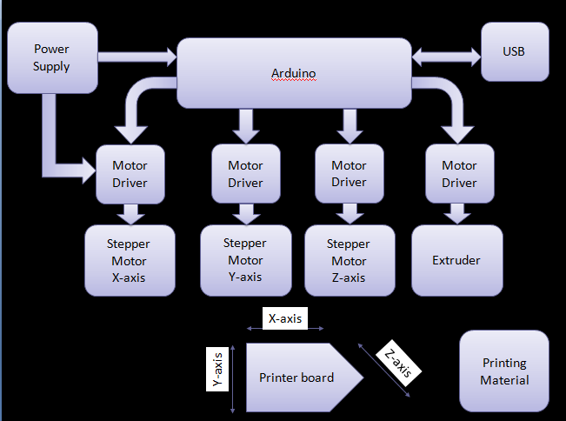
Fig.1 Block Diagram

A) Working of block diagram:
First of all the CAD file is exported to a 3D printing machine. Then the arduino drives the stepper motors in x,y and z axis as specified in CAD file.Then layer by layer printing of object start and finally at printing board we get the final desired object.

B) Component used:
A) Arduino Mega 2560
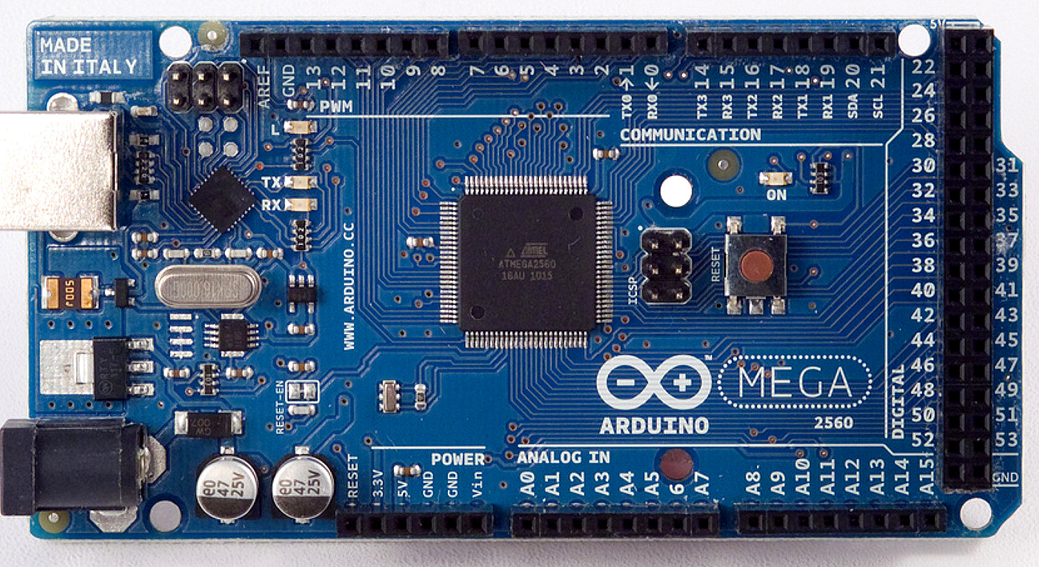
Fig.2 Arduino Mega 2560^{[3]}

The Mega 2560 is a microcontroller board based on the ATmega2560. It has 54 digital input/output pins (of which 15 can be used as PWM outputs), 16 analog inputs, 4 UARTs (hardware serial ports), a 16 MHz crystal oscillator, a USB connection, a power jack, an ICSP header, and a reset button. It contains everything needed to support the microcontroller. It can be started by connecting it to a computer using a USB cable or with an AC-to-DC adapter or battery. [3]
B) Stepper Motors
Stepper motors are basically servo motors which require an external circuit or microcontroller to energize its each electromagnet and make the motor shaft turn. They provide slow, controlled and precise rotation. The stepper motors used in this printer are derived from discarded CD and floppy drives.
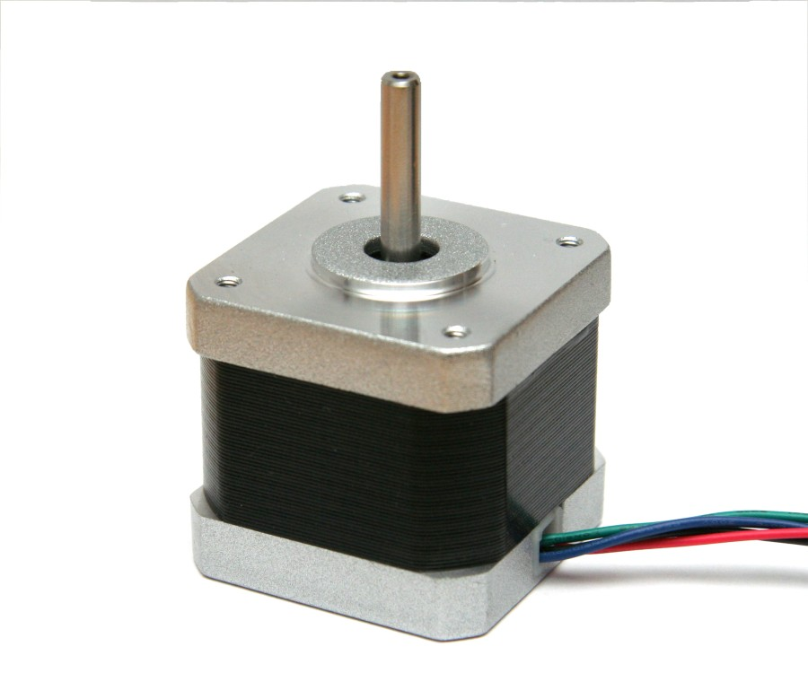
Fig.3 Stepper Motor ^{[4]}

C) Extruder
The extruder helps in melting the plastic filament. A rotating screw within the extruder feeds the filament forward and subjects it to high temperature in order to melt it. This molten plastic is then forced out of the tip of the extruder and is used for creating an object.
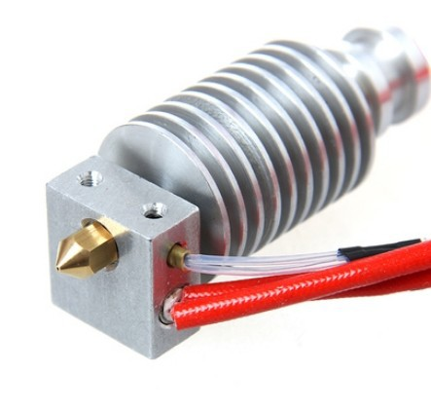
Fig.4 Extruder

D) Poly Lactic Acid (PLA)
Poly lactic acid (PLA) is a bio-degradable polymer that can be produced from lactic acid. It is harder than ABS and melts at a lower temperature of about 180 degrees to 220 degrees Celsius. Unlike ABS, PLA does not shrink after extrusion and is also stronger and more rigid. PLA undergoes more of a phase-change when heated and becomes much more liquid. If actively cooled, much sharper details can be seen on printed corners without the risk of cracking. The increased flow can also lead to stronger binding between layers, improving the strength of the printed part.
E) Power Supply:
Solar power is the use of the sun’s energy either directly as thermal energy (heat) or through the use of photovoltaic cells in solar panels and transparent photovoltaic glass to generate electricity.That converted electricity is stored and used as power supply.

implementation
The three stepper motors required for the X, Y and Z axes movement are derived from the CD drives. The code required to control and drive these motors is checked in the Arduino IDE and then put in the Arduino board. Marlin firmware is then used as a link between the hardware and the software by helping configure the settings of the printer. After assembling the hardware, the printer motors are tested by connecting the printer to a computer and running Repetier Host.The filament is fed to the extruder and a small calibration cube is printed as a test run. Next, the power supply needed for the printer is derived from photovoltaic cells.

V. SOFTWARE
A) G-code: G-code (also RS-274) sometimes called G programming language. Also called preparatory codes. Most widely used NC programming language in which people tell computerized machine tools how to make something. Instructions on where to move, how fast to move and through what path to move.

B) Repetier Host: Repetier host is a software used for communication between computer and printer.It also do slicing of image loaded in the printer.

C) Computer Aided Design (CAD): Computer-aided design (CAD) is the use of computer systems to aid in the creation, modification, analysis, or optimization of a design. CAD output is often in the form of electronic files for print, machining, or other manufacturing operations.

VI. CONCLUSION AND FUTURE SCOPE
This paper aims at implementing a low cost 3D printer powered by solar energy. The printer will be tested by printing a small cube of fixed dimensions in order to check the calibrations. Thus, a feasible and efficient 3D printer running on solar power will be made, which can be used to print small prototypes.

Acknowledgment

We would like to thanks Prof.Ashutosh Werulkar and our team member to provide the needed information. We also would like to thank RKNEC to provide us a big platform where we are able to show case our project idea.

References
- www.3dprinting.com
- http://electronicsforu.com/electronicsforu/circuitarchives/view_article.asp?sno=1883&article_type=2&id=13227
- https://www.arduino.cc/en/Main/ArduinoBoardMega2560
- http://www.megatronics-eg.com/product/arduino-mega-2560-r3/
- https://en.wikipedia.org/wiki/Computer-aided_design
- “3D Printing : Out Of This World & Into Your Bodies” by Abhishek A. Mutha, Electronics For You, (February 2015) (Page no. 18)

