Design of High Speed Multiplier Using Vedic Mathematics

Author 1 : Gopal R. Punvantwar P.C.O.E 9421882757 gopalpunvantwar@gmail.com
Author 2 : Parag H. Raut P.C.O.E 9158265775 rautparag786@gmail.com
Author 3: Manish S. Gakhare P.C.O.E 7387859700 manish.gakhare@live.in
Author 4: Prasad M. Gautre P.C.O.E 9823149566 prasad786gautre@gmail.com
Author 5: Shubham B. Nagrale P.C.O.E 7709004141 shbhmn@gmail.com
Author 6: Praphul P. Khekare P.C.O.E 9823802731 ppkhekare@gmail.com

Abstract - Multipliers are one of the important block in high speed arithmetic logic units, multiplier and accumulate units, Digital Signal Processing, etc. Digital Signal Processing involving applications like convolution needs the high speed multipliers. Multiplier is the heart of the convolution. Therefore, to enhance the speed many methods are invented like Array Multiplier, Booth Multiplier, Wallace tree method and several new techniques are being worked upon. Amongst these methods Multiplier based upon Vedic Mathematics (Urdhava Tiryakbhyam) is currently under focus due to its fast speed and low power consumption.
In this cutting age of technology, the demand of high speed processors is increasing rapidly. Higher throughput arithmetic operations are important to achieve the desire performance in many real time signal and image processing. Multipliers based upon Vedic Mathematics had proved to be fast and low power consuming. This multiplier also reduces the complexity, execution time, area of silicon needed, etc. as compared to the binary multipliers (Partial Product Method).

Index Terms - Vedic Mathematics; Urdhava Tiryakbhyam; Multiplier.

Introduction
Vedic Mathematics is a book written by the Indian Hindu cleric Jagadguru Swami Sri Bharati Krisna Tirthaji Maharaja. The Sanskrit word “Veda” means “the store house of Knowledge”. It is believed to be the Vedic Mathematics is reconstructed from Vedas by Sri Bharati Krisna Tirthaji Maharaja after his Eight years of research (1911 to 1918). It gives explanations of several mathematical terms such as Arithmetic, Geometry, Trigonometry and even calculus. Vedic Mathematics is divided into sixteen different sutras (formulae) from which 14th number sutra Urdhava Tiryakbhyam is used in this project. The list of this sutras is as follows:
- Anurupye Shunyamanyat - If one is in ratio, the other is zero.
- Chalana-Kalanabyham - Differences and similarities.
- Ekadhikina Purvena - By one more than the previous one.
- Ekanyunena Purvena - By one less than the previous one.
- Gunakasamuchyah - Factors of the sum is equal to the sum of factors.
- Gunitasamuchyah - The product of sum is equal to sum of the product.
- Nikhilam Navatashcaramam Dashatah - All from 9 and last from 10.
- Paraavartya Yojayet - Transpose and adjust.
- Puranapuranabyham - By the completion or non-completion.
- Sankalana-vyavakalanabhyam - By addition and by subtraction.
- Shesanyankena Charamena - The remainders by the last digit.
- Shunyam Saamyasamuccaye - When the sum is same then sum is zero.
- Sopaantyadvayamantyam - The ultimate and twice the penultimate.
- Urdhva-tiryakbhyam - Vertically and crosswise.
- Vyashtisamanstih - Part and Whole.
- Yaavadunam - Whatever the extent of its deficiency.
.
II. Proposed Technique
Urdhava Tiryakbhyam is the sutra (formula) in Vedic Mathematics used to do multiplication through mind only in no time. So, we are using this method to implement high speed multiplier.

A. Urdhava Tiryakbhyam Sutra
This multiplier is based upon algorithm used in Indian Ancient Vedic mathematics sutra Urdhava Tiryakbhyam (Vertical and Crosswise). Urdhava Tiryakbhyam Sutra is a general multiplication formula which literally means “Vertical and Crosswise”. This sutra can also be used for multiplication of n × n bit numbers. As in this method partial products and their sums are calculated in parallel manner it requires less clocks to show output and thus increases the speed of the processor. As the number of clocks needed is reduced, low clock frequency processors shows the desired output in lesser time. It also avoids the problem like catastrophic device failures.
E.g. Multiplication of two 2-digit decimal numbers
In this example, 47 and 38 are multiplicand and multiplier respectively. In binary form this two numbers can be written in two 4-bit binary numbers. Now their multiplication follows the below steps to complete:
Step1: In this step, multiplication of the left digit of the multiplier and the left digit of the multiplicand is carried out. As in fig.1
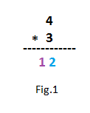
Step2: In this step, multiplication of the left digit of the multiplier and the right digit of the multiplicand is carried out. As in fig.2
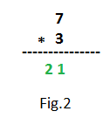
Step3: In this step, multiplication of the right digit of the multiplier and left digit of the multiplier is carried out. As in fig.3
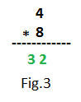
Step4: In this step, multiplication of the right of the multiplier and right digit of the multiplicand is carried out. As in fig.4
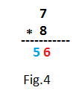
Step5: All calculations in above steps can be shown combine as in below fig.4
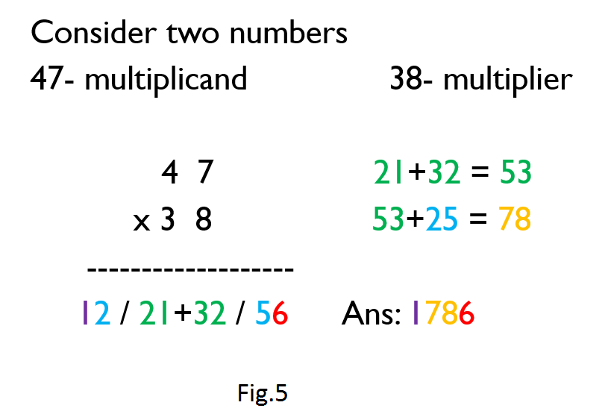
Step6: As shown in above fig.5, add the middle partial products which gives the sum of 53. Then make a new number using left digit of the result in step1 and right digit of the step4, which gives the new number as 25. Now adding the 53 and 25 gives the result of 78.
Step7: In this step, we get the final result. Make the right digit of the step4 as the 1st digit of the ans. Then, 7 and 8 of the result in step6 are the middle two numbers. And left digit of the result in step1 as right most digit of the ans. This gives the complete result as 1786.

III. Program Methodology
A. 4-bit Vedic Multiplier
In 4-bit multiplier, the two inputs will be of 4-bit binary numbers. Each two adjacent bits are indicated as different signals. Then the formed four signals (two signals of input and two signals of output) are multiplied with each other using 2-bit multiplier as the trick explained in Urdhava Tiryakbhyam Sutra. The middle products formed during the process are added with 4-bit look-ahead adder (as Look-ahead adder is faster than Ripple carry adder). Each result formed during the process is indicated by the different signal. The final result is formed by combining the signal as answer explained in Vedic mathematics trick. Therefore it requires 2-bit multiplier, half adder, 2-bit look-ahead adder, 4-bit look-ahead adder as basic building blocks of the multiplier. The block diagram of 4-bit Vedic multiplier is as follows:

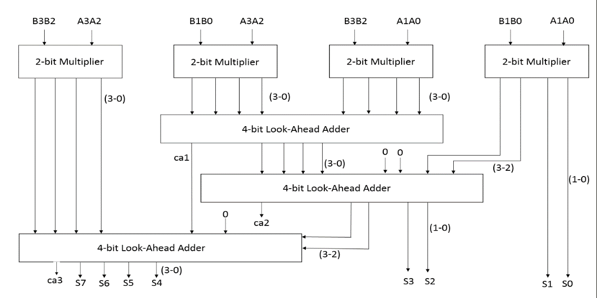
Fig.6

B. 8-bit Vedic Multiplier
As 4-bit Vedic multiplier is implemented similarly 8-bit multiplier or 16-bit, 32-bit, etc. can be implemented. In 8-bit multiplier the 8-bit of input and output is divided into 4-bit of input and output signals (as in 4-bit multiplier input and output are divided into 2-bit signals). Then the multiplication is carried out just analogous to 4-bit multiplier. Therefore it requires 2-bit multiplier, half adder, 2-bit look-ahead adder, 4-bit look-ahead adder, 4-bit multiplier, 8-bit look-ahead adder. The block diagram of 8-bit multiplier is shown below:
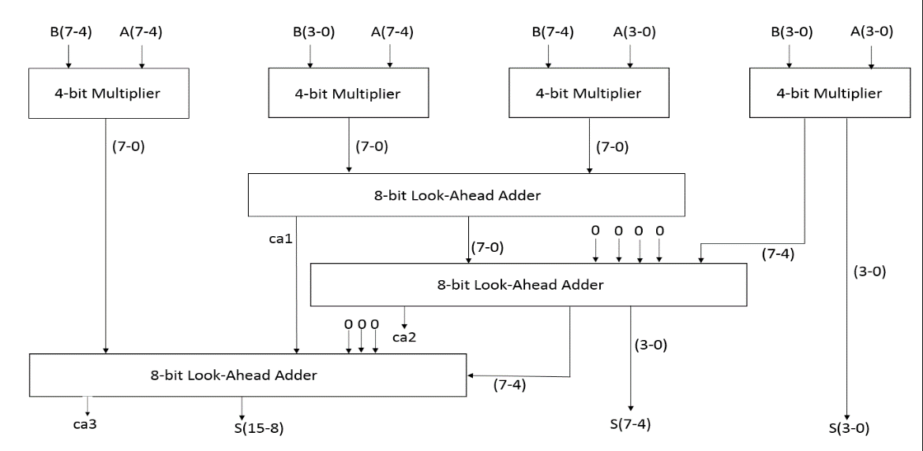
Fig.7
IV. Implementation
In this study, the algorithm is implemented in VHDL (Hardware Descriptive Language) and logic simulation is done in ISE Simulator. After gate level synthesis from high level behavioural or structural RTL HDL codes, basic schematics are optimised. The design is optimised for speed and area using Xilinx, Device Family: Spartan3e xc3s50-5pq208.

V. Simulation Result for 8×8 bit Multiplier

A. Description
A – 8-bit input (Multiplicand)
B – 8-bit input (Multiplier)
P – 16-bit output (Result)

B. Time Analysis
Method | Delay
Conventional Method | 29.549 ns
Proposed Vedic Method | 20.141 ns

C. Synthesis Report
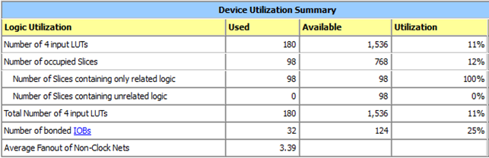
Fig.8
VI. Conclusion
Thus, design of multiplier using Vedic Mathematics is proved to be high speed, power consuming, low cost. It reduces the complexity of the design, increases the throughput.

References
- Jagadguru Swami Sri Bharati Krisna Tirthaji Maharaja, “Vedic Mathematics”, Motilal Banarasidas, Varanasi, India, 1986.
- Yogita Bansal, Charu Madhu, Pardeep Kaur, “High Speed Vedic Multiplier Designs”, IEEE 2014.
- Sumit Vaidya and Deepak Dandeka, “Delay-Power Performance Comparisons of Multipliers in VLSI Circuit Design”, IJCNC, July 2010.
- Poornima M, Shivaraj Kumar Patil, Shivukumar , Shridhar K P , Sanjay H, “Implementation of multiplier using Vedic Algorithm”, IJITEE, May 2013.
- Pushpalata Verma, K. K. Mehta” Implementation of an Efficient Multiplier based on Vedic Mathematics Using EDA Tool” International Journal of Engineering and Advanced Technology (IJEAT) ISSN: 2249 – 8958, Volume-1, Issue-5, June 2012.
- S.S.Kerur, Prakash Narchi, Jayashree C N, Harish M Kittur and Girish V A. “Implementation of Vedic Multiplier for Digital Signal” International conference on VLSI communication & instrumentation.
- Parth Mehta and Dhanashri Gawali, “Conventional versus Vedic mathematics method for Hardware implementation of a multiplier”, International conference on Advances in Computing, Control, and Telecommunication Technologies, pp. 640-642, 2009.
- Himanshu Thapliyal, “Vedic Mathematics for Faster Mental Calculations and High Speed VLSI Arithmetic”, Invited talk at IEEE Computer Society Student Chapter, University of South Florida, Tampa, FL, Nov 14 2008.
- Shripad Kulkarni, “Discrete Fourier Transform (DFT) by using Vedic Mathematics”Papers on implementation of DSP algorithms/VLSI structures using Vedic Mathematics, 2006, www.edaindia.com, IC Design portal.M. King, B. Zhu, and S. Tang, “Optimal path planning,” Mobile Robots, vol. 8, no. 2, pp. 520-531, March 2001.

