Accident Locater and Service Provider Using ARM7 and GPS, GSM Module.

Poonam Bhajipale K.D.K College Of Engineering bhajipalepoonam@gmail.com
Rinku Tidke K.D.K College Of Engineering rinkutidke123@gmail.com
Mangesh Jambhulkar K.D.K College Of Engineering mangeshjambhulkar12@gmail.com
Aditya Banpurkar K.D.K College Of Engineering adityabanpurkar@gmail.com

Prof.V.N.Mahawadiwar K.D.K College Of Engineering vivek_mahawadiwar@rediffmail.com

Abstract - Security in travel is primary concern for everyone. This Project describes a design of effective alarm system that can monitor an automotive / vehicle / car condition in traveling. This project is designed to inform about an accident that is occurred to a vehicle to the family members of the traveling persons. This project uses a piezo-electric sensor which can detect the abrupt vibration when an accident is occurred. This sends a signal to ARM7. This Project presents an automatic vehicle accident detection system using GPS and GSM modems. The system can be interconnected with the car alarm system and alert the owner on his mobile phone. This detection and messaging system is composed of a GPS receiver, Microcontroller and a GSM Modem. GPS Receiver gets the location information from satellites in the form of latitude and longitude. The ARM7 processes this information and this processed information is sent to the user/owner using GSM modem A GSM modem is interfaced to the MCU. The GSM modem sends an SMS to the predefined mobile number and informs about this accident. This enable it to monitor the accident situations and it can immediately alerts the police/ambulance service with the location of accident.

Index Terms–ARM7,GSM and GPS module ,Sensors, Accident Detection,IC2 protocol.

Introduction
An embedded system is a special-purpose computer system designed to perform a dedicated function. , a number of approaches to provide security and safety through monitoring the vehicle's real time precise positioning and information using different technologies have been proposed. A good survey of using GPS, GSM and GIS has been provided in [ 1 ]. The general mechanism is to provide the real time geograph- ical position of a vehicle using GPS receiver and send this information to GSM center through configurable software, this is all done by the monitoring center which is working as a control unit that is connected not only by an optical cable but also connected wirelessly through TCP/IP protocols.

The monitoring center distributes the data to the client in an understandable format and it also stores the travelling records and displays the real time information about vehicle on electronic map through GPS system [ 1 ]. Another approach is that vehicle terminal includes a GPS receiver which extracts information about position through GPS satellites and sends it through GSM network and to the control center which reads the information, process it through GPS management system and saves it in the data base system and on user demand displays it on electronic map via MapX tool [ 2 ].

A different approach is proposed by integrating GPS and GSM/GPRS transmission technologies .The basic idea is to localize the vehicle system by receiving the real time position of the vehicle through GPS and send the information through GSM module via SMS service with an added feature of GPRS transmission to the monitoring center through usage of internet [ 7 ]. Using AT89S52, this project has been designed. It used EEPROM to store the phone numbers.

Working Of System
The ARM 7 processor is of 32 bit processor and it is use for high end application. Here we apply +5v, 7mA regulated power supply. The LCD screen is interfaced with processor for displaying readings. The piezoelectric sensor is used which measure pressure, acceleration, strain etc. But here we measure the abrupt change in vibrations when an accident occur.

MEMS sensor i.e. this number can be changed at any time by user. This number is stored in EEPROM i.e. electrically erasable programmable read only memory. Microelectro-mechanical sensor which gives the positional view in 3 dimensions. With the help of GSM module, we can provide an SMS to the numbers which are stored in it memory. The data stored in EEPROM can not be erase even though system gets off.

The GSM modem and GPS modem is interface with the ARM 7 processor through MAX232. GSM modem i.e. Global system for mobile gives the SMS on predefined mobile number .This type of message will be displayed on the mobile screen after accident occurred. It will give the readings of longitude as well as latitude on mobile screen. GPS modem Global positioning system which gives the exact position of accident spot so that the emergency services can be provide in minimum time. Here we use IIC protocol i.e. Inter integrated circuit protocol which is use for the communication between the components which are placed in circuit board.

Fig.1 Working of the system

ARM7
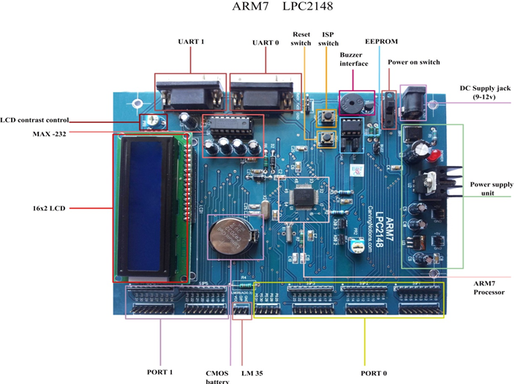 Fig.2 ARM7(LPC2148 development board)

The ARM7 is part of the Advanced RISC Machines (ARM) family of general purpose 32-bit microprocessors, which offer very low power consumption and price for high performance devices. The architecture is based on Reduced Instruction Set Computer (RISC) principles, and the instruction set and related decode mechanism are much simpler in comparison with micro-programmed Complex Instruction Set Computers. This results in a high instruction throughput and impressive real-time interrupt response from a small and cost-effective chip.

GSM Module

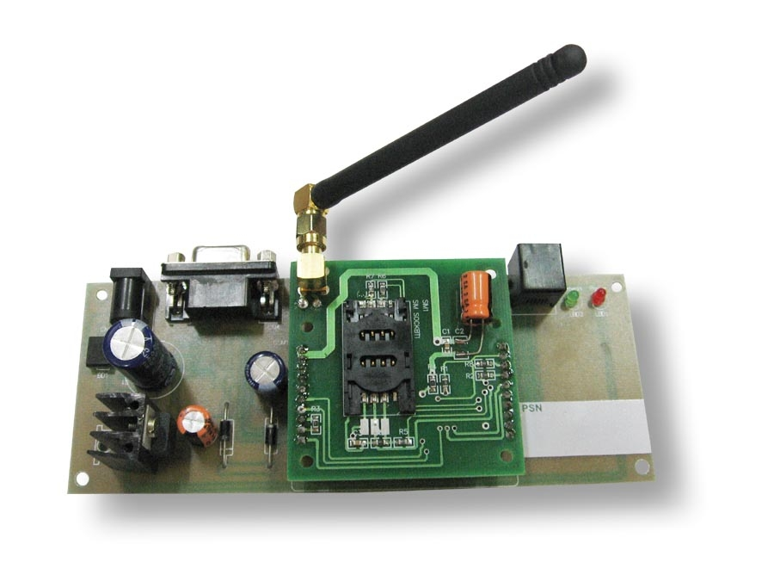
Fig.3 GSM Module

It is a globally accepted standard for digital cellular communication. GSM is the name of standardization group established in 1982 to create a common European mobile telephone standard that would formulate specifications for a pan-European mobile cellular radio system operating at 900MHZ.

V. GPS module
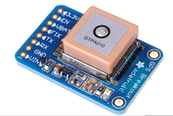

Fig.4 GPS module

The Global Positioning System (GPS) is a U.S. space-based global navigation satellite system. It provides reliable positioning, navigation, and timing services to worldwide users on a continuous basis in all weather, day and night, anywhere on or near the Earth which has an unobstructed view of four or more GPS satellites.

GPS is made up of three segments: Space, Control and User. The Space Segment is composed of 24 to 32 satellites in Medium Earth Orbit and also includes the boosters required to launch them into orbit. The Control Segment is composed of a Master Control Station, an Alternate Master Control Station, and a host of dedicated and shared Ground Antennas and Monitor Stations. The User Segment is composed of hundreds of thousands of U.S. and allied military users of the secure GPS Precise Positioning Service, and tens of millions of civil, commercial and scientific users of the Standard Positioning Service (see GPS navigation devices).

VI. mems sensor mma 7260 q
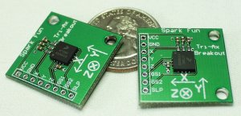

Fig.5 MEMS Sensor MMA 7260 Q
The MMA7260Q is 3-axis accelerometer. An accelerometer measures acceleration (change in speed) of anything that it's mounted on. Single axis accelerometers measure acceleration in only one direction. Dual-axis accelerometers are the most common measure acceleration in two directions, perpendicular to each other. Three-axis accelerometers measure acceleration in three directions.
Accelerometers are very handy for measuring the orientation of an object relative to the earth, because gravity causes all objects to accelerate towards the earth. A two-axis accelerometer can be used to measure how level an object is. With a three-axis accelerometer, you can measure an object's acceleration in every direction.

Acknowledgment
With profound feeling of immense gratitude and affection, we would like to thank our guide Prof. V. N. Mahawadiwar and Prof. V. V. Chakole , Dept. of Electronics Engineering for his continuous support, motivation, enthusiasm and guidance. His encouragement, supervision with constructive criticism and confidence enabled us to complete this paper.

References
- Apurva Mane et al Vehicle Collision Detection and Remote Alarm Device using Arduino 2228 International Journal of Current Engineering and Technology, Vol.4,No.3 (June 2014)
- Mrs.RamyaKulandaivel, P.Ponmalar, B.Geetha, G.Saranya, "Vehicle Collision Recognition and Monitoring System Based on AVR Platform", International Journal of Engineering Research and General Science Volume 2, Issue 6, October-November, 2014
- Prof. Sagar P. More, Prof. P. D. Dudhat, Prof. Mrs. S. P. Rathod ,"Vehicle Accident Detection System Using Sms Application And Gsm" (Research Article Impact Factor, 2014; Volume2).
- Saurabh S. Chakole, Vivek R. Kapur and Y.A.Suryawanshi,(2013), "ARM Hardware Platform for Vehicular Monitoring and Tracking", IEEE proc.CSNT.
- Varsha Gaud and V. Padmja, “Vehicle Accident Automatic Detection and Remote Alarm Device”, IJRES Vol.1 ,No.2 ,(2012.)
- I2c – Inter-Ic Communications Lectures 28, October 26-29, 2012.
- Ioan Lita, Ion Bogdan Cioc, Daniel Alexandru Visan, Mohammad A. Al-Khedher, "Hybrid GPS-GSM Localization of AutomobileTracking System", International Journal of Computer Science & Information Technology ,Vol 3, No 6, Dec 2011.
- Wang Wei and Fan Hanbo, Traffic accident automatic detection and remote alarm device", IEEE proc.ICEICE (2011).
- S. Rauscher, G. Messner, P. Baur, J. Augenstein, K. Digges, E. Perdeck, G. Bahouth, and O. Pieske, "Enhanced Automatic Collision Notification System- Improved Rescue Care Due To Injury Prediction", First Field Experience, (2009).
- "Microcontroller and embedded system" by muhammad-mazidi.

- A. Lie, C. Tingvall, M. Krafft, and A. Kullgren, "The effectiveness of electronic stability control (ESC) in reducing real life crashes and injuries", "Traffic Injury Prevention",(2006).
- "Working Principles Of MEMS And Microsystems" (Lectures On Mems And Microsystems Design And Manufacture)

