Li-Fi Technology

Auther 1 : Sneha Ramteke K.D.K.C.O.E. Nagpur Sneharamteke35@gmail.com
Auther2 : Trushi Nandgavli K.D.K.C.O.E. Nagpur

Abstract - Whether you’re using wireless internet in a coffee shop, stealing it from the guy next door, or competing for bandwidth at a conference, you’ve probably gotten frustrated at the slow speeds you face when more than one device is tapped into the network. As more and more people and their many devices access wireless internet, clogged airwaves are going to make it increasingly difficult to latch onto a reliable signal.
But radio waves are just one part of the spectrum that can carry our data. What if we could use other waves to surf the internet? One German physicist, DR. Harald Haas, has come up with a solution he calls “Data Through Illumination”—taking the fiber out of fiber optics by sending data through an LED light bulb that varies in intensity faster than the human eye can fol. It’s the same idea behind infrared remote controls, but far more powerful.
Haas says his invention, which he calls D-Light, can produce data rates faster than 10 megabits per second, which is speedier than your average bro adband connection. He envisions a future where data for laptops, smartphones, and tablets is transmitted through the light in a room. And security would be a snap—if you can’t see the light, you can’t access the data.
Li-Fi is a VLC, visible light communication, technology developed by a team of scientists including Dr Gordon Povey, Prof. Harald Haas and Dr Mostafa Afgani at the University of Edinburgh. The term Li-Fi was coined by Prof. Haas when he amazed people by streaming high definition video from a standard LED lamp, at TED Global in July 2011. Li-Fi is now part of the Visible Light Communications (VLC) PAN IEEE 802.15.7 standard.
“Li-Fi is typically implemented using white LED light bulbs. These devices are normally used for illumination by applying a constant current through the LED. However, by fast and subtle variations of the current, the optical output can be made to vary at extremely high speeds. Unseen by the human eye, this variation is used to carry high-speed data,” says Dr Povey, , Product Manager of the University of Edinburgh's Li-Fi Program ‘D-Light Project’.

Introduction
In simple terms, Li-Fi can be thought of as a light-based Wi-Fi. That is, it uses light instead of radio waves to transmit information. And instead of Wi-Fi modems, Li-Fi would use transceiver fitted LED lamps that can light a room as well as transmit and receive information. Since simple light bulbs are used, there can technically be any number of access points.
This technology uses a part of the electromagnetic spectrum that is still not greatly utilized- The Visible Spectrum. Light is in fact very much part of our lives for millions and millions of years and does not have any major ill effect. Moreover there is 10,000 times more space available in this spectrum and just counting on the bulbs in use, it also multiplies to 10,000 times more availability as an infrastructure, globally.
It is possible to encode data in the light by varying the rate at which the LEDs flicker on and off to give different strings of 1s and 0s. The LED intensity is modulated so rapidly that human eyes cannot notice, so the output appears constant.
More sophisticated techniques could dramatically increase VLC data rates. Teams at the University of Oxford and the University of Edinburgh are focusing on parallel data transmission using arrays of LEDs, where each LED transmits a different data stream. Other groups are using mixtures of red, green and blue LEDs to alter the light's frequency, with each frequency encoding a different data channel.
Li-Fi, as it has been dubbed, has already achieved blisteringly high speeds in the lab. Researchers at the Heinrich Hertz Institute in Berlin, Germany, have reached data rates of over 500 megabytes per second using a standard white-light LED. Haas has set up a spin-off firm to sell a consumer VLC transmitter that is due for launch next year. It is capable of transmitting data at 100 MB/s - faster than most UK broadband connections.

Genesis of Li-Fi
Harald Haas, a professor at the University of Edinburgh who began his research in the field in 2004, gave a debut demonstration of what he called a Li-Fi prototype at the TED Global conference in Edinburgh on 12th July 2011. He used a table lamp with an LED bulb to transmit a video of blooming flowers that was then projected onto a screen behind him.

During the event he periodically blocked the light from lamp to prove that the lamp was indeed the source of incoming data. At TED Global, Haas demonstrated a data rate of transmission of around 10Mbps -- comparable to a fairly good UK broadband connection. Two months later he achieved 123Mbps.

How Li-Fi Works?

Li-Fi is typically implemented using white LED light bulbs at the downlink transmitter. These devices are normally used for illumination only by applying a constant current. However, by fast and subtle variations of the current, the optical output can be made to vary at extremely high speeds.
This very property of optical current is used in Li-Fi setup. The operational procedure is very simple-, if the LED is on, you transmit a digital 1, if it’s off you transmit a 0. The LEDs can be switched on and off very quickly, which gives nice opportunities for transmitting data. Hence all that is required is some LEDs and a controller that code data into those LEDs. All one has to do is to vary the rate at which the LED’s flicker depending upon the data we want to encode.
Further enhancements can be made in this method, like using an array of LEDs for parallel data transmission, or using mixtures of red, green and blue LEDs to alter the light’s frequency with each frequency encoding a different data channel. Such advancements promise a theoretical speed of 10 Gbps – meaning one can download a full high-definition film in just 30 seconds.

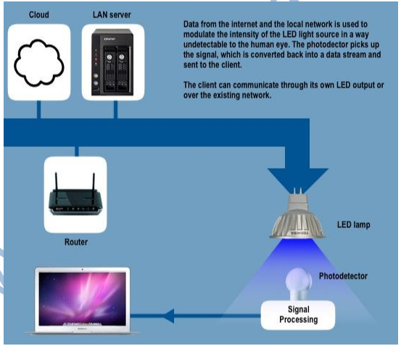

TTo further get a grasp of Li-Fi consider an IR remote.(fig 3.3). It sends a single data stream of bits at the rate of 10,000-20,000 bps. Now replace the IR LED with a Light Box containing a large LED array. This system, fig 3.4, is capable of sending thousands of such streams at very fast rate.

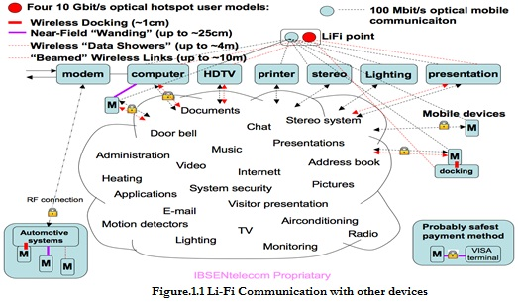

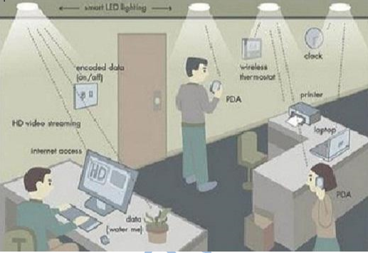

Light is inherently safe and can be used in places where radio frequency communication is often deemed problematic, such as in aircraft cabins or hospitals. So visible light communication not only has the potential to solve the problem of lack of spectrum space, but can also enable novel application. The visible light spectrum is unused, it's not regulated, and can be used for communication at very high speeds.

Application of Li-Fi Technology

- You Might Just Live Longer
You Might Just Live Longer For a long time, med- ical technology has lagged behind the rest of the wireless world. Operating rooms do not allow Wi-Fi over radiation concerns, and there is also that whole lack of dedicated spectrum. While Wi-Fi is in place in many hospitals, interference from cell phones and computers can block signals from monitoring equipment.
Li-Fi solves both problems: lights are not only allowed in operating rooms, but tend to be the most glaring (punintended) fixtures in the room. And, as Haas mentions in his TED Talk, Li-Fi has 10,000 times the spectrum of Wi-Fi, so maybe we can, I dunno, delegate red light to priority medical data. Code Red!

- Airlines
Airline Wi-Fi. Ugh. Nothing says captive audience like having to pay for the "service" of dialup speed Wi-Fi on the plane. And don’t get me started on the pricing.
The best I’ve heard so far is that passengers will "soon" be offered a "high-speed like" connection on some airlines. United is planning on speeds as high as 9.8 Mbps per plane.
Uh, I have twice that capacity in my living room. And at the same price as checking a bag, I expect it. Li-Fi could easily introduce that sort of speed to each seat's reading light. I’ll be the guy go Wing next to you. Its better than listening to you tell me about your wildly successful son, ma’am.

- Smarter Power Plants
Wi-Fi and many other radiation types are bad for sensitive areas. Like those surrounding power plants. But power plants need fast, inter-connected data systems to monitor things like demand, grid integrity and (in nuclear plants) core temperature. The savings from proper monitoring at a single power plant can add up to hundreds of thousands of dollars.
Li-Fi could offer safe, abundant connectivity for all areas of these sensitive locations. Not only would this save money related to currently implemented solutions, but the draw on a power plant’s own reserves could be lessened if they haven’t yet converted to LE D lighting.
4. Undersea Awesomeness
Underwater ROVs, those favourite toys of treasure seekers and James Cameron, operate from large cables that supply their power and allow them to receive signals from their pilots above. ROVs work great, except when the tether isn’t long enough to explore an area, or when it gets stuck on something.
If their wires were cut and replaced with light —say from a submerged, high-powered lamp — then they would be much freer to explore. They could also use their headlamps to communicate with each other, processing data autonomously and referring findings periodically back to the surface, all the while obtaining their next batch of orders.

5. It Could Keep You Informed and Save Lives
Say there’s an earthquake in New York. Or a hurricane. Take your pick —it’s a wacky city. The average New Yorker may not know what the protocols are for those kinds of disasters. Until they pass under a street light, that is.
Remember, with Li-Fi, if there’s light, you’re online. Subway stations and tunnels, common dead zones for most emergency communications, pose no obstruction. Plus, in times less stressing cities could opt to provide cheap high speed Web access to every street corner.

How it is different?
Li-Fi technology is based on LEDs for the transfer of data. The transfer of the data can be with the help of all kinds of light, no matter the part of the spectrum that they belong. That is, the light can belong to the invisible, ultraviolet or the visible part of the spectrum. Also, the speed of the internet is incredibly high and you can download movies, games, music etc in just a few minutes with the help of this technology.
Also, the technology removes limitations that have been put on the user by the Wi-Fi. You no more need to be in a region that is Wi-Fi enabled to have access to the internet. You can simply stand under any form of light and surf the internet as the connection is made in case of any light presence. There cannot be anything better than this technology.

Uses In Various Areae
Can be used in the places where it is difficult to lay the optical fiber like hospitals. In operation theatre Li-Fi can be used for modern medical instruments. In traffic signals Li-Fi can be used which will communicate with the LED lights of the cars and accident numbers can be decreased.
Thousand and millions of street lamps can be transferred to Li-Fi lamps to transfer data. In aircraft Li-Fi can be used for data transmission .It can be used in petroleum or chemical plants where other transmission or frequencies could be hazardous.

Advantages of Li-Fi
• Li-Fi can solve problems related to the insufficiency of radio frequency bandwidth because this technology uses Visible light spectrum that has still not been greatly utilized.
• High data transmission rates of up to 10Gbps can be achieved.
• Since, light cannot penetrate walls, it provides privacy and security that Wi-Fi cannot.
• Li-Fi has low implementation and maintenance costs.
• It is safe for humans since light, unlike radio frequencies, cannot penetrate human body. Hence, concerns of cell mutation are mitigated.

Disadvantages of Li-Fi
• Light can't pass through objects.
• A major challenge facing Li-Fi is how the receiving device will transmit back to transmitter.
• High installation cost of the VLC systems.
• Interferences from external light sources like sun, light, normal bulbs, opaque materials

VII. Conclusion
The possibilities are numerous and can be explored further. If his technology can be put into practical use, every bulb can be used something like a Wi-Fi hotspot to transmit wireless data and we will proceed toward the cleaner, greener, safer and brighter future.
The concept of Li-Fi is currently attracting a great deal of interest, not least because it may offer a genuine and very efficient alternative to radio-based wireless. As a growing number of people and their many devices access wireless internet, the airwaves are becoming increasingly clogged, making it more and more difficult to get a reliable, high-speed signal.
This may solve issues such as the shortage of radio-frequency bandwidth and also allow internet where traditional radio based wireless isn’t allowed such as aircraft or hospitals. One of the shortcomings however is that it only work in direct line of sight.

References
- Dr. Y.P.Singh, ”Critical Technical Aspect and Extensive Research Study of the Light Fidelity” International Journal of IT, Engineering and Applied Sciences Research(IJIEASR),Volume 2, No. 9,
- M. Thanigavel “Li-fi Technology in Wireless Communication”, International Journal of Engineering Research & Technology (IJERT),ISSN: 2278-0181,Vol. 2 .

