Automatic Scheduler for Farmer

Prajwal Shinde , K.D.K College of Engineering, Nagpur prajwal2341995@gmail.com
Sumeet Nikhare K.D.K College of Engineering, Nagpur snsumeetnikhare7@gmail.com
Prof. J S Gawai, K.D.K College of Engineering, Nagpur jyotsna12.gawai@gmail.com

Abstract - The farmers working in the farm land are solely dependent on the rain and bore wells for irrigation of the land. Even if the farm land has a water-pump, manual intervention by farmers is required to turn the pump on/off whenever needed. The aim of this project is to minimize this manual intervention by the farmers. Second main purposes of the automated scheduler are due to the high level precision of the device, there is no un-planned usage of water, a lot of water is saved from being wasted. This also gives much needed rest to the farmers, as they don’t have to go and turn the pump on/off manually.
keywords- Irrigation, Scheduler, GSM, Agricultural ,Advantages.

Introduction

India is basically an agricultural nation, and most of its income depends on the agricultural productivity. With the speedy development of agriculture in India, many automatic technologies have been introduced into agricultural productions.The farmer’s life is full of struggle, hard work, they always spend their lots of time in field.

In the world of advance electronics, life of human beings should be simpler hence to make a life simpler and convenient; we are making “AUTOMATIC SCHEDULER FOR FARMER”.

The main idea behind the proposed architecture is to design system, which would be used as a platform which provides the services needed to perform remote control of agricultural devices. The farmer should be able to on/off the motor. Many times farmer misses their farming tasks because he/she is not able to remember all the activities and their correct timing on which it is necessary to perform that activity. This system should provide reminder to the user so that their farming activity will take place on time and the motor will switch on and off automatically as per time mentioned in the message.

Overview
In rural area it is very difficult for the farmer to go and switch ON and OFF the motor in a very late night. The new technology is introduced from which the motor can be operate by using GSM (message service). The farmers can switch ON and OFF the motor by sending the command message to the controller connected to the motor from anywhere in world. We can switch ON and OFF the motor by Instant ON and Instant OFF command and even by scheduling the controller through the mobile phone.
The paper titled by “Scheduling, Controlling and Monitoring of Agricultural Devices Using Android Application” proposes a new architecture for remote control of agriculture devices and provides security to the farm through online-streaming. Proposed system makes use of few technologies which allow remote control of the agricultural motor, pesticides thereby making a farmer's work much easier and less dependent of the conditions present.
The paper titled by “SURVEY ON WEB BASED INTELLIGENT IRRIGATION SYSTEM IN WIRELESS SESNSOR NETWORK” presents a design Web based intelligent drip irrigation system which is one and only solution to water management and precision agriculture. In web based system we can control water supply using solenoid valve. This whole system is micro control based and can be operated from remote location through web based.
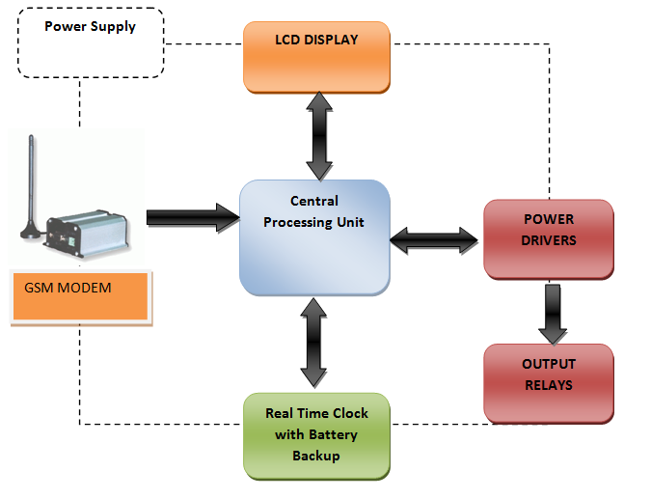
Figure-1 Block diagram of automatic scheduler for farmer

GSM MODEM
A GSM modem is a wireless modem that works with a GSM wireless network. A wireless modem behaves like a dial-up modem. The main computers use AT commands to control modems. Both GSM modems and dial-up modems support a common set of standard AT commands modem sends and receives data through radio waves. Computers use AT commands to control modems. Both GSM modems and dial-up modems support a common set of standard AT commands
The GSM modem works on AT commands. Commands which we will use in our project are [8]
@M<Mobile_Number># to register the mobile number.
@O0# Mode 0
@O1# Mode 1
@O2# Mode 2
@O3# Mode 3
@O4# Mode 4
@S<Mode><Time># Schedule Mode

CONTROLLER
Micro controller IC 89c52 is heart of our work. This micro controller IC having number of advantages:

    - Internal 64K bytes of electrically erasable programmable read only memory for feeding program so that there is no need of external EPROM.
    - Four 8 bit i/p o/p port out of which we use one port to read ADC o/p other port is use to connect relay and display for operating devices.
    - Operating voltage of 3.5 to 6v D.C. This is easily available by using voltage regulator IC.
    - Internal 128 byte RAM to store temporally storage of data. In which we can feed took up table to turn ON/OFF relay.
    - Two 16 bit time/counter are present for timing and counting purpose.
    - 4 external and 2 internal interrupt are available.

WORKING
Automatic scheduler for farmer with a GSM modem is able to control the switch during certain circumstance like late night or whenever the operator is away from the fields, etc. this can be done by the help of GSM modem. The operator can register his mobile number in the GSM modem by using the specified command. A GPS receiver can shorten its startup time by comparing the current time, according to its RTC, with the time at which it last had a valid signal. If it has been less than a few hours, then the previous ephemeris is still usable. RTCs often have an alternate source of power, so they can continue to keep time while the primary source of power is off or unavailable. This alternate source of power is normally a lithium battery in older systems, but some newer systems use a super capacitor, because they are rechargeable and can be soldered. The alternate power source can also supply power to battery backed RAM.[9]

Instant ON and OFF
The motor can be switch ON and OFF directly by the command given by the mobile phone.
If the farmer wants to switch ON the motor the he will send the command i.e. @ON#. The feedback message will be receive to the farmer conforming that the motor is ON.
Similarly, if the farmer want to switch OFF the motor then he will the send the command i.e. @OFF# and again the feedback message will be receive to the farmer that the motor is OFF.

Scheduling
The farmer can switch ON and OFF the motor at any time . he can set the schedule for the motor whenever he wants to switch ON or OFF. For schedule the motor farmer will send the command. To perform this operation farmer will send the command to GSM modem to either switch ON or OFF the motor including the control of flow of water using solenoid valve.

Flow Control
Irrigation is the need of farmer to save water resources which is essential and need to use in minimum quantity because it is not free forever to use. In every season crops require different amount of water for irrigation and manage the level of water. We have four different modes to perform this operation.
Mode 1 with 25% -
If farmer want to switch ON the motor then the farmer will send the command i.e. @S1time#.the motor will start with 25% at the mentioned time in the message.
Mode 2 with 50% -
If farmer want to switch ON the motor then the farmer will send the command i.e. @S2time#.the motor will start with 25% at the mentioned time in the message.
Mode 3 with 75% -
If farmer want to switch ON the motor then the farmer will send the command i.e. @S3time#.the motor will start with 25% at the mentioned time in the message.
Mode 4 with 100% -
If farmer want to switch ON the motor then the farmer will send the command i.e. @S4time#.the motor will start with 25% at the mentioned time in the message.
Similarly, the motor can be schedule of off by sending the command to the controller i.e. @S0time#. The motor will get OFF.

By using these commands we can control the flow and switch ON and OFF the motor and this is the motive of our project.

Advantages
By using GSM modem we can operate from anywhere via sending message to the controller i.e. motor ON or motor OFF. Feedback message of every command is given by the controller via SMS to the operator. For ex. Motor started at 11pm with 25% and gradual increase in the percentage can be done accordingly. By the use of relay, user can operate multiple devices at a time that will save time and mechanical power too.
Mobile number can be register and change easily. A user can also register more than one mobile in the controller and with the flexibility of the controller we can easily change the number anytime we want. Saves the water. As we are controlling water supply a particular quantity of water is send in the given schedule, this method saves water in the huge quantity and even save it for the future use. Farmer can also work with this some advance technology easily as it is a user friendly technology.

- APPLICATION
It can be used by the farmers as irrigation facilities in the farms for the cultivation purpose. It Can also be used in a factory for various purposes. It Can be used in a municipal corporation for water supply. It Can be used in Public Park for watering. Also can be used for industrial purpose as well as household purpose too.

References

- Melaku Nigus, Abubeker Seid, Dejene Zewude, “Development of Green Energy Automatic Plant Irrigator” in Debre Berhan University, Volume 5, Issue 8, August 2015, ISSN: 2277 128X

- H.T.Ingale, N.N.Kasat, “Automated Irrigation System”, International Journal of Engineering Research and Development, Volume 4, Issue 11 (November 2012), PP. 51-54

- Mukesh Choudhary, Sumeet Dhone, Akshay Jadhav, Chetan Dhandal, Prof. J. M. Nighot, “Scheduling, Controlling and Monitoring of Agricultural Devices Using Android Application”, International Journal of Advanced Research in Computer Engineering & Technology (IJARCET) Volume 4 Issue 4, April 2015

- Aniket H. Hade, Dr. M.K. Sengupta, “Automatic control of drip irrigation system and monitoring soil by wireless”, IOSR Journal of Agriculture and Veterinary Science (IOSR-JAVS) , Volume 7, Issue 4 Ver. III (Apr. 2014), PP 57-61

- Prashant B. Yahide, Prof. S. A. Jain, Prof. Manish Giri, “Survey on web based intelligent irrigation system in wireless sensor network”, Multidisciplinary Journal of Research in Engineering and Technology, Volume 2, Issue 1, Pg.375 -385
- R. Suresh, S .Gopinath, K. Govindaraju, T. Devika, N. Suthanthira Vanitha, “GSM based Automated Irrigation Control using Raingun Irrigation System”, International Journal of Advanced Research in Computer and Communication Engineering Vol. 3, Issue 2, February 2014

- Data Sheet1: Atmel AT89s51 1919B–MICRO–11/03

- Data Sheet2: SIM300 AT Commands Set Designed by SIMCOM version 01.062006-10-16 SIM300_ATC_V1.06

- Data Sheet3: Texas instruments: TMS320VC5503/5507/5509 Real-Time Clock (RTC) Literature no: SPRU594B (JUNE 2004).

- Data Sheet4: Positron technologies, GSM SIM 300 Module, product id PT0006

.

