Design of High Speed Multiplier Using Vedic Mathematics

Author 1 : Ms. Surabhi Choudhary
Author2 : Ms. Tejasvini Bhaware
Author 3: Ms. Kalyani Dhawas

Abstract - Machine plays a vital role in the plant. Maintenance is a very important factor for a machine, which is required regularly. Vibration monitoring and analysis is a predictive maintenance technique by which the faults can be detected in the machines. In this work, data acquisition system, signal analysis and dot net are used to detect various faults which occur in the machine. As a result, the necessary control action can be taken on the machine in advance.
Machine Vibration analysis and motor current spectral analysis have recently being widely used for the purpose of condition monitoring and detection of mechanical faults in induction machines. Although the current is as good as the vibration in indicating the presence of the fault but the most important, is that the vibration sensors measures the absolute moment of the motor while the current reflects the relative moment for processing and analysis of vibration signal in time domain. Spectrum analysis might provide more accurate information about the vibration signal type, signal fault region and fault extent as compared to time domain analysis.

Block Diagram
An LVDT accelerometer is mounted on the motor. The vibration are sensed and send to inbuilt ADC of the PIC microcontroller. The vibrations in all the three namely X,Y,Z axes are displayed on the LCD. RS232 is used to interface with the PC. Here the values of vibration are displayed in X,Y,Z, direction and the graph is plotted simultaneously.
During fault condition, the vibrations increase. After increase beyond specified limit, the relay trips the motor. Thus, prevents the loss. Power supply is provided to the relay and PIC microcontroller.
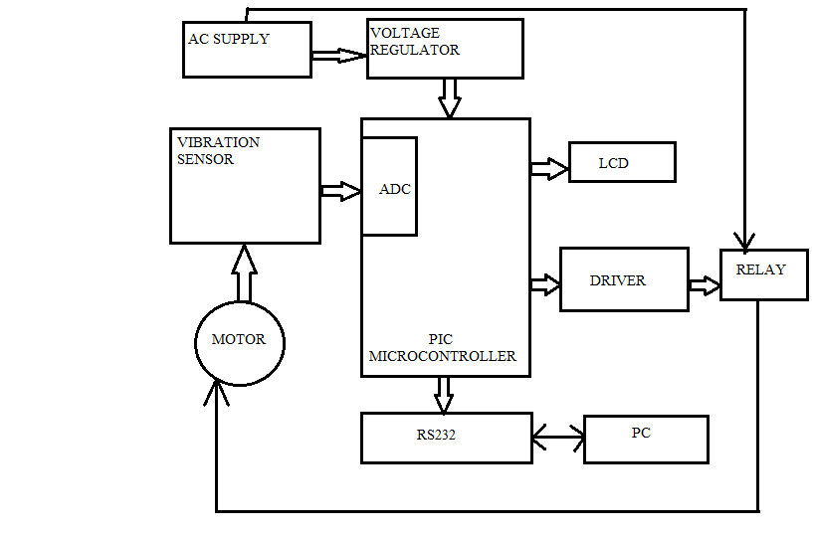

Circuit Diagram
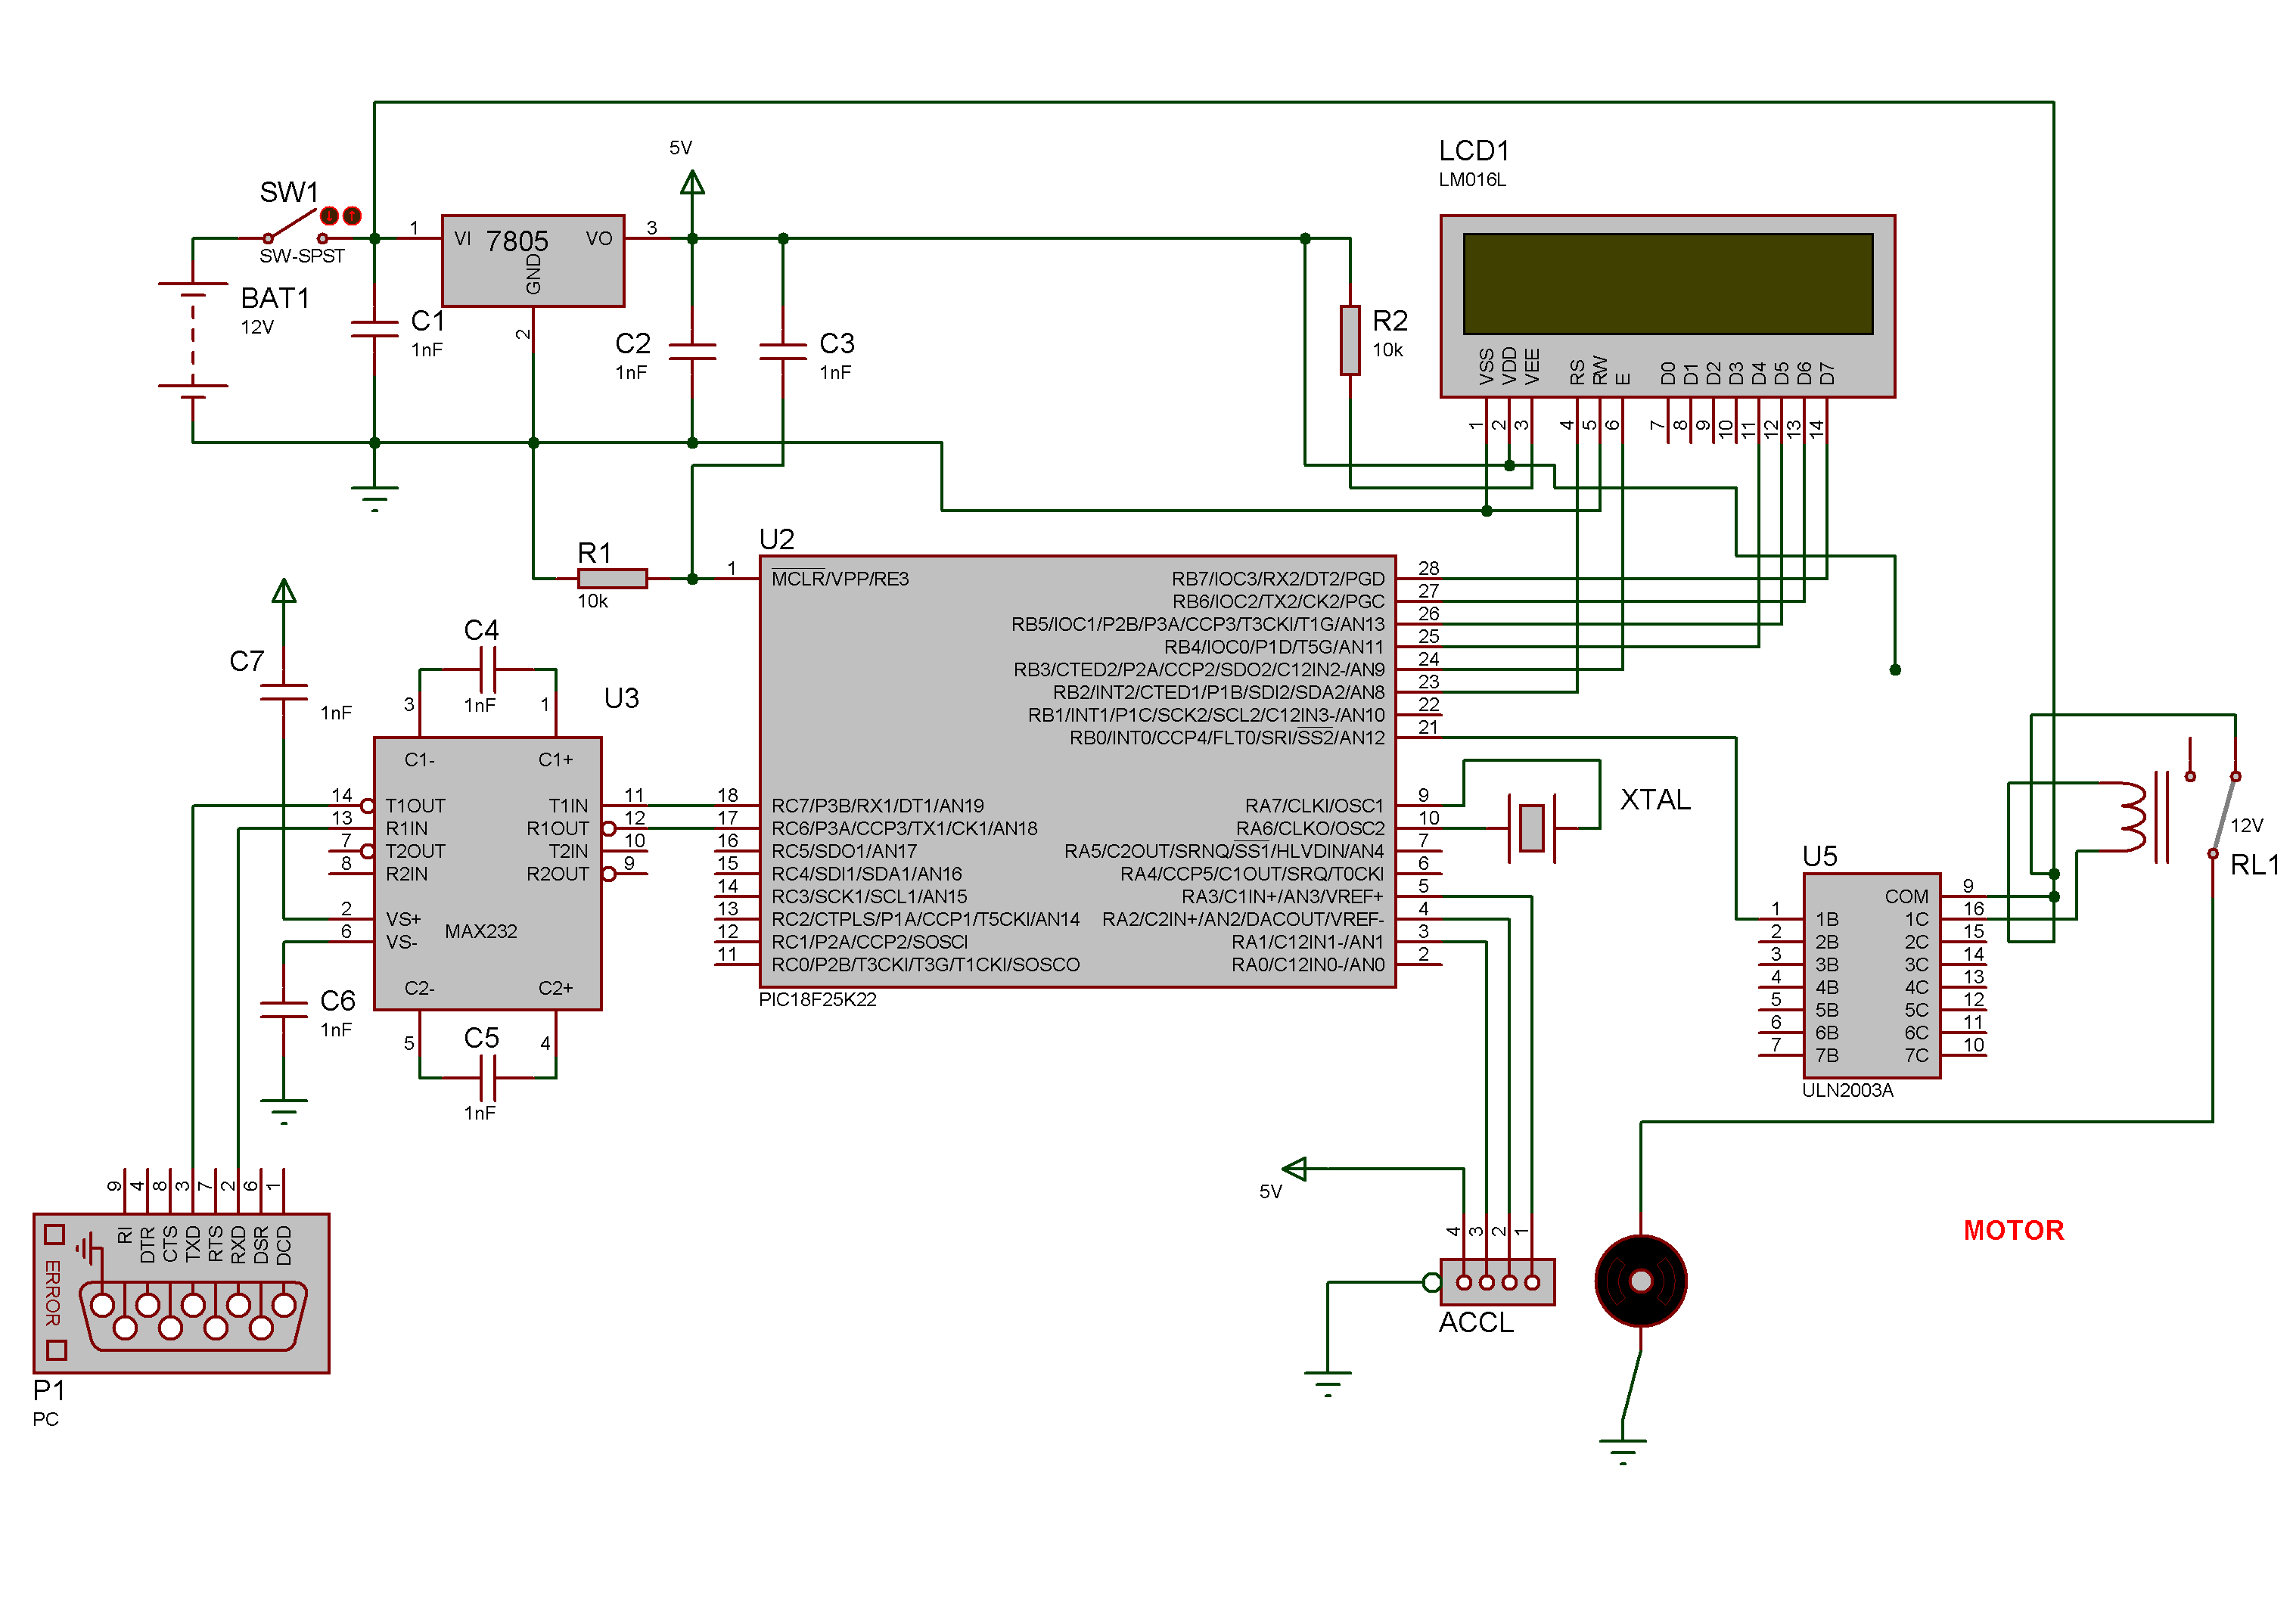

Literature Review
The risk of motor fault can remarkably induce a serious danger to the normal life and productive activities of the people. It may reduce costly expense downtime if signs of failure can be distinguished availably. Vibration is one of the key indicators of quality of motor, when they are at steady work, the vibration spectrum has certain characteristics, if their internal fails, their corresponding vibration spectrum or other parameters will also change. Over the past 20 years, the virtual instrument technology has made considerable development and been widely used in areas such as engineering tests. Compared with traditional instruments, virtual instrumentation technology has several advantages.

Accelerometer
An accelerometer is an electromechanical device that will measure acceleration forces. These forces may be static, like the constant force of gravity pulling at your feet, or they could be dynamic - caused by moving or vibrating the accelerometer. It is a device that measures the vibration, or acceleration of motion of a structure.

Microcontroller
The microcontroller that has been used for this project is from PIC series. PIC microcontroller is the first RISC based microcontroller fabricated in CMOS that uses separate bus for instruction and data allowing simultaneous access of program and data memory. The main advantage of CMOS and RISC combination is low power consumption resulting in a very small chip size with a small pin count. The main advantage of CMOS is that it has immunity to noise than other fabrication techniques.
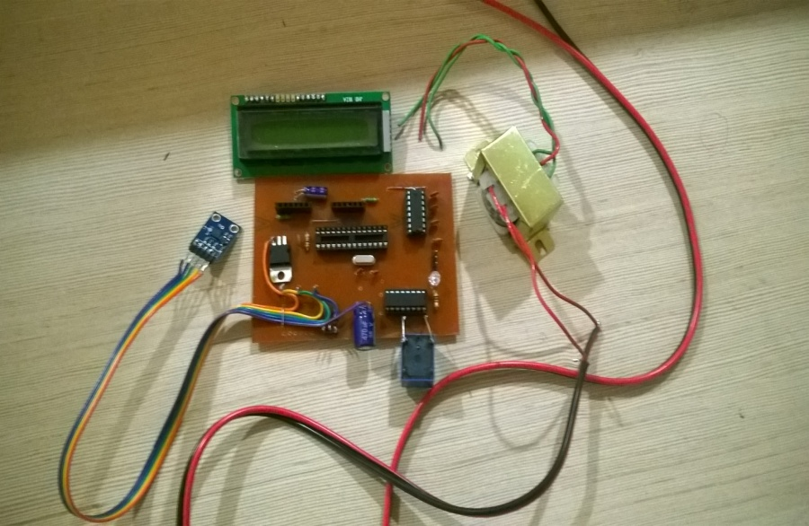
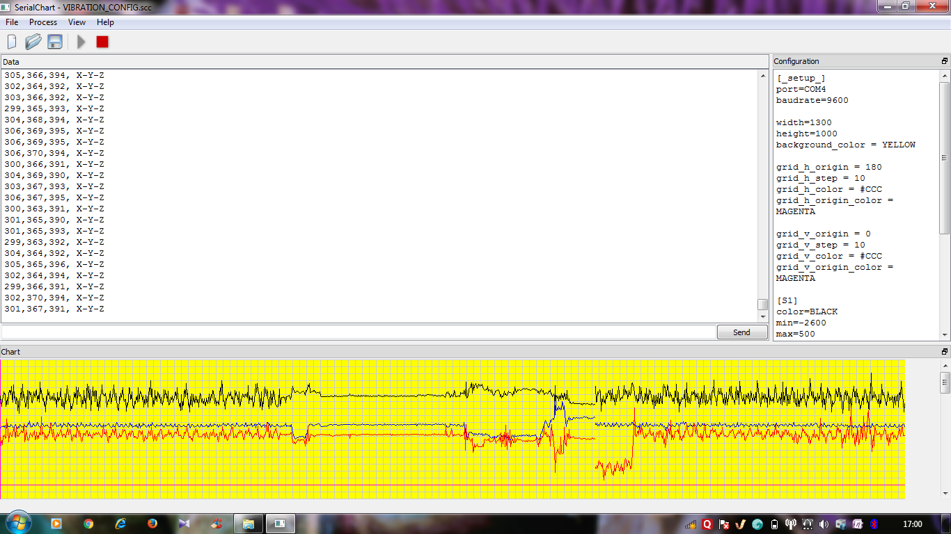

- Conclusion

- The project is aimed to deal with analysis and monitoring of vibration signal in terms of time domain.
- Accelerometer is used as a sensor. Vibration are graphically analyzed in X-Y-Z directions.
- Above the threshold level the circuit is tripped off.
- Frequency Domain will be better suited than time domain due to ease of differentiation.
The project helps in taking preventive control action immediately

