*Network Topology*

*Author 1:Khangesh matte K.D.K.C.O.E 8446473573 khangeshmatte@gmail.com*

*Author 2:Sonalkumarsingh K.D.K.C.O.E 7387599811 sonalkumars1994@gmail.com*

*Author 3:Ketan jaiswal K.D.K.C.O.E 9890818058 ketanjaiswal5@gmail.com*

***Abstract –*The geometrical arrangement of resources,remote devices and communication facilities is known as Network structure and Network topology.Networks topology describes the layout or appearance of a network that is ,how the computers, cablesand other comp+onents within a data communication network are interconnected both physically and logically.There are different types of the topologies like bus,ring,tree,mesh etc.however ,we will consider five basic network topology.**

***keywords–* How topology use,Advantages,Disadvantages**

1. INTRODUCTION

Network Topology is the study of the arrangement or mapping of the elements (links, nodes, etc.) of a network interconnection between the nodes.Topologies can be physical or logical. Physical Topology means the physical design of a network including thedevices, location and cable installation. Logical Topology refers to the fact that how data actually transfers in a network as opposed to its design.The five basics topologies are:

1.Bus Topology

2.Ring Topology

3.Star Topology

4.Mesh Topology

5.Tree Topology

*1. Bus Topology*

A Bus Network is a multipoint connection in which stations are connected to a single cable called **bus.** One long cable acts as a backbone to link all the devices in a network.

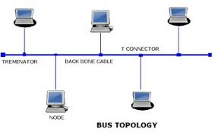

The bus topology is usually used when a netework installation is small,simple or temporary.By this type of topology, if one node goes faulty all nodes may be affected as all nodes share the same cable for the sending and receiving of information. The cabling cost of bus systems is the least of all the different topologies. Each end of the cable is terminated using a special terminator.

1. *Advantages*

* Bus topology is easy to understand,install,and use for small networks.
* It requires least amount of cable to connect the computers together and therefore is less expensive than other cabling arrangements.
* The bus topology is easy to expand by joining two cables with a BNC barrel connector.
* A repeater can also used to extend a bus configuration.

1. *Disadvantages*

* Heavy network traffic can slow a bus considerably because any computer can transmit at any time. But networks do not Co-ordinate when information is sent. Computer interrupting each other can use a lot of bandwidth.
* The BNC connectors the connections between two cables weakens the electrical signal.

*2. Ring Topology*

This is yet another structure for local area networks. It is in vented by IBM known as IBM token ring .In a ring topology ,all the stations are connected with each other in the form ring or loop. In a ring topology each computer is connected with to the next computer, with the last one connected to the first .

There is a direct point-to-point link between two neighbouring nodes. These links are unidirectional which ensures that transmission by a node traverse the whole ring and comes back to the node, which made the transmission as shown in fig.

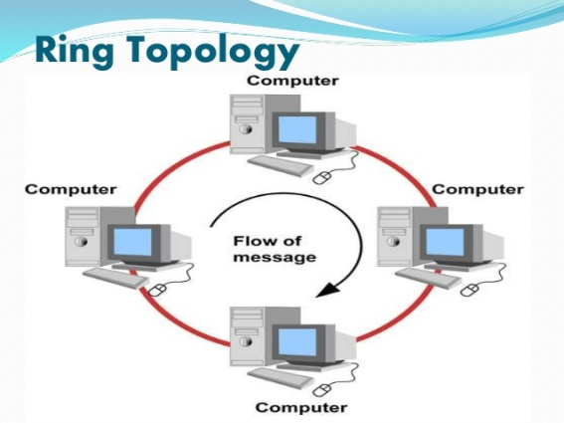

Information travels around the ring from one node to the next. Each packet of data sent to the rink is prefixed by the address of the station to which it is being sent. When a packet of data arrives, the node checks to see if the packet address is the same as its own, if it is, it grabs the data in the packet. If the packet does not belong to it, it sends the packet to the next node in the ring.

Faulty nodes can be isolated from the ring. When the workstation is powered on, it connects itself to the ring. When power is off, it disconnects itself from the ring and allows the information to bypass the node.

1. *Advantages*

* Ring networks are easily extendable.
* No one computer can monopolise the network to because every computer is given equal access to the token.
* Ring networks can span longer distances than other types of networks.
* Unlike Bus topology, there is no signal loss in Ring topology because the tokens are data packets that are re-generated at each node.

1. *Disadvantages*

* Failure of one computer on the ring can affect the whole network.
* It is difficult to troubleshoot the ring.
* Adding or removing the computers disturbs the network activity.
* It is much slower than an Ethernet network under normal load.

*3.* *Star Topology*

In a star topology, all the cables run from the computers to a central location where they are all connected by device called a **hub.**

Stars are used in concentrated networks,where the end points are directly reachable from a central location when network expansion is expressed and when the greater reliability of a star topology is required.

Nodes communicate across the network by passing data through the hub. A star network uses a significant amount of cable as each terminal is wired back to the central hub, even if two terminals are side by side but several hundred meters away from the host. The central hub makes all routing decisions, and all other workstations can be simple

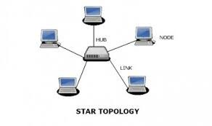

1. *Advantages*

* It is more reliable (if one connection fails, it does not affect others)
* The centre of a star network is a good place to diagnose network faults and if one computer fails whole network is not disturbed. Hub detects the fault and isolates the faulty computer.
* Use of multiple cable types in a same network with a hub.
* It has good performance

1. *Disadvantages*

* If the central hub fails,the whole network fails to operate.
* Many star networks require a device at the central point to rebroadcast or switch the network traffic.
* The cabling cost is more since cables must be pulled from all computers to the central hub.

*4.* *Mesh Topology*

In a mesh topology,every device has a dedicated point-to-point link to every other device.

The term dedicated means that the link carries traffic only between two devices it connects.

Failure in one of the computers does not cause the network to break down, as they have alternative paths to other computers.

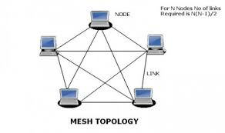

A fully connected mesh network therefore has n(n-1)/2 physical channels to link n devices .To accommodate those links every device on the network must have n-1 input/output ports.

1. *Advantages*

* Yield the greatest amount of redundancy in the event that one of the nodes fails where network traffic can be redirected to another node.
* Point-to-point link makes fault isolation easy.
* Privacy between computers is maintained as messages travel along dedicated path.

1. *Disadvantages*

* The amount of cabling required is high.
* A large number of I/O (input/output) ports are required.

*5. Tree Topology*

The most common structure or topology known as Tree topology, Tree topology is a LAN topology in which only one route exists between any two nodes on the network. The pattern of connection resembles a tree in which all branches spring from one root.

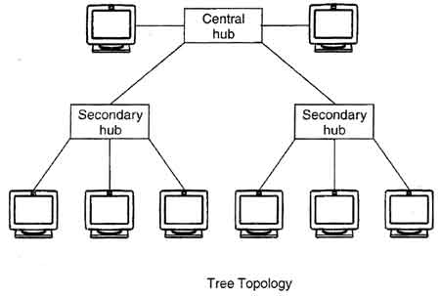

1. *Advantages*

* Installation and configuration of network are easy.
* The addition of the secondary hub allows more devices to be attached to the central hub.
* Less expensive when compared to mesh topology.
* Faults in the network can be detected traces.

1. *Disadvantages*

* Failure in the central hub brings the entire network to a halt.
* More cabling is required when compared to the bus topology because each node is connected to the central hub.

1. Conclusion

In this paper, we have done analytical study of different basic topologies which provide us a brief idea about each topology and their features. Each topology have some advantages and disadvantages as we discussed above so the solution is that we can integrate two or more different topologies to form a resultant topology having characteristic of combine topology known as Hybrid topology. This topology is reliable, scalable, flexible and effective. Only disadvantage is its complexity of design and costly infrastructure as we are combining two or more different topologies.

# Acknowledgment

We would like to thank our Head of Department (Electronics) Dr. P. D. Khandait and Assistant Prof. Mrs. J. S. Gawai for their support and guidance for completing this paper. We are grateful to Assistant Prof. V. V. Chakole for his constant motivation. Also we extend our gratitude to all Authors whose Books and papers are reviewed for completion of this paper.

# References

[1] Forouzan, Data Communication and Networking 5th Edition, Tata McGraw-Hill.

[2] Kartikpandya, “Network Structure or Topology”,International journal of advance research in computer science and management studies Volume 1,Issue 2 july 2013.

[3] Dr.Sanjaysharma,Data Communication and computer Networks,page no.22 to 27.

[4] Network Topology [On-Line] Available at. [http://en.wikipedia.org](http://en.wikipedia.org/)

[5] Sushruta Mishra, Lamboder Jena &AartiPradhan , “*Networking Devices and Topologies : A Succinct Study*” , International Journal of Advanced Research in Computer Science and Software Engineering/volume 2,Issue 11,November 2012,pp. 347-357.

[6] Geon Yoon, Dae Hyun Kwan Soon Chang Kwon,YongOonPark,YoungJoon Le “*Ring Topology-based Redundancy Ethernet for Industrial Network*” SICE-ICASE International Joint Conference, pp.1404-1407,18-21 oct. 2006

[7] Niveditabisht,sapanasingh “ANALYTICAL STUDY OF DIFFERENT NETWORK TOPOLOGIES”International Research Journal of Engineering and Technology.vol.2 issue 01 march 2015.

[8] SantanuSantra, PinakiPratimAcharjya, “*A Study and Analysis on Computer Network Topology for Data Communication*”, International Journal of Emerging Technology and Advanced Engineering/ volume 3, Issue 1 , January 2013

[9] Sanjay Kumar Pal and Samar SenSarma, “ *Computer Network Topology Design in Limelight OF pascal Graph Property*” ,The International Journal of Next Generation Network (IJNGN) ,Vol. 2, No. 1,March 2010.