*Text-To-voice Convertor*

*Author 1: Akshay Gahukar KDKCE, Nagpur* [*akshaygahukar51@gmail.com*](mailto:akshaygahukar51@gmail.com)

*Author 2: Snehal Balge KDKCE, Nagpur* [*snehal18balge@gmail.com*](mailto:snehal18balge@gmail.com)

*Author 3: Ketan Harde KDKCE, Nagpur* [*ketanharde@rediffmail.com*](mailto:ketanharde@rediffmail.com)

*Author 4: Snehal Kalambe KDKCE, Nagpur* [*kalambe0505@gmail.com*](mailto:kalambe0505@gmail.com)

*Author 5: Prof. V. V. Chakole KDKCE, Nagpur Chakole_vijay@rediffmail.com*

***Abstract –* This paper presents Text-to-voice convertor using AVR microcontroller .It received the data in the form of text with help of GSM modem and convert it into the voice with the help of Voice synthesizer. It is useful for blind person and also for announcement of message which is in the form of text.**

1. INTRODUCTION

Text-to-speech (TTS) convention transforms linguistic information stored as data or text into speech. It is widely used in audio reading devices for blind people now days. In the last few years however, the use of text-to-speech conversion technology has grown far beyond the disabled community to become a major adjunct to the rapidly growing use of digital voice storage for voice mail and voice response systems. Also developments in Speech synthesis technology for various languages have already taken place.

Many speech synthesizers using complex neural networks have also been designed. In the bigger picture, the module can open up a window of opportunities for the less privileged paving the way for a plethora of employment opportunities for them in the job sector. It can also play a defining role in establishing communication of the blind if it is incorporated into mobile phones (so that text messages could be converted into speech).

1. SYSTEM OVERVIEW

To achieve the goal, the following additional technical arrangements are implemented in the system. Multiple devices are controlled and processed by AVR.GSM Modem is use for received the text in the form of sms.UART is interface GSM Modem with AVR through which it transfer a data to the controller. Thereis synthesizer which converts code into speech.Amplifier process these signal and given to the speaker which is shown in fig.

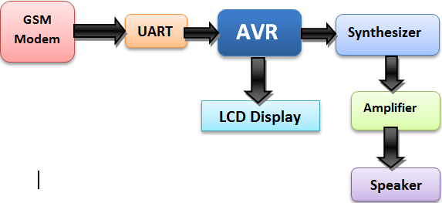

Fig. 1.System Functional Diagram

1. *GSM Modem*

A GSM modem is a wireless modem that works with a GSM wireless network. A wireless modem behaves like a dial-up modem. The main computers use AT commands to control modems. Both GSM modems and dial-up modems support a common set of standard AT commands modem sends and receives data through radio waves. Computers use AT commands to control modems. Both GSM

modems and dial-up modems support a common set of standard AT commands

1. *AVR Microcontroller*

The ATmega1284P is a low-power CMOS 8-bit microcontroller based on the AVR enhanced RISC architecture. By executing powerful instructions in a single clock cycle. The AVR core

Combines a rich instruction set with 32 general purpose working registers. All the32 registers are directly connected to the Arithmetic Logic Unit (ALU), allowing two independent registers to be accessed in one single instruction executed in one clock cycle. The resulting architecture is more code efficient while achieving throughputs up to ten times faster than conventional CISC microcontrollers.

The ATmega1284P provides the following features: 128K bytes of In-System ProgrammableFlash with Read-While-Write capabilities, 4K bytes EEPROM, 16K bytes SRAM, 32 general purpose I/O lines, 32 general purpose working registers, Real Time Counter (RTC), three flexible Timer/Counters with compare modes and PWM, 2 USARTs, a byte oriented 2-wire Serial Interface, a 8-channel, 10-bit ADC with optional differential input stage with programmable gain, programmable Watchdog Timer with Internal Oscillator, an SPI serial port.

1. *Synthesizer*

A synthesizer system converts normal language text into speech; other system render symbolic linguistic representations like phonetic transcriptions into speech. A text-to-speech system is composed of two parts: a front-end and a back-end. The front-end has two major tasks. First, it converts raw text containing symbols like numbers and abbreviations into the equivalent of written-out words. This process is often called text normalization, pre-processing, or tokenization. The front-end then assigns phonetic transcriptions to each word, and divides and marks the text into prosodic units, like phrases, clauses, and sentences.

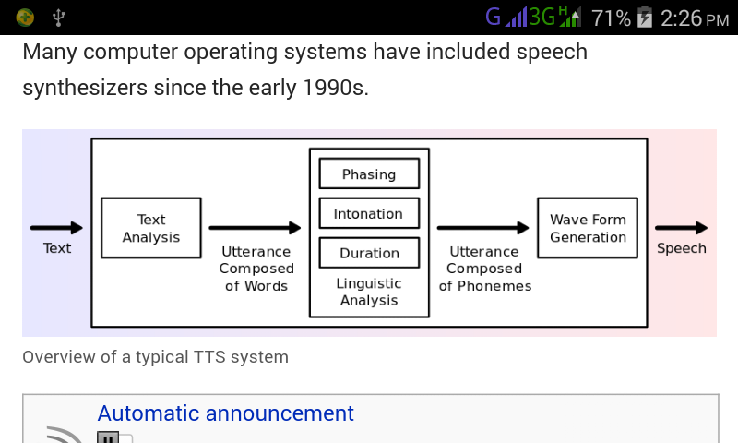

Fig 2: Synthesizer [2]

The process of assigning phonetic transcriptions to words is called text-to-phoneme or grapheme-to-phoneme conversion.Phonetic transcriptions and prosody information together make up the symbolic linguistic representation that is output by the front-end. The back-end then converts the symbolic linguistic representation into sound. In certain systems, this parts includes the computation of the target prosody which is then imposed on the output speech.

1. WORKING

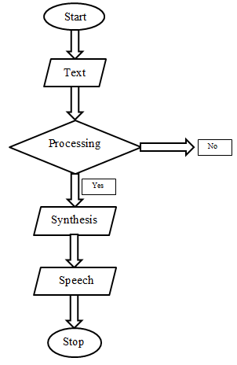

Fig. 3. Working flow chart

The working of model will explain by the above flow chart. It shows different step of working after started working GSM modem received the input text in the form of SMS. Modem is controlled by using AT command.

Then this data in the form of binary stream is passed toward processing unit it is nothing but AVR microcontroller. The interfacing between GSM modem and AVR is done by UART. It is the pair of receiver and transmitter it received the data in parallel form and converts it into serial form and at the transmitter side the serial data is converted into parallel form. The AVR check whether the massage properly received or not. If it is received properly then this massage will go throve further processing as shown in fig.2. If it is not then that massage is discarded. AVR process this data and make ready for the synthesiser.

A synthesizer system converts normal language text into speech. It has two main parta front-end and a back-end.The front-end has two major tasks. First, it converts raw text containing symbols like numbers and abbreviations into the equivalent of written-out words. This process is often called text normalization, pre-processing, or tokenization. The front-end then assigns phonetic transcriptions to each word, and divides and marks the text into prosodic units, like phrases, clauses, and sentences.The back-end then converts the symbolic linguistic representation into sound. In this way this system convert text massage in the form of voice.

1. CONCLUSION

This paper describes the successful implementation of a simple text message to speech conversion by synthesizer. Hence this method is very easy and efficient to implement unlike other methods which involve many complex algorithms and techniques. This method is helpful for blind person for listen the texted matter

ACKNOWLEDGMENT

We would like to acknowledge and extend our heartfelt gratitude to the theproject guide prof.V. V. Chakole for their vital support.REFERENCES

1. Tapas Kumar Patra, BiplabPatra, PuspanjaliMahapatra, “*International Journal of Electronics Communication & Computer Technology (IJECCT)*” Volume-2, Issue-5 (September 2012)
2. Sasirekha, E. Chandra, “*International Journal of Soft Computing & Engineering (IJSCE)*” ISSN: 2231-2307, Volume-2, Issue-1, March 2012
3. Sagar S. Alande, Soumi S. Sharma, Ajita A. Chavan, “*Text-to-Speech Convertor- International journal of computer science and applications*”, Vol. 8, No. 2, Apr-June 2015, EISSN: 0974-1011
4. Subbarao. Y. K., J. S. Chitode, Member, IEEE, “*Text-to-Speech Implementation in field programmable Gate Array- National conference on Advanced Computing & Computer networks (NCACCN)*” 2007
5. Qing Guo, Jie Zhang, Nobuyuki Katae, Hao Yu, “*High Quality Prosody Generation in Mandrain Text-to-Speech System*”, FujiTSu Sci. Tech., J., Vol. 46, No. 1, pp. 40-46, 2010
6. Qinghua Sun, Keikichi Hirose, WentaoGu, Nobuaki Minematsu, “*Rule-based Generation of Phrase Components in Two-step Synthesis of Fundamental Frequency Contours of Mandarin*”
7. NuzhatatiquaNafis, Md. SafaetHossain, “*International Journal of Innovation and Scientific Research*” ISSN 2351-8014 Vol. 17 No. 2 Aug. 2015
8. Black, H. Zen and K. Tokuda, “*Statistical parametric speech synthesis*”, in proc. ICASSP, Honolulu, HI 2007, Vol. IV, pp. 1229-1232
9. S. Saychum, N. Thatphithakkul, C. Wutiwiwatchai, P. Lamsrichan, T. Kobayashi, “*Fast-track Text processing for Real time Text-to-Speech on Mobile Devices*”
10. R. Sproat, J. Hu, H. Chen, “*Emu: An e-mail preprocessor for text-to-speech*” Proc. IEEE Workshop on Multimedia Signal proc. Pp. 239-244, Dec. 1998
11. ATMEL : 8 bit AVR Microcontroller with 16K Bytes In-System Programmable Flash
12. THE COMPLETE SYNTHESIZER : A Comprehensive Guide By David Crombie