*Industrial IVRS*

*Author 1: Ankita Kamdi KDKCE,Nagpur akamdi21@gmail.com*

*Author 2: Akanksha Khaire KDKCE,Nagpur khaireakan13@gmail.com*

*Author 3: Sneha Rakesh KDKCE,Nagpur rakeshsneha3@gmail.com*

*Author 4: Ratnadip Ingle KDKCE,Nagpur* [*ratnadipingle@gmail.com*](mailto:ratnadipingle@gmail.com)

*Author 4: Prof.V. N. Mahawadiwar KDKCE,Nagpur vivek_mahawadiwar@rediffmail.com*

***Abstract –* This paper presents Interactive Voice Response System for Industrial Automation .It received the data in the form of text and convert it into the voice with the help of Speech Application Programming Interface. It is useful for Industrial Purpose and also for announcement of message which is in the form of voice**

I. INTRODUCTION

Interactive Voice Response (IVR) is a phone system application that prompts callers with recorded messages and options and processes voice input and/or touch-phone keypad selections from these menus. The IVRS responds to this input by providing appropriate information in the form of voice answer or provides a connection to a "live" operator. Application: this project could be used for variety of purpose where you want to control something remotely.

Suppose you own a company and are three or more partners and are always travelling. You have an office located somewhere. And have a main server you do not want that somebody other than your partner should handle this server due to security reason. At the same time you do not want to keep your server all the time on so there this device comes to your help only requirement for this device is a parallel telephone connection. and of course power supply. you can switch on your server remotely from any where in the world. When you dial the number where this device is connected with the server, after five number of bell ringing you will hear please enter your password. When you enter the password. If your password is correct then device will further respond otherwise without giving any further response device will disconnect you.

*Interactive Voice Response System Works:* Someone calls your number and is greeted by a recorded voice message, for example: "Welcome to the Engineering College Enter your child’s Roll Number ". During this process system waits for 30 seconds or half minute, if caller not respond then system cut the phone and wait for new call. If caller press the appropriate number then system process further with the database information with respect to that particular Roll number to the caller. If the entered Roll Number is not found in the database entries then the system play the recorded message like: “Roll Number not found please check the roll number and try again. Thank You”. The caller presses appropriate number on their telephone key pad. The whole process is automated.

These systems are useful for guiding callers to specific information, such as a news broadcast or update, or allowing them to leave a message. Although IVR systems are more traditionally used in high-volume call centers (typically in telephone banking or customer services), they can also help NGOs to gather and distribute information, via voice, from and to the people they serve.

II. OBJECTIVE

This helps in minimizing human error, paperless office, information’s about the data on very easy search printing the details, showing comparative statements, process of order information remainder if there is any delays and inaccuracy that might create problems. Earlier the working of all this process was done manually which was tedious task of handling data and time consuming a to process an order it would take more time, but with the help of computerization the data can be managed very easily, efficiently and effectively with very less time. Thus this project will help in managing large data easily, and accurately at one place**.**

1. BLOCK DIAGRAM

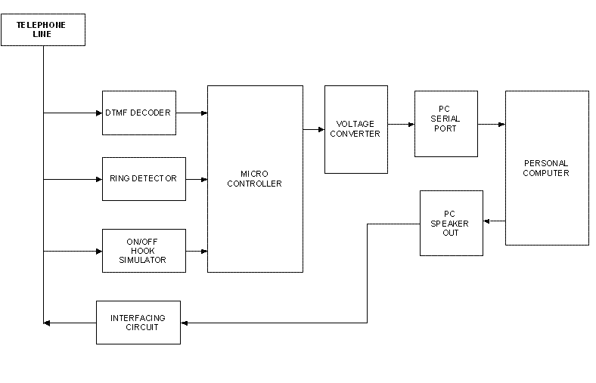

D

evice control



Device control



Device control



Device control

IV. CIRCUIT DIAGRAM

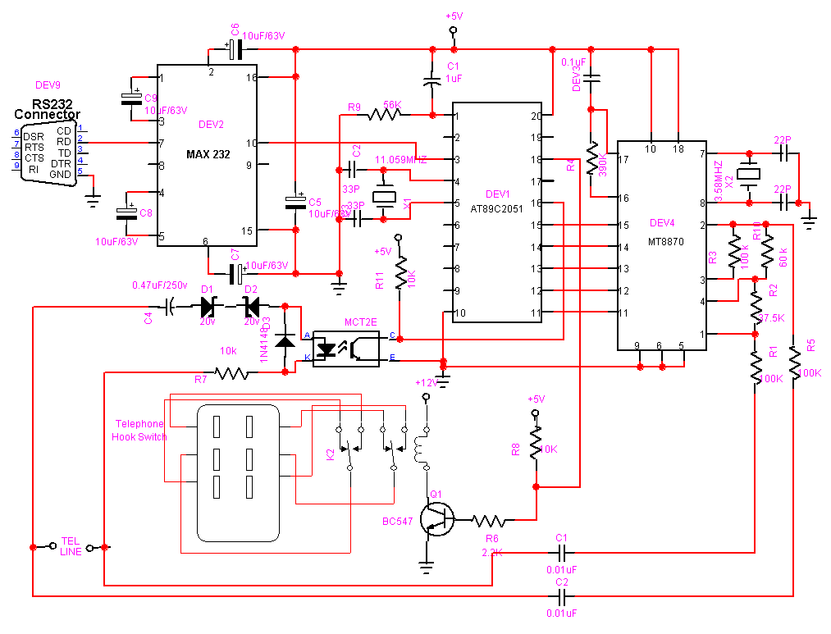

1. SYSTEM REQUIREMENTS

The hardware deals with the physical components of a system. They are the parts which deals with all electronic devices connected to form a machine and the peripherals connected to Hardware are the structure of computer or body of computer. For the requirement for this project the computers must have Pentium I, II, III, and IV (any one) with 32 MB RAM minimum 2GB hard disk space, operating system 95, 98, 2000, XP professional etc.

1. SOFTWARE REQUIREMENTS

TOOLS: C# .[object-oriented](http://en.wikipedia.org/wiki/Object-oriented_programming" \o "Object-oriented programming) [computer language](http://en.wikipedia.org/wiki/Computer_language) that can be viewed as an evolution of [Microsoft's](http://en.wikipedia.org/wiki/Microsoft) [C#](http://en.wikipedia.org/wiki/Visual_Basic)

1. WORKING

When remote phone dials the number of then ringing signals reaches to the ring detector, then ring detector sends the signal to the micro controller, when microcontroller program senses the ringing from ring detector, after sensing three rings microcontroller sends high signal to the telephone hook switch and tends the telephone to the hook up and then computer program welcomes the remote phone and sends options through the voice and when remote phone presses the buttons by options then DTMF tone reaches to the DTMF ic and it converts this DTMF signals into the equivalent binary digits and fed to the microcontroller. Then microcontroller program sends the signals to the MAX232 ic, this ic converts this signals into the serial data form and feds to the computer serial port and then computer program gives the answers to the remote phone according to the pressing buttons and signals reaches to the computer by remote phone

1. APPLICATIONS

I.V.R.S. is a unique solution for problems in existing manual system. I.V.R.S. is self-assured automation system. Implementation of I.V.R.S. with the help of standalone system is an innovative idea.

The I.V.R.S. can be used in any small or big industries or companies or campuses, where the communication is the important thing for getting some correct and possible information. The Interactive Voice Response System is use in this type of companies/industries/campuses just for reduce human efforts. It can be use by handicap or physically disable persons too. The application of this project may be as below:

* Voice- activated dialers(Call center routing)
* Anonymous access (Bank balance inquiry)
* Stock lookup and quotes
* Customer satisfaction surveys
* Political polls
* Order entry and tracking
* Information lookup
* Entertainment and information (Movie schedules, etc.)
* Clinical trials
* Product knowledge quiz line
* Automated reward transfer line

1. CONCLUSION

The feasibility study is conducted under the various areas in order to find the whether the study or the projects are suitable to work on. Feasibility study is conducted after finding out the systems objectives in order to carry out the feasibility study, following steps should be completed.

Technical feasibility concentrates on aspect of project it tries to find out the various hardware and software requirement for project. As computer system basically a mixture of hardware and software, its necessary to find that to what extent it support the proposed addition. This project is technical feasible as it does not need any new hardware or software to implement. This project and no other software is required to access this project.

ACKNOWLEDGEMENT

We would like to acknowledge and extend our heartfelt gratitude to the project guide Prof. R.B.KHULE for their vital support.

REFERENCES:

1. Shah S.A.A, NWFP University of Engineering and Technology, “Interactive Voice Response With Pattern Recognition Based on Artificial Neural Networks Approach”,Volume-3, Isuuse-3,May 2007.
2. Aditi Sharma ,Grover, Osanuyimen Stewart, “Designing Interactive Voice Response Interfaces”,Volume-2,Issue-4,March-2006.
3. K.M.Lee and J. Lai Speech Versus Touch, “International Journal of Human Computer Interaction ”,Volume-2,Issue-3,March 2005.
4. Power electronics and drive by G. k. Dubey and C. Rao.
5. Integrated electronics by J. Millan and C. Halkias.
6. 8051 Microcontroller and embedded system by Mazidi.
7. Electical technology volume 2 byB. l. Thereja and A. k. Thereja