A Review on Error Control Capabilities Using Orthogonal Code Convolution

Ms. Kumudini Thote

Abstract - Information and communication technology has brought enormous changes to our life. With the increase of data transmission and hence source of noise and interference, engineers have been struggling with the demand for more efficient and reliable techniques for detecting and correcting errors in received data. Although several techniques and approaches have been proposed and applied in the last decade, data reliability in transmission is still a problem. Error detection and correction techniques are therefore required. Among other techniques such as Cyclic Redundancy Check and Solomon Codes; orthogonal coding is one of the codes which can detect errors and correct corrupted data in an efficient way. An n-bit orthogonal code has n/2 1s and n/2 0s. In a previous work these properties have been exploited to detect and correct errors. In this review paper we discussed a new methodology to enhance error detection capabilities of the orthogonal code.

Index Terms—Antipodal Codes, Data transmission, Error capability, Error Correction, Error Detection, Orthogonal Codes.

INTRODUCTION
In communication system, day by day, there is an increasing demand of network capacity due to the use of internet and real time transmission of voice and picture. To fulfill these requirements data transmission at high bit rates is essential, with the increase of data transmission and hence sources of noise and interference, engineers have been struggling with the demand for more efficient and reliable techniques for detecting and correcting error in received data. Although several techniques and approaches have been proposed and applied but data reliability in transmission is still problem. When data is stored, compressed, or communicated through a media such as cable or air sources of noise and other parameters such as EMI, crosstalk, and distance can considerably affect the reliability of these data. Error detection and correction techniques are therefore required. The techniques which can detect and correct error are Cyclic Redundancy Check [1][2], Reed Soloman code[1], Hamming code[1] and Orthogonal code. In cyclic redundancy check one bit error can be detected but cannot correct any error. Its speed is moderate and used in optical disk and storage device whereas in Reed Solomon only burst error can be detected and corrected. Its speed is moderate and used in CD and DVD. Hamming code can detect only two bit error and correct one bit error. Its speed is low and is use in satellite broadcasting and internet. In Orthogonal code multiple bit error can be detected and one bit error is corrected for 8 bit orthogonal code [1]. Its speed is high and
use in wide band CDMA and GSM. As we compare all these techniques, orthogonal code is efficient. Thus main objective of the paper is to review Orthogonal code for convolution technique to enhance its error control capability.

Orthogonal Code Convolution
Orthogonal codes are binary valued and they have equal number of 1’s and 0’s. An n-bit orthogonal code has n/2 1’s and n/2 0’s; i.e., there are n/2 positions where 1’s and 0’s differ. Therefore, all orthogonal codes will generate zero parity bits. Since there is an equal number of 1’s and 0’s, each orthogonal code will generate a zero parity bit. Therefore, each antipodal code will also generate a zero parity bit. A notable distinction in this method is that the transmitter does not have to send the parity bit since the parity bit is known to be always zero. Therefore, if there is a transmission error, the receiver will be able to detect it by generating a parity bit at the receiving end. This offers a decision process, where the, incoming impaired orthogonal code is examined for correlation with the neighboring codes for a possible match. The acceptance criterion for a valid code is that an n-bit comparison must yield a good auto-correlation value; otherwise, a false detection will occur. Simulation results are verified for 16-bit orthogonal codes.The error detection rate can be calculated for a k- block of n –bit code is given in equation below:.
Detection rate (%) =
orthogonal codes antipodal codes

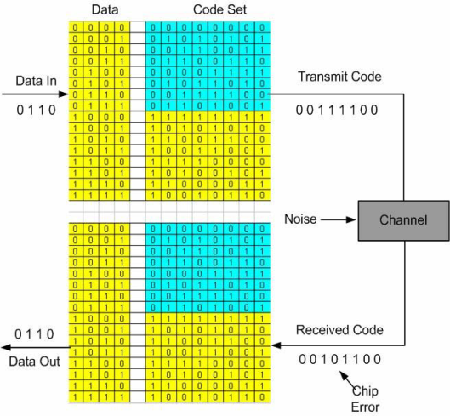
Look up table (LUT)

- MATH

A. Equations

This is governed by the following correlation process, where a pair of n-bit codes x1, x2... xn and y1, y2 … yn is compared to yield,
(1)
where, n= code length ;= Threshold value
The threshold value is placed in the middle of two orthogonal codes.
Where 16 is the number of orthogonal codes and is the threshold value for orthogonal codes. Error correction is carried out by a mechanism called decision process. This process will correct the corrupted data. The incoming orthogonal codes are compared with the codes that are stored in the LUT (Look Up Table). In this method the incoming data are checked for a good correlation between the stored codes. If a good correlation is achieved a valid code is obtained otherwise the detection will be false. The correlation process is carried out by using a couple of n-bit codes. The codes are given below:
= cross correlation function
= threshold value that is already define
An additional offset bit is added to the equation (2) for valid detection. The number of errors that can be corrected properly can be calculated by the equation (3).

(3)

Where,
N = The total number of errors that can be corrected.
The equation (3) can be obtained by combining the equations (1) & (2). From the equation (3),it is clear that 2 errors can be corrected for 8-bit orthogonal code, 3 errors can be corrected for 16-bit orthogonal code,7 errors can be corrected for 32-bit orthogonal code and so on. The proposed method is done by using the EXOR operations among the impaired received code and each code that is saved in the LUT(Look Up Table).The LUT stores all the codes. There is a need of a counter to count the number ones present in the resulting data. 32 counter result is needed for 16 bit orthogonal codes.

TABLE I
ORTHOGONAL CODE AND THEIR ERROR CORRECTION CAPABILITY

Code length (n) No. of error that can be corrected

8 1
16 3
32 7
64 15
128 31
256 63
TABLE II
ERROR CORRECTION RATE OF ORTHOGONAL CODE

Code length Detection Rate(%)

8 93.47
16 99.54
32 99.89
64 100

- DESIGN METHODOLOGY

Since there is an equal number of 1’s and 0’s, each orthogonal code will generate a zero parity bit. If the data has been corrupted during the transmission the receiver can detect errors by generating the parity bit for the received code and if it is not zero then the data is corrupted. However the parity bit doesn’t change for an even number of errors, hence the receiver can only detect errors combinations of the received code. Therefore detection percentage is 50% [1]. Our approach is not to use the parity generation method to detect the errors, but a simple technique based on the comparison between the received code and all the orthogonal code combinations stored in a look up table. The technique which involves a transmitter and receiver is described below.

A. Transmitter
The transmitter side contains two important modules they are,
(1) Encoder
(2) Shift Register
The purpose of the encoder is, it encodes the k-bit data stream and the data is mapped to n-bits of orthogonal codes.
Where, = number of orthogonal codes.
The function of the shift register converts the code to a serial data which is shown in Figure3.1.1. A parallel to serial conversion is taken place. An example can explain this concept. A 5-bit data is encoded, then a 16-bit () orthogonal code is produced. The generated orthogonal code is converted to serial data by using shift register with the rising edge of the clock

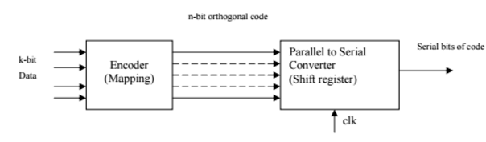
Figure 4.1.1 Block Diagram Of Transmitter

B. Receiver
The received code is processed through the sequential steps, as shown in Fig.3.2.1. The incoming serial bits are converted into n-bit parallel codes. The received code is compared with all the codes in the lookup table for error detection. This is done by counting the number of ones in the signal resulting from ‘XOR’ operation between the received code and each combination of the orthogonal codes. A counter is used to count the number of ones in the resulting n-bit signal and also searches for the minimum count. However a value rather than zero shows an error in the received code.
The orthogonal code which is associated with the minimum count is the closest match for the corrupted received code. The matched orthogonal code in the lookup table is the corrected code, which is then decoded to k-bit data. The receiver is able to correct up to () bits in the received impaired code. However, if the minimum count is associated with more than one combination of orthogonal code then a signal, REQ, goes high.

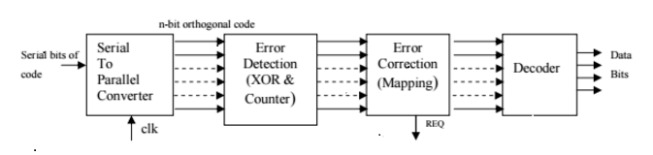
Figure 4.2.1 Block Diagram Of Receiver

CONCLUSION

In this review paper we conclude that, detection rate and correction rate improve using Orthogonal code convolution. The Orthogonal code convolution technique proposed can be applied to any encoding system used for digital transmission such as wide band transmission, satellite broadcasting. Future work includes improvement of correction capabilities of the orthogonal code and parallel simulation to speed up the data processing. The main advantage of the orthogonal code convolution is that ,there is no parity bit on the transmitting side.

REFERENCE
[1] Naima kaabouch, Aparna Dhirde,Saleh Faruque, “Improvement of Orthogonal code convolution Capabilities using FPGA implementation.” IEEE EIT proceeding. comms. 2007.
[2] Ms.Smita D.Jirapure , Prof. Sanjay Balwani, “Design and Implementation of Orthogonal Code Convolution Using Enhanced Error Control Technique.” IJERA ISSN: 2248-9622, International Conference on Industrial Automation and Computing [online] (2014 April).
[3] Reshmi R, Sebin Joseph, Praveen EDAC by Using Orthogonal Codes. IJARECE Volume 4,Issue 3,[online]
U K, March 2015
[4] Mukesh Gholase1, L.P.Thakare2, Dr. A.Y. Deshmukh3,
“Error control capability of orthogonal code convolution
by means of FPGA implementation.” International Journal of Engineering Science Paradigms and Researches, Vol. 05,Issue01,[online]
[5] Akanksha Kant, “ ENHANCE ORTHOGONAL CODE CONVOLUTION CAPABILITIES FOR EFFICIENT DIGITAL COMMUNICATION.” International Journal For
Technological Research In Engineering Volume 2, Issue
4,[online] December 2014.

