Bluetooth Remote Home Automation System Using Android Application

Author 1: Naina Meshram K.D.K College of Engineering Meshramnaina61@gmail.com
Author 2: Sanjana Sahu K.D.K College of Engineering sanjanasshahu@gmail.com
Author 3: Shubham Patil K.D.K College of Engineering Patilshubh19@gmail.com
Author 4: Anjali Thool K.D.K College of Engineering Anjalithool2309@gmail.com

Abstract - This paper present the overall design of Home Automation System(HAS) with low cost and wireless remote control. This system Is provide support in order to designed to assist and fulfill the needs of elderly and disabled in home .Also, the smart the smart home concept in the system improves the standard living at home. The main control system implements wireless. Bluetooth technology to provide remote access from PC/laptop or smart phone. The design remains the existing electrical switches and provide more safety control on the switches with low voltage activating method. In the present times, we can find most of the people clinging to their mobile phones and smart devices throughout the day. Hence with the help of this companion- a mobile phone, some daily household tasks can be accomplished by personifying the use of the mobile phone. Analyzing the current smart phone market, mobile users are opting for Android based phones.

Index Terms – Home Automation System, Android, ARM 7 Microcontroller, Bluetooth, appliances.

Introduction
Today’s homes require sophistication control in its different gadgets which are basically electronic appliances. This has revolutionized the area of home automation with respect to an increased level of afforda and simplicity through the integration of home appliances with smart phone connectivity.
Smart phone are already feature perfect and can be made to communicate to any other devices in an ad hoc network with a connectivity option like Bluetooth. With the advent of mobile phones, Mobile applications development has seen a major outbreak. Home automation system is a mobile application developed using Android targeting its vast developed using Android targeting its vast market which will beneficial for the masses. According to the International data corporation (IDC) Worldwide Quarterly Mobile Phone Tracker, Android maintained its leadership position in global market share.
Bluetooth is a short-range wireless communication technology that comes in handy as the solution while communicating over an ad hoc network environment like the home environment for connecting the home appliances with the mobile phones. Bluetooth works over 2.4 GHz frequency range up to the range of 100 m with 1 Mbps speed, providing a safe and efficient solution for controlling home automation. The capabilities of Bluetooth are more than enough to be implemented in the design. Also, most of the current laptop/notebook or cell phones are come with built-in Bluetooth adapter. It will indirectly reduce the cost of this system.
Due to the advancement of wireless technology, there are several different of connections are introduced such as GSM, WIFI, ZIGBEE, and Bluetooth. Each of connection has their own unique specifications and applications. Among the four popular wireless connections that often implemented in HAS project, Bluetooth is being chosen with its suitable capability. Bluetooth with globally available frequencies of 2400Hz is able to provide connectivity up to 100 meters at speed of up to 3Mbps depending on the Bluetooth device class. In addition, a Bluetooth master device is able to connect up to 7 devices in a “Piconet” .

Overview
Home automation is automation of the home & household activity. Home automation may include centralized control of lightning HVAC(Heating ventilition & Air Conditioning) appliances & other system, to provided security. The concept of home automation system is that, the modern house are gradually shifting from the conventional switches to centralized control system, involving wireless control switches. Presently, the conventional wall switches located in different parts of the house makes in difficult for the user to go near them to operate. Even more it become more difficult for the elderly or physically handicapped people to do so. Remote operation is achieved by any smart phone/tablet,etc.....with android os, upon a GUI(Graphical User Interface) based touch screen operation. Android application act as a transmitter, which sends ON/OFF commands to the receiver where loads are connected. The ARM processor is used hear.
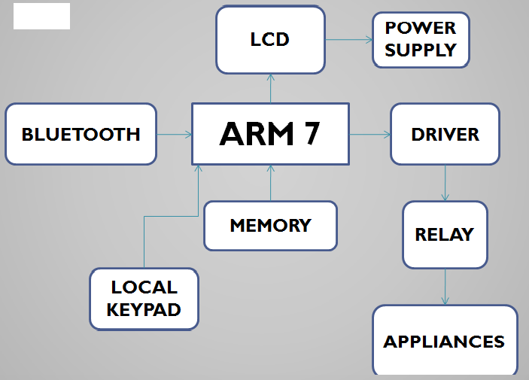
Fig.1. Block diagram of home automation using Android Based system
APPLIANCES

Android

Android is everywhere. Present days Phones, Tablets, Android will be in cars, in in-flight entertainment systems on planes, and even in Android was originally created by Andy Rubin as an operating system for mobile phone twenty-first century. In 2005, Google acquired Android Inc., and made Andy Rubin the Director of Mobile Platforms for Google. Many think the acquisition was largely in response to the emergence of the Apple iPhone around that time; however, there were enough other large players, such as RIM Blackberry, Nokia Symbian, and Microsoft Windows Mobile, that it seemed a salient business decision for Google to purchase the talent and intellectual property necessary to assert the company into this emerging space,the appliances control in a HAS. This system ensures a secured exchange of data conventional ON/OFF system of appliances. A user interface (UI) on the as well as Keil vision IDE [10] for compiling C Language Code and uCflash.

- BLUETOOTH

The Bluetooth profile used in Home Automation System (HAS) Android mobile phone application is the Bluetooth Serial Port Profile (btspp) [15]. RFCOMM is a connection-oriented protocol. It provides streaming communication between the devices. The btspp profile and RFCOMM protocol are used in the application to access the serial port and communicate using streaming data. All of the Bluetooth APIs is available in the android .Bluetooth package. Different types of Bluetooth applications can be developed using Android platform architecture using the Bluetooth profiles . The device manufacturers provide the services using the support of these profiles in their devices to maintain compatibility for the Bluetooth technology.

Arm-7 controller

1) 16-bit/32-bit ARM7TDMI-S microcontroller in a tiny LQFP64 package.8 kB to 40 kB of on-chip static RAM and 32 kB to 512 kB of on-chip flash memory;
2) 128-bit wide interface/accelerator enables high-speed 60 MHz operation. In-System Programming/In-Application Programming (ISP/IAP) via on-chip boot
3) loader software, single flash sector or full chip erase in 400 ms and programming of 256 B in 1 ms Embedded ICE RT and Embedded Trace interfaces offer real-time debugging with the on-chip Real Monitor software and high-speed tracing of instruction execution
4) In addition, the LPC2146/48 provides 8 kB of on-chip RAM accessible to USB by DMA.
5) Single 10-bit DAC provides variable analog output (lpc2142/44/46/48 only).
\

- WORKING

Power up the Circuit and scan the Bluetooth devices on your Mobile Device. If everything’s done correctly you will be able to find a Bluetooth device named pairing code in case of the above model (Tiny OS) it is 1234 but it might be different if you are using a Bluetooth module from another vendor.

- Instant On and OFF

For operating devices listed in program.
- Start Bluetooth connection of your mobile phone.
- Open the ‘HAS’ application on your Android mobile phone.
- Select connect device from option menu using scan for new devices.
- Bluetooth Serial Module will be available under ‘select a device to connect’ list.
- Pair ‘Bluetooth Serial Module’ by providing pair code ‘1234’
- Start selecting particular device for making ‘ON/OFF’ from List Menu .

ADVANTAGES

    - Low cost smart phone are already available so most of the people can use and operate.
    - This system is easy to operate.
    - The another advantage is that application software is based on Android which today has the largest smart phone base.
    - It is enhancing comfort in daily life to enabling more independent life for elderly and handicap people.
    - This system is easily reliable.

- APPLICATIONS

- The home automation system is used for handling home appliances.
- It can be used for handling industrial applications such as boiler , PLC etc.
- It can be also used in vehicles.

Acknowledgement
First of all, the special appreciation and thanks go to Dr.P.D.Khandait for providing the invaluable knowledge and the necessary guidance as well as encouragement in completing this paper.The supervision and support are truly help the progression and smoothness of this project. Moreover, the great deals appreciated go to the contribution from every team members for the valuable shares, opinions and resources provided in completing the report. The co-operation is much indeed appreciated.

References
- N. Sriskanthan and Tan Karand. “Bluetooth Based Home Automation System”. Journal of Microprocessors and Microsystems, Vol. 26, pp.281-289, 2002.
- R.Piyare, M.Tazil. “Bluetooth based home automation system using cell phone.”2011 IEEE 15th International Symposium on Consumer Electronics.
- Hiroshi Kanma, Noboru Wakabayashi, Ritsuko Kanazawa & Hirimichi Ito, “Home Appliance Control System over Bluetooth with a Cellular Phone”, in IEEE, 2003, pp. 1049-1053
- Wijetunge S.P., Wijetunge U.S., Peiris G.R.V, Aluthgedara C.S. & Samarasinghe A.T.L.K., “Design and Implementation of a Bluetooth based General Purpose Controlling Module”, in IEEE, 2008, pp. 206-211
- N. Sriskanthan, F. Tan, A. Karande, "Bluetooth based home automation system", Microprocessors and Microsystems, Elsevier, 26, pp. 281-289, 2002.
- [6] S. Panth, M. Jivani, “Designing Home Automation system (HAS) using Java ME for Mobile Phone”, International Journal of Electronics and Computer Science Engineering, Vol. 2 No. 02, pp. 798-807, July 2013.

