Integrated Membrane Process for Treatment of Wastewater From Potato Processing for Biofuel Production

Neha Gautam, Dr. V.S. Sapkal, Dr. R.S. Sapkal
University Department of Chemical Technology, Sant Gadge Baba Amravati University, Amravati, (444602) M.S., India.

Abstract – Wastewater from the potato processing industry has been challenge for many years. In potato chips industry, the water obtained at washing after cutting the potato into slices. These wastewater contain high amount of biodegradable components such as starch and protein. Starch is recovered form wastewater using membrane technology (RO), thus reducing the consumption of fresh water and water can be reused. Starch is further used in fermentation for manufacturing of Biofuel, so the production of energy in order to meet the energy demand. Process optimization and quality improvement of ethanol through energy efficient membrane process (Pervaporation). Pervaporation is a highly selective, cost & energy saving technology as compare to distillation. This paper reviews the research on integrated membrane technology for treatment of potato processing wastewater in order to minimize the water consumption and to utilize the industry’s byproducts so the potato processing industry is characterized as a clean industry.

Keywords:- Potato Processing Wastewater, Reverse Osmosis , Enzyme, Baker’s yeast, Biofuel , Pervaporation.

Introduction
Wastewater discharged by industrial operations are one of the major sources of water pollution. Potato processing is much important in making India self-reliant in sustaining food supply. Potato processing industry in India is mainly composed of three segments:- potato snacks (including potato chips, Alu Bhujia, etc.), potato flakes/ powder and French fries[6]. The total world potato production is estimated at 36,48,08,768 tones in 2012[8]. India produces nearly 8% of the total global potato production, which is forecasted to be at about 2,91,84,701 tones for the year 2012[8]. A huge amount of water is required for washing of potatoes therefore produce large quantities of liquid waste. In potato chips industry, for one tone of influent potato, 4.78m³ water is required for washing. This derives from the initial potato washing of 0.57m³/tone , 0.73m³/tone for the peeling, 0.28m³/tone for the water transport, 1.66m³/tone for the cut and chips washing and 1.54m³/tone for the machines and floor washing[2]. Advances in membranes technology have showed many advantages for treatment of wastewater of food industry. Reverse osmosis membranes have been shown to significantly reduce total dissolved solids, heavy metals, organic pollutants, viruses, bacteria and clean water are often recoverable in a chemically unchanged form and are therefore easily re-used[3].
The potato is a starchy, tuberous crop and around 15 gm of starch contain in 100 gm of potato. The starch is a polymer of glucose and molecular formula of starch is (C₆H₁₀O₅)n. The density of starch is 1500kg/m³. Potato starch contains typical large oval spherical granules and their size ranges between 5 to 100 μm. Starch consists of two types of molecules, linear amylose & branched amylopectin . Depending on the plant, starch generally contain 20 to 25% amylose and 75 to 80% amylopectin by weight[7]. Starch is insoluble in water and alcohol, it is soluble in hot water. Sugar-based raw materials such as cane juice or molasses can be fermented directly but this is not possible for starchy based raw materials. Starchy materials has to be converted to fermentable sugars first[1]. The hydrolysis or chemical breakdown of starch may be performed in two ways(acid and enzymatic hydrolysis). Enzymatic hydrolysis is carried out under mild conditions, where as acid hydrolysis required high temperature and low pH. By enzymatic hydrolysis 100% conversion of starch or cellulose to glucose is achieved, it is difficult to achieve with acid hydrolysis[1].
Due to gradual reduction of fossil fuels and the increasing price of petroleum together with environmental concerns, the search for alternative renewable fuels has attracts attention in recent years. The world bioethanol production has reached up to 51000 million with United States and Brazil getting top position and India getting fourth position[5]. For production of ethanol, potatoes are cheap substrate because it is rich in starch and require less processing than other grains[5]. Production of ethanol after fermentation of glucose using yeast(sacchromyces ceverisiae), Bio-ethanol must be anhydrous, if it is used as a fuel. For dehydration of ethanol conventional purification process such as distillation is commonly used. Alcohol content of the distillation product is limited to 95 vol-% due to the formation of a water-ethanol azeotrope. So distillation is costly and very energy-intensive process[4]. Pervaporation is combination of membrane permeation and evaporation, and it can be used for separation of ethanol and water mixture. Product which is ethanol concentration is 99,9% can be obtained by using energy efficient pervaporation process[9].

MATERIAL AND METHOD
  - Raw Material:-
Wastewater from potato chips industry. In potato chips industry , wastewater obtained at washing after cutting the potatoes into slices(chips). This wastewater is first sent to screening to remove coarse solid(macro size potato pieces). After screening, water is sent for sedimentation because starch is insoluble in water, so most of starch present in water are settle down. Then send to Reverse Osmosis (RO) system for recovery of remaining starch present in wastewater thus water can be reused.

  - Reverse Osmosis Unit:-
Reverse osmosis unit is used for separation, concentration and recovery of starch from potato processing wastewater. The equipment consisted of a feed tank , a high pressure feed pump, a permeate flowmeter and a pressure control system. The plant is equipped with a spiral-wound membrane module (ployethersulfone membrane of pore size 0.0001μm, salt rejection minimum 99.0%, nominal membrane area 1.85m², pressure operating range 1–69 bar, temperature operating range 25-40°C, pH operating range 3–10).

  - Enzymes:-
Alpha-amylase and glucoamylase are commonly used enzymes for hydrolysis of starch. Alpha-Amylase is produced by submerged fermentation of a selected strain of Bacillus licheniformis. Application pH range 5.5 - 6.5 and application Temperature range 50-100 °C[7]. Glucoamylase is produced by submerged fermentation of a specially selected producer strain of Asp. niger. Application pH range 4- 4.5, and Temperature range 30-100°C[7].

  - Enzymatic Hydrolysis of Starch:-
20 gm Starch powder is mixed with 100ml distilled water[11]. Now this slurry is heated at 63°C for 15min. This process is called gelatinization. Starch hydrolysis is carried out using enzymes(α-amylase, Glucoamylase ) in two steps. Enzyme α-amylase is applied at about 1% v/v of slurry. It is heated at water bath at 65°C for 3 hrs. Aim of Alpha-amylase is to hydrolyze α-1,4 glycosidic bonds of starch and starch derivatives into soluble dextrin and oligosaccharides. This process is called liquefaction. After that enzyme Glucoamylase is dosed at 0.8% v/v of slurry and it is heated in water bath at about 90-92°C for 2 hrs[1]. Aim of Glucoamylase is to convert starch to glucose. This process is called saccharification.
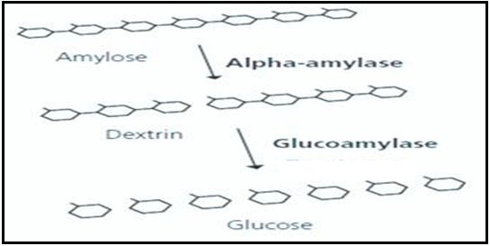
Fig:-1. Mechanisms of Enzymatic Hydrolysis
  - Yeast:-
Saccharomyces cerevisiae (baker's yeast) :- Dry active yeast is rehydrated in water bath at 40°C, by using clean water and allowed taking to room temperature before for Fermentation
  - Fermentation of Glucose:-
After completion of hydrolysis of starch, the solution is autoclave for 15min at 121 °C and 15psi. The resulting solution is cooled and transferred to the fermentor where yeast is added. The yeast species Saccharomyces cerevisiae convert glucose to ethanol and carbondioxide. If the fermentation process is performed continuously the fermentation time is around 48-72 hrs in incubator at 120 rpm. Fermentation carried out under optimized conditions (31 ºC & 6.0 pH). After fermentation, the clean sterile cotton cloth is used to sieve the product from the residue. The fermentor broth is transferred to the pervaporation process where the ethanol is separated from the remaining broth.
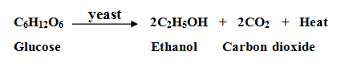
  - Pervaporation:-
Pervaporation is a membrane separation process where ethanol is selectively separated from the fermentation broth. The pervaporation unit consists of vacuum pump, membrane and condenser. In pervaporation, liquid mixture is brought in contact with a membrane at the upstream side and the permeate is removed as a vapor at the downstream side. The driving force is established by reducing the relative pressure at the downstream side by either the use of an inert carrier gas or an applied vacuum. In pervaporation, a phase transition takes place as the feed is in a liquid state, whereas the permeate is obtained as a vapor . The permeate is then condensed[9]. Hydrophobic Polytetrafluoroethylene Membrane (PTFE) of pore size 0.2μm is used for pervaporation of Bioethanol from fermented broth. The operation temperatures varied from 40°C to 80°C with permeate side pressure of 600-650 mmHg.
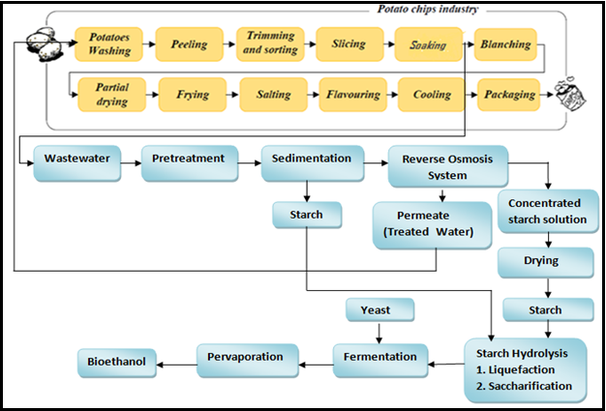
Fig:-2.Flowchart of overall process

III. ANALYTICAL TECHNIQUES

- pH and TDS:-
pH is determined by pH meter and TDS is measured by TDS meter.

- Chemical Oxygen Demand (COD):-
COD determines the amount of oxygen required to oxidize the organic matter in waste-water sample. COD is determine by Open Reflux Method.

- Biological oxygen demand (BOD):-
BOD determines the amount of oxygen required for the biological decomposition of dissolved organic matter to occur under standard condition at a standardized time and temperature.

- Glucose estimation:-
Glucose content is determined according to the method of Miller (1959). Take 3ml of glucose sample in test tube and Add 3ml of dinitrosalicylic (DNS) reagent solution and mix the contents.The mixture is then heated in water bath for 5 to 15 min at 90°C until the red-brown color appeared. Then, 1 ml of a 40% potassium sodium tartrate (Rochelle salt) solution is added to stabilize the color. The absorbance values of the reducing sugar is measured using spectrophotometer at 575 nm, after cooling to room temperature in a cold water bath. Compare its absorbance value with standard once.

- Bioethanol Estimation:-
Ethanol concentration was determined according to the method of Williams and Darwin(1950) .
Take 2ml of ethanol sample in test tube and add 1ml of potassium dichromate reagent solution then add 1ml of s–Diphenyl carbazide solution. Mix the contents, The mixture is then heated in water bath for 5 to 15 min at 90°C until the red-brown color appeared. Then, 1 ml of a 40% potassium sodium tartrate (Rochelle salt) solution is added to stabilize the color. The absorbance values of the ethanol is measured using spectrophotometer at 575 nm, after cooling to room temperature in a cold water bath. Compare its absorbance value with standard once.

CONCLUSION
Bio-fuel is a useful product for future biorefineries, By using sustainable techniques(RO)for recovery of starch from wastewater may reduce the environmental problem as well as it is investigated as source/raw material for production of bioethanol. The membrane separation processes have many advantages that can improve the total efficiency and purity of final product. Pervaporation seems to be energy saving process for bioethanol production as compare to distillation.

Acknowledgement
The gratefully acknowledge from University Department Of Chemical Technology, Amravati, Maharashtra.

REFERENCE
- Sharm El-Sheikh, Egypt.Adhip Ghosal¹, Soumitra Banerjee², Sayan Chaterjee ³, “Biofuel precursor from potato waste” International Journal of Research in Engineering and Technology, ISSN: 2319-1163.
- D. Arapoglou¹, A. Vlyssides², Th. Varzakas³, K. Haidemenaki³, V. Malli², R. Marchant⁴ and C. Israilides¹, “Alternative ways for potato industries waste utilization”, Proceedings of the 11th International Conference on Environmental Science and Technology, Chaina, Crete, Greece, 3-5 September 2009.
- Craig R. Bartels, “Reverse Osmosis Membranes for Wastewater Reclamation”, Hydranautics, 401 Jones Road, Oceanside California, USA 92054.
- Masoud Vazirzadeh¹, Reza Robati², “Investigation of bio-ethanol Production from Waste Potatoes”, Annals of Biological Research, 2013, 4 (1):104-106.
- Rahmat Ali Khan¹*, Allah Nawaz¹, Mustaq Ahmed¹, Muhammad Rashid Khan², Fazal Dian¹ Nasir Azam¹, Sami Ullah¹ and Farheen Sadullah¹, Akhlaq Ahmad¹, Mir Sadiq Shah¹ and Nisar Khan¹, “Production of Bioethanol through Enzymatic Hydrolysis of Potato”, African Journal of Biotechnology Vol. 11(25), pp. 6739-6743, 27 March, 2012.
- S.K. Pandey1, R.S. Marwaha2, Dinesh Kumar and S.V. Singh³, “Indian Potato Processing Story: Industrial Limitations, Challenges Ahead and Vision for the Future”, Potato J. 36 (1 - 2): 1-13, 2009.
- Starch hydrolysis and required enzymes REBEL WP7: Bioenergy http://www.responsiblebusiness.eu/display/rebwp7/
- World Potato Statistics: http://www.potatopro.com//.
- Nwe Nwe Win1, P. Bösch², A. Friedl²,“ Separation of Ethanol-water Mixture by Pervaporation with Organic Composite Membrane: Modelling of Separation Performance using Model Parameters Derived from Experimental Data”, May 15, 2012 .
- Monica Mironescu, “Investigations on wastewaters at potato processing and starch recovery and characterization”, Journal of Agroalimentary Processes and Technologies 2011, 17(2), 134-138.
- Abul Kalam Azad¹*, Nilufa Yesmin¹, Shanjit Kumar Sarker¹, Abdus Sattar², Rezaul Karim³, “Optimum Conditions for Bioethanol Production from Potato of Bangladesh”, Advances in Bioscience and Biotechnology, 2014, 5, 501-507.
- Larry S. Ferro, Stephen C. O’Brien, Henry J. Camin, Bruce M. Wright, “Potato wastewater treatment method” Patent US6555003B2, 2003.
- Sajjad Haydar¹, Ghulam Hussain², Obaidullah Nadeem³, Husnain Haider⁴, A.J. Bari⁵ and Abdul Hayee⁶, “Performance Evaluation of Anaerobic-Aerobic Treatment for the Wastewater of Potato Processing Industry: A Case Study of a Local Chips Factory”, Pak. J. Engg. & Appl. Sci. Vol. 14, Jan., 2014 (p. 27-37).
- S.M. Sadati.T¹, K. Ghasemzadeh¹*, N. Jafarharasi² and P. Vousoughi³, “An Overviwe on the Bioethanol Production using Membrane Technologies”, International Journal of Membrane Science and Technology, 2014, 1, 9-22.

