Comparison of Properties of Biodiesel(Cotton Seed)with Diesel

Mahendra Meshram KDKCOE, Nagpur meshramm93@gmail.com
Shubham Kawale KDKCOE, Nagpur shubhamkawale31@gmail.com
Shubham Bansod KDKCOE, Nagpur shubhambansod9@gmail.com
Tushar Sapate KDKCOE, Nagpur tushar240594@gmail.com

Abstract – The development of internal combustion engines over the past century has resulted from the complimentary refinement of the engine design and fuel properties. As such, engines have been developed to utilize the properties of the fuels that were available. Replacement of existing fuels with new fuel formulations requires understanding the critical fuel properties to insure that the new fuels can be used. Discussed in this section will be some key fuel properties as well as the methods to measure these properties. The properties discussed will be specific gravity, kinematic viscosity, flash point, boiling point (distillation test), cetane number, cloud point, pour point.

Keywords— Biodiesel Characterization, Properties of fuel, Specific gravity, Kinematic viscosity, Cetane number, Flash point and fire point, Cloud point and pour point ,Soap and Catalyst Measurement, Calorific value.

Biodiesel Characterization
The specific gravity reduces after transesterification, viscosity from 57 to 4.73 centistokes, which is acceptable as per ASTM norms for Biodiesel. Flash point and fire point are important temperatures specified for safety during transport, storage and handling. The flash point and fire point of biodiesel was found to be 128°C and 136°C respectively. Flash point of oil decreases after transesterification, which shows that its volatile characteristics had improved and it is also safe to handle . Higher density means more mass of fuel per unit volume for vegetable compared to diesel oil. The higher mass of fuel would give higher energy available for work output per unit volume . Higher viscosity is a major problem in using vegetable oil as fuel for diesel engines. Cloud and pour point are criterion used for low temperature performance of fuel.
The cloud point for diesel is 4⁰C which is very low and the fuel performs satisfactorily even in cold climatic conditions. The higher cloud point can affect the engine performance and emission adversely under cold climatic conditions. The pour point for Diesel is -4⁰C. In general higher pour point often limits their use as fuels for Diesel engines in cold climatic conditions. When the ambient temperature is below the pour point of the oil, wax precipitates in the vegetable oils and they loose their flow characteristics, wax can block the filters and fuel supply line. Under these conditions fuel cannot be pumped through the injector. In India, ambient temperatures can go down to 0⁰C in winters .Fuels with flash point above 66⁰C are considered as safe fuel.

Properties of fuel
  - Specific Gravity
The specific gravity is a relative measure of the density of a substance. It is defined as the ratio of the density of the substance, ρ, to a reference density, ρref. The equation for the specific gravity (SG) is SG = ρ/ρref. The most common reference density used in the measurement of specific gravity is the density of water at 4°C, which corresponds to a reference density of 1 g/cc. The specific gravity of diesel fuel is about 0.85 while a typical density of biodiesel is 0.88, which means that biodiesel is more dense than conventional diesel fuel. Figure shows a hydrometer for measuring specific gravity.

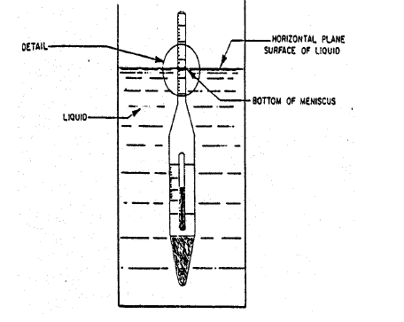
Fig. hydrometer for measuring specific gravity.

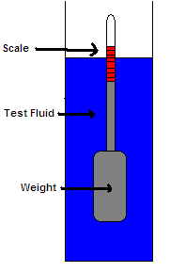

  - Kinematic Viscosity
To define kinematic viscosity it is useful to begin with the definition of viscosity . Viscosity (η) is the ease with which a fluid will flow is also known as dynamic viscosity . The kinematic viscosity (ν) is the resistance to flow of a fluid under gravity. Therefore, the kinematic viscosity of a fluid is related to the dynamic viscosity through the density (ρ), i.e., ν = η/ρ. The standard procedure for measuring kinematic viscosity in diesel or biodiesel fuels is ASTM D 445. The test is usually conducted by measuring the time required for a volume of liquid to flow under gravity through a calibrated glass capillary tube. Figure shows a Cannon-Fenske style glass capillary tube that is commonly used for ASTM D 445.Biodiesel is more viscous than diesel fuel, but only by a small amount. Depending on feedstock and the amount of oxidation, biodiesel’s viscosity will vary between 4.0 and 6.2.

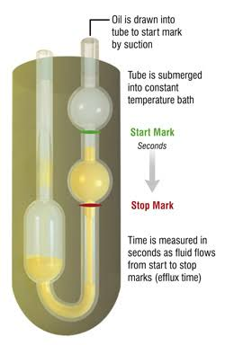

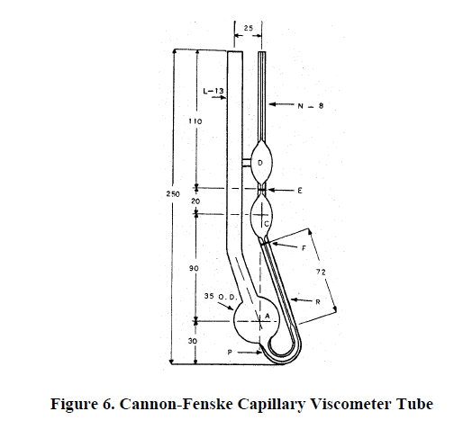
  - Cetane Number
The most important measure of ignition characteristics of diesel and biodiesel fuels is the Cetane number, since it directly pertains to ignition within compression ignition engines. The Cetane number is a numerical measurement of the influence the diesel fuel has in determining the ignition delay .Higher the Cetane rating of the fuel lesser is the knock tendency. The Cetane number of diesel fuel is a measure of its ignition quality.
The Cetane number of a fuel is the percentage by volume of Cetane in a mixture of Cetane and alpha-methyl napthalane that has same performance in the standard test engines that of the fuel. It is commonly used by refiners, marketers and engine manufacturers to describe diesel fuels. Cetane number is measuring by using a specific test, ASTM D 613.

  - Flash and Fire Points
A key property determining the flammability of a fuel is the flash point. The flash point is the lowest temperature at which an applied ignition source will cause the vapors of a sample to ignite. It is a measure of the tendency of a sample to form a flammable mixture with air. The value of the flash point is used for the classification of flammable and combustible materials needed for safety and shipping regulations. The standard procedure for measuring the flash point for diesel and biodiesel fuels is ASTM D 93. The flash point is determined by heating a sample of the fuel in a stirred container and passing a flame over the surface of the liquid. If the temperature is at or above the flash point, the vapor will ignite and an easily detectable flash can be observed. The flash need not correspond to a sustained flame. The "fire point" is sometimes used to designate the fuel temperature that will produce sufficient vapor to maintain a continuous flame

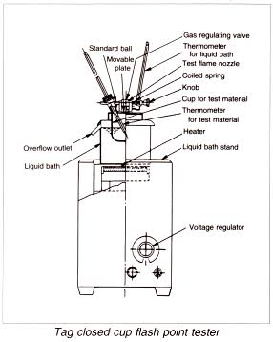

  - Cloud Point and Pour point
A fuel property that is particularly important for the low temperature operability of diesel fuel is the cloud point. The cloud point is the temperature at which a cloud of wax crystals first appears in a liquid upon cooling. The cloud point is an important property for biodiesel since biodiesel fuels typically have higher cloud points, i.e., crystals begin to form at higher temperature, than standard diesel fuel . This feature has implications on the use of biodiesel in cold weather applications. An alternative procedure for measuring the cloud point of diesel/biodiesel fuels is ASTM D 5773. A summary of the procedure steps is,

1) The sample is cooled in a Peltier device at a constant rate.
2) The sample is continuously monitored by optical detectors.
3) The temperature is recorded that corresponds to the first formation of a cloud in the fuel. Pour point is defined as the lowest temperature at which a liquid can flow.
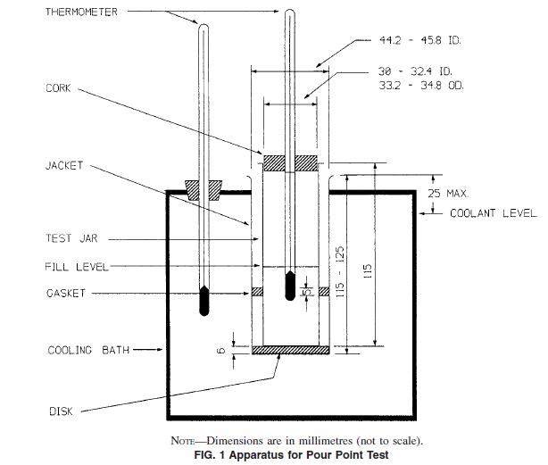

  - Calorific value
The calorific value is defined as in terms of the number of heat unit liberated in KJ/Kg. Bomb calorimeter is used to measure the calorific value of fuel as per specification method ASTM D240
Hc=Wc*Dt/Ms
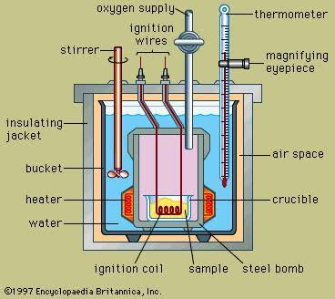

Comparing Property Of Biodiesel With Diesel

Property | Diesel | Biodiesel
Flash point ⁰C | 65 | 128
Fire point ⁰C | 78 | 136
Pour point ⁰C | -6 | -2
Cloud point ⁰C | 5 | 8
Viscosity | 2.86 | 4.82
Specific  gravity | 0.792 | 0.84
Calorific value (MJ/kg) | 44.34 | 42.80
Cetane number | 46 | 51.6

Conclusion
In the current investigation, it has confirmed that the biodiesel can be used as the alternate fuel for diesel engine. The experimental result, and the properties of the biodiesel are nearly match with the properties of the biodiesel. These various properties of biodiesel are specific gravity, kinematic viscosity, flash point, boiling point (distillation test), Cetane number, cloud point, pour point, are measured by using different apparatus and compared it with the diesel.

References
- J. Van Gerpen, B. Shanks, and R. Pruszko Iowa State University ,D. Clements Renewable Products Development Laboratory, G. Knothe USDA/NCAUR“Biodiesel Analytical Methods”,(August 2002–January 2004)
- R.K. Singh and Saroj Pardhi , “Characterization of jathropha oil for the preparation of biodiesel” NIT Rourkela Orissa, India (2009).
- National Renewable Energy Laboratory,”Biodiesel Handling and Use Guide Fourth Edition (Jan 2009).

