Design and Fabrication of Pedal Powered Tennis Ball Launcher

Chetan Gahukar, Parit Patel, Sourabh Khekare
Department of Mechanical Engineering,
Rashtrasant Tukadoji Maharaj Nagpur University,India
chetangahukar1@gmail.com
sour9822khekare@gmail.com

Abstract – There are three main objectives in producing the pedal powered tennis ball launcher. The first objective is to design a prototype of thrower mechanism for tennis ball launcher. While for the second objective is to fabricate a prototype of thrower mechanism for tennis ball launcher. Last but not least is to reduce the production cost of this machinery by using low cost material. For this project, there are three different concept designs generated. Each design has its own characteristics. One of them needs to be chosen to pursue this project. So Pugh Concept Selection Method is used to select the best concept design for this project. Then concept design which used rotating wheels is selected as the best concept design. The fabrication of this tennis ball launcher is using materials which are easily available in markets. The materials selection is based on the lower price because one of the project’s objectives is to reduce the production cost. Furthermore, local and recycles products are used as the machine’s component. This project not only focuses on the thrower mechanism, but generally the whole tennis ball launcher using pedal power is constructed. So when the construction finished, this machine can benefit many people especially Malaysian tennis players.

Keyword-Mechanism, Prototype, Recycle, Production, machine.

Introduction
Pedal Power Tennis ball launcher is used primarily for training exercises to include Lawn Tennis and Cycling. These are several advantages of using the tennis ball launcher. The first advantage is that the machine will keep players focused while training. The Portable ball machine does the pitching of the ball for players accurately and the way they want it. Consequently, this will keep players focus on their swing and helps them to hit the balls the right way without having to worry about what their training partner is doing. Furthermore, players can set their portable ball machine to feed and pitch the tennis balls according to their level of expertise. Players can gradually increase the speed, set the direction and the trajectory of the tennis balls that come at them and the manner that they are delivered for players to hit. Therefore, the machine is suitable for players of all abilities.

DESIGN
The design of the Pedal powered Tennis ball launcher is carried out with a thorough understanding of the working of the various mechanical elements and parts used in the fabrication of Tennis ball launcher. The various mechanical elements of the system are:
- Shaft,
- Chain,
- Sprocket,
- spring
- Coupling.

Synthesis Mechanism
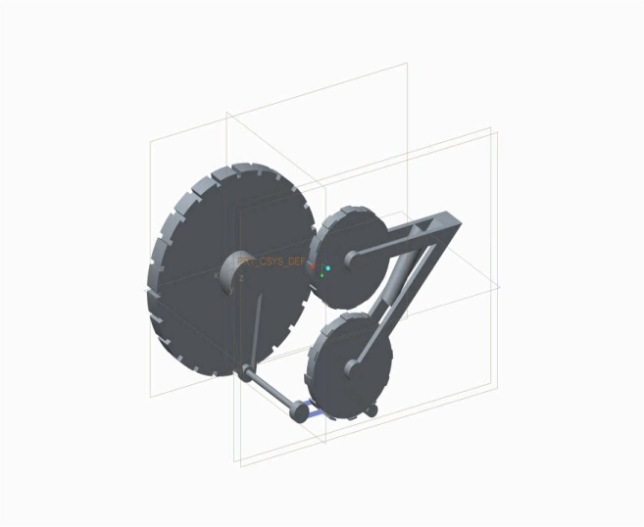

Fig: Thrower Mechanism
The first factor that must be considered when constructing a thrower mechanism is the throwing distance of the ball. The distance consists of length and height travelled by the ball. This mechanism used the concept of projectile motion. Refer Figure. In order to analyze the travelling distance of the ball ejected from the rotating wheels, the theoretical calculation of projectile motion is considered.
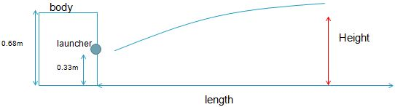
Fig 4.1: Projectile motion diagram for this project.

From study and analysis, the ball speed range of tennis ball machine available in market is in between 20 km/h to 150 km/h. So for this project, the ball speed ejected from the launcher is assumed to be 100 km/h as the average speed. The position of the ball launcher is located 0.33 meter from the ground. So the height travelled by the ball must be combined with this value to get the total height travelled by the ball. The thrower mechanism of this tennis ball machine is designed with six elevation angles that can be adjusted. The elevation angles are 2.5°, 5.0°, 7.5°, 10.0°, 12.5° and 15°. The calculations are such below.
Length travelled by the ball;
- Length, L = (V²sin 2θ) / g
- V = 100 km/h and g = 9.81 m/s
Height travelled by the ball;
- Height, H = [ (V²sin2 θ) / 2g ] + 0.33
V = 100 km/h and g = 9.81 m/s
Drag force Fd is the component of the aerodynamic force appearing during the motion of the solid. It acts opposite to the direction of motion.
Fd=-0.5Cₐρπr²vvˈ
where: Cₐ is the drag force coefficient depending on the shape of the solid, ρ is air density, r is ball radius, and v ball translational velocity.

Forces Acting On Tennis Ball
For the purposes of the mathematical analysis, the following brief for design for the new launcher were formulated:-The ball can be thrown from different altitudes in order to practice the return of serve; the maximum altitude of the throw can be set to 3 meters above the court level. Time period between subsequent ball shots (launch rate) can be set from 1 to 15 seconds with the step value of 1 second. The ball can be rotated around its axis in any plane by rotating the throwing mechanism around its symmetry axis from -180° to +180° (from -3.14 to 3.14 radians) with the step value of 1 degree. Rotating speed of the ball can be set from 0 to 2000 rpm with the step value of 1 rpm, the maximum is the average value of the advanced players. Only the drag force resulting from the translational motion of the ball is considered. The influence of the drag resulting from the rotation is neglected. The video recordings confirm that during the hit at the court the rotational speed of the ball is almost the same as just after the serve, i.e. the rotational speed drop during the flight is quite negligible. This means that the moment of the air drag force during the rotation does not influence the flight of the ball in a noticeable manner. However, the lift force resulting from the rotation of the ball around its axis; i.e. from the so called Magnus effect is taken into consideration. Fig. Rotating ball influences the surrounding air and makes it rotate too. On the other hand, the air pushing the ball in the translational motion flows AT one side of the ball at the same direction as the rotation of the ball. At this side the air is accelerated and its pressure drops. At the other side the flow direction of the air is opposite to the rotation. This decelerates the air and increases its pressure. Consequently, the pressure difference between the two sides of the ball evolves and changes the motion trajectory of the ball.
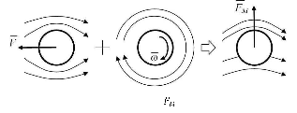
Fig. Forces and geometry at the contact between the ball and the rollers during throwing the ball away: ball inertia force , pressure force , friction force , ball radius , rollers radius , distance between rollers , radius of the ball deformed (squeezed) by the rollers, ball deformation Δ due to the rollers pressure.
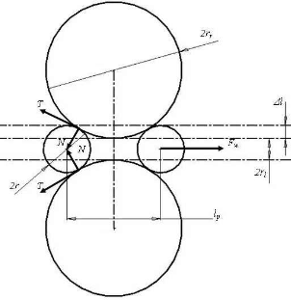

The height of tennis net from the ground is 1.07 meter. From this calculation, it shows that the ball can pass through beyond the net of the tennis court starting from 10.0° elevation angle if the tennis ball machine is placed right behind the baseline. Although the thrown height at 15.0° elevation angle quite high, it does not affect this project because there is no height limitation at the tennis court. No problem if the ball is ejected higher as long as it falls right into the opposite side.

Conclusion
A prototype of a working robot was designed and tested. Pedal power Tennis ball launcher is economical, easily operated , portable and use for various practices like tennis , cycling etc

Reference

- Alam F., Tio W., Watkins S., Subic A., Naser J. (2007), Effects of Spin on Tennis Ball Aerodynamics: An Experimental and Computational Study, 16th Australasian Fluid Mechanics Conference, 2-7 December 2007, Crown Plaza, Gold Coast, Australia.
- "Sprocket - Definition". Merriam-Webster. Retrieved 2011-11-14. sprocket, n. 1: a toothed wheel whose teeth engage the links of chain.
- Design of machine elements by – “R.K Jain”. Designdatabook by – “B.D.Shivalkar”.
- Machine design by – “R.S.Khurmi”.
- Machines And Mechanisms Applied Kinematic Analysis 4th EditioN by “Myszka David”.
- Bikeforums.net: why Shimano stopped 10 mm small pitch chain Quote: "...10mm required new chain, new hubs, new sprockets, new chainrings, new chainwhips. Basically just about anythnig that touched the drivetrain was incompatible with 10-pitch with the exception of the spiders on your crank arms.

