Design of Wheelchair cum Tricycle With Single Slider Crank Drive Mechanism

Vineet Gadmade KDKCE, Nagpur vgadmade@gmail.com
Dnyaneshwar Bhonde KDKCE, Nagpur dipbhonde@gmail.com
Piyush Tiple KDKCE, Nagpur piyushbtiple@gmail.com
Akshay Khawas KDKCE, Nagpur akshay.khawas09@gmail.com

Abstract – The project is the development of traditional manual operated tricycle with single slider crank drive mechanism. It is rear wheel drive. The design concept of this model is taken from manually operated tricycle and manually operated railroad car. The complete body looks like traditional tricycle in which chain drive mechanism replaced with single slider mechanism. This wheelchair cum tricycle is useful for handicapped person. This modified tricycle gives the both advantages of wheelchair (for short distance use or in-door) as well as tricycle (for long distance use) in one machine. The power and motion transmission takes place from steering bat to rear wheel through linkages and rotating disc. Modification of this tricycle by single slider drive mechanism is to make the tricycle faster at fewer efforts as compared to existing tricycle. This paper provides the details of components used & designing parameters takes in consideration while designing tricycle. This wheelchair cum tricycle is very efficiently design and can be proved as better replacement for tricycle having chain drive mechanism.

Introduction
Physical term of every human are not the same and as up to date always. Due some mishap or some medical problem some have to suffer for his rest of the journey with un- comforts. To serve such peoples the project is just a beginning. The design of wheelchair cum tricycle is an improvement on the existing ones. It is carried out to benefit the user conveniently, physically, and comfortably such that when a little effort is exerted, a greater output (movement) is achieved as a result of the fast transmission generated by the single slider mechanism. Instead of chain mechanism, we use single slider mechanism to drive the tricycle which allows the user much more efficient propulsion at less effort. In single slider mechanism consists of main three parts. First is crank, second is slider and third is connecting rod. When we start to slide the slider then slider move and due to this connecting rod also move and it transfer liner sliding motion to crank i.e. rotating disc. And this disc converts this motion into rotational motion and this motion transfer to shaft or axle of wheel.

TYPES OF TRICYCLE
There are two categories in which tricycle is divided.

A) Human powered tricycle-
1. Upright Tricycle:-
Upright resembles a two-wheeled bicycle, traditionally diamond frame, or open frame, but with either two widely spaced wheels at the back or two wheels at the front.

2. Recumbent delta:-
Recumbent delta is similar to an upright, with two wheels at the back and one at the front, but has recumbent layout in which one rider is seated in a chair like seat.

3. Recumbent tadpole:-
Recumbent tadpole or reverse trike is a recumbent design with two steered wheels at the front and one driven wheel at the back through one model has front wheels driven while the rear wheel steers.

4. Other designs:-
Another design is an in line three wheeled vehicle with two steered wheel one at the front and other in middle or at the rear.

B) Motorized tricycle
A motorized tricycle’s wheels may be arranged in either configuration: Delta or Tadpole.

- Motorized freight trikes:-
Motorised trikes are used as small freight truck and commercial vehicles.
- Motorized scooter trike.

Objective Of Project
- To reduce the efforts of paddling.
- To provide combined advantage of wheelchair and tricycle in one single machine.
- To increase the efficiency of handicapped wheelchair and tricycle.
- To obtain more speed as compared to regular handicapped wheel chair.
- To provide economical wheelchair + Tricycle to poor people.
- To provide mechanism to tricycle for reverse motion

Design
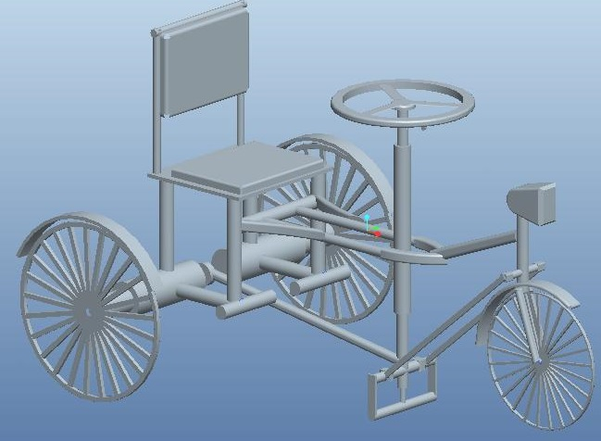

Components Of Tricycle
In our project we used different mechanical components. These components are used to run the tricycle. The list of components is as follows-

- Shaft or Axle
Shaft is a mechanical component for transmitting torque and rotation. The shaft serves to transmit driving torque to wheel, as well as to maintain the position of the wheel relative to each other and to vehicle body.
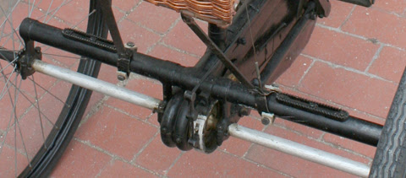
Fig: Axle

- Pedestal bearing
It is supporting and rotating device which support and rotate the rear axle. It is consist of bearing, sleeve, which is enclosed in casing made up of cast iron.

- Steering mechanism
Steering mechanism consists of steering wheel with bar. At the end of bar a circular disc is attached which control the turning of tricycle through linkage.
- Breaking system
A bicycle brake reduces the speed of cycle or prevents form moving. The mechanical brakes have three main types are rim brakes, disc brakes, and drum brakes. In our cycle we used mechanical brake of rim brake type.

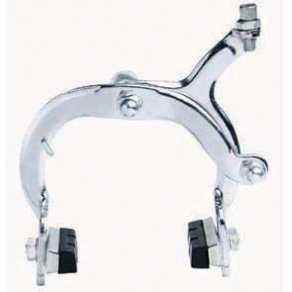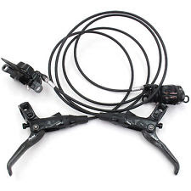
Fig: Mechanical Rim type Brake

- Tyres or Wheels
A wheel is a cushion provided with an automobile wheel. It is consists of mainly the outer cover, i.e. the tyre proper and the tube inside. The tyre tube assembly is mounted over the wheel rim. It is the air inside the tube that carries the entire load and provides the cushion. It helps the tricycle run smoothly on road.
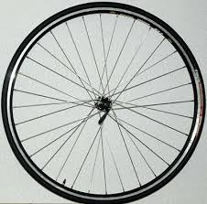
Fig: Tyres or Wheels

- Joint
Some mechanical flexible joints are used to connect or disconnect the tricycle from wheelchair.

- Single slider mechanism
When one of the turning pair of four-bar chain is replacing by a sliding pair, it become a single slider crank mechanism. In single slider mechanism there are three parts. First is crank second slider and third is connecting rod. When we start to slide the slider then slider move and due to this connecting rod also move and it transfer liner sliding motion to crank i.e. rotating disc. And this disc converts this motion in to rotational motion and transfer to shaft. As the slider moves to right the connecting rod pushes the wheel round for the first 180 degrees of wheel rotation. When the slider begins to move back into original position the connecting rod pull the wheel to complete the rotation.
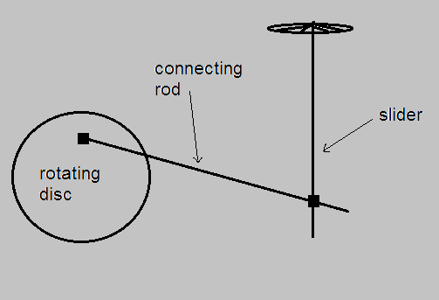
Figure - single slider mechanism

Working
  - For Forward Direction
When the tricycle in steady condition and we have to go in forward direction then pull the steering in backward direction as shown in figure(1). After that push in fornt direction shown in figure(2). And continue so on as shown in figure(3) and(4). So this way the tricycle move in forword direction.
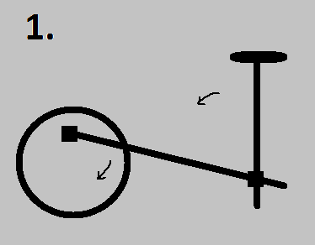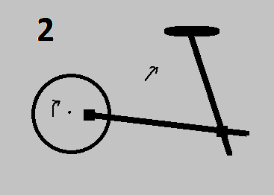
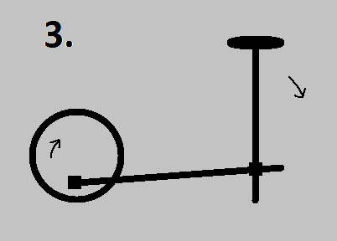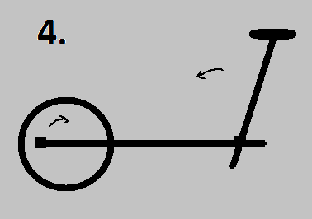
Fig: - Different position of single slider mechanism for forward direction

  - For Reverse Direction
For reverse motion we have to first stop the tricycle if cycle is in moving condition. So we have to come into rest position. Then for reverse motion we applied the force on starring or push in front direction as shown in figure no 1. Then we pull it in backward direction as shown in fig 2.and then it is continue as shown in figure 3 and figure 4. And so on, this way we get the reverse motion for tricycle.
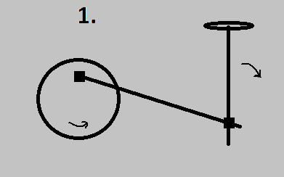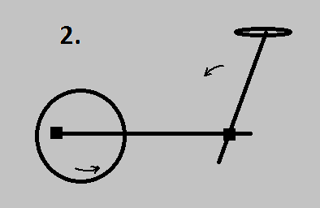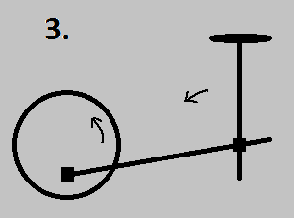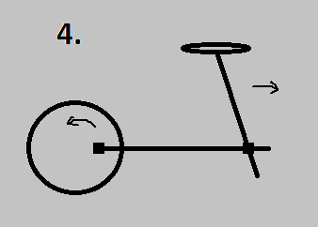
Fig: - Different position of single slider mechanism for reveres direction

Design Calculation

For Single Slider Mechanism With Total Weight
Wt. of tricycle=35 Kg &
Wt. of disable people=65 Kg,
Diameter of wheel= 60cm,
N=100 rpm (maximum condition)

Angular velocity= (2πN/60) = (2π*100/60) =10 .47 rad/sec
Velocity = w*r =10.47*0.3=3.141 m/sec
Total force= total weight = 35+65=100 Kg =100*9.81 =981 N
Force On each wheel
F₁=F₂ = 490.5 N
Torque = F₁*r=490.5*0.3=147.15Nm
So effort required, T= effort* dist. of link
Effort= (147.15*10³/1200)=122.625N=12.5Kg
Power = (2πNT/60)=2π*100*147.15/60=1.5 KW
Speed V=3.14 m/sec=11.3 Km/hr

  - For Chain Mechanism With Total Weight
Wt. of tricycle=45 Kg &
Wt. of disable people=65 Kg,
Diameter of wheel= 60cm =0.6m,
N =80rpm (maximum condition)

Angular Velocity = (2πN/60) = (2π*80/60) =8.38 rad/sec
Velocity = w*r =8.38*0.3=2.5m/sec=9 Km/hr
Total force = total weight=110 Kg =110*9.81 =1080
Force on each wheel
F₁=F₂=540 N
Torque = F₁*r=540*0.3=162 Nm
So effort required, T=effort* dist. Of chain
Effort= (162*10³/800)=202.5N=20.64 Kg
Power = (2πNT)/60= (2π*80*162)/60=1.4 KW
Speed V=2.5 m/sec=9 Km/hr

  - Design Of Shaft
Formula for diameter: T= (π* Ss*d³)/16
Where,
T=torque, S_{s}= S_{us} =ultimate shear strength & d = diameter of shaft
Material for shaft – SAE 1045 (Carbon steel) oil quenched and drawn 700 deg. celcius
Sut=579 MPa & Syt=306 MPa ……….(From T.N. II-7 of data book)

We Have relation,
Sus/Sut=0.75 ……….(From T.N. II-6A of data book)
Sus= 0.75*579=434.25 MPa
Design Torque,
T=60*P*K/2 πN ……..(From T.N. XI-1 of data book)
P= Load* Velocity=100*9.81*3.14=3080.34 Watts
P= P*K= 3080.34*1.0= 3080.34 Watts
Where K=Load Factor=Rotating Shaft with gradually applied load=1.0 ……(From T.N. XI-3 of data book)
Therefore,
T=3080.34*60/2π*100= 294.15 Nm
Also we know that,
T= (π* Ss*d³)/16
So diameter of shaft,
(π* 434.25*d³)/16=294.15

D=16 mm

Material Selection
While selecting the material for fabrication, prime motive is to select material that can provide high strength and reliability to the tricycle. Another consideration is to reduce material cost and overall weight of tricycle. Some desirable properties of material required for fabrication of model are:-

1. Material must have high tensile strength.
2. Material should withstand torsional and shear stresses.
3. Material should be highly resistant to changing weather conditions.
4. Material should be light in weight.
5. Material should be cost-effective & cheap.

Material: Cast Iron

Table:- Mechanical properties of cast iron
Sr. No. | Mechanical properties | symbol | unit | value
1 | Youngs modulus | E | GPa | 105
2 | Shear modulus | G | Gpa | 36.75
3 | Poisons ratio | v |  | 0.23
4 | Density | ƍ | Kg/m³ | 7209
5 | Yield strength | S_{y} | MPa | 130
6 | Shear strength | S_{s} | Mpa | 169

Comparison
Sr.  no. | Tricycle with single  slider mechanism | Tricycle with chain mechanism
1 | Required less effort to drive. | Required more effort to paddling.
2 | Only with one hand  controlling of tricycle is possible. | Required both hand to control tricycle.
3 | This tricycle provides the  advantage of wheelchair too. | Used as tricycle only.
4 | More speed and power. | Less speed and power.
5 | More economical. | Less economical.
6 | More efficiency. | Less efficiency.

Conclusion
In our project we utilized single slider mechanisms for driving tricycle instead of chain hence it is most useful and economical as compared to the other tricycle. This tricycle is made of cast iron which is available easily in market. This tricycle is mostly useful for elder and handicapped people. It is simple in design, easy to operate and maintenance is very less. The efforts made for operating tricycle is less; this is an advantage of this tricycle. The tricycle cost is less as compare to other tricycle. It is payable by common man and poor people. This wheelchair cum tricycle is useful for handicapped person. This modified tricycle gives the both advantages of wheelchair (for short distance use or in-door) as well as tricycle (for long distance use) in one machine.

References
- M. Reddi Sankar, T. Pushpaveni, V. Bhanu Prakash Reddy, “Design and Development of Solar Assisted Bicycle.” International Journal of Scientific and Research Publications, (Volume 3, Issue 3), (March 2013), ISSN 2250-3153(pp 201-202),

- Abdulkadir Baba Hassan (Department of Mechanical Engineering, Federal University of Technology, Minna, Niger State, Nigeria), “Design and Fabrication of Motorized Prototype Tricycle For the Disable Persons.” IOSR Journal of Engineering, (Volume 2(5)), May 2012, (pp 386-388)

- N.Sasikumar (Ph.D(Part-Time) Research Scholar, Kamban Arts & Science College, Coimbatore), Dr. P. Jayasubramaniam (Head & Asst.Prof. in Professional Accounting, Dr. N.G.P. Arts & Science College, Coimbatore). “Solar Energy System in India.” IOSR Journal of Business and Management (IOSR-JBM) ISSN: 2278-487X. Volume 7, Issue 1 (Jan- Feb 2013) (pp 62-66),

- Satish Kumar Dwivedi, Deepak Kumar Yadav, Ashutosh Mishra, Madhusudan Jaiswal, Shrikant Singh, Sujeet Kumar , (Department of Mechanical Engineering, Buddha Institute of Technology, Gorakhpur,U.P).“Design and Fabrication of a Motorized Tricycle for Physically Challenged Persons” International Journal of Engineering Science Invention, ISSN (Online): 2319 – 6734, ISSN (Print): 2319 – 6726 April 2014 Volume 3 (pp216-218),

- Arun Manohar Gurram, P.S.V Ramana Rao, Raghuveer Dontikurti “Solar Powered Wheel Chair: Mobility for Physically Challenged” International Journal of Current Engineering and Technology Volume 2, No.1 (March 2012) (pp 182-184)

- Design Data Book For Machine Element by B.D. Shiwalkar,Central techno publications,2014 edition
(Page No.35,38,39,109,110,111)

- A textbook of machine design by R.S. KHURMI & J.K. GUPTA (pp 507-586)

