Fabrication of Beans Sheller Machine

Akash Aru KDKCOE, Nagpur aruakash123@gmail.com
Vinaychandra Gode KDKCOE, Nagpur godevinay128@gmail.com
Nayan Tiwaskar KDKCOE, Nagpur tiwaskar1993@gmail.com

Abstract – Bean shelling in most part of the world is usually done manually by hand, and like all manual operations, it is time consuming and strenuous.
The design and construction of motorized bean shelling machine using roller method was done in order to meet the domestic, commercial and industrial demand of various beans for food processing and for other industrial uses. The bean shelling machine is made up of the following main units, container, rollers, pulleys, electric motor and supporting base. The shelling chamber consists of the shelling drum, the shelling vanes and guided roller and secondary roller. The machine was made from locally sourced materials and it can be used in both urban and rural areas. The Roller method is use in our beans Sheller machine. The cost of the machine will also low.

Keywords— Bean , Roller Mechanism , shelling , Gears

Introduction
The process of removing dried beans from their pods (also known as ‘shelling’.) is an incredibly time consuming task when done by hand. Due to the fact that there are few beans contained in each bean pod, the time required to process any deliverable quantity of produce makes bean farming very costly for small farms. While shelling machines are available commercially, the capacities of these systems only cover very small or very large operations with no alternatives available for mid-sized operations. Using a machine intended for small operations is hardly more efficient than shelling the beans by hand and using an industrial machine intended for large operations is not financially feasible.
There are typically two mechanical methods employed to shell beans. The first small scale method forces the bean pod between parallel rollers and squeezes the beans out the end. The second, more industrial scale method uses vibrations or impacts to shake the beans from the pods and then separates the shelled beans from the pods using screens.

Need of Beans Sheller Machine
Large scale harvesting combines use this method by tumbling the bean pods inside of a rotating screen. When used for their intended applications and scale both methods work effectively and provide a favorable ratio of cost to productivity. However, for a medium sized farm neither application is appropriate. Machines that employ the roller method typically require an operator to align the bean pods perpendicular to the rollers and feed each pod into the machine by hand. This system works well for garden sized produce yields but becomes inefficient when dealing with a more substantial volume. Larger machines that employ the vibratory method require a large initial investment and consume a huge footprint.

Methods of beans shelling

  - Roller Method
The roller method of bean shelling can be found in several readily available hand crank and/or table top models; these machines are designed to shell fresh peas in the pod. The
pea pods are fed into two very closely spaced rotating rollers which squeeze the peas out of the pod and then pull the empty pods through the roller mechanism to be collected and
discarded. Most of these devices are too small for our needs and are designed specifically for fresh peas.

  - Tumbler Method
Shelling machines that use the tumbler method consist of a slowly rotating inner mesh cylinder which contains a quickly rotating shaft with attached paddles, and an external wall. The pods are loaded into the inner cylinder which rotates and directs the pods to fall into the spinning shaft which breaks up the pods through contact with the rotating paddles. The shelled beans then fall through the inner cylinder mesh and are collected from the external wall, while the empty pods remain within the inner cylinder to be later collected and discarded. The only commercially available tumbler style machines are designed for an industrial scale and therefore are both too large and expensive. To put this into perspective, a tumbling shelling machine with an appropriate capacity.

  - Shearing Method
The only device in production that our research uncovered that employs the shearing method is found in a rice huller. In this method the rice is fed onto a stationary table with an oscillating or reciprocating surface just above the table. The friction and shearing forces applied by the table split the rice hulls open and then separate the chaff and grains of rice. The chaff and rice grains are then separated using an additional device or process. Alternate Rice huller designs employ a rotating drum that shears the rice against a curved surface.

Concept Screening
The team’s concept generation determined several subsystems to accomplish the tasks of loading, orienting, bean removal, and pod separation. The roller method requires a subsystem that orients the beans perpendicular to the rollers for proper removal, while the tumbler method requires no orientation. Also, the tumbler method requires a subsystem that will separate the shelled beans from the empty pods, while the roller method separates the pod from the bean when it is removed. Due to the difference in removal method between the tumbler and the rollers, it was necessary to evaluate the subsystems for loading, orienting, and separating individually. Each subsystem was then put into a matrix and compared to other variations based on the following:
● ease of use - how easy it is for the operator to use the machine
● load handling - how well the machine can handle a large load without jamming or failing
● manufacturability - how difficult it will be for the team to manufacture
● versatility - the capability to shell different types of beans
● simplicity - how simple the overall design is
● rate - how fast the machine can remove the beans and separate the empty pods
● certainty of success - the team’s overall certainty that the machine will function properly
Each variation was scored on a 1-5 scale with 1 being the lowest, 3 being neutral, and 5 being the highest.

Methodology
Our invention relates to an improvement in pea shelling machines and the object is to provide a simple mechanism capable of being actuated by hand or by power for shelling
peas or beans and separating the pods from the peas and beans. With the foregoing object in view, my invention consists in certain novel features of construction and combinations of parts which will be here inafter described and
pointed out in the claims.

1. Roller Mechanism
2. Process cycle of bean shelling
3. Working of bean shelling machine
4. Design and calculation
5. Major component of machine
6. Cost estimation

Rollers Used

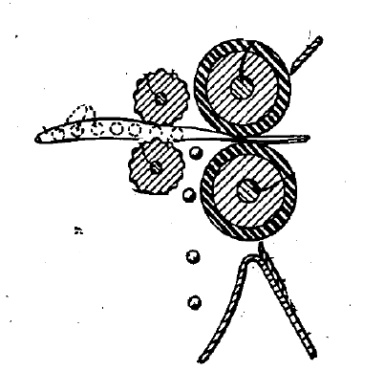



Design

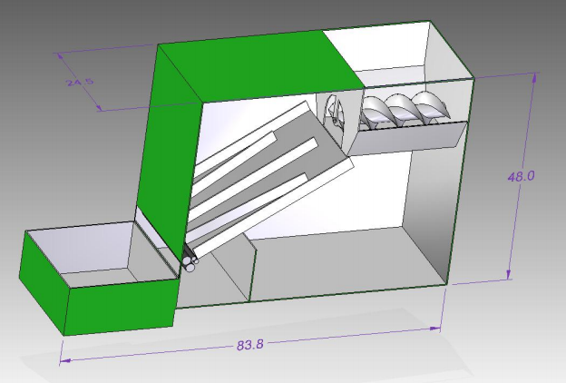

Force Calculation
Power required to shell the beans from pods
Force = K*X
=3*0.61
=1.83 N
= 2N
where, K=stiffness
x= displacement
Pressure required
P=F/A
=2/.56
=3.5mpa
T=µRn
=0.35*2
=0.7Nm
P= 2πNT/60*1000
= P= 2π*140*0.7/60*1000
=.01 Kw
Kw to Hp convertor:
.01 *1.36
= .01Hp

Selection Of Mptor
Power required
P= 2πNT/60*1000 Kw
T=(π/16)* d³ * τ
Assume d=45mm
Driven and Driving pulley
Material Selection SAE1030
S_{yt}=296Mpa
S_{ut}=527Mpa
τ_{max} <0.30 S_{yt} or τ_{max}<0.18S_{ut}
so τ_{max}=66.66Mpa (with key ways)
Now, T= 26.480 Nm by (2)
P=0.4Kw=0.6hp
P_{std}= 1hp

Belt Design

Pd=1hp
Belt tension, f₁-f₂ = pd/vp
Vp=0.109 mps
f₁-f₂=6743.119 N
Belt Tension ratio
f₁/f₂ =e^{µƟ}
µ=0.35
Ɵ = π+d₂-d₁/C
f₁/f₂=2.73
f₁=10640.86N (tight side)
f₂=3897.75N (slack side)
Belt thickness:- 10mm
Width= 60mm
Length of belt=π/2 * (d₂+d₁) + 2c+ (d₂-d₁)²/4c
=948.87 =1m(std)

Roller Design
For smaller roller ( Guide rollers)
N=140rpm
Dia.=15mm
Gap between smaller rollers= 6mm
For larger diameter roller (Secondary roller)
Dia.=30mm
Gap between rollers = Negligible
Distance between two rollers= 65mm
Machine Dimension:- 60x20x45 inches

References

- Design Manual On “System Automation” By Kuka Robotics (Ny) And Services
- Review papers on Shelling Pea Pods the Old-Fashioned Way.
- Andria Cummings, www.mginfo.org, Oct. 16, 2012.Agnes S. Adam, Application field, April 28, 1906.Serial no.314,156. Patented on June 1907.
- S.B. Adeiuyigbe and B. O. Bolaji, Mechanical/ production engineering Dept.,
- Federal University of technology, P.M.B 704 Akure,
- Journal of Science and technology, volume 25, No. 1
- H. A. Arnold and M. A. Sharp, Bulletin No. 179, May, 1942.

