DESIGN AND FABRICATION OF ROTOMOULDING
MACHINE

Nikhil Shrikhande KDKCOE, Nagpur shrikhandenikhil@gmail.com
Sagar Mandhare KDKCOE, Nagpur msagar.12@gmail.com
Prof. A.K.Kapse KDKCOE, Nagpur

Abstract – Rotational moulding is a process with a range of unique benefits, currently experiencing significant growth within industry. A primary limitation of the process, however, is the restricted range of suitable materials and the subsequent limitations placed upon the
mechanical performance of rotationally moulded products.
The rotational molding process is a hightemperature, low-pressure plastic-forming process that uses heat and biaxial rotation (i.e., angular rotation on two axes) to produce hollow, one-piece parts. Critics of the process point to its long cycle times—only one or two cycles an hour can typically occur, as opposed to other processes such as injection molding, where parts can be made in a few seconds. The process does have distinct advantages. Manufacturing large, hollow parts such as oil tanks is much easier by rotational molding than any other method. Rotational molds are significantly cheaper than other types of mold. Very little material is wasted using this process, and excess material
can often be re-used, making it a very economically and environmentally viable manufacturing process.

Introduction
Rotational moulding (often abbreviated to rotomoulding) is a processing method that has found application with polymer materials since the late 1930’s and the basic principles of the technique can be traced even further back into history. Despite its age, however, rotational moulding is a growth industry that has benefited greatly from recent technological and processing advancements;it was identified in 2003 as having the fastest growth rate of any plastic manufacturing method.The development and tailoring of advanced materials to suit the rotational moulding process is an important factor in maintaining this trend, and necessary to allow the fullest potential of the method to be realised.

Literature Review
In 1855 R. Peters of Britain documented the first use of biaxial rotation and heat. This rotational molding process was used to create metal artillery shells and other hollow vessels. The main purpose of using rotational molding was to create consistency in wall thickness and density. In 1905 in the United States F.A. Voelke used this method for the hollowing of wax objects. This led to G.S. Baker's and G.W. Perks's process of making hollow chocolate eggs in 1910. Rotational molding developed further and R.J. Powell used this process for moulding plaster of Paris in the 1920s. These early methods using different materials directed the advancements in the way rotational molding is used today with plastics.

FACULTY OF MATERIALS SCIENCE AND TECHNOLOGY IN TRNAVA SLOVAK UNIVERSITY OF TECHNOLOGY IN BRATISLAVA:
The submitted article discusses rotational moulding technology and filled plastics. For testing, linear low density polyethylene filled with talc was used. The materials tested varied way of mixing the filler into the polymer. For the prepared samples were evaluated by tensile, elongation, melt flow index, density, Shore hardness and Vicat softening temperature. Experiments showed that, in principle, it is possible to produce rotational moulding technology filled thermoplastics.

P L RAMKUMAR, D M KULKARNI and V.V CHAUDHARI:
In this research work, extensive literature review of the rotational moulding process using linear low density polythene (LLDPE) has been carried out to summarize the present status of the characterization in order to maintain quality and reliability of the products. The present characterization of rotomoulded products using LLDPE is based on the mechanical properties which are being altered by changing process
parameters. However, it is observed that in the majority of applications of the products made of LLDPE using rotational moulding technology are prone to cracking failure due to manufacturing defects at room temperature. Therefore, study of fracture characterization of the material is equally important in relation to quality and reliability. In this article, the present characterization of the rotational moulded products using different polymers is summarized in the form of review and the importance of evaluation of the fracture behaviour of rotomoulded products is emphasized.

About Rotational Moulding

The mould or cavity is filled with a predetermined amount of polyethylene powder, such as Equistar PVC powders. This is called “charging the mould”. The mould halves are secured together by a series of bolts or clamps. For totally enclosed pieces, the entire mould is made of heat –conductive metal. When one or both ends of the pieces are open, heat insulating covers are used to close the mould. The charged mould is placed in an oven where it is heated and simultaneously rotated around two axes in planes at right angles to each other. During the heating / rotation cycle the resin melts, fuses and then takes on the shape of the mould being used to form the hollow
object. When all powder has fused into a homogeneous layer on the walls of the mould cavity, a combination of air and water is used in cooling chamber to cool the mould slowly. This helps maintain the part’s dimensional stability. The mould are removed from the cooling chamber, opened and the finished parts removed. The mould is then readied for the next cycle.

Raw Material For Process Lldpe
(Liner Low density polyethylene)/MDPE (Medium density Polyethylene)/ HDPE (High density Polyethylene) are being used with density of 0.92 to 0.95 gm/cm3 and Melt Flow index in the range of 3 to 4.5 gm per 10 minutes. To produce the good quality water tanks by Rotational Moulding, the material should have following properties.
1) Good mechanical strength.
2) Good material stability over a wide range of
temperature and cycle time.
3) Good resistance over warpage
4) Consistency in shrinkage at least 2.5 % or
slightly more
5) High ESCR (Environmental stress crack
resistance)

Problem Definition
1) The moulding process has several disadvantages to other moulding processes. The following is a short list of some of the disadvantages to Injection Moulding.
2) This is not a preferred method of manufacturing for short production runs. This is mainly due to the cost of tooling and the cost of operation. However B.J. Moulding can handle smaller runs than most shops.
3) Design and development of parts that will work well with Injection Moulding often takes a very long time. Many parts are just not suited to the process.
4) Outer frame and inner frame cannot be adjusted to required size of mould.

V. Objective
1) To make adjustment in model so that smaller to medium size object can be made easily.
2) To make hollow type object by rotating mould.
3) To reduce consumption of time.
4) Design and build a physical prototype.
5) To study and design various mechanical drives used in this machine.

Machine Components
Outer Frame: This frame will help to rotate mould box around horizontal axis.
Inner Frame: This frame will help to rotate mould box around vertical axis.
Bevel Gears: Bevel gears are used to connect shafts which intersect usually but not necessarily at 90 degrees. The teeth on a bevel gear are subjected to much the same action as spur gear teeth. Bevel gears are not interchangeable and in consequence are designed in pairs (except in the case of mitre bevel gears).
Bearing: The use of bearing is essential to all types of machines they provide the function of supporting heavier component in a desired position. These bearings have contact with the rotating part and causes surface wear which can be controlled by lubrication.
Chain Drive: This help to rotate outer frame around horizontal axis with help of chain

Design Calculations
Design of V-Belt
1) Design Power:-
Pd=PR×K1…… (T-XV-9)
Rated power (PR) =1.472Kw (Assume 2HP)
Load factor (K1) = 1.1….. (T-XV-2)
By putting value in equation we get
Pd=1.6192Kw

2) Designation of V-belt
Now selecting designation of belt form (T-XV-8)
Designation of V-belt=B for Pd=1.6192Kw,
Nominal width W=17mm, Nominal thickness
t=11mm., Recommended minimum pulley diameter
D=135mm, Maximum no. of strands used=9,
Bending stress factor (Kb) =45.6×10³, Centrifugal
tension factor (Kc) =4.34,

3) Power Rating per Belt

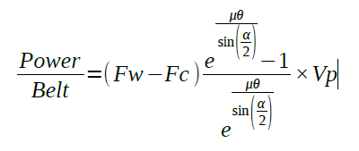
Working load ( Fw ) =w²=17²=289N
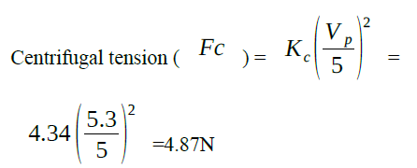
Coefficient of friction=0.3
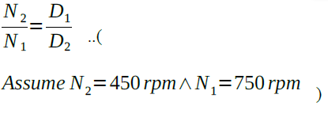
Assume N2=450 rpm∧N1=750 rpm )
D2=225mm
Arc of contact on smaller pulley radians
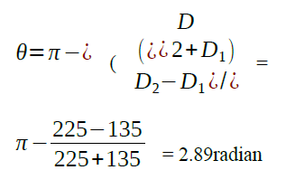
Cone angle
α=38 (Assume value form T-XV-11)
By putting all value in power per belt equation we
get
Power /Belt =1.4 Kw

4) No. of belt required
No. of belt= Pd power per belt
=1.6192/1.4 =2
5) Length of Belt
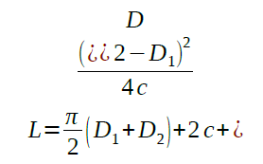
D1=135mm, D2=225mm, C=D1+D2=360mm, By
putting all value in equation we get L=1.3m

6) Pulley Groove Detail… (T-XV-11)
Groove section =B, lp=14 , b =4.2mm, h=10.8mm , e=19.4, f=12.9mm

7) Width of pulley
W=(n−1) e+2f
N=2, e =19.4mm, f =12.9, By all value we get, W=45.2mm

8) Dimension of pulley…… (T-XV-7)
Considering larger pulley D=225mm, Type of material=Cast Iron, Type of Construction=Arm Construction, For D2=225mm W=b= 45.2mm, No. of arm=4… (T-XV-7)

9) Rim Thickness
t=.375√D+3
By putting value of D in equation we get t =8.65mm

DESIGN OF ROLLER CHAIN DRIVE
1) Design Power:-
Pd=PR×K1…. (T-XIV-9)
Rated power (PR) =1.619Kw, Load factor (K1) = 1.2… (T-XIV-2, for moderate shock and 10 hrs service)
By putting value in equation we get Pd=2.65HP
For 450rpm, 2.65HP and double strand (Fig. 14.1)
Selecting chain no. =35, Pitch= 9.525, No. Of teeth=25
Pitch Diameter
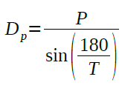
Pitch (P) =9.525mm, No. of teeth (T) =25
By putting value in equation we get,
Dp=63.9mm
Pitch Line Velocity,
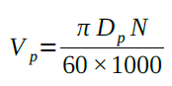
Dp=63.9mm , N=450rpm
By putting value in equation we get
V p=1.505 m se c
Assume T1=T2=21, Dp1=Dp2=63.9mm

2) Power Capacity of Roller Chain
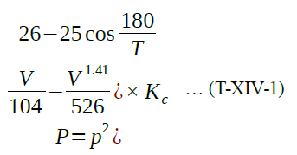
Chain pitch (P) =9.525mm, V=1.505m/sec, T=21,
Capacity factor for no. of strands (Kc) = 1.7
By putting value in equation we get P=1.56Kw

3) No. of strand required
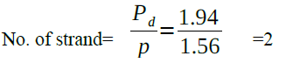

4) Length of pitches
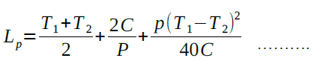
(T-XIV-1)
T1=T2=21
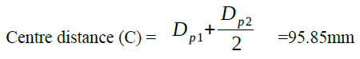
Dp1=Dp2=63.9mm
By putting value in equation we get Lp=41.13mm

5) Standard Roller Chain Sprocket Dimension…
(T-XIV-4)
Pitch (P) = 9.525mm
a) Width of sprocket teeth
to = .56P - .15 =5.484mm
b) Transverse pitch for multiple strand chains
A=101525P =10.977mm
c) Corner relief e=0.125P =1.19mm
d) Chamfer Radius r = 0.54P =5.14mm
e) Outside Diameter
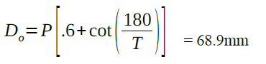
f) Root Diameter
Dr = Dp - 0.625P =57.04mm

DESIGN OF BEVEL GEAR
Bevel Gears
Teeth on pinion (tp) =21, Teeth on gear (tg) =21,N
=450rpm, Rated Power PR =1.472Kw, Let m be the
module Dp = mtp = 21m mm, Dg = mtg = 21m mm
1) Pitch angle
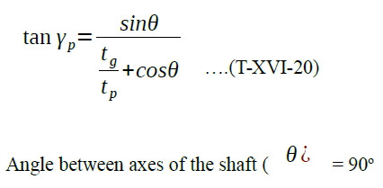
tp =21, tg =21, By putting value in equation we get
γ p=450 , γ g=450

2) Formative no. of teeth
tf= t/cosγ ………. (T-XVI-20)
t = 21, γ=450, By putting value in equation we get
tf=29.69 It will same for both pinion and gear.

3) Design Power:-
Pd=PR×K1………. (T-XVI-20)
Rated power (PR) =1.472Kw, Load factor (K1) =
1.25…… (T-XVI-2, for steady continous
24hrs/day)
By putting value in equation we get Pd=1.84Kw

4) Tooth load
Ft=Pd/V p …………………….(T-XVI-20)
Pd=1.84Kw, Vp =πDN/60×1000 ,
D = 21m, N =450rpm,
Vp = 0.5m m/sec, By putting value in equation we get
Ft=3680 mN

5) Beam Strength
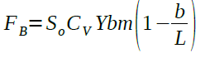
Now selecting cast iron grade for pinion and gear Basic strength (So ) = 105MPa……..(T-XVI-20)
Velocity factor (Cv)=0.5….(For N<1000rpm) Lewis 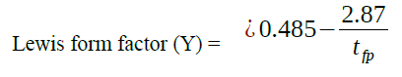
tf=29.69 , Yp= 0.388, Yg = 0.388
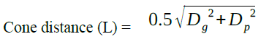
Dp = 21m mm, Dg = 21m mm, L = 14.84m, Width
of gear face (b) = 6.5m……(for L<30m)
By putting value in equation we get FB = 74.41m2
Apply limiting condition
FB = Ft
74.41m2 =3680/m
m = 3.67
Taking standard value of m……..(T-XVI-2)
m = 5
parameter related to m = 5 L = 14.85m =74.2mm
Dg = Dp =21m = 105mm Vp = 0.5m = 2.5m/sec
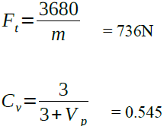
By putting actual value in BEAM STRENGTH
equation we get FB = 62.39 bmin N
FB = Ft
62.39 bmin = 736
bmin = 11.79mm
It is not in range, so selecting b = 30…(b =30 to 35,
T-XVI-21)
FB = 62.39 bmin
FB =1871.7N
FB >Ft
Design is safe
6) Dynamic load
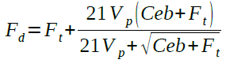
For value of c ,selecting gray cast iron
Deformation factor (C) =5900
Error in profile (e) = 0.012.(Fig. 16.1 , for m =5 and class 1) b = 30, Vp = 2.5m/sec, Ft=736 N
By putting value in equation we get Fd=762.99 N

7) Limiting wear load
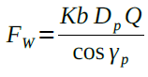
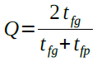
tfg = tfp = 29.68, Q = 1, b = 30mm, Dp = 105mm,
γ p=45o
By putting value in equation we get Fw = 4454.77 Kmin
Now equating Fd and Fw, Fd = Fw 762.99N = 4454.77 Kmin Kmin = 0.17
Selecting actual value of K =0.288………(T-XVI- 6)
Fw(actual) = 1282.97N
Fw > Fd

References
[1] Iman M. Almomani, Nour Y. Alkhalil, Enas M. Ahmad and Rania M. Jodeh, "Ubiquitous GPS Vehicle Tracking and Management System", IEEE Jordan Conference on Applied Electrical Engineering and Computing Technologies (AEECT), 2011.
[2] ZongweiLuo, Tianle Zhang and ChunluWgan, "RFID Enabled Vehicular Wireless Query for Travel Information in Intelligent Transportation System", IEEE International Conference on RFID-Technologies and Applications, 2011.
[3] SaeFujii, Atsushi Fujita, TakaakiUmeduHirozumi Yamaguchi, TeruoHigashino, Shigeru KanedaandMineoTakai, "Cooperative Vehicle Positioning via V2V Communications and Onboard Sensors", IEEE 2011.
[4] Ghassan Samara, Wafaa A.H. Al-Salihy and R. Sures, "Security Analysis of Vehicular Ad Hoc Networks", Second International Conference on Network Applications, Protocols and Services, 2010.
[5] Atmel 32 bit AVR MICROCONTROLLER AT320C3LO123
[6] SKYLAB DS-SKM58-V1.0-110101.
[7] TEXAS INSTRUMENT ULTRASONIC Ranging module HC-SROH.
[8] ANALOG DEVICES Small, Low Power 3-Axis 3g accelerometer.
[9]TEXAS INSTRUMENTS NATION SEMICONDUCTOR LM386 Voltage Audio Amplifier.

