Design of Bicycle Powered Weeder

Ramkrushna Pathekar KDKCOE, Nagpur rajeshpathekar143@gmail.com
Swapnil Thakre KDKCOE, Nagpur Swapnilthakre007@gmail.com

Abstract – Every year in INDIA, an average of 1980 Cr of rupees is wasted due to weeds. Our country faces the total loss of 33% of its economy from Weeds. The Losses are due to some of the following reasons, total loss of 26% from Crop Diseases, total loss of 20% from Insects and Worms, total loss of 6% from Rats. Has been surveyed. Shrinking farm lands, acute labour shortage, decreasing income per acre of cultivation, and economic frustration are some of the key factors hurting a farmer's confidence in continuing farming. Weeding control is done by: mechanical weeding, thermal weeding: flaming, biological control, chemical control, and by farming pattern. It has always been a problem to successfully and completely remove weeds and other innocuous plants. Invariably, weeds always grow where they are not wanted. This work involved the design and construction of mechanical weeder, after discovering that tools such as cutlass and hoes require high drudgery, time consuming and high labour force. As a solution to these problems, mechanical weeder was designed and constructed. The mechanical weeder was made of two implements attachment i.e. the primary cutting edge which is in front to loose soil above and the secondary cutting edge which is behind to do cutting and lifting of weeds. The overall machine field efficiency was 98.67%.

Keywords – Mechanical weeding, field performance.

Introduction
Weeding operation is mostly performed manually with cutlass or hoe that requires high labour input, very tedious and it is a time-consuming process. Moreover, the labour requirement for weeding depends on weed flora, weed intensity, time of weeding, and soil moisture at the time of weeding and efficiency of worker. Often several weeding operation are necessary to keep the crop weed free. Reduction in yield due to weed alone was estimated to be 16 to 42 % depending on crop and location which involves one third of the cost of cultivation. Weeding and hoeing is generally done 15 to 20 days after sowing. The weed should be controlled and eliminated at their early stage.
The earliest and the simplest weed control method is manual weed control. This method was and is accomplished by a person bending down and using their hands to pull weeds out of the soil. This method then advanced to hand tools, from using a stick to using a hand-hoe. The labor required for weeding is expensive, time consuming. To achieve a high yielding vegetable production, good agricultural practices are required.

- AIM OF PROJECT
The aim of the project is to design, construct and test manual weeder, to provide the best opportunity for the crop to establish itself after planting and to grow vigorously up to the time of harvesting.
Weeding with the use of tools like cutlass and hoe requires high labour force in a commercial farming system hence mechanical weeder is necessary to reduce the labour force. Environmental degradation and pollution caused by chemical is reduced by the use of Mechanical weeder. Low effective operation, low work effort and high time requirement for different types of hoe or cutlass, can be overcome with the use of mechanical weeder.
Presently in India, weeding with simple tools such as cutlass, hoe etc is labour intensive and intensive and time consuming. Thus, there is a need for the design of manually operated weeder for intensive and commercial farming system in India. One of the problems in crops and vegetables production is poor weed control; hence there is need of mechanical weeder to increase the production of these products. The cost for employing a Labour force when using simple tools is very high in commercial farming system. This can be reduced using mechanical weeder.

III. METHODOLOGIES
Weeding efficiency (Functional efficiency) was determined by removing manually the weeds in 1m x 1m area of the farm, the weeds was weighed and recorded. The process was repeated in five randomly selected locations on the farm. The average weight of the weeds in 1m x 1m area was calculated for the types of soil. The average weight of the weeds in 1m x 1m area after pass of the weeder through the farm was deducted from the actual weight of the weeds in 1m x 1m area. Thus, functional efficiency was determined from the relation:
Functional efficiency = wt. of weed removed by weed remover
Actual wt. of weed remove manually
The functional efficiency was carried out on different types of soil at the same average speed. The machine performance was evaluated using actual field capacity and design field capacity of the machine.

IV. CONCEPT
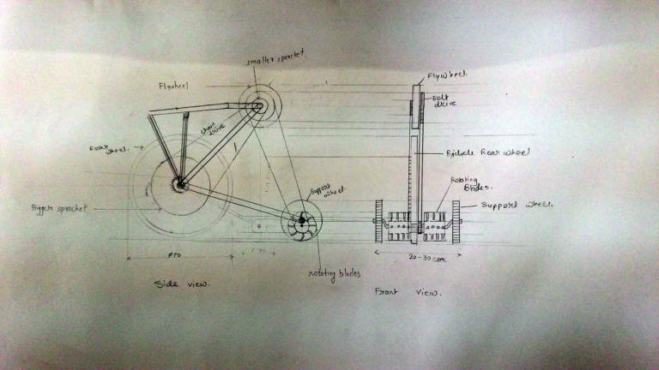
Fig. 3 Concept idea
This Concept involved the development of mechanical weeder, after discovering that tools such as cutlass and hoes require high drudgery, time consuming and high labour requirement. As a solution to these problems, mechanical weeder was designed and developed. The mechanical weeder was made of two implements attachment i.e. the primary cutting edge which is in front to loose soil above and the secondary cutting edge which is behind to do cutting and lifting of weeds. An extra attachment of funnel and circular pipe for fertilizing and seeding of ragi after cultivation. The tool developed will be able to fulfill the present requirement for the weed control. Accordingly, the present development is directed to an improved manual tilling, mulching and weeding tool.

V. SCOPE OF FUTURE WORK
1. The weight of the weeder can be reduced by using lightweight materials and by reducing the size of wheel.
2. Since the weeder was designed for low cost, the weeder was made manual but it can be made automatic by placing a motor.
3. By using some advanced attaching mechanisms, the time required for assembling can be reduced for additional attachments.
4. Fixing the extra attachment of leveler.

VI. CONCLUSION
In conclusion, it was found during observations after the development and testing of this particular manually operated weeder that the overall benefits accruing and associated with the use of the equipment includes:
1. It was faster than the traditional method of removing weed.
2. Less labor needed and it is more economical than hand weeding.
3. Here do not use any fuel and power, Hence maintenance cost is very less.

ACKNOWLEDGEMENT
We feel immense pleasure while expressing my sincere, humble and deepest sense of gratitude to Project guide Dr. C. C. Handa Department of Mechanical Engineering for the valuable guidance and necessary help. He guided us right from the beginning for preparation & presentation of Project.
We extend our thanks to Head of the Department Dr. C. C. Handa who made available the faculties required to ensure the success of the Project. Also we would like to express our deep gratitude to Class Incharge Prof. A.P. Ninawe, Project Incharge Er. P.M. Zode & other faculties of Mechanical Engineering Department of K.D.K.C.E. Nagpur who were constant source of our inspiration.
We also thank our Principal Dr. D. P. Singh and Vice Principal Prof. A. M. Badar K. D. K. College of Engineering, Nagpur for providing us all the facilities in the college required for the completion of our project.

REFERENCES
[1]. Anonymous, 1985. RNAM test codes and procedure for farm machinery, Technical series No. 12, Economic and Social Commission for Asia and the Pacific, Regional Network for Agricultural Mechanization, Bangkok, Thailand.
[2]. Nag P.K. and P.Dutt. 1979. Effectives of some simple agricultural weeders with reference to physiological responses, Journal of Human Ergonomics, 13-21.
[3]. Tiwari, V.K., R. Ailavadi, K.N.Dewangan and S Sharangi. 2007. Rationalized database of Indian agricultural workers for equipment design. Agricultural Engineering International: the CIGRE journal. Manuscript MES 05 004, Vol IX. August, 2007.
[4]. Singh, G.and K.M.Sahay. 2001. Research Development and Technology Dissemination. A silver Jubilee Publication, CIAE, Bhopal, India.
[5]. Biswas, H.S. 1990. Soil tool interaction for mechanical control of weeds in black soils. Unpublished Ph.D. thesis, Indian Institute of Technology, Kharagpur.

