*Implementing Six Sigma for Continuous Improvement*

***Ashutosh K Singh,*** *KDKCE, 9970922189, ashutosh_7singh@rediffmail.com* ***Ulhas H Dhruve****, KDKCE, 9595473121, ulhasdhruve@gmail.com*

***Abstract -* The Six Sigma method is a complex and flexible system of achieving, maintaining and maximizing the business success. Six-Sigma is based mainly on understanding the customer needs and expectation, disciplined use of facts and statistics analysis, and responsible approach to managing, improving and establishing new business, manufacturing and service processes.**

***Keywords:* Safety Management, Six Sigma, Quality, DMAIC, Improvement.**

I. INTRODUCTION

*A. Definition*

Six Sigma is a gauge of quality and efficiency, and a measure of excellence. It means delivering top quality services and products while virtually eliminating all internal inefficiencies.It consists of a set of tools and techniques for process improvement. It contains the formulae and calculative part for calculating the errors and the efficiency of the products.

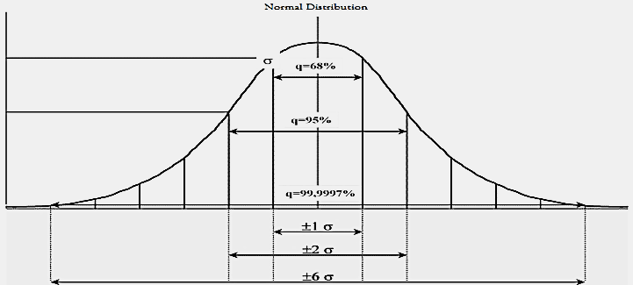

Fig 1.Figure showing probability values of different sigma.

*B. Background of Six-Sigma.*

Sigma is a statistical unit of measure that reflects process capability. It is a way to determine or even predict errors or defects in your process, whether it be manufacturing or delivering a service. In this probability bell curve the standard deviations are obtained.

Six Steps to Six Sigma are:

* Identify the product or service you provide.
* Identify the customers for your service.
* Identify your needs.
* Define the process.
* Makes the process mistake-proof.
* Ensure continuous improvement.

A six sigma process is one in which **99.99966%** of the products manufactured are statistically expected to be free of defects (**3.4 defective parts/million**).

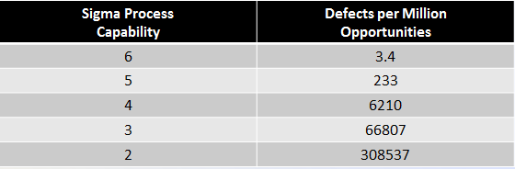

Fig 2.Figure showing defects per million for different sigma.

*C. History of Six-Sigma*

The Six Sigma methodology was formalized in mid 1980s at the Motorola. New theories and ideas were combined with basic principles and statically methods that have existed in quality engineering circles for decades. The building blocks were enhanced with business and leadership principles to form the basis of the complete management system. The results were staggering increase in the level of the quality for several Motorola products and the inaugural Malcom Baldrige National Quality Award was bestowed on the company in 1988.

Everyone wanted to know how Motorola had done it. Then President Robert Galvin then chose to share Motorola’s secret openly and by the mid-1990s, corporations like Texas Instrument, Asean Brown Boveri, Allied Signal and General Electric had begun to reap similar rewards. By 2000 many of the world top corporations had a Six Sigma initiative underway, and by 2003, over $100 billion in combined savings had been tallied.

Six Sigma became the global standard of quality business practice embraced by the American Society for Quality. Universities worldwide now offer courses. Dozens of consulting and softwares companies have brought products and tools to the market. By the end of 2004, over 200 books of Six-Sigma were in print, and entering them “Six Sigma”

returned 23,20,0000 hits in Google.

Carl Fredrick Gauss introduced the Normal Deviation Curve. Carl Fredrick Gauss was the first one to introduce the Normal Distribution Curve for Six Sigma.

Even Henry Ford knew about this distribution curve 100 years ago. He and his other industrialist of his day incorporated specifications and standards into their business. Ford also designated variation in limits within which to operate. By doing so, he could accept the inevitable presence of variation while not ignoring its tendency to create defects and business loss.

*D. Technical Prospective of Six-Sigma.*

The technical objective of the Six Sigma is to ensure the high quality and reliability of the products, services and the transactions the lifeblood of all the business and organizations. The technical goals of six sigma is for products, services, and transactions all to be performed with highest quality as effectively and efficiently as possible. This requires performance targets for all the components in the system, and for each important characteristic of every component.

For E.g. A car axle (component) has to have the proper form, fit, and function to perform as intended, and if it to fit together with other component of the car. The goal of Six Sigma is to come as closer as possible to your target.

II. METHODOLOGY OF SIX-SIGMA

1. *Definition*

The working with Six Sigma process is also based on some tools and technology to calculate the value of sigma from the given data and to work upon the problems faced upon by the industry and the other manufacturing firms.

1. *DMAIC Phase*

The methodology for working with Six Sigma is DMAIC. DMAIC stands as:-

D-D stands for Define. Defining the problem or the errors faced by the manufacturing firms or the industry.

M-M stands for Measure. Measure the error of the given problem or the find out the sigma value.

A-It stands for Analyze. Analyses the given problem and to find a method to solve the given problem.

I-I stands for Improve. Improving the status of the problem taken and thus helping to irradiate the problem from it.

C-C stands for Control. Controlling or maintaining the solution which has been provided for it.

1. *DEFINE Phase*

This phase is mainly used for defining errors.

This is mainly a problem identification phase in which we carry out detection of safety related problems of the Industry.

In this phase we observe the problems of the industry and try to implement Six-Sigma Methodology to find the solution for it. The main aim of this phase is defining the errors. Once the errors are defined it becomes very easy to solve them.

The tools to work with Define Phase are:-

1. *PDCA Chart.*

PDCA stands for Plan Do Check and Act. Here first the problem is planned then done then checked how to do and finally acted for it.

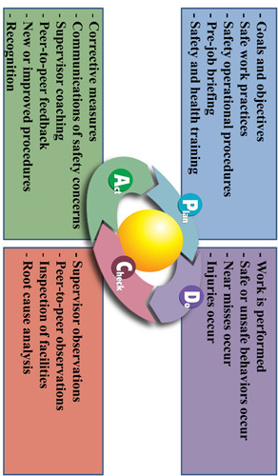

Fig 3.PDCA Chart

1. *Cause & Effect Analysis*

The Cause & Effect Analysis shows the cause of each problem due to which it occurred and then finding its effect on the solution trying to be obtained.

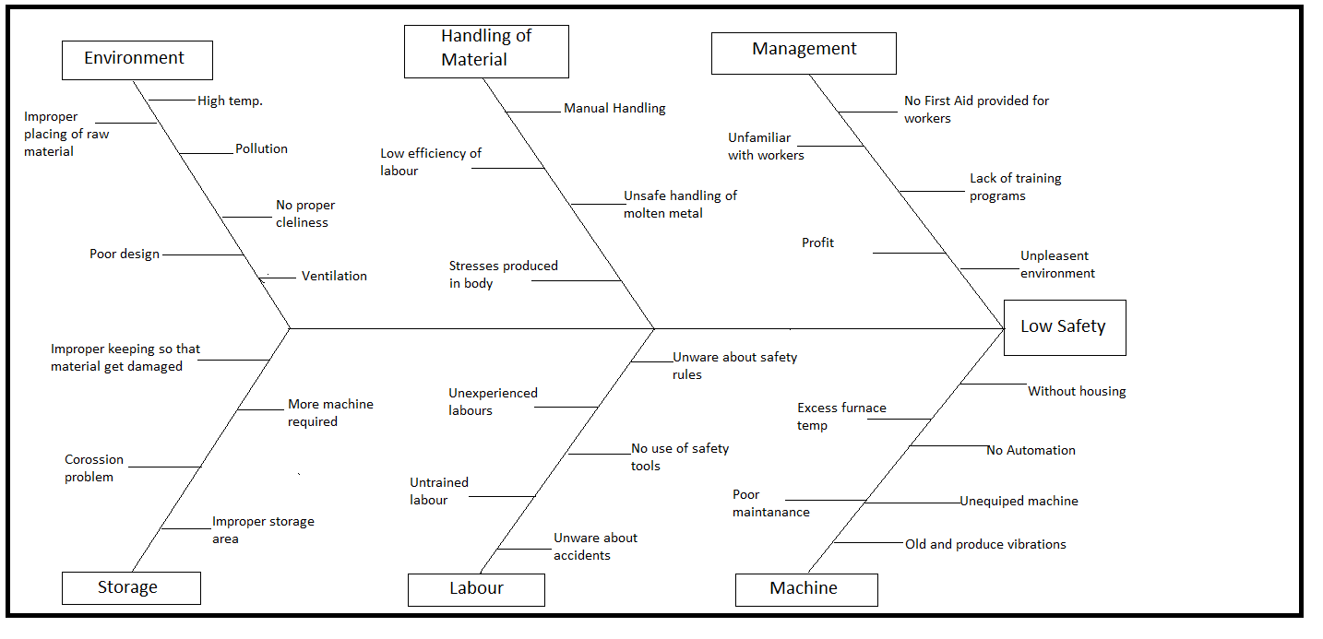

Fig 4.Cause and Effect Analysis Chart

1. *MEASURE Phase*

This phase involves numerical studies and analysis of data obtained during the DEFINE phase. This phase mainly focuses on measurement system validation and gathering root causes. Here in this phase the calculation of sigma value is done. For the calculation of the sigma value we can use the formula.

Sigma = 0.8406 + √(29.37 - 2.221*ln(PPM)) Where, PPM : (DPU*106)/(Opportunity for Error) DPU : (Total Defects)/(Total Units) Defects : Employees Recordable Injury/ Illness.

1. *ANALYSE Phase*

This basic steps followed under this phase were defining performance, objectives, identifying the various sources of errors and establishing process capability. In this phase different statistical tools are analysed to cause of accidents identified in the previous phase**.**

1. *FMEA Process*

In this process, the analysis of the failure mode effect is done to ensure the improvement of this process. Here in this phase scores are given upto 10 in various aspects of the problems and then total effective RPN is calculated and thus total effect is calculated of the problem.

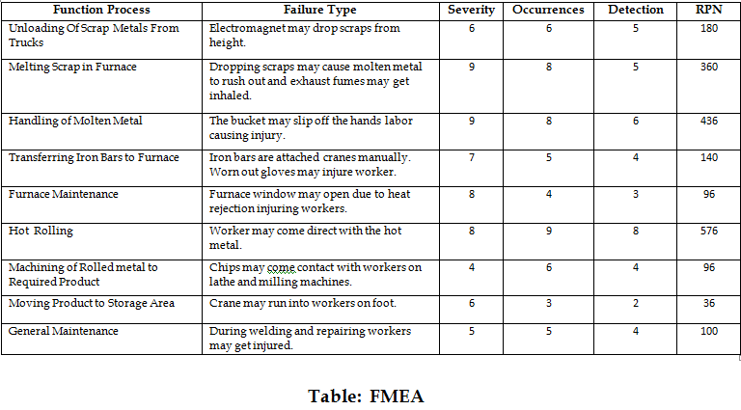

Fig 5. FMEA Chart

1. *IMPROVE Phase*

In improve phase we identify the methods by which solutions to the problems noted in the Analyse phase can be applied. We note down the improvements done. The tools for this phase are 5-S Audit Sheet etc. In this phase two most important aspects are done:-

* Calculations of the value of sigma after the improvement phase.
* Observations to be made after the Improvement phase.

1. *CONTROL Phase*

This is the last phase of the DMAIC Methodology implemented in our project. Here we try to sustain the developments made in our DMAIC Phase and aim towards the continuous improvement. We check that no degradation in the sigma level occurs.

III. APPLICATIONS OF SIX-SIGMA

Six-Sigma has found a lot of applications in the commercial, business and other marketing areas. Problem-solving approach is traditionally used in the following fields:-

1. *Business*

* Sales & Marketing
* Human Resources.

1. *Engineering*

* Software
* Information Technology.

1. *Production Processes*

* Manufacturing.
* Inventory/Warehousing.

IV. IMPLEMENTATIONS OF SIX-SIGMA

The Companies that are currently implementing Six-Sigma are:-

* Motorola
* 3M
* Lockheed Martin
* Texas Instruments
* Bell Helicopter
* Apple Computer
* Chevron
* Citigroup
* Hewlett Packard
* Ford Motor Company
* Honeywell
* General Dynamics
* Adolph Coors
* Eastman Kodak
* United States Army
* Xerox
* NASA

And many more.

V. BENEFITS OF SIX-SIGMA.

The benefits of applying Six-Sigma Methodology are:-

* Reduction in costs.
* Reduction in waste chain.
* Better understanding of customer requirements.
* Improves quality performance.
* Develops robust products and processes.
* Provides critical process inputs.

ACKNOWLEDGMENT

Ashutosh K Singh, Ulhas H Dhruve thanks to all of those researchers who have made a lot of contributions and made milestones in this area of research.

REFERENCES

1. Craig Gyai, Neil De Carlo and Bruce Williams, “SIX SIGMA FOR DUMMIES,” Wiley Publication, 2005.
2. Thomas Pyzdek,“THE SIX SIGMA HANDBOOK” McGraw Hill, 2003.
3. Allison Adams “SIX-SIGMA Constantly Improving Quality”, EMIS 7370 – FALL 2007.
4. Patricia O’Rourke,“Using Six-Sigma in Safety Matrices”, Safety and Industrial Hygiene Motorola Plantation Florida, 30 June 2011.
5. Lateef–Ur-Rehman, Ateekh-Ur-Rehman, “Safety Management in a Manufacturing Company: A Six Sigma Approach”, King Saud University, Riyad, KSA ISSN: 2248-6985 Engineering 2012.
6. Miroslav Rusko, Ruzena Kralikova. “Application of Six Sigma into EMS Design” Slovak University of Technology, Bratislava, 2011