*Impact of Lean Manufacturing on Global World*

Govind T Gaurikar,KDKCE, 8624803747, *sonu866@gmail.com*  Samiksha R Sukhadeve, KDKCE, 7588123911, *samikshasukhadeve.19@gmail.com*

***Abstract -* Lean Manufacturing was developed by Toyota Motor Company to address their specific needs in a restricted market in times of economic trouble. These concepts have been studied and proven to be transferrable and applicable to a wide variety of industries. This paper aims to integrate a set of metrics that have been proposed by different authors in such a way that they are consistent with the different stages and elements of Lean Manufacturing implementations. To achieve this, two frameworks for Lean implementations are presented and then the main factors for success are used as the basis to propose metrics that measure the advance in these factors. A tabular display of the impact of “Lean activities” on the metrics is presented, proposing that many a priori assumptions about the benefits on many different levels of improvement should be accurate. Finally, some ideas for future research and extension of the applications proposed on this paper are presented as closing points.**

***Keywords*: Lean Manufacturing, Performance Metrics, Measurement Systems, Lean Activities.**

1. INTRODUCTION

This article presents the relationship between the activities that are normally considered part of Lean Manufacturing and the performance metrics that are proposed for Lean environments.

To accomplish this, first a brief historical and conceptual background in Lean Manufacturing is presented, followed by a framework of success factors for Lean implementations. Then, the dimensions of performance that should be measured in a Lean environment are presented, followed by the development of metrics for each of these dimensions.

Finally, a table is used to relate the activities that are associated with Lean production to the performance indicators previously described.

Avenues for future research are mentioned, in order to suggest possibilities for further exploration in this topic of the effect of Lean Activities in the performance measures.

1. *Background in Lean Manufacturing*
2. *Historical Development*

To provide context for Lean Manufacturing and measurement systems, it is important to understand the historical development of Lean concepts.

All roots of Lean point first to Henry Ford, who put in place an impressive production system in the Highland Park manufacturing plant, in 1913.

There, a set of practices and tools (interchangeable parts, standard work and the assembly flow line) was put in place in such an integrated way that allowed them to turn out products at incredible speeds, with very short flow times and high consistency.

This system was not very flexible, though. The Model T was manufactured virtually unchanged during 19 years under this system, and there was no need for setups or changeovers since there was only one product being processed in that line. Increased demand for shorter product cycles and more variety, as well as the market demands after World War II, changed the competitive marketplace in such a way that Ford’s early “Leanness” was not sustained in the long run.

But, there were good students learning important lessons. Kiichiro Toyoda (member of the founding family of Toyota) and Taiichi Ohno (Toyota’s leading manufacturing engineer) visited Ford factories right after World War II and observed their operation. They were convinced that with some elements from the Ford system, their adaptation to their scale and reality and a lot of ingenuity they could make Toyota a competitive force in the automotive market.

Essentially, they changed the emphasis from machine and workstation optimization to product flow through the total process, implementing some clever and “simple” ideas like dimensioning the manufacturing resources according to actual demand (rightsizing), improving the self-monitoring capabilities of equipment to ensure quality (Jidoka), designing the process layout to facilitate the sequence of the operations (Group Technology), studying and improving quick setups to enable rapid changeovers (SMED) and the use of kanbans to coordinate the production pull from and link one workstation to its predecessors and successors, and also to link the company with its suppliers and enable JIT supply (Womack, 2002).

These processing improvements made possible to offer a wide variety of products in a sequence that reflected more closely the market’s demands, reducing lead times and eliminating the need for large volumes of inventory (which, with the space constraints for manufacturing and warehousing facilities in Japan, was critical for the financial success of any business).

Also, a management system was developed to reflect and support all these changes in focus and style, which is now known as the “Toyota Production System” (TPS). It is not the focus of this document to go into great detail about TPS, however some elements will be mentioned, like autonomous work teams, visual controls and information displays, “andon” lights to observe the status of the process, “jidoka” (autonomation) or the ability of equipment to detect out of control processes and stop itself, and the continuous strive to reach one piece flow.

II. GENERAL PRINCIPLES

It has been said that the two basic concepts in Lean thinking are to eliminate waste and create value (Murman et. al., 2002). Emiliani (1998), based on Womack and Jones (1996) presents a more detailed framework with five basic steps:

*• Specify Value:* What do customers want? When and how do they want it? What combination of features, capabilities, availability and price will be preferred by them?

*• Value Stream Analysis:* A Value Stream is the collection of processes and activities required to bring a product to the customer, from beginning to end. The Value Stream is not limited by boundaries between companies; that is the reason to strive to integrate suppliers, manufacturers, distributors and even retailers in the efforts to recognize and analyze the Value Stream. Also, three

main categories of activities are distinguished: a). Those that add value; b). Those that do not add

value but cannot be currently avoided and c). Those that do not add value and should therefore be eliminated.

*• Continuous Flow:* Companies should try to make value flow continuously, not in batches. In this paradigm, the term *one piece flow* has great appeal and is highly coveted. Also, traditional functional organizations do not help continuous flow, therefore a focused teams approach (closer to the product) is recommended.

*• Customer Pull:* A principle made popular by the JIT concepts; it states that companies should not

*push* their products to customers, and rather let them pull “value” (products or services) and link all the production chain (even with suppliers) in such a way that materials are not released and activities are not done until they are needed. The discipline of pull is established and enforced by using *kanbans*, which are physical or electronic mechanisms to transmit the need for parts and subassemblies from one point in the process to the preceding one.

*• Continuous Improvement:* As the commercial slogan for the Toyota luxury brand (Lexus) puts it, it is *“The passionate pursuit of perfection”*. It is the conviction that improvement efforts are never finished, and it is the consistency to keep the discipline for improvement in place (*kaizen*).

III. THE TRANSFORMATION PROCESS

1. *Planning the change*

The first steps to do when embarking on a transformation process provide an important foundation for the journey. Three things should be present before starting any project:

1. *Define the need for change (burning platform):* It is essential to understand and communicate

Continuously what is the motivation for a Lean transformation effort? This should provide guidance and clarity to everybody in the company (Hyer, et.al, 1999).

2. *Top management commitment and support:* If employees don’t see, feel and believe in a real

commitment from upper management, nothing much will happen. This involvement and support should be not only verbal but also factual, with managers participating in shop floor activities and kaizen events.

*3. Identify target areas, model lines and propagation strategy:* A plan should be crafted, indicating which production lines will be transformed to Lean, in what sequence and time frame. This plan should also address which lines are going to go first, to be used for demonstration effect, and also how the people from that line (with newly acquired knowledge and skills) are going to contribute in the propagation of Lean concepts through training and coaching for subsequent product lines.

1. *Success Factors*

According to the framework developed by Liker (1998), presented (with minor additions and changes) in Figure 1, there are four key factors for success in the implementation of a Lean effort.

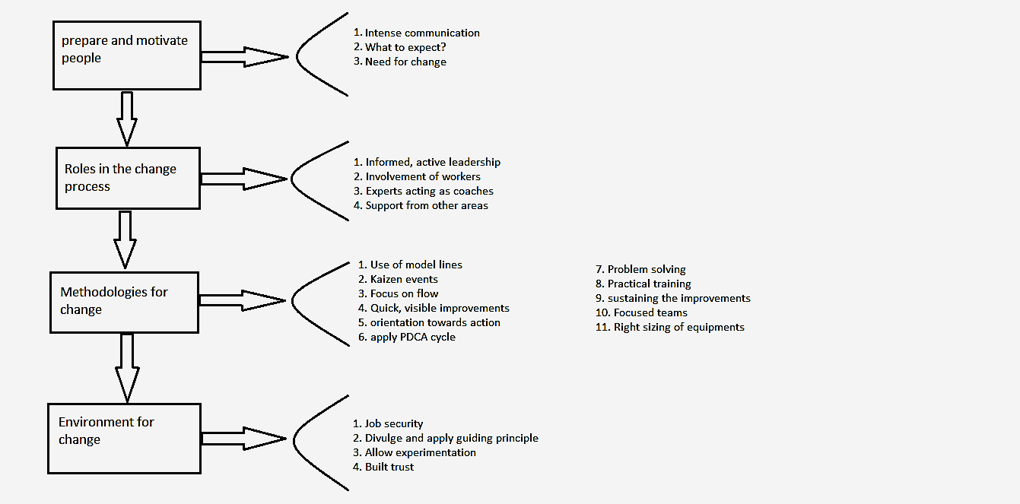

Fig 1Figure showing key for success.

1. *Preparation and motivation of people*

Intense communication, clarification of expectations, emphasize the need for change and, essentially, letting people know what’s ahead.

1. *Roles in the change process*

The need for an informed and active leadership, the involvement of the employees in all aspects of the project, experts acting as coaches and support from management and the other functional areas are required roles that need to be filled for the success of a lean implementation.

1. *Methodologies for change:*

Here all the technical tools that sometimes are thought to be “the Lean things” come into play, like the use of model lines, kaizen events as a way to participate and show quick and visible improvements, the orientation to action (training is done simultaneously in the classroom and in the practice in the shop floor), the work in focused teams, the right sizing of equipment and the change of the physical line layout.

1. *Environment for change:*

As in any transformation effort, the environment that upper management facilitates and puts in place is critical for success. In Lean implementations is important to provide job security (no Lean-related layoffs), constant reinforcement of the guiding principles, a safe environment for experimentation and a climate of mutual trust between workers and management and also amongst different work teams.

These success factors have to be taken into account in the planning of the process, so the implementation phase can begin. These implementation activities should lead to improvement in five dimensions, which are the concepts the company is trying to put into action (Adapted from Karlsson and Ahlstrom, 1996 and Martinez and Perez, 2001)**.**

1. Elimination of waste

2. Continuous improvement

3. Continuous flow and Pull-driven systems

4. Multifunctional teams

5. Information systems

The degree to which these goals are “reached” will lead to the proposal of metrics that reflect the advancement of a team or line in the implementation of Lean Manufacturing.

IV. IMPLEMENTATION

In Figure 2 a framework for Lean Manufacturing implementation is presented.

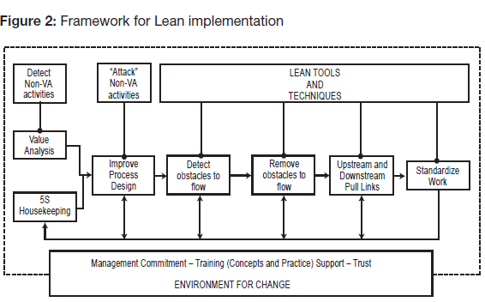

Fig 2.Figure showing framework for lean manufacturing

1. *Measuring the progress*

For each of the improvement dimensions, several indicators can show the company the evolution of the line in its process (Karlsson and Ahlstrom, 1996 and Martinez and Perez, 2001).

1. *Elimination of waste*

Waste is everything that does not add value to the product, like inventories, machine setups, machine downtime, movement of parts and scrap. Therefore, the metrics should reflect those categories of waste:

1. *WIP:* Value of WIP in the line.
2. *Setup time:* Time spent in setups/ total productive time (percentage).
3. *Machine downtime:* Hours-machine lost due to malfunction/Total machine hours scheduled (percentage).
4. *Transportation:* Number of parts (trips) transported * Distance.
5. *Space Utilization:* How much area does the line need, including its WIP and tools.
6. *Continuous improvement*

It represents the discipline of considering evolution as the normal state of a system. Some ideas to measure this include (Rentes and Van Aken, 2003)

1. *Continuous flow and Pull-driven Systems*

It is the ability to abandon the batch mentality and adjust the processes to accept smoother movement of products through the line, which are going to be triggered by the pull of the customer of each process. Some metrics:

1. *Lot sizes:* Average lot size for each product.

*Order flow time:* Time an order spends being processed in the shop floor.

1. *Order lead time:* Average time from the placement of an order (by a customer) to its delivery.

*c) Pulling Processes:* Percentage of the line processes that pull their inputs from their predecessors.

*d) Pull Value:* % of the total annual value or throughput of the system that is scheduled through pull mechanisms.

*4) Multifunctional teams*

In Lean implementations, teams have more responsibility and autonomy, so improvement and problem-solving can happen closer to the source (Niepce and Molleman, 1996; Forza, 1996). Also, to make flexibility in the line feasible, it is necessary to have a multi-skilled workforce. Some metrics for these aspects:

*a) Autonomous control:* % of quality inspection carried out by the team.

*b) Workteam Task Content:* % of the tasks required to make the product performed by the team.

*c) Cross training:* Average over team members of Number of skills a team member possesses/ Number of skills needed in a team.

d) Number of employees capable of assignment rotation.

1. *Information systems:*

The reduction of vertical levels in the structure, and the autonomous operation that teams have to reach, makes necessary that employees have timely access to better information to enable problem solving and decision making. It does not necessarily mean, but it certainly does not exclude, computerized information systems. Some metrics:

1. Frequency with which information is given to employees.
2. Percentage of procedures that are documented in the company.
3. Frequency with which the line or cell progress boards are updated.
4. *Purpose of the Metrics*

Every metrics system has different applications. A proposal such as the one presented in this article would have several uses, such as:

1) *Monitoring the progress of a Lean implementation*

The establishment of a baseline for the different metrics at the outset of an implementation process is necessary to show progress and to assess the effectiveness of the different changes, tools and techniques that are implemented.

1. *Continuous monitoring*

Once different tools are implemented (post-implementation), these metrics will serve, in a way, as the input to build control charts and to establish improvement goals for report periods (monthly, quarterly and yearly review meetings).

1. *Benchmarking*

It should be clear that no two factories are identical, not even manufacturing the exact same product. However, metrics can always be used for partial comparisons and to stimulate exchange of ideas and learning processes. Benchmarking is a key use of metrics to examine and compare processes that are similar; team performances; use of materials and process inputs; total and factor-specific productivity. No useful comparison can be drawn without the existence of at least basic measurements of the inputs, outputs and performances of processes and functions in the company.

V. IMPACT OF THE TYPICAL LEAN ACTIVITIES ON THE METRICS

The framework presented in this section is a proposal that and would require a technical investigation to be confirmed. It is, however, an interesting starting point to understand the relationship between the actions taken and their measured results.

When Lean Manufacturing is brought up, there are several things that come to mind such as production lines organized in cells, the use of kanbans for production control and many others. These, however, are not the principles that drive lean implementations, they are the tools that transformation teams have at their disposal to operationalize the Lean concepts. These are the “things to do” once it is known which are the “things to achieve”.

However, it is interesting to try and classify the impact these activities should have on the Lean metrics that have been presented. This can illustrate the level of the impact that activities can have on the overall Lean transformation process, and will also serve to clarify why the adoption of some tools without the conceptual clarity of “why is the company doing this?” and “where is the company headed with this?” can have disappointing results.

The activities or features of a Lean system have been classified in four main categories, according to their focus. Some activities can be clearly considered to belong in more than one category, so they have been placed in the category that seemed to have a stronger association with them. The categories and activities are:

1. *Industrial Engineering:*

This category includes the activities and features related to production planning and methods. The activities are:

1. *Production Smoothing:* It is the effort to run the process in a sequence that resembles as closely as possible the composition of the actual market demand.
2. *Use of kanbans for pull:* It is the employment of a signaling mechanism to inform the previous stage in the process that a certain number of a specific part is required.
3. *SMED (Single Minute Exchange of Dies):* It is a systematic way of analyzing and shortening setup times.
4. *TPM (Total Productive Maintenance):* It is a set of tools and techniques aimed at transforming maintenance from an activity done “when problems arise” to a normal part of operation.
5. *Work standardization:* It is the formalization of the way things are done, to enhance their consistency and repeatability.
6. *Physical Processes:*

These are the activities that require physical changes to equipment and workplace (probably suggested by Industrial Engineers anyway).

*1)Rearrange processes in cell layouts*

This is the grouping of the equipment needed to produce a family of products into one specific area, to make them a unit.

*2)Right-sizing of equipment.*

Instead of rigid, hard automation, large batch equipment with lengthy setups, Lean operations require flexible, small lot size with faster changeover machines.

*3)Change the material handling equipment*

For example, going from industrial trucks moving pallets(batches) of product to conveyors moving units without room for WIP accumulation.

4)*Visual Controls*

It is the use of visual aids for different purposes in the workplace, like tool placement, control of equipment parameters and status of the process, for example.

1. *Personnel Activities:*

These are activities and features that work mostly with people and the way they interact in and with the workplace.

*5S:* It is a set of principles and practices that improve the environment in the workplace and the quality of work life, starting from cleaning and sorting and evolving to self-discipline and autonomous teams. *Power to stop the line:* In Lean environments the workers have the authority to stop the production line when they detect defects to work immediately in their solution and attack the problem at its roots.

*Cross training:* As work cells need to be more autonomous and also the production rhythm can be altered changing the staffing of a cell, it becomes essential that workers become multi-skilled. This also enriches the content of their work and improves their perspective for process improvement.

*Root-cause analysis:* It implies the use of simple tools (Five whys, Fishbone Diagrams, 5M diagrams) to tackle the problems at work and find the solution to the problem, not to symptoms. This is essential in an environment with autonomous teams.

*Information Displays:* Lean environments use a great deal of information displayed in the work cells and in the plant to enable everybody to know the status of the process at any given time.

1. *Management Support:*

These features deal mostly with the environment set-up by management, to ensure that the transformation process takes place.

1. *Management Commitment:*

This has to be experienced all the workers, because if only middle management or the production area try to change to a Lean environment they will clash with other areas and upper management.

1. *Empowerment:*

The ability to make decisions as close as possible to the problem, the power and tools to know what to do or how to find help.

1. *Leading by example – involvement:*

Managers and engineers have to participate in training, 5S events and kaizen events. A manager with a messy and cluttered office can not praise the advantages of 5S to his workers.

1. *Monetary support:*

Some changes will require investment, like acquiring a rack for tool storage or installing a conveyor belt. The teams need to know that necessary investments will be done.

ACKNOWLEDGMENT

Govind T Gaurikar, Samiksha R Sukhadeve thanks to all of those researchers who have made a lot of contributions and milestones in this area of research.

CONCLUSIONS

Lean Manufacturing implementations require the establishment of an environment that makes the rest of the elements of the process possible. This environment (set up by management) will ensure that employees feel empowered and have the necessary tools to gain product and process ownership, focused teams work and autonomy in the development of solutions and process improvements.

Five main dimensions can be measured to assess the degree of evolution in a Lean transformation. These are Elimination of Waste, Continuous Improvement, Continuous Flow and Pull Driven Systems, Multifunctional Teams and Information Systems. Four or five metrics were defined for each of the dimensions.

What is the relationship between the activities and features of a Lean environment (which are commonly mentioned in practice and in the literature) and the Lean performance metrics presented? This question was addressed in a speculative fashion, leaving open the door for more research to establish these relationships with actual data.

Lean Manufacturing is much more than a manufacturing technique. It is a different way of viewing the labour relationships, the way operations are done, the way value is added and therefore the way used to measure it should be different. This paper presented some of the commonly used performance metrics in the research literature.

REFERENCES

1. Sohal, A (1996). Developing a Lean Production Organization: An Australian case study. *International Journal or Operations & Production Management, 16(2),* 91-102.
2. Martinez, A. & Perez, M (2001). Lean Indicators and Manufacturing Strategies. *International Journal of Operations & Production Management, 21(11)*,1433-1451.
3. Thompson, P. & Wallace, T. (1996). Redesigning production through teamworking: Case studies from the Volvo Truck Corporation. *International Journal of Operations & Production Management, 16(2),* 103-118.
4. Niepce, W., Molleman, E. (1996). A Case Study: Characteristics of work organization in Lean Production and Socio-Technical Systems. *International Journal of Operations & Production Management,16(2),* 77-90.
5. Emiliani, M.L. (1998). Lean Behaviors. *Management Decision, 36 (9),* 615-631.
6. Andreas Huttmeir, Suzannede Treville, Annvan Ackere, Leonard Monnier, Johann Prenninger, Trading off between hei junka and just-in-sequence, Int. J. Production Economics 118 (2009) 501–507.
7. Muris Lage Junior, Moacir Godinho Filho, Variations of the Kanban system: Literature review and classification, Int. J. Production Economics 125 (2010)13–21