“An Experimental Investigation Into the Performance of a Flat Basin Type Solar Still for Single and Double Glass Covers with Various Glass Cover Angles”

Author 1 : Shubham Bhanarkar K.D.K.CE +919405353923 shubhu1894@gmail.com
Author 2 : Mahesh Jagtap K.D.K.CE +917385671973 maheshjagtap723@gmail.com
Author 3 : Sumit Hajare K.D.K.CE +917387327315 sumithajare5@gmail.com

Abstract - Solar energy has the greatest potential of all the sources of renewable energy. Solar energy is available in abundance and considered the easiest and cleanest means of tapping renewable energy. A device which will convert the dirty/ saline water in to pure/ potable water using the renewable source of energy called solar still. Solar still method of distillation is simple, cost effective and economically friendly
Keyword: flat basin, renewable energy, saline water, pure water, various angles, single and double glass cover.

Introduction

Solar energy is available in abundance and considered the easiest and cleanest means of tapping renewable energy. All forms of energy on the earth are derived from sun. However, the more conventional forms of energy. No significant polluting effects. Only one percentage of earth’s water is in a fresh, liquid state and nearly all of this is polluted by both diseases and toxic chemicals. For this reason, purification of water supplies is extremely important. A device which will convert the dirty/ saline water in to pure/ potable water using the renewable source of energy called solar still.
This project focuses mainly on small-scale basin-type solar stills as suppliers of portable water for families and other small users. Of all the solar still designs developed thus far, the basin-type continues to be the most economical. Solar still is an airtight basin that contains saline or contaminated water (i.e. feed water). It is enclosed by a transparent top cover, usually of glass or plastic, which allows incident solar radiation to pass through. The inner surface of the basin is usually blackened to increase the efficiency of system by absorbing more of the incident solar radiation. The feed water is heated up, starting to evaporate and subsequently condensed on the inside of the top cover, which is at lower temperature as it is in contact with the ambient air. The condensed water (i.e. the distillate) flowing down the cover is collected in a collecting trough and then stored in a separate Basin. According to number of glass cover used solar still can be classified as two types – Single Effect Type and Double Effect Type.

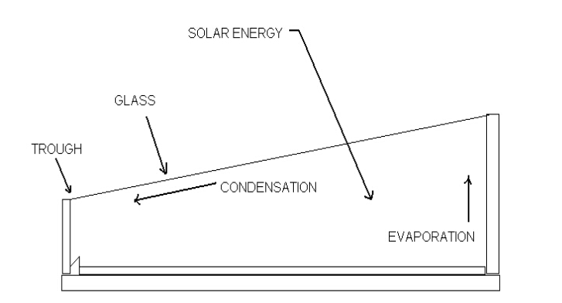

Fig.1: Single effect type solar still

Single Effect Type is most common in conventional solar still. It generally consists of a basin with black bottom having trays for saline water with shallow depth. A transparent air tight glass or a plastic slanting cover encloses completely the space above the basin. Incident solar radiation passes through the transparent cover and is absorbed by black surface the still.
Brackish water is then heated and water vapour, condenses over the cool interior surface of the transparent cover. Condensate flows down the glass and gets collected in troughs installed as outer frame of solar still.

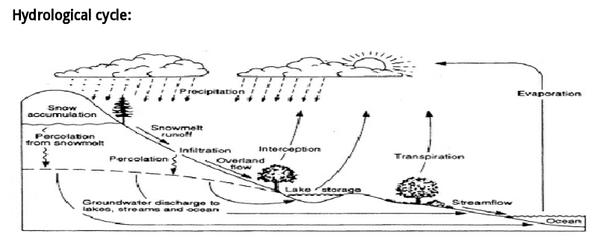

- EXPERIMENTAL SETUP

The experimental setups consist of a single and double glass covers solar still. Solar still has a black painted FRP basin which is filled with brackish water. The layout diagram is shown in fig. 2

The single and double glass cover solar still is placed in north-south direction. Solar sill is mounted on an iron stand

Fig.2: layout of solar still (all dim. are in mm.)

- WORKING OF SOLAR STILL

The setup consists of a double glass solar still. The different angles were selected for performing an experiment (i.e. 5⁰, 14⁰&30⁰). The objective of this experiment is to find out the best suited angle and for which angle solar still is most efficient with single and double glass covers.

- EXPERIMENTAL PLAN

Experiment are planned to conduct at the Mechanical Engineering Department block of KDKCE, Nagpur, Maharashtra, India during March and April. The experiment will be conducted for different glass angles and single & double glass cover.

- MEASURING INSTRUMENTS
  - Thermometer

The mercury-in-glass or mercury thermometer was invented by physicist Daniel Gabriel Fahrenheit in Amsterdam(1714). It consists of a bulb containing mercury attached to a glass tube of narrow diameter; the volume of mercury in the tube is much less than the volume in the bulb. The volume of mercury changes slightly with

temperature; the small change in volume drives the narrow mercury column a relatively long way up the tube. The space above the mercury may be filled with nitrogen or it may be at less than atmospheric pressure, a partial vacuum.
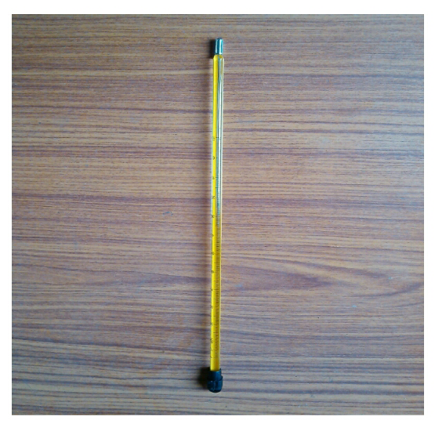

Fig.3: Mercury-in-glass thermometer

  - Radiation meter

A radiation meter is a device for measuring the radiant flux (power) of electromagnetic radiation. Generally, the term radiometer denotes an infrared radiation detector or ultraviolet detector yet it also includes detectors operating on any electromagnetic wavelength.
Fig.4: Radiation meter

A common example is the Crookes radiometer, an early-model device wherein a rotor (having vanes which are dark on one side, and light on the other) in a partial vacuum spins when exposed to light. A common myth (one originally held even by Crookes) is that the momentum of the absorbed light on the black faces makes the radiometer operate. If this were true however, the radiometer would spin away from the non-black faces, since the photons bouncing of those faces impart even more momentum than the photons absorbed on the black faces.

  - Wind speed anemometer

An anemometer is a device used for measuring wind speed, and is a common weather station instrument. The term is derived from the Greek word anemos, meaning wind, and is used to describe any air speed measurement instrument used in meteorology or aerodynamics. The first known description of an anemometer was given by Leon Battista Alberta around 1450.

Anemometers can be divided into two classes: those that measure the wind’s pressure; but as there is a close connection between the pressure and the speed, an anemometer designed for one will give information about both.

Fig.5: Anemometer

- CONCLUSIONS
Never before experiments have been conducted with double glass cover and various glass angles.
Optimized angle will be known after the performance of an experiment

REFERENCES
[1] G.N Tiwari and Sangeetha Suneja, Performance Evaluation of an inverted absorber solar still, Energy convers Mgmt.Vol-39 (1996) pp 173-180.
[2] G.N Tiwari, A. Kupfermann, Shruti Aggarwal A new design for a double slope condensing chamber solar still, Desalination 114(1997) 153-164.
[3] Sangeeta Suneja, GN Tiwari, Parametric study of an inverted absorber triple effect solar still, Energy Conversion & Management 40 (1999) 1871-1884.
[4] El-Bahi, D-Inan, A solar still with minimum inclination, coupled to an outside condenser, Desalination Vol-123(1999), page 79-83.
[5] Zheng Hongfei , Zhang Xiaoyan, Zhang Jing, Wu Yuyuan, A group of improved heat and mass transfer correlations in solar stills, Energy Conservation and Management,Vol-43(2001),pp 2469-2478.

