Design of Paddle Operated Air Compressor for Filling Air in Tow Wheelers

Akshay Munghate, KDKCOE, Nagpur munghate.akshay08@gmail.com
Rohit kale, KDKCOE, Nagpur rohitkale775@gmail.com
Yogeshri Tarware, KDKCOE, Nagpur tarwarey@gmail.com
Pratik Bhoyar, KDKCOE, Nagpur pratikbhoyar31@gmail.com
Prof. P.G. Mehar KDKCOE, Nagpur

Abstract – The first idea for powering the pump would be a stationary bicycle. Pedal power is simple, efficient, and practical. Its most familiar use is the bicycle for personal use. But pedals can also power small stationary machines. Since the system is to remain human powered and large amounts of power are required. A stationary pedal-driven device seemed to agree with most of the design considerations related to the power source. Initially our design settled on using a pedaling system to harness the human input energy. We decided to go with this style of power procurement. In day to day life the compressor available are operate by electricity and the initial cost of this air compressor is high near about 20,000 to 25,000/- rupees. That’s why the poor mechanics are not able to purchase these types of air compressor. The working place of these mechanics is not fixed hence there is always problem of portability of compressor as well as electricity. That why they will use hand pump and foot pump therefore the time required and effort required is much more as compare to air compressor.
Keywords—Reciprocating Pump, Tank Capacity, Work Done, Human Effort.

Introduction
We know that about 70% people live in villages and that people are below poverty level. The problem of load shading in the rural areas that why the electrical equipments will they are not use 24 hrs. In day to day life the compressor available are operate by electricity that’s why the poor mechanics are not able to purchase these types of air compressor. The working place of these mechanics is not fixed hence there is always problem of portability of compressor as well as electricity. That why they will use hand pump and foot pump therefore the time required and effort required is much more as compare to air compressor. After few days the ergonomically problems are created in human body.

Objective
Today the use of electricity is widely used as source of energy in various different field like for

domestic use, for industrial purpose etc. But its stock is very limited due to this tremendous use. So overcome to tis energy crisis we are working on HPA. So that energy fuel can be conserved.
- The objective of the project is to achieve the following three conditions.
- To run the bicycle only and keeping the system stationary.
- To run both, bicycle as well as the system.
- To run on the system alone keeping bicycle stationary
- Successfully replace the electric motor by human.
- To make applicable where no electricity available.
- To make the project pollution free.
- To transport easily.
- To made compressor in less cost which is easily purchase by poor mechanics.

Literature Review
Paddle operated air compressor concept was proposed by Vishal Gehlot et al^{[1]}becausePedal power is simple, efficient, and practical. Its most familiar use is the bi-cycle for personal or cargo transportation. But pedals can also power small stationary machines.
Rahul U. Urunkar et al ^{[2]} a cycle or cycle rickshaw is a small-scale local means of transport. Cycle rickshaws are human-powered, a type of tricycle designed to carry passengers in addition to the driver. Tricycles are used primarily for commercial transportation. Various locally made configurations of bi-cycle or tricycle are available. The present form of cycle has many shortcomings. One of the major problems faced by available bi-cycle or tricycle is its less efficiency or mechanical advantage.
The analysis of Double acting reciprocating compressor was presented by P.K. Jadhao et al ^{[3]} was based on Compressed air is used in spray painting blast furnaces, compressed air is widely used in braking system of automobiles, railway coaches, wagons etc. and the list is endless where the compressed air is used.They find it is extensively used in all field of application due to Wide availability of fresh air. Compressibility, Easy transportability of compressed air in pressure vessel, containers and long pipes The advantage of double acting compressor is that it delivers almost double compressed air (almost in half time) which saves time and money of the user.

Working
Pedal operated air compressor is works on the principle of, rotary motion of crank is converted into reciprocating motion of piston & cylinder.Pedal operated air compressor works when the pedal rotates it transmit its rotary motion to rear wheel by means of chain mechanism.As the rear wheel rotate the crank also rotates because crank is fixed on rear axle. Due to rotation of crank piston gets reciprocate and suck atmospheric air and compressed.This compressed air is stored in the reservoir and used as per requirement.

Design Calculation
  - Calculation for Work-Done of first cylinder
W₁ =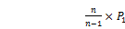……….(1)
P₁ = 1.0134 bar
P₂ =
For V₁ = Vs = Swept Volume of Cylinder,
Assume Volumetric Efficiency () = 80%
0.80 =………….(2)
Where d = Cylinder Diameter = 75mm = 0.075 m
L = Stroke Length = 130 mm = 0.13 m
And for speed of crank (N),
No. of Teeth on Larger sprocket (T₁) = 48
No. of teeth on Smaller Sprocket (T₂) = 20
We know that,
……{Assume Speed for larger sprocket,N₁ = 50 rpm}
Therefore, N₂ = 120 rpm
Put the values of d, L, N₂ in equation no. (2)
We get, V_{s} = 0.054 m³ /min.
Therefore Work Done of first cylinder,
W₁ =
W₁ = 3.15 KN-m/min

  - Calculation for Work-Done of second cylinder
W₂ =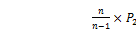
We know that P₂ = 1.74 bar
V₂ = V₁ = Vs = 0.054 m3/min
n = 1.5
Therefore, W₂ = 5.653 KN-m/min
Total Work done = W = W₁+W₂ = 3.25+5.65 = 8.90 KN.m/min
Power required to run compressor
Power = = 148.33 WATT

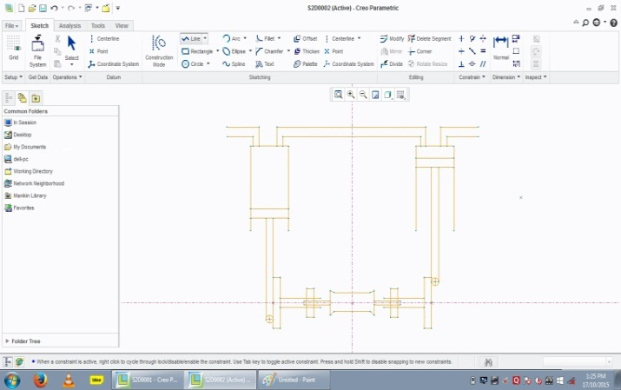

  - Human effort calculation
Wheel diameter = 60 cm = 0.6m
Centre distance between two sprocket = 460 mm = 0.46 m
Weight of cycle = 15 kg
Weight of accessories = 5 kg
Weight of person = 60 kg
Total force = Total weight
= 15+5+60 = 80 kg = 80 9.81 = 784.8 N
Force on each wheel
F₁=392.4 N
F₂=392.4 N
Torque = Force on each wheel Radius of wheel = 392.40.3 = 117.72 N-m
Effort = = 225.91 N
Effort in (KG) = 225.91/9.81 = 26.08 KG
- Chain Design
from design data book (B.D.Shiwalkarpg.no.150-154)
By considering standerd bicycle chain assumption
T₁ = 48 N₁ = 50 RPM
T₂ = 20 N₂ = 120 RPM
To calculate design power for bicycle
P_{d}= = = 616.38 WATT
Pitch circle diameter of sprocket calculation
D_{P} =
Where,
P = 20 mm
D_{P1} = 127.84mm
D_{P2} = 305.79mm
Pitch line velocity
V_{P} = = 0.334 m/sec
Number of strands
N= = = 0.5742
Total power
TP = Power of strands * No. of strands = 1072.73*0.5742 = 615.96 WATT
Total Power = 615.96 design is safe
Theoretical central distance between two sprockets
C = D_{P1}+05*D_{P2}
C = 305.79+0.5*127.84 = 369.69 mm
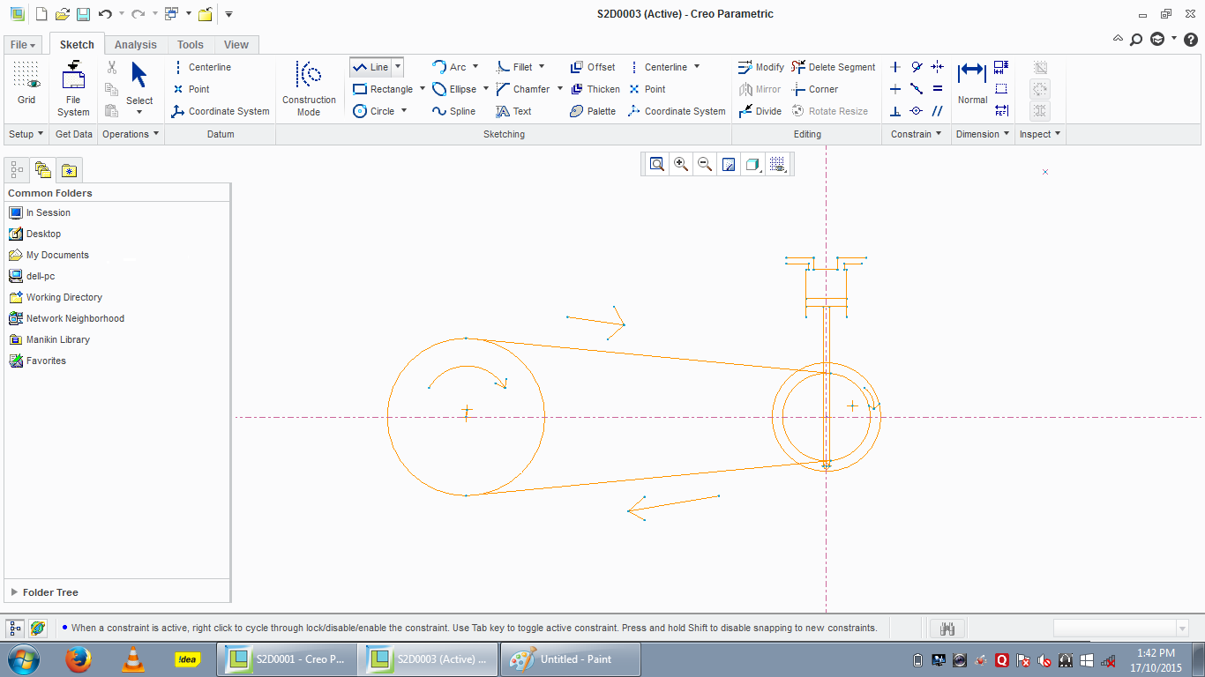

Conclusion
Form the different design calculation of double acting reciprocating compressor,bicycle chain human effort required, it can be concluded that the total work done required by the double acting compressorshould be 8..90 kn.m/min to generate a pressure of 2.5 to 3 bar and the human effort required to run the bicycle should be 2255..91 N or 26.088 kg. It can be concluded that the volume of first cylinder should be greater than second cylinder therefore human effort required to compress the air reduces.

References
[1] Vishal Gehlot, Abhinay Nigam, Kunal Marmat. International Journal of Science and Research (IJSR) ISSN (Online): 2319-7064 Index Copernicus Value (2013): 6.14 | Impact Factor (2013): 4.438.
[2] Rahul U. Urunkar et al Int. Journal of Engineering Research and Applications www.ijera.com ISSN : 2248-9622, Vol. 4, Issue 1( Version 2), January 2014, pp.214-219.
[3] P.K.Jadhao,K.K.Jadhao, S. S. Bhagwat .International Journal of Scientific & Engineering Research Volume 3, Issue 4, April-2012 ISSN 2229-5518.
[4] P.L BALLANY ,THERMAL ENGINEERING ,KHANNA PUBLICATION page no.372-439.
[5] DESIGN DATA FOR MACHINE ELEMENT,B.DSHIWALAKAR,page no.151-154.

