Design of Bicycle Powered Weeder

Harshal S. Wakharkar KDKCOE, Nagpur wakharkar.harshal@gmail.com
Pratap Daiya KDKCOE, Nagpur pratapdaiya@gmail.com

Abstract – In agriculture, unwanted weeds is the major problem. Weeds are the unwanted plants in the middle of crop fields which absorbs the nutrients from the soil, which can affect the health of primary crops. Weeding is the process to remove these unwanted weeds. This can be done by various methods such as manual weeding, mechanical weeding, thermal weeding, biological control, chemical control, and by farming pattern. In modern days, mechanical weeding is used in large scale. But in the economy like India, farmers are not that economically well, so it is not possible for those to afford such weeders. Manual weeders are also invented for such economy, but those are not as efficient as power weeders. So to overcome this problem a machine is developed which will be beneficial to the farmer for the weeding operations which will be bicycle powered.

Introduction
Weeding is a process of removing unwanted plants from the crop-fields. Weeds are basically removed to protect the primary crop. Weeds decrease the value of land. It affects its fertility. It affects directly to the crop production. Conventionally, weeding is done manually. Lot of labour work is required in the process. It consumes more time.As compared to manual weeding, powered weeding is less time consuming process. Power weeders are the weeding machines which are powered by IC Engines. But the problem with these power weeders is that they are too costly. The basic power weeder may also cost approximately above Rs. 20,000. Since the economy of Indian farmers is not that good so they are not able to afford such type of weeders
This is where, bicycle powered weeder will show its importance. Bicycle weeder will provide farmer with a weeder which will utilize the power generated by the pedaling to rotate the weeder blades for efficient weeding.

Problem Identification
The idea of bicycle weeder is inspired from the problems faced by the farmers in India. There are generally two types of weeders available in the market. These are as follows:
1. Power weeders (or engine weeders).
2. Manual Weeders.
In case of power weeders, the use of power weeders results in an effective weeding of field. It can cover up to 0.0712 ha/hr. It removes all the weeds coming in the way of it. The only problem in power weeders is its initial cost and maintenance cost. Initial cost, because the market price of the power weeders ranges from Rs. 20,000 to Rs. 50,000 according to the manufacturer of the machine. In spite of the initial cost, the maintenance cost is also more. Power weeders run on fuel viz. petrol, diesel. There is also problem of non-availability of fuel in the remote villages. This is why; a common farmer of India cannot afford such weeder.
Manual weeding is comparatively of low price. Manual weeding requires huge labour force and accounts for about 25 per cent of the total labour requirement which is usually 900 to 1200 man M hours/hectares. The labour requirement for weeding depends on weed flora, weed intensity, time of weeding, and soil moisture at the time of weeding and efficiency of worker. Scarcity of work force is also
major problem in manual weeders. 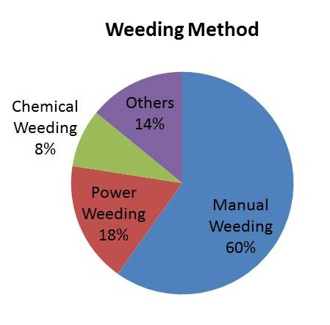
Fig. 1 Different Methods used in India
There are other different methods also which are having their own advantages and limitations. For example, chemical weeding is effective in killing of all the weeds but it can also affect the primary crop. So the main problem faced by the farmers is the high cost of the machine or the labour cost.

Objective
The aim of the project is to design, construct and test bicycle weeder, to provide the best opportunity for the crop to establish itself after planting and to grow vigorously up to the time of harvesting. Bicycle power weeder is to be specifically designed for the weeding of dry or semi-dry fields.
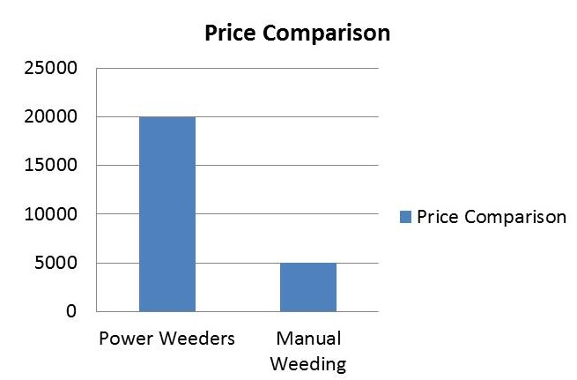
Fig. 2Comparison of weeders cost in India

The main objective of the bicycle weeder is to provide farmers with a weeder which is equally efficient to conventional weeding methods with the possible low cost, so that every farmer in India will be able to afford a weeder.
Objective:
1. To design bicycle weeder for semi-dry lands.
2. To lower the cost of the weeding process.
3. To improve the efficiency of the weeding.

IV. Research Methodology

A. Study of Conventional methods
Weeders which are available in the market are very costly. But the efficiency of these weeders is upto 70 to 90%. This makes them necessary for the job of weeding. In India, due to lack of capital, it is not possible for the farmers to afford such weeder. Power weeder can run upto 1800 to 5000rpm according to its range and engine power.
B. Field Inspection
We’ll be visiting different fields for the testing of soil quality. To check whether the bicycle weeder is effective in different types of soil in different weathers. For the convenience, we’ve assumed the soil resistance i.e. force required to hold the weed in soil equal to 1.05kgf/cm2.

C. Synthesis of Mechanism
The current design is not a final design. After the conduction of experiments with the soil and compatibility of the weeder with it, we can modify the design as per the requirements. As per the requirement of the movement of our machine different mechanisms will be implemented.

D. Design of Mechanism
The machine will be tested in the fields for the process of actual weeding. The efficiency of the weeding will be calculated. Any scope of improvements will be taken into consideration. The design can be modified after the whole testing of machine which results into final design.

E. Testing of the machine
The final design of the bicycle weeder after the modifications in it will be tested for the final results.

V. Design

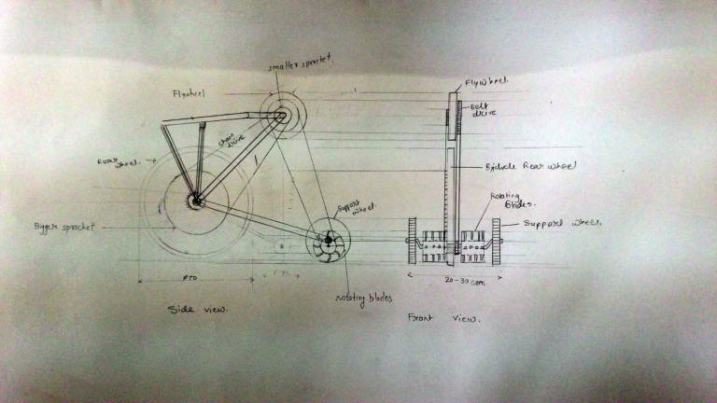
Fig. 3 Tentative Drawing of Bicycle Power Weeder

The bicycle weeder is designed in such a way that maximum torque can be generated in minimum power supplied.
Due to Chain drive mechanism, it is possible to provide velocity ratio approximately 7. That is, suppose if speed of cycle wheel is 60rpm, blade can rotate to 150rpm.

VI. Conclusion
The bicycle powered weeder is designed successfully which is able to provide the required torque and rotary speed of the blade resulting in increment in efficiency of manual powered weeding methods. After hitting the market, this product will be able to change the current phase of Indian Agriculture.

Acknowledgement
We feel immense pleasure while expressing my sincere, humble and deepest sense of gratitude to Project guide Dr. C. C. Handa Department of Mechanical Engineering for the valuable guidance and necessary help. He guided us right from the beginning for preparation & presentation of Project.
We extend our thanks to Head of the Department Dr. C. C. Handa who made available the faculties required to ensure the success of the Project. Also we would like to express our deep gratitude to Class Incharge Prof. A.P. Ninawe, Project InchargeEr. P.M. Zode& other faculties of Mechanical Engineering Department of K.D.K.C.E. Nagpur who were constant source of our inspiration.
We also thank our Principal Dr. D. P. Singh and Vice Principal Prof. A. M. Badar K. D. K. College of Engineering, Nagpur for providing us all the facilities in the college required for the completion of our project.
Although we sincerely hope the work free from inaccurate statements and faulty judgment in interpreting data. For these short comings we offer our sincere apology.

References
- Sridhar. H .S.,‘Development of Single wheel multi use manually operated weed remover’, (IJMER) Vol. 3, Issue. 6, Nov - Dec. 2013 pp-3836-3840 ISSN: 2249-6645.
- Olaoye, J. O. and T. A. Adekanye, ‘Development and Evaluation of a rotary power weeder’.
- RajvirYadav 1* and SahastrarashmiPund 2 - 1* Professor, Department of Farm Machinery & Power, College of Agril. Engg. & Tech., JAU - Junagadh 362001 India and 2Dy. Manager, Mahindra & Mahindra (R & D) Nashik, India. ’Development and Ergonomic Evaluation of Manual Weeder’.
- Lawale John Olukunlea, Philip Oguntundea. ‘Design of a Row Crop Weeder’, Federal University of Technology, Department of Agricultural Engineering, PMB 704Akure, Nigeria, y of Technology, Netherland.
- Godfrey Mwinama. ‘Blade Design’, Centre for Agricultural Mechanization and Rural Technology - (CAMARTEC), Arusha, Tanzania.
- Sri. MallikarjunaB.O. and Dr. Devaraja T.N. ‘Cycle weeder-handy for the small farmer’.
- Jonathan Jacob Shiru. ‘Design and Development of a Push pull mechanical weeder for farmer use’
- MohdTaufik Bin Ahmad. ‘Development of an Automated Mechanical Intra-Row Weeder for Vegetable Crops’, Iowa State University.

