Experimental Analysis of Parabolic Trough Collector for Heating Process

Prashant Rao K.D.K C.E. +919867679170 prashantr121 @gmail.com
Soham Pagote K.D.K C.E. +919325763310
Kunal Chouhan K.D.K C.E. +919049143705 chouhankunal06@gmail.com

Abstract – The Parabolic trough collector is the most proven technology for direct steam generation in solar thermal plants.Its capability to supply thermal energy over a wide range of temprature without serious degradation in efficiency. Water is heated without using solar pannel. It is easy to install and has less cost as compared to conventional solar heater. Less copper tube required in PTC and it is more efficient as compared to other conventional solar heater system.
Parabolic trough technology is the most mature concentrated solar power design. It is currently utilized by multiple operational large-scale CSP farms around the world.
Solar Electric Generating Systems (SEGS) is a collection of fully operational PTC systems located in the California desert with a total capacity of 354 MW. SEGS is at present the largest PTC power plant in the world.
Another PTC plant with a 280 MW capacity is being built in Arizona and is scheduled to become operational in 2011. PTCs effectively produce heat at temperatures ranging from 50 to 400⁰C. These temperatures are generally high enough for most industrial heating processes and applications, the great majority of which run below 300⁰C.

Keywords—PTC,Motor,Lenses,Copper tube,Parabolic Sheet.

Introduction
The concentrator usually used for concentrating solar radiation from large area on to the small area.Concentrating system concentrates large amount of solar radiation from large surface area to small size tube, concerts radiation energy fall on large area to heat energy. Concentrated solar systems use mirrors or lenses to concentrate a large area of sunlight, or solar thermal energy, onto a small area.
Solar radiation falls on lenses and concentrate on copper tube.Some parts of radiations strikes on parabola and reflects back to copper tube. Water flowing through copper tube absorbs heat and it will get heated.
The idea behind a concentrating solar collector is to minimize the heat losses associatedwith solar collection. In many instances it is desirable to deliver energy at higher temperatures than those possible with flat plate solar collectors. In this case, a parabolic “mirror” concentrates incident solar irradiation onto a much smaller receiver area, greatly decreasing heat loss and maximizing the available energy from the sun.

Objective

- The aim To reduced convection losses by using glass to cover absorbing surface .

- To reduced losses due to irregularities, we will used mirror polished stainless steel as a reflector.
- To reduced losses due to geometry using reflecting surface as a perfect parabola.
- To increase concentration ratio.
- To increase outlet temperature and efficiency by adjusting proper fluid flow rate.

Literature Review
The main purpose of this literature review is to get information about the project from the reference books, journals, technical papers and web sites.

- J.MECADO-VALENCIA et al. (ENERGY PROCEDIA 57 (2014)989-998)- In this paper PTC for heating water as a prototype are presented. The result of the evaluation to determine the thermal performance of PTC.

- ALHASSAN SALAMI TIJANI et al. (PROCEDIA TECHNOLOGY 15 (2014)841-848)- In this paper some of the losses associated with PTC including thermal losses and losses due to geometry is studied. Purpose of this paper is to simulate and describe the heat losses associated with heat collection element of solar PTC. Effect of wind speeds and mass flow rate of the fluid on thermal losses were investigated.

- IRVING ELEAZAR PEREZ MONTES et al. (ENERGY PROCEDIA 57(2014)2149-2158)- This paper presented the result of designing a parabolic trough collector and its application in a solar thermal system for the production of process heat.

Working
- Solar radiation falls on lenses and concentrate on copper tube.
- Some parts of radiations strikes on parabola and reflects back to copper tube.
- Water flowing through copper tube absorbs heat and it will get heated.

V. Design & Dimensions

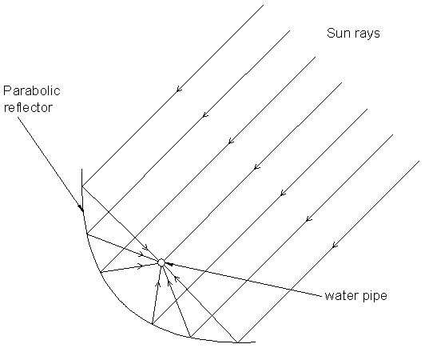

The fig shows parabolic reflector which having dimensions:
Focal length= 150mm
Ark length = 688.75mm
Concentrating area = 60cm×90cm
Receiving area = 2.5cm×90cm
Concentrating ratio = Concentrating area/Receiving area = 5400/225 = 24

- Design of parabola:-
Width aperture of parabola(Wa)=0.6 m
Concentraion Ratio= 0.0025/π*d
=0.6/ π*0.0025
=76.39
- Rim angle(α)
L=Wa/tan(α /2)
0.95=0.5/tan (α /2)
α= 55.51
- PTC length:-
L=Wa/tan(α /2)
L =0.6/tan(55.51/2)
L=1.14 m
- Focal length:-
Lf=Hp/2*(sec(α/2)+tan(α/2)+ln(sec(α/2)+tan(α/2))
Lf =0.1525/2*(1.65+0.5)
Lf =0.1639m
- Dimensions of stand:-
According to dimensions of parabola
Height=0.6m length=1m
- Storage tank:-
Do=0.32m Di=0.28m
A=π/4*(D02-Di2)
A=π/4*(0.322-0.282)
A =0.0188m2
Volume=0.0188*0.4
V =7.53*10-3
Insulating material-cotton have high absorbency
Reflecting surface- stainless steel reflectivity=90%
- Absorbing pipe:-
Di=0.0025 A=π/4 *0.0025^2=4.9*10-6m2

Length of parabola= length of absorbing pipe
L =1.14m
- Design of shaft:-
assume, d=15mm l=0.4m
Weight of concentrator=8 kg
Weight of shaft=ρ*area*length ……..mild steel
=8000*π/4 *0.0152*0.4
=0.5654 kg
- Required diameter:-
For no axial loading code equation reduce to
d3=16/π*Ss *moment
Sut=841mpa Syt=248 mpa
Ss=0.3Syt = 0.3*248=74.4 N/mm2
Ss=0.18Sut = 0.18*841=151.38 N/mm2
Maximum velocity of air( V)=11 m/s
Wind pressure (p)=0.6*v2
p =0.6*112
p =72.6 N/m2

- Pressure force:-
f=p/A=72.6/1.03=70.48 N
Moment= f*l=70.48*0.6=42.29 N-m
d3=16/74.4*π *(42.29*103) 2
d=14.25 mm
Our diameter =15 mm, hence design is safe
- Drag force:-
Fd=1/2*ρ*v2*Cd*A
Assume Cd=1.28 ρ=0.122
Fd =1/2*0.122*112*1.28*1.03
Fd=9.77 N

Conclusion
Hence with the use of this aluminium sheet in place of solar panel we not only can reduce the cost of solar heater but also maintaining its efficiency , reliability and affectiveness.

Refrences

- Science Direct.
- Research paper on PTC by J.Macedo-Valencia (2013).
- Research paper on PTC by A.Tijani (2014).
- Research paper on PTC by Omar Mercado (2013).
- DESIGN DATA FOR MACHINE ELEMENT,B,D SHIWALAKAR.

